COON VALLEY LUTHERAN CHURCH
“We are a family of God, striving to enrich
the lives of all through the love of Christ.”

PRELUDE MUSIC Mary Schultz
~ GATHERING ~
The Holy Spirit calls us together as the people of God

WELCOME and ANNOUNCEMENTS

CALL to WORSHIP
Alleluia! Christ is risen!
He is risen indeed! Alleluia!
This is the day that the Lord has made!
Let us rejoice and be glad in it!

GATHERING HYMN #526 God Is Here!

GREETING and PRAYER of the DAY
The grace of our Lord Jesus Christ, the love of God, and the communion of the Holy Spirit be with you all. And also with you.

O God our shepherd, you know your sheep by name and lead us to safety through the valleys of death. Guide us by your voice, that we may walk in certainty and security to the joyous feast prepared in your house, through Jesus Christ, our Savior and Lord, who lives and reigns with you and the Holy Spirit, one God, now and forever. Amen.

~WORD ~
God speaks to us in scripture reading, preaching, and song

FIRST READING ACTS 2:42-47

PSALM 23 (Read responsively)

SECOND READING: 1 Peter 2:19-25

GOSPEL ACCLAMATION ELW page 151
Alleluia. Lord, to whom shall we go?
You have the words of eternal life. Alleluia.

GOSPEL: John 10:1-10
Response after the Gospel reading: Praise to you, O Christ.

SERMON

HYMN of the DAY #574 Here I Am, Lord

SERVICE OF AFFIRMATION OF BAPTSIM (Please see insert)
Presentation of Confirmands
Profession of Faith
Affirmation of Baptismal Promises
Words of Welcome

OFFERING and OFFERING SONG #674 Let Us Talents and Tongues Employ
OFFERING PRAYER
Blessed are you, O god, maker of all things. Through your goodness you have blessed us with these gifts: ourselves, our time, and our possessions. Use us and what we have gathered in feeding the world with your love, through the one who gave himself for us, Jesus Christ our Savior and Lord. Amen.

THANKSGIVING at the TABLE and THE LORD’s PRAYER
The Lord be with you. And also with you.
Lift up your hearts. We lift them to the Lord.
Let us give thanks to the Lord our God. It is right to give our thanks and praise

Blessed are you, O God of the universe.
Your mercy is everlasting and your faithfulness endures from age to age.
We praise you for the words and deeds of Jesus, your anointed one.
We praise you for his death and resurrection and for your Spirit poured
out on all nations.

In the night in which he was betrayed . . . Do this for the remembrance of me.
With this bread and cup we remember our Lord’s victory over sin and death
as we proclaim the mystery of faith:

Christ has died. Christ is risen. Christ will come again.
Risen Lord, reveal yourself to us in the breaking of bread.
Raise us up as the body of Christ for the world.
With your people of all times and places we praise you, O God, now and forever.
Amen.

THE LORD’S PRAYER
Our Father who art in heaven, hallowed be thy name, thy kingdom come, thy will be done, on earth as it is in heaven.
Give us this day our daily bread; and forgive us our trespasses,
as we forgive those who trespass against us;
and lead us not into temptation, but deliver us from evil.
For thine is the kingdom, and the power, and the glory,
forever and ever. Amen.

THE COMMUNION
Communion Assistants: Malana Kinstler, Landon Lee
Hymns during distribution #677 This Little Light of Mine; #496 One Bread,
One Body; #491 Come, Let Us Eat

~ SENDING ~
God blesses us and sends us in mission to the world

BLESSING
The God of all,
who raised + Jesus from the dead,
bless you by the power of the Holy Spirit
to live in the new creation. Amen.

BELLS

DISMISSAL Go in peace. Serve the Risen Lord! Thanks be to God!

SENDING HYMN #720 We Are Called

POSTLUDE Mary Schultz
00000000000000000

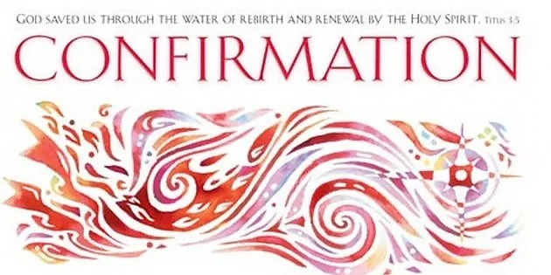

COON VALLEY LUTHERAN CHURCH
AFFIRMATION OF BAPTISM
FOURTH SUNDAY of EASTER
April 30, 2023
10:30 a.m.

