COON VALLEY LUTHERAN CHURCH
“We are a family of God, striving to enrich
the lives of all through the love of Christ.”
PRELUDE MUSIC
BELLS
WELCOME and ANNOUNCEMENTS

THANKSGIVING FOR BAPTISM
Blessed be the holy Trinity, ☩ one God, the fountain of living water,
the rock who gave us birth, our light and our salvation. Amen.

Joined to Christ in the waters of baptism, we are clothed with God's mercy and forgiveness. Let us give thanks for the gift of baptism.

Water may be poured into the font as the presiding minister gives thanks.
We give you thanks, O God, for in the beginning your Spirit moved over the waters
and by your Word you created the world, calling forth life in which you took delight.

Through the waters of the flood you delivered Noah and his family. Through the sea you led your people Israel from slavery into freedom. At the river your Son was baptized by John and anointed with the Holy Spirit. By water and your Word you claim us as daughters and sons, making us heirs of your promise and servants of all.

We praise you for the gift of water that sustains life, and above all we praise you for the gift of new life in Jesus Christ. Shower us with your Spirit, and renew our lives with your forgiveness, grace, and love.

To you be given honor and praise through Jesus Christ our Lord in the unity of the Holy Spirit, now and forever. Amen.

GATHERING HYMN ELW (red hymnal) #614 There is a Balm in Gilead
PRAYER OF THE DAY
God of miracles, sometimes we are slow to believe in your power, even when your miracles occur all around us each and every day. Open our eyes to see and our hearts to believe. Amen.
GREET THE WORD- ACS (purple hymnal) #976 Sung 1 time
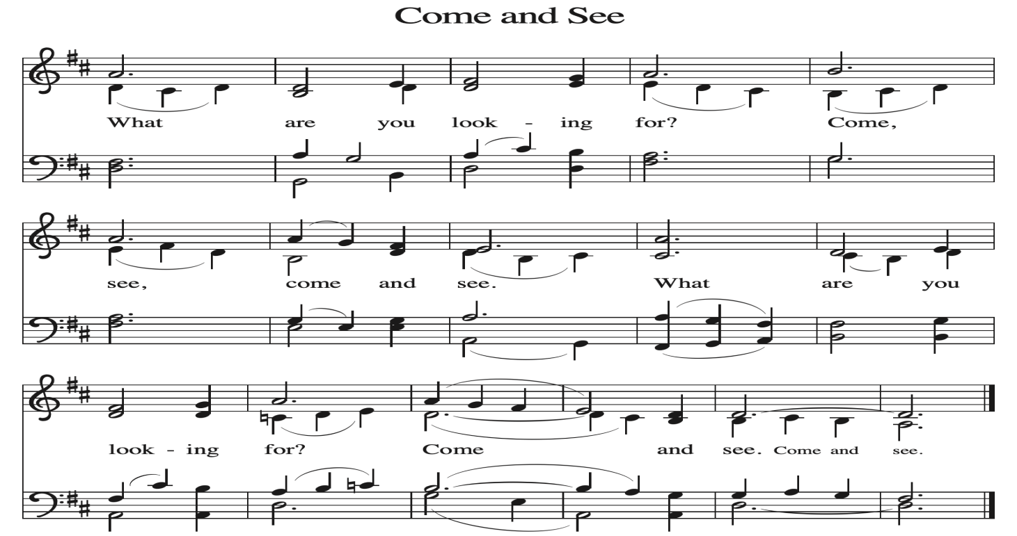
~ Proclamation of the WORD ~ (Scripture insert)
God speaks to us in scripture reading, preaching, and song.

GOSPEL READING: JOHN 4:46-54
The Gospel of the Lord. Praise to you, O Christ.

SERMON Rev. Ben Morris

HYMN of the DAY ELW (red hymnal) #612 Healer of Our Every Ill

APOSTLES’ CREED ELW (red hymnal) Page 105

PRAYERS of INTERCESSION
Petitions end: Merciful God....Receive our prayer.

PASSING OF THE PEACE
Please be aware of those who may not be comfortable shaking hands. You may also share the peace sign. Or any other contactless gesture that you are comfortable with.

OFFERING & SOLO

OFFERTORY ELW (red hymnal) #186 Create in Me a Clean Heart, O Lord

OFFERTORY PRAYER
God of majesty, no eye has seen, no ear has heard what you have prepared for those who love you, yet in this meal you reveal the wideness of your mercy.
Use what we have gathered to feed us with the reign of God come near,
Jesus Christ, our Savior and Lord. Amen.

THE LORD’S PRAYER

COMMUNION and SOLO

POST-COMMUNION BLESSING and PRAYER
Radiant God, we have seen your glory in the face of Jesus Christ.
In the sacrament of his body and blood you have drawn us to your heart.
Send us from this table with delight, that our lives may reflect the beauty of your love,
and bear witness to all we have seen and heard, through Jesus Christ, our Savior and Lord. Amen.
~ SENDING ~
God blesses us and sends us in mission to the world

BLESSING
May the triune God, who has put a new song in your mouth and tuned your heart for praise ☩ bless you now and forever. Amen.

BELLS
SENDING HYMN ELW (red hymnal) #543 Go, My Children, with My Blessing

DISMISSAL
Go in peace. Do justice. Love mercy.
Thanks be to God.

POSTLUDE
Reprinted / podcast / streamed with permission under ONE LICENSE #A-738444. All rights reserved.

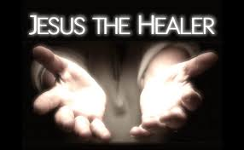
COON VALLEY LUTHERAN CHURCH
Sunday, February 8, 2026
Fifth Sunday after Epiphany

~Bulletins are in memory of Kathleen (Kathy) Knudson from Corrine Appleman & Ainsley Lichtie

Coffee Servers: Melinda Marsh, Jenny Briseno
Usher: Matt White
Reader: Sara Lieurance
Altar Guild: Karen McGarvey
Communion Servers: Laura Hofslien, Kim Cade
Attendance & Offering Last Sunday: 9:00a/88; $5,139.23
Sunday School Attendance Last Sunday: 3

Scan this code with your phone to contribute electronically with Vanco.

SCHEDULE
TODAY: 10:15a-11a/Sunday School, Coffee Fellowship, Directory Meeting in Library
MONDAY: 1:00-6:00pm/CVLC Blood Drive
TUESDAY: 9:00a-Noon/South Conference Pastor’s at CVLC
WEDNESDAY: 9:00a/Quilting
THURSDAY: 10:00a/Bible Study; Luminary Deadline
FRIDAY: Pastor Ben’s sabbath; Carillon Deadline
NEXT SUNDAY: 9:00a/Worship; 10:15a/Sunday School, Coffee Fellowship, Finance Committee
Coon Valley Lutheran Church
www.coonvalleylutheranchurch.org
Pastor: Rev. Benjamin Morris, Office 452-3772/Cell 608-406-1556, pastor@coonvalleylutheranchurch.org
Office Administrator: Jamie Thomas, office@coonvalleylutheranchurch.org
Office Hours: Tuesday & Wednesday 9:00-4:00p; Thursday 9:00a-3:30p
Office 452-3772/Cell 317-0007
Treasurer: Becky Lusk, treasurer@coonvalleylutheranchurch.org
Organist: Mary Schultz
Indoor Custodian: Tracy Stellner

Remember "Thumbs Up" When you come up for communion if you would like a gluten free wafer, give the wafer server a thumbs up as you approach. As you approach the wine server, give him or her a thumbs up to receive grape juice instead of wine.

GOSPEL: John 4:46-54
⁴⁶ Then he came again to Cana in Galilee, where he had changed the water into wine. Now there was a royal official whose son lay ill in Capernaum.
⁴⁷ When he heard that Jesus had come from Judea to Galilee, he went and begged him to come down and heal his son, for he was at the point of death.
⁴⁸ Then Jesus said to him, “Unless you see signs and wonders you will not believe.”
⁴⁹ The official said to him, “Sir, come down before my little boy dies.”
⁵⁰ Jesus said to him, “Go; your son will live.” The man believed the word that Jesus spoke to him and started on his way.
⁵¹ As he was going down, his slaves met him and told him that his child was alive.
⁵² So he asked them the hour when he began to recover, and they said to him, “Yesterday at one in the afternoon the fever left him.”
⁵³ The father realized that this was the hour when Jesus had said to him, “Your son will live.” So he himself believed, along with his whole household.
⁵⁴ Now this was the second sign that Jesus did after coming from Judea to Galilee.
The Gospel of the Lord. Praise to you, O Christ

*We are always so happy to include you and our CVLC family in our prayers. If you feel your name, or the name of a family member can be added or removed from this list please contact Jamie. Thank you!

We remember in prayer:
† Those hospitalized this past week: Tip Bagstad
† Our members whose names we lift up in prayer today: Corrine Appleman, Beverly Bagstad, Clifford Bakkum, Pastor Barbara Bruneau, Ellie Brye, Herby Cornell, Rita Erlandson, Gloria Galstad, Kira Hoff, Becky Ihle, Donna Ihle, Ray Ihle, Todd King, Margaret Lee, Russell Lee, Aaron Leisso, Aaron Marx, LuEtta Nelson, Romaine Nelson, Sandra Onshus, Elaine Proksch, Eunice Quast, Lori Roach, Jojo Satona, Heidi Saupe, Mary Schultz, Orrin Stakston, LaVonne Stendahl, Krin (Dreves) Stendalen, Joyce Temp, Teri Tomten, Renita Williamson
† Our members who are currently in health care facilities & Assisted Living:
Tip Bagstad, Rachel Berg, Carl Daffinrud, Jeanne Ebli, Carl Holte, Bob Moilien, Geri Nestingen, Irene Nestingen, Cathy Ofte, Annie Olson, Beatrice Olson (Alden),
Ellen Runice, Bob & Evelyn Schulze.
† Those who grieve: Family of Eddie Kanieski
† Our members who are currently home bound
† All those in need of God’s healing and help
† Family and friends of our members
† Local Military: Alex Hendrickson

