COON VALLEY LUTHERAN CHURCH
“We are a family of God, striving to enrich
the lives of all through the love of Christ.”

PRELUDE Mary Schultz

~ GATHERING ~
The Holy Spirit calls us together as the people of God.
RINGING OF THE BELLS

WELCOME and ANNOUNCEMENTS

CONFESSION and FORGIVENESS

Blessed be the holy Trinity, one God, who forgives all our sin, whose mercy endures forever. Amen.

Let us pray:
Almighty God, to whom all hearts are open, all desires known, and from whom no secrets are hid: cleanse the thoughts of our hearts by the inspiration of your Holy Spirit, that we may perfectly love you and worthily magnify your holy name, through Jesus Christ our Lord. Amen.

Let us confess our sin in the presence of God and of one another

Gracious God, have mercy on us. We confess that we have turned from you and given ourselves into the power of sin. We are truly sorry and humbly repent. In your compassion forgive us our sins, known and unknown, things we have done and things we have failed to do. Turn us again to you, and uphold us by your Spirit, so that we may live and serve you in newness of life through Jesus Christ, our Savior and Lord. Amen.

GATHERING HYMN #863 My God, How Wonderful Thou Art

KYRIE Page 147

GLORIA Page 148

GREETING and PRAYER of the DAY
The grace of our Lord Jesus Christ, the love of God, and the Communion of the Holy Spirit be with you all. And also with you.

O Lord God, merciful judge, you are the inexhaustible fountain of forgiveness. Replace our hearts of stone with hearts that love and adore you, that we may delight in doing your will, through Jesus Christ, our Savior and Lord.
~ WORD ~ (Scripture insert)
God speaks to us in scripture reading, preaching, and song.
FIRST READING: Genesis 50:15-21
SECOND READING: Colossians 3:12-14
Word of God. Word of Life. Thanks be to God.
GOSPEL ACCLAMATION Page 151
Alleluia. Lord, to whom shall we go?
You have the words of eternal life. Alleluia. Alleluia.
The Holy Gospel according to St. Matthew the 18th chapter.
Glory to you, O Lord.
GOSPEL: MATTHEW 18:21-35
After the Gospel is read…The Gospel of the Lord. Praise to you, O Christ.

SERMON

HYMN of the DAY #608 Softly and Tenderly Jesus is Calling

~ RESPONSE TO THE WORD ~
The Holy Spirit calls us as a community to say what we believe,
reach out to each other and offer gifts and prayers for God’s purposes.

THE APOSTLES’ CREED
I believe in God, the Father Almighty,
Creator of Heaven and earth;
I believe in Jesus Christ, God’s only Son Our Lord,
who was conceived by the Holy Spirit,
born of the Virgin Mary,
suffered under Pontius Pilate,
was crucified, died, and was buried;
he descended to the dead.
On the third day he rose again;
he ascended into heaven,
he is seated at the right hand of the Father,
and he will come to judge the living and the dead.
I believe in the Holy Spirit,
the holy catholic church,
the communion of saints,
the forgiveness of sins,
the resurrection of the body,
and the life everlasting. Amen.

PRAYERS of INTERCESSION
Hear us, O God. Your mercy is great.

PASSING OF THE PEACE
The Peace of Christ with you all. And also with you.
Please pass the peace to one another in Covid and germ safe manner.

OFFERING and OFFERING SONG: Making Their Way-on insert in pews

OFFERTORY PRAYER
God of field and forest, sea and sky, you are the giver of all good things.
Sustain us with the gifts of your creation, and multiply your graciousness in us, that the world may be fed with your love, through Jesus Christ, our Savior and Lord. Amen.

THE LORD’S PRAYER
Our Father who art in heaven, hallowed be thy name, thy kingdom come, thy will be done, on earth as it is in heaven.
Give us this day our daily bread; and forgive us our trespasses,
as we forgive those who trespass against us;
and lead us not into temptation, but deliver us from evil.
For thine is the kingdom, and the power, and the glory,
forever and ever. Amen.
~SENDING ~
God blesses us and sends us in mission to the world.

BENEDICTION

BELLS

SENDING HYMN #544 Praise the Lord, Rise up Rejoicing

DISMISSAL Go in peace. Serve the Lord. Thanks be to God!

POSTLUDE Mary Schultz

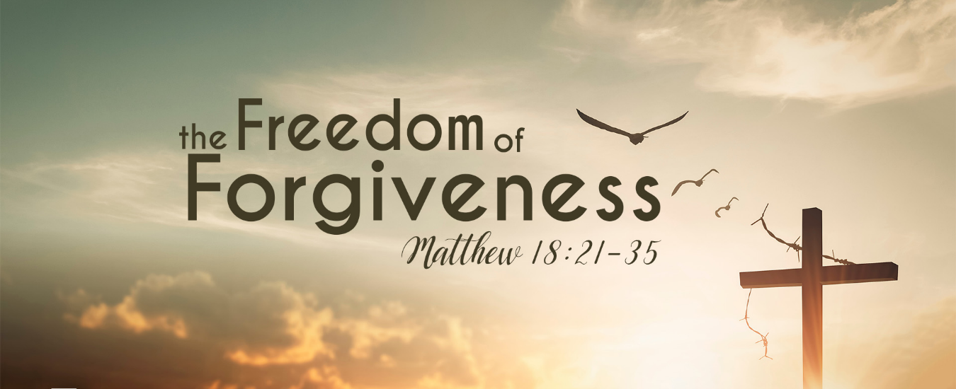

Coon Valley Lutheran Church
The Season Sixteenth Sunday of Pentecost

September 17, 2023
8:00 a.m. & 10:00 a.m.

~Bulletins are in memory of Maxine & John Rahanian from Cindy Swartz

Coffee Servers: Rachel Pederson & Gwen Bahr
Head Usher: 8:00/Mike Lusk; 10:00/Jan Bender
Reader: 8:00/Jane Simmons; 10:00/Jan Bender
Attendance & Offering Last Sunday: 87; $3,205.55

SCHEDULE
THURSDAY: 10:00a/WELCA
SATURDAY: 11:00a/Chaseburg Sole Burner
SUNDAY: 8:00 & 10:00a/Worship; 9:00a/Sunday School; Coffee Fellowship

Marge C. (Hagen) Hagen, 94, passed away on July 28, 2023 in Sioux Falls, SD. She was born December 25, 1928, the daughter of Joseph and Malla (Lokken) Hagen in the original house on land her Norwegian immigrant great-grandfather Johannes homestead near Coon Valley, WI. Marge and her husband, Phil Hagen owned and operated several drug stores (St Paul/Zumbrota MN) before retiring. She was interned at Ft. Snelling with her husband who passed away in 2017.

Coon Valley Lutheran Church
www.coonvalleylutheranchurch.org
Interim Pastor: Jim Scaife
Office Administrator: Jamie Thomas, jamiel@mwt.net
Office Hours: Tuesday, Wednesday, Thursday 9:00a-2:30p
Office 452-3772/Cell 317-0007
Treasurer: Becky Lusk, treasurer1005@mwt.net
Organist: Mary Schultz
Indoor Custodian: Tracy Stellner

FIRST READING: GENESIS 50:15-21
Realizing that their father was dead, Joseph’s brothers said, “What if Joseph still bears a grudge against us and pays us back in full for all the wrong that we did to him?” So they approached Joseph, saying, “Your father gave this instruction before he died, “Say to Joseph: I beg you, forgive the crime of your brothers and the wrong they did in harming you.’ Now therefore please forgive the crime of the servants of the God of your father.” Joseph wept when they spoke to him. Then his brothers also wept, fell down before him, and said, “We are here as your slaves.” But Joseph said to them, “Do not be afraid! Am I in the place of God? Even though you intended to do harm to me, God intended it for good, in order to preserve a numerous people, as he is doing today. So have no fear; I myself will provide for you and your little ones.” In this way he reassured them, speaking kindly to them.
Word of God. Word of life. Thanks be to God.

SECOND READING: COLOSSIANS 3:12-14
As God’s chosen ones, holy and beloved, clothe yourselves with compassion, kindness, humility, meekness, and patience. Bear with one another and, if anyone has a complaint against another, forgive each other; just as the Lord has forgiven you, so you also must forgive. Above all, clothe yourselves with love, which binds everything together in perfect harmony.
Word of God. Word of life. Thanks be to God.

GOSPEL READING: MATTHEW 18:21-35
Peter came and said to Jesus, “Lord, if another member of the church sins against me, how often should I forgive? As many as seven times?” Jesus said to him, “Not seven times, but, I tell you, seventy-seven times. “For this reason the kingdom of heaven may be compared to a king who wished to settle accounts with his slaves. When he began the reckoning, one who owed him ten thousand talents was brought to him; and, as he could not pay, his lord ordered him to be sold, together with his wife and children and all his possessions, and payment to be made. So the slave fell on his knees before him, saying, ‘Have patience with me, and I will pay you everything.’ And out of pity for him, the lord of that slave released him and forgave him the debt. But that same slave, as he went out, came upon one of his fellow slaves who owed him a hundred denarii; and seizing him by the throat, he said, ‘Pay what you owe.’ Then his fellow slave fell down and pleaded with him, ‘Have patience with me, and I will pay you.’ But he refused; then he went and threw him into prison until he would pay the debt. When his fellow slaves saw what had happened, they were greatly distressed, and they went and reported to their lord all that had taken place. Then his lord summoned him and said to him, ‘You wicked slave! I forgave you all that debt because you pleaded with me. Should you not have had mercy on your fellow slave, as I had mercy on you?’ And in anger his lord handed him over to be tortured until he would pay his entire debt. “So my heavenly Father will also do to every one of you, if you do not forgive your brother or sister from your heart.”
The Gospel of the Lord. Praise to you, O Christ.

*We are always so happy to include you and our CVLC family in our prayers. If you feel your name, or the name of a family member can be removed from this list please contact Jamie. Thank you!

We remember in prayer:
† Those hospitalized this past week
† Our members whose names we lift up in prayer today: Corrine Appleman, Beverly Bagstad, Clifford Bakkum, Brian Berg, Richard Brose, Herby Cornell, Jeanne Ebli, Kira Foster, Phyllis Galstad, Bonnie Holey, Donna Ihle, Verlin Ihle, Alan Jacobson, Todd King, Mike Kellogg, Jim Knutson, Margaret Lee, Russell Lee, Aaron Leisso, Larry Lichtie, Cindy Manske, Aaron Marx, Frank Mathison, Bud Miyamoto, Marianne Myhre, LuEtta Nelson, Romaine Nelson, Sandy Nelson, Cathy Ofte, Lisa Olson, Sandra Onshus, Eunice Quast, Lori Roach, Melanie Role, Jojo Satona, Mary Schultz, Billie Slater, LaVonne Stendahl, Joyce Temp, Teri Tomten.
† Our members who are currently in health care facilities & Assisted Living: Tip Bagstad, Inez Beck, Rachel Berg, Evelyn Dahlen, Joanne Fletcher,
Betty Gilbertson, Erma Graupe, Lenore Henley, Carl Holte, Sylvester King Jr., Bob Moilien, Irene Nestingen, Annie Olson, Beatrice Olson (Alden), Betty Sanders.
† Those who grieve
† Our members who are currently home bound
† All those in need of God’s healing and help
† Family and friends of our members

