COON VALLEY LUTHERAN CHURCH
“We are a family of God, striving to enrich
the lives of all through the love of Christ.”
PRELUDE MUSIC
BELLS
WELCOME and ANNOUNCEMENTS

CONFESSION AND FORGIVENESS
Blessed be the holy Trinity, ☩ one God, who pours love into our hearts
and healing upon the earth. Amen.

Confident that God justifies us by grace through faith, let us confess our sin.
Silence is kept for reflection.
Compassionate God,
we confess that we struggle to embody your goodness in the world and in our own hearts. Creation groans from overuse. Jealousy and bitterness strain our relationships. Indifference keeps us from seeking justice.
Divisions disrupt your call to show genuine love to others. Turn our hearts back to you. Restore our world and reconcile us to one another. Renew us to live as your holy people, following the way of Jesus Christ. Amen.
Hear this good news:
We have peace with God through ☩ Jesus Christ, in whom there is no condemnation,
but only forgiveness and the promise of eternal life. Receive freely this healing gift of grace. Amen.

GATHERING HYMN ELW (red hymnal) #532 Gather Us In

PRAYER OF THE DAY
Lord God, your loving kindness always goes before us and follows after us. Summon us into your light and direct our steps in the ways of goodness that come through the cross of your Son, Jesus Christ, our Savior and Lord. Amen.

~ Proclamation of the WORD ~ (Scripture insert)
God speaks to us in scripture reading, preaching, and song.

FIRST READING: Ephesians 4:1-13
Word of God. Word of Life. Thanks be to God.

GREET THE WORD- ELW (red hymnal) #174 Sung 2 times
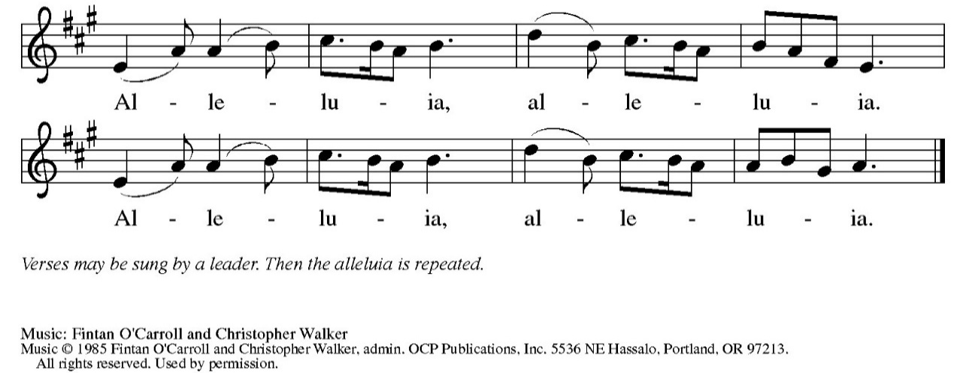

The Holy Gospel according to St. Matthew the fifth chapter
Glory to you, O Lord.

GOSPEL READING: Matthew 5: 13-16
The Gospel of the Lord. Praise to you, O Christ.

SERMON Rev. Benjamin Morris

HYMN of the DAY ELW (red hymnal) #715 Christ, Be Our Light

APOSTLES’ CREED ELW (red hymnal) Page 105
PRAYERS of INTERCESSION
Petitions end: Hear us, O God,...Your mercy is great.

PASSING OF THE PEACE
Please be aware of those who may not be comfortable shaking hands. You may also share the peace sign. Or any other contactless gesture that you are comfortable with.

OFFERING & NOISY OFFERING (Sunday School) & SOLO
OFFERTORY ELW (red hymnal) #182 Let the Vineyards Be Fruitful
Let the vineyards be fruitful, Lord, and ﬁll to the brim our cup of blessing.
Gather a harvest from the seeds that were sown,
that we may be fed with the bread of life.
Gather the hopes and the dreams of all;
unite them with the prayers we offer now.
Grace our table with your presence,
and give us a foretaste of the feast to come.
Text © 1978 Lutheran Book of Worship, admin. Augsburg Fortress.
OFFERTORY PRAYER
God of creation, you send rain and the earth springs forth abundantly.
All blessings are from you; make us generous with what we have.
Use our gifts, our abilities, and our hearts in service to you and in love to our neighbors, today and always. Amen.

THE LORD’S PRAYER

COMMUNION & HYMNS ELW (red hymnal)
#461 All Who Hunger, Gather Gladly
#471 Let Us Break Bread Together

POST-COMMUNION PRAYER and BLESSING
Sustaining God, with this bread and cup, you nourish us with mercy and abundant life. By your Spirit, send us from this table to serve a needy world.
Make us living signs of your liberation, healing, and love, following the way of Jesus, in whose name we pray. Amen.

~ SENDING ~
God blesses us and sends us in mission to the world
BLESSING
The God of grace ☩ bless you now and forever.
Amen

BELLS
SENDING HYMN ELW (red hymnal) #688 Lord of Light

DISMISSAL Go out in joy. Be led forth in peace. Thanks be to God.

POSTLUDE

Reprinted / podcast / streamed with permission under ONE LICENSE #A-738444. All rights reserved

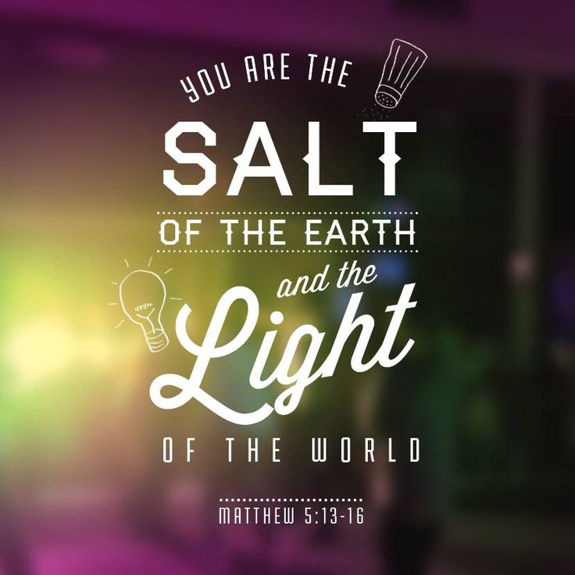
COON VALLEY LUTHERAN CHURCH
Twentieth Sunday of Pentecost
Sunday, October 11, 2026

Ephesians 4:1-13
4 I, therefore, the prisoner in the Lord, beg you to walk in a manner worthy of the calling to which you have been called, ² with all humility and gentleness, with patience, bearing with one another in love, ³ making every effort to maintain the unity of the Spirit in the bond of peace: ⁴ there is one body and one Spirit, just as you were called to the one hope of your calling, ⁵ one Lord, one faith, one baptism, ⁶ one God and Father of all, who is above all and through all and in all.
⁷ But each of us was given grace according to the measure of Christ’s gift. ⁸ Therefore it is said,
“When he ascended on high, he made captivity itself a captive;
he gave gifts to his people.”
⁹ (When it says, “He ascended,” what does it mean but that he had also descended into the lower parts of the earth? ¹⁰ He who descended is the same one who ascended far above all the heavens, so that he might fill all things.) ¹¹ He himself granted that some are apostles, prophets, evangelists, pastors and teachers ¹² to equip the saints for the work of ministry, for building up the body of Christ, ¹³ until all of us come to the unity of the faith and of the knowledge of the Son of God, to maturity, to the measure of the full stature of Christ.

Word of God. Word of Life. Thanks be to God.

The Holy Gospel according to St. Matthew the fifth chapter
Glory to you, O Lord.

GOSPEL: Matthew 5:13-16
¹³ “You are the salt of the earth, but if salt has lost its taste, how can its saltiness be restored? It is no longer good for anything but is thrown out and trampled under foot.
¹⁴ “You are the light of the world. A city built on a hill cannot be hid. ¹⁵ People do not light a lamp and put it under the bushel basket; rather, they put it on the lampstand, and it gives light to all in the house. ¹⁶ In the same way, let your light shine before others, so that they may see your good works and give glory to your Father in heaven.

The Gospel of the Lord. Praise to you, O Christ.

*We are always so happy to include you and our CVLC family in our prayers. If you feel your name, or the name of a family member can be added or removed from this list please contact Jamie. Thank you!

We remember in prayer:
† Those hospitalized this past week:
† Our members whose names we lift up in prayer today: Corrine Appleman, Beverly Bagstad, Clifford Bakkum, Pastor Barbara Bruneau, Ellie Brye, Herby Cornell, Ardell Daffinrud, Gloria Galstad, Kira Hoff, Becky Ihle, Donna Ihle, Ray Ihle, Julie Kruizenga, Margaret Lee, Russell Lee, Aaron Leisso, Aaron Marx, Bob Nelson, Julie Nelson, LuEtta Nelson, Mike Nelson, Romaine Nelson, Sandra Onshus, Elaine Proksch, Eunice Quast, Lori Roach, Jojo Satona, Heidi Saupe, Orrin Stakston, LaVonne Stendahl, Joyce Temp, Kevin Traastad, Renita Williamson
† Our members who are currently in health care facilities & Assisted Living: Tip Bagstad, Mike Brye, Carl Daffinrud, Jeanne Ebli, Carl Holte, Patty Helgerson, Bob Moilien, Geri Nestingen, Irene Nestingen, Cathy Ofte, Annie Olson, Beatrice Olson (Alden), Elaine Proksch, Ellen Runice, Bob & Evelyn Schulze.
† Those who grieve
† Our members who are currently home bound
† All those in need of God’s healing and help
† All those affected by recent storms
† Family and friends of our members
† Local Military: Alex Hendrickson

~Bulletins are in memory of Aaron Schweitzer from Jason, Jamie Kristina & Karly Thomas

Coffee Servers: Laurie Holte, Jane Simmons
Altar Guild: Sarah Ofte
Communion Servers: Laura Hofslien
Usher: Matthew White
Reader: Steve Pauloski
Attendance & Offering Last Sunday: 9:00a/103; $5,377.35
Sunday School Attendance last Sunday: 7


Scan this code with your phone to contribute electronically with Vanco.

SCHEDULE

TODAY: 6:00-7:30p/Confirmation
TUESDAY: 9:00a/Pastor’s Text Study
WEDNESDAY: 9:00a/Quilting; Carillon Deadline
THURSDAY: 10:00a/WELCA; 6:00p/Church Council
FRIDAY: Pastor Ben’s Sabbath
NEXT SUNDAY: 10:00a/Worship; 10:00a/Sunday School; 11:00a/Men’s Club Meatball Dinner; 6:00-7:30p/Confirmation

Coon Valley Lutheran Church
www.coonvalleylutheranchurch.org
Pastor: Rev. Benjamin Morris, Office 452-3772/Cell 608-406-1556, pastor@coonvalleylutheranchurch.org
Office Administrator: Jamie Thomas, office@coonvalleylutheranchurch.org
Office Hours: Tues. -Thurs 9:00a-3:30p
Office 452-3772
Treasurer: Becky Lusk, treasurer@coonvalleylutheranchurch.org
Organist: Aaron Stakston
Indoor Custodian: Tracy Stellner

