COON VALLEY LUTHERAN CHURCH
“We are a family of God, striving to enrich
the lives of all through the love of Christ.”

PRELUDE Mary Schultz

~ GATHERING ~
The Holy Spirit calls us together as the people of God.

WELCOME and ANNOUNCEMENTS

CALL to WORSHIP
Make a joyful noise to the LORD, all the earth!
Worship the LORD with gladness; come into God's presence with a song.
Know that the LORD is God, we are his people, and the sheep of his pasture.
Enter his gates with thanksgiving and his courts with praise.
Give thanks to God, bless God's holy name.
For the Lord is good; his faithfulness endures to all generations.

GATHERING HYMN #824 This Is My Father’s World

GREETING and PRAYER of the DAY
The grace of our Lord Jesus Christ, the love of God, and the Communion of the Holy Spirit be with you all. And also with you.

God of love, you who called disciples and sent them: gather us now, equip us for your service, and send us in your name for the sake of the healing of the world, in the loving presence and the healing spirit of Christ. Amen.

~ WORD ~ (Scripture insert)
God speaks to us in scripture reading, preaching, and song.

FIRST READING: Exodus 19:2-8a
SECOND READING: Romans 5:1-8
Word of God. Word of Life. Thanks be to God.
GOSPEL: Matthew 9:35-10:8
After the Gospel is read…The Gospel of the Lord. Praise to you, O Christ.

SERMON

HYMN of the DAY#661 I Love to Tell the Story

~ RESPONSE TO THE WORD ~
The Holy Spirit calls us as a community to say what we believe,
reach out to each other and offer gifts and prayers for God’s purposes.

ORDER of HOLY BAPTISM of GRACEN RAY KLUM

PRAYERS of INTERCESSION
God, in your mercy, hear our prayer.

THE LORD’S PRAYER
Our Father who art in heaven, hallowed be thy name, thy kingdom come, thy will be done, on earth as it is in heaven.
Give us this day our daily bread; and forgive us our trespasses,
as we forgive those who trespass against us;
and lead us not into temptation, but deliver us from evil.
For thine is the kingdom, and the power, and the glory,
forever and ever. Amen.

OFFERING and OFFERING SONG Build a Longer Table (On the back)

OFFERTORY PRAYER
Blessed are you, O God, maker of all things. Through your goodness you have blessed us with these gifts: ourselves, our time, and our possessions. Use us, and what we have gathered, in feeding the world with your love, through the one who gave himself for us, Jesus Christ, our Savior and Lord. Amen.

~SENDING ~
God blesses us and sends us in mission to the world.
BENEDICTION

BELLS

SENDING HYMN #671 Shine, Jesus, Shine (Requested by Rachel Pederson)

DISMISSAL Go in peace. Serve our risen Lord. Thanks be to God. Alleluia!

POSTLUDE Mary Schultz

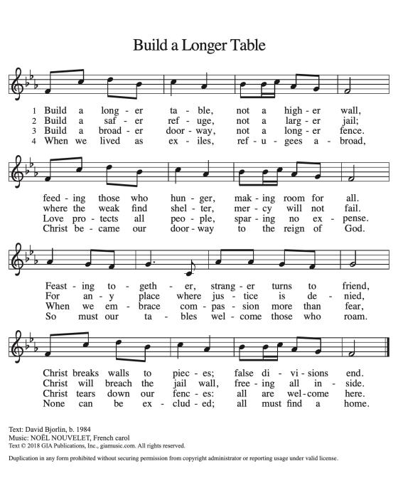

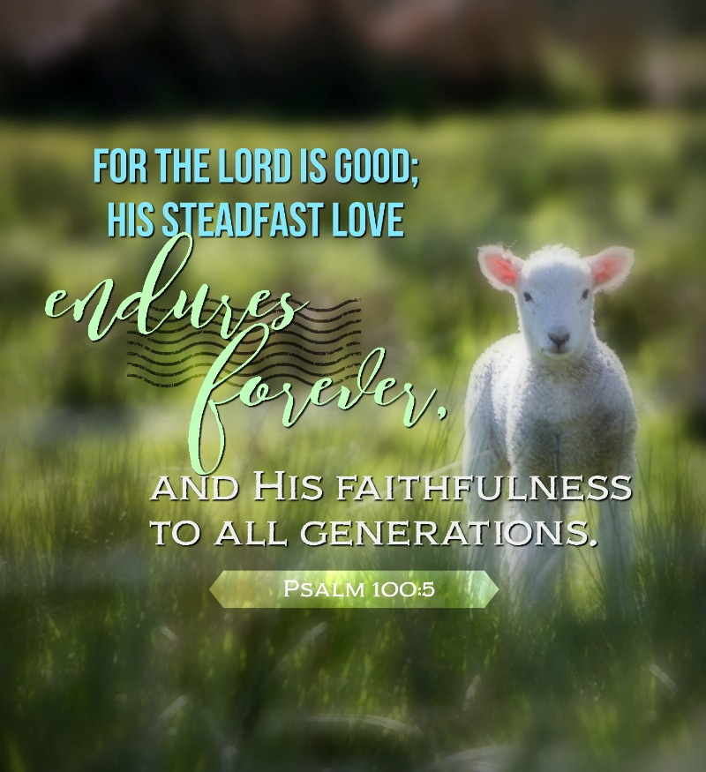

Coon Valley Lutheran Church
The Third Sunday after Pentecost
Father’s Day
June 18, 2023

~ Bulletins are in memory of Philip Stakston & John Jacobson from Orrin & Becky Stakston

Head Usher: Heather Wichman
Reader: Jane Simmons
Attendance & Offering Last Sunday: 9am/64; $2,647.71

SCHEDULE
MONDAY: 8:00a-4:00p/Sugar Creek Explorer Day-Sign up today!!
TUESDAY: 10:00/Pastor’s Text Study
SUNDAY: 9:00a/Worship

Coon Valley Lutheran Church
www.coonvalleylutheranchurch.org
Pastor: Rev. Julie Wollman, pastorjuliecvlc@gmail.com Home Phone 634-3797
Office Administrator: Jamie Thomas, jamiel@mwt.net
Office Hours: Tuesday 9:00a-11:30a; Wednesday & Thursday 9:00a-3:00p
Office 452-3772/Cell 317-0007
Treasurer: Becky Lusk, treasurer1005@mwt.net
Organist: Mary Schultz
Indoor Custodian: Tracy Stellner

FIRST READING: EXODUS 19:2-8a
The Israelites had journeyed from Rephidim, entered the wilderness of Sinai, and camped in the wilderness; Israel camped there in front of the mountain. Then Moses went up to God; the LORD called to him from the mountain, saying, “Thus you shall say to the house of Jacob, and tell the Israelites: You have seen what I did to the Egyptians, and how I bore you on eagles’ wings and brought you to myself. Now therefore, if you obey my voice and keep my covenant, you shall be my treasured possession out of all the peoples. Indeed, the whole earth is mine, but you shall be for me a priestly kingdom and a holy nation. These are the words that you shall speak to the Israelites.” So Moses came, summoned the elders of the people, and set before them all these words that the LORD had commanded him. The people all answered as one: “Everything that the LORD has spoken we will do.”
Word of God. Word of Life. Thanks be to God.

SECOND READING: ROMANS 5:1-8
Since we are justified by faith, we have peace with God through our Lord Jesus Christ, through whom we have obtained access to this grace in which we stand; and we boast in our hope of sharing the glory of God. And not only that, but we also boast in our sufferings, knowing that suffering produces endurance, and endurance produces character, and character produces hope, and hope does not disappoint us, because God’s love has been poured into our hearts through the Holy Spirit that has been given to us. For while we were still weak, at the right time Christ died for the ungodly. Indeed, rarely will anyone die for a righteous person—though perhaps for a good person someone might actually dare to die. But God proves his love for us in that while we still were sinners Christ died for us.
Word of God. Word of Life. Thanks be to God.

GOSPEL READING: MATTHEW 9:35-10:8
Then Jesus went about all the cities and villages, teaching in their synagogues, and proclaiming the good news of the kingdom, and curing every disease and every sickness. When he saw the crowds, he had compassion for them, because they were harassed and helpless, like sheep without a shepherd. Then he said to his disciples, “The harvest is plentiful, but the laborers are few; therefore ask the Lord of the harvest to send out laborers into his harvest.” Then Jesus summoned his twelve disciples and gave them authority over unclean spirits, to cast them out, and to cure every disease and every sickness. These are the names of the twelve apostles: first, Simon, also known as Peter, and his brother Andrew; James son of Zebedee, and his brother John; Philip and Bartholomew; Thomas and Matthew the tax collector; James son of Alphaeus, and Thaddaeus; Simon the Cananaean, and Judas Iscariot, the one who betrayed him. These twelve Jesus sent out with the following instructions: “Go nowhere among the Gentiles, and enter no town of the Samaritans, but go rather to the lost sheep of the house of Israel. As you go, proclaim the good news, ‘The kingdom of heaven has come near.’ Cure the sick, raise the dead, cleanse the lepers, cast out demons. You received without payment; give without payment.
The Gospel of the Lord. Praise to you, O Christ.

*We are always so happy to include you and our CVLC family in our prayers. If you feel your name, or the name of a family member can be removed from this list please contact Jamie. Thank you!

We remember in prayer:
† Those hospitalized this past week:
† Our members whose names we lift up in prayer today: Corrine Appleman, Beverly Bagstad, Clifford Bakkum, Richard Brose, Jeanne Ebli, Kira Foster, Phyllis Galstad, Lucy Hardie, Bonnie Holey, Donna Ihle, Verlin Ihle, Alan Jacobson, Todd King, Mike Kellogg, Jim Knutson, Margaret Lee, Russell Lee, Aaron Leisso, Christy Swartz-Leonard, Larry Lichtie, Cindy Manske, Aaron Marx, Frank Mathison, Bud Miyamoto, Marianne Myhre, LuEtta Nelson, Romaine Nelson, Sandy Nelson, Cathy Ofte, Lisa Olson, Sandra Onshus, Eunice Quast, Melanie Role, Jojo Satona, Mary Schultz, Billie Slater, LaVonne Stendahl, Suzanne Strangstalien, Patty Stuempges, Susan Syverson, Joyce Temp, Teri Tomten.
† Our members who are currently in health care facilities & Assisted Living: Tip Bagstad, Inez Beck, Rachel Berg, Evelyn Dahlen, Joanne Fletcher, Betty Gilbertson, Erma Graupe, Lenore Henley, Carl Holte, Sylvester King Jr., Bob Moilien, Irene Nestingen, Annie Olson, Beatrice Olson (Alden), Betty Sanders.
† Those who grieve: Becky Lusk and family in the death of her father Edwin Giese
† Our members who are currently home bound
† All those in need of God’s healing and help
† Family and friends of our members

