COON VALLEY LUTHERAN CHURCH
“We are a family of God, striving to enrich
the lives of all through the love of Christ.”
PRELUDE MUSIC
BELLS
WELCOME and ANNOUNCEMENTS

THANKSGIVING FOR BAPTISM
Alleluia! Christ is risen.
Christ is risen indeed. Alleluia!
Salvation belongs to our God who is seated on the throne
and to the Lamb!
Amen.
Let us give thanks for the gifts of baptism.
Water may be poured into the font as the presiding minister continues.
Merciful God,
you are the one who was, who is, and who is to come.
You lead us beside still waters.
We thank you for the waters of creation:
morning dew, gentle rain, roaring waves.
We thank you for the waters that nourish us (local waters may be named).
Blessed are you.
You guide us to springs of the water of life.
Jesus Christ, you are the faithful witness
who accompanies us on our journeys.
We give you thanks for your life-giving death and resurrection.
We praise you for joining us in joy and sorrow.
Blessed are you.
You guide us to springs of the water of life.
Holy Spirit, you anoint our head with oil and our cup overflows.
Break down barriers that divide us.
Fill us with the breath of peace.
Blessed are you.
You guide us to springs of the water of life.
Holy One, we thank you for the gifts and grace of baptism,
and for making us a new creation.
We join with saints and angels, giving you honor and praise,
now and forever.
Amen.
GATHERING HYMN ELW (red hymnal) #400 God of Tempest, God of Whirlwind
PRAYER OF THE DAY
God of Spirit, we give thanks that when you sent your Advocate, the apostles were empowered to speak about your deeds of power in all languages, for every people. Give us boldness to share the Spirit’s power with our neighbors. Amen.
GREET THE WORD- ACS (purple hymnal) #976 Sung 1 time
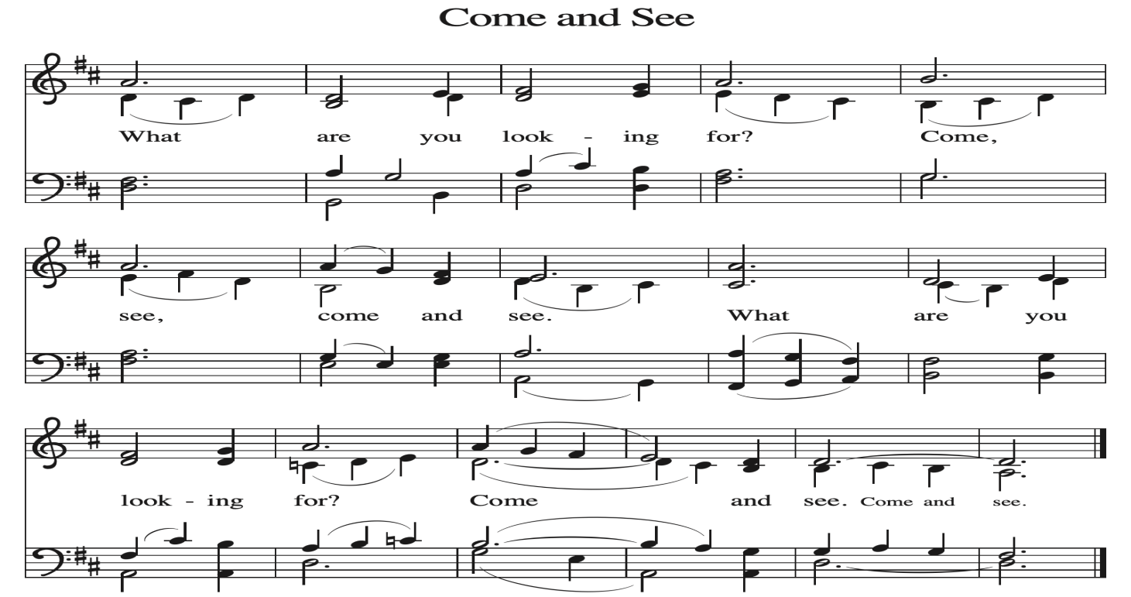
~ Proclamation of the WORD ~ (Scripture insert)
God speaks to us in scripture reading, preaching, and song.

READING: ACTS 2:1-21

PHILIPPIANS 4:4-7
Word of God. Word of Life. Thanks be to God.
SERMON Rev. Benjamin Morris

HYMN of the DAY ELW (red hymnal) #843 Praise the One Who Breaks the Darkness

NICENE CREED ELW (red hymnal) Page 104
PRAYERS of INTERCESSION
Petitions end: Merciful God,...receive our prayer.

PASSING OF THE PEACE
Please be aware of those who may not be comfortable shaking hands. You may also share the peace sign. Or any other contactless gesture that you are comfortable with.

OFFERING & SOLO
OFFERTORY ELW (red hymnal) #186 Create in Me a Clean Heart, O Lord

OFFERTORY PRAYER
Merciful God, accept the fruits of our labor, gathered to give you glory.
You have set a table before us, a glimpse of that great day when we will hunger and thirst no more. Nourish us with the body and blood of Jesus,
that goodness and mercy may follow us and bless the world you love.
In the name of Jesus, Amen.

THANKSGIVING FOR THE WORD
O God of justice and love, we give thanks to you that you illumine our way through life with the words of your Son. Give us the light we need, awaken us to the needs of others, and at the end bring all the world to your feast; through Jesus Christ, our Savior and Lord, to whom, with you and the Holy Spirit, be honor and glory forever. Amen.

THE LORD’S PRAYER

~ SENDING ~
God blesses us and sends us in mission to the world
BLESSING
God Almighty, who is the beginning and the end, Jesus Christ, the firstborn of the dead,
and the Spirit, our advocate and peace, ☩ bless you now and forever. Amen.

BELLS
SENDING HYMN ELW (red hymnal) #545 Lord, Dismiss Us with Your Blessing

DISMISSAL
Go in peace. Praise the Lord. Alleluia! Thanks be to God. Alleluia!

POSTLUDE

Reprinted / podcast / streamed with permission under ONE LICENSE #A-738444. All rights reserved


COON VALLEY LUTHERAN CHURCH
Day of Pentecost
Sunday, May 24, 2026

~Bulletins are in honor of the birthday of Donald Role!

Coffee Servers: Deb Holen, Nancy King
Piano/Organ: Aaron Stakston
Usher: Phil Moilien
Reader: Deb Holen
Attendance & Offering Last Sunday: 9:00a/121; $3,923.22


Scan this code with your phone to contribute electronically with Vanco.

SCHEDULE
TODAY: 10:15am/Coffee Fellowship in honor of the birthday of Don Role
TUESDAY: 9:00a-Noon/Pastor’s text study
WEDNESDAY: 9:00a/Quilting
THURSDAY: 10:00a/Bible Study
FRIDAY: Pastor Ben’s sabbath
NEXT SUNDAY: 9:00a/Worship

Coon Valley Lutheran Church
www.coonvalleylutheranchurch.org
Pastor: Rev. Benjamin Morris, Office 452-3772/Cell 608-406-1556, pastor@coonvalleylutheranchurch.org
Office Administrator: Jamie Thomas, office@coonvalleylutheranchurch.org
Office Hours: Thursday 9:00a-2:30p
Office 452-3772/Cell 317-0007
Treasurer: Becky Lusk, treasurer@coonvalleylutheranchurch.org
Organist:
Indoor Custodian: Tracy Stellner

Acts 2:1-21
2 When the day of Pentecost had come, they were all together in one place. ² And suddenly from heaven there came a sound like the rush of a violent wind, and it filled the entire house where they were sitting. ³ Divided tongues, as of fire, appeared among them, and a tongue rested on each of them. ⁴ All of them were filled with the Holy Spirit and began to speak in other languages, as the Spirit gave them ability.
⁵ Now there were devout Jews from every people under heaven living in Jerusalem. ⁶ And at this sound the crowd gathered and was bewildered, because each one heard them speaking in the native language of each. ⁷ Amazed and astonished, they asked, “Are not all these who are speaking Galileans? ⁸ And how is it that we hear, each of us, in our own native language? ⁹ Parthians, Medes, Elamites, and residents of Mesopotamia, Judea and Cappadocia, Pontus and Asia, ¹⁰ Phrygia and Pamphylia, Egypt and the parts of Libya belonging to Cyrene, and visitors from Rome, both Jews and proselytes, ¹¹ Cretans and Arabs—in our own languages we hear them speaking about God’s deeds of power.” ¹² All were amazed and perplexed, saying to one another, “What does this mean?” ¹³ But others sneered and said, “They are filled with new wine.”
¹⁴ But Peter, standing with the eleven, raised his voice and addressed them, “Fellow Jews and all who live in Jerusalem, let this be known to you, and listen to what I say. ¹⁵ Indeed, these are not drunk, as you suppose, for it is only nine o’clock in the morning. ¹⁶ No, this is what was spoken through the prophet Joel:
¹⁷ ‘In the last days it will be, God declares,
that I will pour out my Spirit upon all flesh,
and your sons and your daughters shall prophesy,
and your young men shall see visions,
and your old men shall dream dreams.
¹⁸ Even upon my slaves, both men and women,
in those days I will pour out my Spirit,
and they shall prophesy.
¹⁹ And I will show portents in the heaven above
and signs on the earth below,
blood, and fire, and smoky mist.
²⁰ The sun shall be turned to darkness
and the moon to blood,
before the coming of the Lord’s great and glorious day.
²¹ Then everyone who calls on the name of the Lord shall be saved.’

Word of God. Word of Life. Thanks be to God.

Philippians 4:4-7
⁴ Rejoice in the Lord always; again I will say, Rejoice. ⁵ Let your gentleness be known to everyone. The Lord is near. ⁶ Do not be anxious about anything, but in everything by prayer and supplication with thanksgiving let your requests be made known to God. ⁷ And the peace of God, which surpasses all understanding, will guard your hearts and your minds in Christ Jesus.
Word of God. Word of Life. Thanks be to God.

Remember "Thumbs Up" When you come up for communion if you would like a gluten free wafer, give the wafer server a thumbs up as you approach. As you approach the wine server,
give him or her a thumbs up to receive grape juice instead of wine.

*If you would like communion brought to you, please let the usher know as they are dismissing people into the communion line

*We are always so happy to include you and our CVLC family in our prayers. If you feel your name, or the name of a family member can be added or removed from this list please contact Jamie. Thank you!

We remember in prayer:
† Those hospitalized this past week:
† Our members whose names we lift up in prayer today: Corrine Appleman, Beverly Bagstad, Clifford Bakkum, Pastor Barbara Bruneau, Ellie Brye, Herby Cornell, Gloria Galstad, Kira Hoff, Becky Ihle, Donna Ihle, Ray Ihle, Margaret Lee, Russell Lee, Aaron Leisso, Aaron Marx, LuEtta Nelson, Romaine Nelson, Sandra Onshus, Elaine Proksch, Eunice Quast, Lori Roach, Jojo Satona, Heidi Saupe, Orrin Stakston, LaVonne Stendahl, Krin (Dreves) Stendalen, Joyce Temp, Jamie Thomas, Teri Tomten, Renita Williamson
† Our members who are currently in health care facilities & Assisted Living:
Tip Bagstad, Rachel Berg, Carl Daffinrud, Jeanne Ebli, Carl Holte, Patty Helgerson, Bob Moilien, Geri Nestingen, Irene Nestingen, Cathy Ofte, Annie Olson, Beatrice Olson (Alden), Elaine Proksch, Ellen Runice, Bob & Evelyn Schulze.
† Those who grieve: Family and friends of Jon Larson & Todd King
† Our members who are currently home bound
† All those in need of God’s healing and help
† All those affected by recent storms
† Family and friends of our members
† Local Military: Alex Hendrickson

