COON VALLEY LUTHERAN CHURCH
“We are a family of God, striving to enrich
the lives of all through the love of Christ.”
PRELUDE MUSIC
BELLS
WELCOME and ANNOUNCEMENTS

THANKSGIVING FOR BAPTISM
Alleluia! Christ is risen.
Christ is risen indeed. Alleluia!
Salvation belongs to our God who is seated on the throne
and to the Lamb!
Amen.
Let us give thanks for the gifts of baptism.
Water may be poured into the font as the presiding minister continues.
Merciful God,
you are the one who was, who is, and who is to come.
You lead us beside still waters.
We thank you for the waters of creation:
morning dew, gentle rain, roaring waves.
We thank you for the waters that nourish us (local waters may be named).
Blessed are you.
You guide us to springs of the water of life.
Jesus Christ, you are the faithful witness
who accompanies us on our journeys.
We give you thanks for your life-giving death and resurrection.
We praise you for joining us in joy and sorrow.
Blessed are you.
You guide us to springs of the water of life.
Holy Spirit, you anoint our head with oil and our cup overflows.
Break down barriers that divide us.
Fill us with the breath of peace.
Blessed are you.
You guide us to springs of the water of life.
Holy One, we thank you for the gifts and grace of baptism,
and for making us a new creation.
We join with saints and angels, giving you honor and praise,
now and forever.
Amen.
GATHERING HYMN ELW (red hymnal) #392 Alleluia! Sing to Jesus
PRAYER OF THE DAY
Holy Lord, may our love overflow more and more with knowledge and full insight to help us determine what is best, so that we may be pure and blameless in the sight of Jesus Christ. Amen.
SUNDAY SCHOOL SINGS
SUNDAY SCHOOL STAFF RECOGNITION

GREET THE WORD- ACS (purple hymnal) #976 Sung 1 time
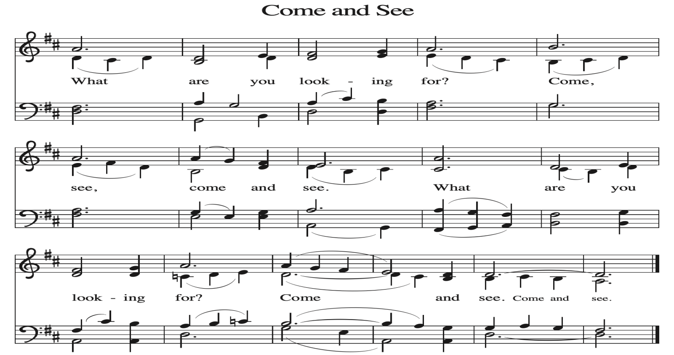
~ Proclamation of the WORD ~ (Scripture insert)
God speaks to us in scripture reading, preaching, and song.

READING: PHILIPPIANS 1:1-18a
Word of God. Word of Life. Thanks be to God.
SERMON Rev. Benjamin Morris

HYMN of the DAY ELW (red hymnal) #659 Will You Let Me Be Your Servant
NICENE CREED ELW (red hymnal) Page 104

PRAYERS of INTERCESSION
Petitions end: Merciful God,...receive our prayer.

PASSING OF THE PEACE
Please be aware of those who may not be comfortable shaking hands. You may also share the peace sign. Or any other contactless gesture that you are comfortable with.

OFFERING & SOLO
OFFERTORY ELW (red hymnal) #186 Create in Me a Clean Heart, O Lord

OFFERTORY PRAYER
Merciful God, accept the fruits of our labor, gathered to give you glory.
You have set a table before us, a glimpse of that great day when we will hunger and thirst no more. Nourish us with the body and blood of Jesus,
that goodness and mercy may follow us and bless the world you love.
In the name of Jesus, Amen.

THE LORD’S PRAYER
COMMUNION and Hymns: #195 Lamb of God; #488 Soul, Adorn Yourself with Gladness; #479 We Come to the Hungry Feast

POST-COMMUNION PRAYER and BLESSING
Holy One, through this meal you have made your home among us
and are making all things new. Send us now to speak peace to anxious hearts,
to love our enemies, and to bring your healing to the nations. In the name of Jesus,
Amen.
~ SENDING ~
God blesses us and sends us in mission to the world
BLESSING
God Almighty, who is the beginning and the end, Jesus Christ, the firstborn of the dead,
and the Spirit, our advocate and peace, ☩ bless you now and forever. Amen.

BELLS
SENDING HYMN ELW (red hymnal) #856 How Great Thou Art

DISMISSAL
Go in peace. Praise the Lord. Alleluia! Thanks be to God. Alleluia!
POSTLUDE

Reprinted / podcast / streamed with permission under ONE LICENSE #A-738444. All rights reserved

COON VALLEY LUTHERAN CHURCH
Sunday, May 10, 2026
Sunday School Recognition
Sixth Sunday of Easter

~Bulletins are in memory of Larry Litchtie

~We thank our Sunday School Staff: Maggie Traastad, Amy Stakston-Weidemann, Renita Williamson & David Schultz

Coffee Servers: Men’s Club
Piano/Organ: Aaron Stakston
Usher: Jay Strangstalien
Altar Guild: Karen McGarvey
Communion Servers: Patty Nelson, Laura Hofslien
Reader: Nancy King
Attendance & Offering Sunday April 26: 9:00a/87: $2,830.80
Attendance & Offering Last Sunday: 9:00a/176; $4,807.72

Scan this code with your phone to contribute electronically with Vanco.

SCHEDULE
TODAY: 10:15am/Sunday School, Coffee Fellowship
TUESDAY: 9:00a-Noon/Pastor’s text study
WEDNESDAY: 9:00a/Quilting
THURSDAY: 10:00a/Bible Study; Carillon Deadline
FRIDAY: Pastor Ben’s sabbath
NEXT SUNDAY: 9:00a/Worship with High School Senior Recognition; Baptism; 10:15a/Coffee Fellowship
Coon Valley Lutheran Church
www.coonvalleylutheranchurch.org
Pastor: Rev. Benjamin Morris, Office 452-3772/Cell 608-406-1556, pastor@coonvalleylutheranchurch.org
Office Administrator: Jamie Thomas, office@coonvalleylutheranchurch.org
Office Hours: Thursday 9:00a-2:30p
Office 452-3772/Cell 317-0007
Treasurer: Becky Lusk, treasurer@coonvalleylutheranchurch.org
Organist:
Indoor Custodian: Tracy Stellner

Philippians 1:1-18
1 Paul and Timothy, servants of Christ Jesus, to all the saints in Christ Jesus who are in Philippi, with the bishops and deacons:
² Grace to you and peace from God our Father and the Lord Jesus Christ.
³ I thank my God for every remembrance of you,
⁴ always in every one of my prayers for all of you, praying with joy
⁵ for your partnership in the gospel from the first day until now.
⁶ I am confident of this, that the one who began a good work in you will continue to complete it until the day of Jesus Christ.
⁷ It is right for me to think this way about all of you, because I hold you in my heart, for all of you are my partners in God’s grace, both in my imprisonment and in the defense and confirmation of the gospel.
⁸ For God is my witness, how I long for all of you with the tender affection of Christ Jesus.
⁹ And this is my prayer, that your love may overflow more and more with knowledge and full insight
¹⁰ to help you to determine what really matters, so that in the day of Christ you may be pure and blameless,
¹¹ having produced the harvest of righteousness that comes through Jesus Christ for the glory and praise of God.
¹² I want you to know, brothers and sisters, that what has happened to me has actually resulted in the progress of the gospel,
¹³ so that it has become known throughout the whole imperial guard and to everyone else that my imprisonment is for Christ,
¹⁴ and most of the brothers and sisters, having been made confident in the Lord by my imprisonment, dare to speak the word with greater boldness and without fear.
¹⁵ Some proclaim Christ from envy and rivalry but others from goodwill.
¹⁶ These proclaim Christ out of love, knowing that I have been put here for the defense of the gospel;
¹⁷ the others proclaim Christ out of selfish ambition, not sincerely but intending to increase my suffering in my imprisonment.
¹⁸ What does it matter? Just this, that Christ is proclaimed in every way, whether out of false motives or true, and in that I rejoice.
Yes, and I will rejoice.
Word of God. Word of Life. Thanks be to God.

Remember "Thumbs Up" When you come up for communion if you would like a gluten free wafer, give the wafer server a thumbs up as you approach. As you approach the wine server, give him or her a thumbs up to receive grape juice instead of wine.

*We are always so happy to include you and our CVLC family in our prayers. If you feel your name, or the name of a family member can be added or removed from this list please contact Jamie. Thank you!

We remember in prayer:
† Those hospitalized this past week:
† Our members whose names we lift up in prayer today: Corrine Appleman, Beverly Bagstad, Clifford Bakkum, Pastor Barbara Bruneau, Ellie Brye, Herby Cornell, Rita Erlandson, Gloria Galstad, Kira Hoff, Becky Ihle, Donna Ihle, Ray Ihle, Todd King, Jon Larson, Margaret Lee, Russell Lee, Aaron Leisso, Aaron Marx, LuEtta Nelson, Romaine Nelson, Sandra Onshus, Elaine Proksch, Eunice Quast, Lori Roach, Jojo Satona, Heidi Saupe, Orrin Stakston, LaVonne Stendahl, Krin (Dreves) Stendalen, Joyce Temp, Jamie Thomas, Teri Tomten, Renita Williamson
† Our members who are currently in health care facilities & Assisted Living:
Tip Bagstad, Rachel Berg, Carl Daffinrud, Jeanne Ebli, Carl Holte, Patty Helgerson, Bob Moilien, Geri Nestingen, Irene Nestingen, Cathy Ofte, Annie Olson, Beatrice Olson (Alden), Elaine Proksch, Ellen Runice, Bob & Evelyn Schulze.
† Those who grieve: Family and friends of Scott Strangstalien
† Our members who are currently home bound
† All those in need of God’s healing and help
† All those affected by recent storms
† Family and friends of our members
† Local Military: Alex Hendrickson

