COON VALLEY LUTHERAN CHURCH
“We are a family of God, striving to enrich
the lives of all through the love of Christ.”
PRELUDE MUSIC
BELLS
WELCOME and ANNOUNCEMENTS

CONFESSION & FORGIVENESS
Blessed be the holy Trinity, ☩ one God, who forgives all our sin, whose mercy endures forever.
Amen.
Let us confess our sin before God, who removes our guilt and blots out all offenses.
Silence is kept for reflection.
Gracious God,
have mercy on us according to your steadfast love.
For seeking worldly delights that deceive us and dishonor you:
Gracious God,
have mercy on us according to your steadfast love.
For desiring self-reliance instead of hungering for your word:
Gracious God,
have mercy on us according to your steadfast love.
For failing to recognize your coming reign,
and for hindering the work of the Spirit: Gracious God,
have mercy on us according to your steadfast love.
For drawing from the well of self-serving ambition,
and for disdaining the living water Christ offers: Gracious God,
have mercy on us according to your steadfast love.
For disregarding voices from the margin,
and for distrusting signs of your healing and hope in the world:
Gracious God,
have mercy on us according to your steadfast love.
For dwelling in tombs of self-pity and discontent,
and for disregarding Christ’s call to come forth to life:
Gracious God,
have mercy on us according to your steadfast love.
God’s steadfast love, grace, and forgiveness abound.
Through faith, the free gift of God,
you have been clothed in the righteousness of Christ.
In the name of ☩ Jesus Christ, your sins are forgiven.
The Spirit of the One who raised Christ from the dead
dwells in you,
pours God’s love into your hearts,
and gives you life and peace.
Amen.
GATHERING HYMN ELW (red hymnal) #712 Lord, Whose Love in Humble Service
PRAYER OF THE DAY
God of new life, as Jesus raised Lazarus from the dead, renew and restore us to new life, leaving in the grave all that prevents us from loving you fully. Amen.

GREET THE WORD- ACS (purple hymnal) #976 Sung 1 time
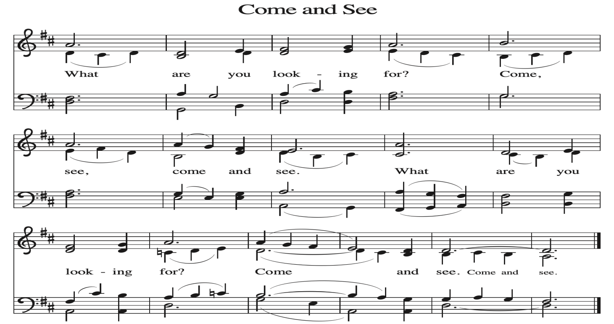
~ Proclamation of the WORD ~ (Scripture insert)
God speaks to us in scripture reading, preaching, and song.

GOSPEL READING: JOHN 11: 1-44
The Gospel of the Lord. Praise to you, O Christ.
SERMON Glen Hoff

HYMN of the DAY ELW (red hymnal) #334 Tree of Life and Awesome Mystery
APOSTLES’ CREED ELW (red hymnal) Page 105
PRAYERS of INTERCESSION
Petitions end: Hear us, O God....Your mercy is great.

PASSING OF THE PEACE
Please be aware of those who may not be comfortable shaking hands. You may also share the peace sign. Or any other contactless gesture that you are comfortable with.

OFFERING & SOLO
OFFERTORY ELW (red hymnal) #186 Create in Me a Clean Heart, O Lord

OFFERTORY PRAYER
O God, maker of heaven and earth, your steadfast love embraces all creation. You send rain and sunshine to nourish the earth and bring forth its bounty.
Through these gifts of bread and wine, draw us into the death and life of your Son, who calls us to bear witness to his saving work. We ask this in Jesus’ name. Amen.

THANKSGIVING FOR THE WORD
O God of justice and love, we give thanks to you that you illumine our way through life with the words of your Son. Give us the light we need, awaken us to the needs of others, and at the end bring all the world to your feast; through Jesus Christ, our Savior and Lord, to whom, with you and the Holy Spirit, be honor and glory forever. Amen.

THE LORD’S PRAYER
~ SENDING ~
God blesses us and sends us in mission to the world

BLESSING
Receive the blessing of the holy Trinity: God, who calls all things into existence, Jesus Christ, who redeems us, and the Holy Spirit, whose breath sustains creation, ☩ bless you now and always. Amen.

BELLS
SENDING HYMN ELW (red hymnal) #758 You Are the Way

DISMISSAL
Go in peace. Believe the good news. Thanks be to God.

POSTLUDE

Reprinted / podcast / streamed with permission under ONE LICENSE #A-738444. All rights reserved.



COON VALLEY LUTHERAN CHURCH
Sunday, February 22, 2026
First Sunday in Lent

Thanks to Aaron Stakston for stepping in to play for us today!

Worship Leader: Glen Hoff
Coffee Servers: Sunday School
Usher: Tim Hatlan
Reader: Sarah Ofte
Attendance & Offering Last Sunday: 9:00a/104; $4,064.41
Sunday School Attendance Last Sunday: 11

Scan this code with your phone to contribute electronically with Vanco.

SCHEDULE
TODAY: 10:30a-11:30a/Sunday School
TUESDAY: 9:00a-Noon/Pastor’s text study
WEDNESDAY: 9:00a/Quilting; 5:00-6:30p/Table Together Community Meal; 7:00p/Lenten Worship
THURSDAY: 10:00a/Bible Study
FRIDAY: Pastor Ben’s sabbath
NEXT SUNDAY: 9:00a/Worship with Holy Communion; 8:00a-Noon/WELCA Pancake Breakfast; 10:15a/Sunday School; Last day to order Pictorial Directory
Coon Valley Lutheran Church
www.coonvalleylutheranchurch.org
Pastor: Rev. Benjamin Morris, Office 452-3772/Cell 608-406-1556, pastor@coonvalleylutheranchurch.org
Office Administrator: Jamie Thomas, office@coonvalleylutheranchurch.org
Office Hours: Tuesday & Wednesday 9:00-4:00p; Thursday 9:00a-3:30p
Office 452-3772/Cell 317-0007
Treasurer: Becky Lusk, treasurer@coonvalleylutheranchurch.org
Organist: Mary Schultz
Indoor Custodian: Tracy Stellner

Remember "Thumbs Up" When you come up for communion if you would like a gluten free wafer, give the wafer server a thumbs up as you approach. As you approach the wine server, give him or her a thumbs up to receive grape juice instead of wine.

GOSPEL: John 11:1-44

11 Now a certain man was ill, Lazarus of Bethany, the village of Mary and her sister Martha. ² Mary was the one who anointed the Lord with perfume and wiped his feet with her hair; her brother Lazarus was ill. ³ So the sisters sent a message to Jesus, “Lord, he whom you love is ill.” ⁴ But when Jesus heard it, he said, “This illness does not lead to death; rather, it is for God’s glory, so that the Son of God may be glorified through it.” ⁵ Accordingly, though Jesus loved Martha and her sister and Lazarus, ⁶ after having heard that Lazarus was ill, he stayed two days longer in the place where he was.⁷ Then after this he said to the disciples, “Let us go to Judea again.” ⁸ The disciples said to him, “Rabbi, the Jews were just now trying to stone you, and are you going there again?” ⁹ Jesus answered, “Are there not twelve hours of daylight? Those who walk during the day do not stumble because they see the light of this world. ¹⁰ But those who walk at night stumble because the light is not in them.” ¹¹ After saying this, he told them, “Our friend Lazarus has fallen asleep, but I am going there to awaken him.” ¹² The disciples said to him, “Lord, if he has fallen asleep, he will be all right.” ¹³ Jesus, however, had been speaking about his death, but they thought that he was referring merely to sleep. ¹⁴ Then Jesus told them plainly, “Lazarus is dead. ¹⁵ For your sake I am glad I was not there, so that you may believe. But let us go to him.” ¹⁶ Thomas, who was called the Twin, said to his fellow disciples, “Let us also go, that we may die with him.”¹⁷ When Jesus arrived, he found that Lazarus had already been in the tomb four days. ¹⁸ Now Bethany was near Jerusalem, some two miles away, ¹⁹ and many of the Jews had come to Martha and Mary to console them about their brother. ²⁰ When Martha heard that Jesus was coming, she went and met him, while Mary stayed at home. ²¹ Martha said to Jesus, “Lord, if you had been here, my brother would not have died. ²² But even now I know that God will give you whatever you ask of him.” ²³ Jesus said to her, “Your brother will rise again.” ²⁴ Martha said to him, “I know that he will rise again in the resurrection on the last day.”
²⁵ Jesus said to her, “I am the resurrection and the life. Those who believe in me, even though they die, will live, ²⁶ and everyone who lives and believes in me will never die. Do you believe this?” ²⁷ She said to him, “Yes, Lord, I believe that you are the Messiah, the Son of God, the one coming into the world.”
²⁸ When she had said this, she went back and called her sister Mary and told her privately, “The Teacher is here and is calling for you.” ²⁹ And when she heard it, she got up quickly and went to him. ³⁰ Now Jesus had not yet come to the village but was still at the place where Martha had met him. ³¹ The Jews who were with her in the house consoling her saw Mary get up quickly and go out. They followed her because they thought that she was going to the tomb to weep there. ³² When Mary came where Jesus was and saw him, she knelt at his feet and said to him, “Lord, if you had been here, my brother would not have died.” ³³ When Jesus saw her weeping and the Jews who came with her also weeping, he was greatly disturbed in spirit and deeply moved. ³⁴ He said, “Where have you laid him?” They said to him, “Lord, come and see.” ³⁵ Jesus began to weep. ³⁶ So the Jews said, “See how he loved him!” ³⁷ But some of them said, “Could not he who opened the eyes of the blind man have kept this man from dying?”
³⁸ Then Jesus, again greatly disturbed, came to the tomb. It was a cave, and a stone was lying against it. ³⁹ Jesus said, “Take away the stone.” Martha, the sister of the dead man, said to him, “Lord, already there is a stench because he has been dead four days.” ⁴⁰ Jesus said to her, “Did I not tell you that if you believed you would see the glory of God?” ⁴¹ So they took away the stone. And Jesus looked upward and said, “Father, I thank you for having heard me. ⁴² I knew that you always hear me, but I have said this for the sake of the crowd standing here, so that they may believe that you sent me.” ⁴³ When he had said this, he cried with a loud voice, “Lazarus, come out!” ⁴⁴ The dead man came out, his hands and feet bound with strips of cloth and his face wrapped in a cloth. Jesus said to them, “Unbind him, and let him go.”
The Gospel of the Lord. Praise to you, O Christ.

*We are always so happy to include you and our CVLC family in our prayers. If you feel your name, or the name of a family member can be added or removed from this list please contact Jamie. Thank you!

We remember in prayer:
† Those hospitalized this past week: Mary Schultz
† Our members whose names we lift up in prayer today: Corrine Appleman, Beverly Bagstad, Clifford Bakkum, Pastor Barbara Bruneau, Ellie Brye, Herby Cornell, Rita Erlandson, Gloria Galstad, Kira Hoff, Becky Ihle, Donna Ihle, Ray Ihle, Todd King, Margaret Lee, Russell Lee, Aaron Leisso, Aaron Marx, LuEtta Nelson, Romaine Nelson, Sandra Onshus, Elaine Proksch, Eunice Quast, Lori Roach, Jojo Satona, Heidi Saupe, Mary Schultz, Orrin Stakston, LaVonne Stendahl, Krin (Dreves) Stendalen, Joyce Temp, Teri Tomten, Renita Williamson
† Our members who are currently in health care facilities & Assisted Living:
Tip Bagstad, Rachel Berg, Carl Daffinrud, Jeanne Ebli, Carl Holte, Bob Moilien, Geri Nestingen, Irene Nestingen, Cathy Ofte, Annie Olson, Beatrice Olson (Alden),
Ellen Runice, Bob & Evelyn Schulze.
† Those who grieve:
† Our members who are currently home bound
† All those in need of God’s healing and help
† Family and friends of our members
† Local Military: Alex Hendrickson

