| The Carillon | |
| --- | --- |
| Page 1 | August, 2023 |

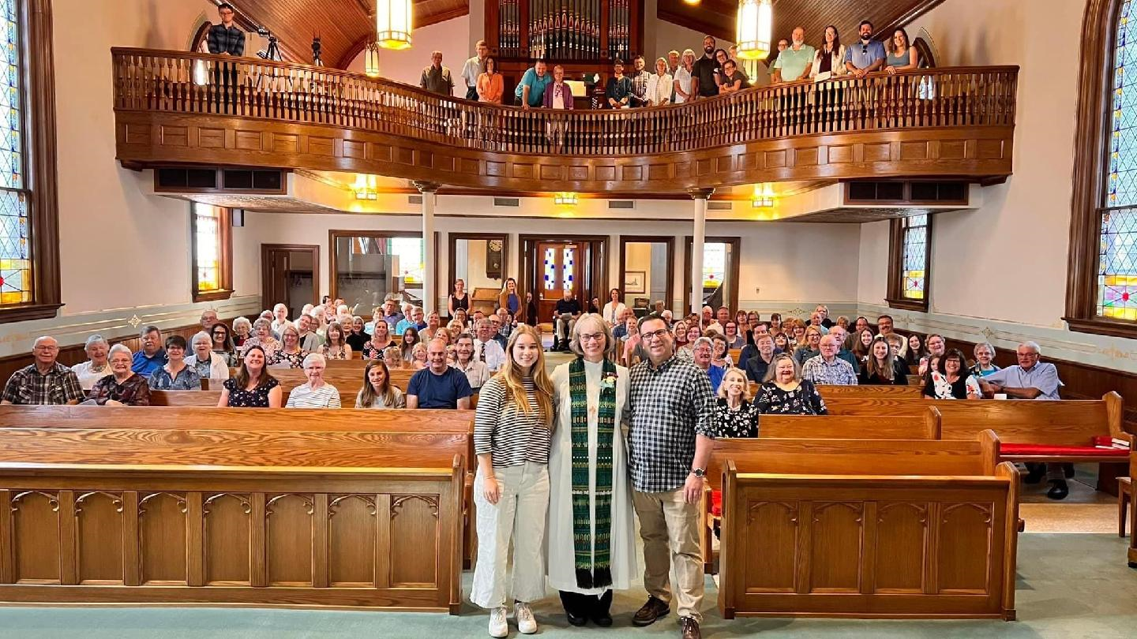Dear Siblings in Christ,

Thank you all so much for the beautiful sending service, flowers, corsage, and delicious cake and coffee fellowship!  Thank you to our council and all who served, and thank you all for your thoughtful words, cards, and gifts.

It has been a great honor and joy to serve as your pastor the past five years.  Our family will hold you in our hearts and prayers as you discern the Holy Spirit’s leading in this time of transition.

Thank you so much.

Love,

Pastor Julie and Dan, Caya and Jesse, and Katie

BLOOD DRIVE

Our next blood drive is scheduled for Monday, September 11th from 1-6pm. The current supply of blood is critically low! Visit [redcrossblood.org](https://d.docs.live.net/a077a1d88e72bfe6/Documents/Newsletter/redcrossblood.org) to schedule an appointment or call Mike Lusk to set up an appointment or to volunteer to help with the drive. After your donation, you will receive refreshments.

JOIN YOUR FRIENDS FOR VACATION BIBLE SCHOOL AUGUST 6-8 at Coon Valley Lutheran Church!

Invite your neighbors to join us for three evenings of faith, fun, music, crafts, and making friends and memories at Coon Valley Lutheran Church!

VBS is open to all students 4 years of age through Fifth Grade. We will gather on Sunday and Monday evening and celebrate our time with the Community Corn Roast on Tuesday!

Our VBS will be led by two young adults with years of Bible Camp leadership experience! We will be partnering with our friends Middle Coon Valley Lutheran Church. Please invite your neighbors and friends! Older students will be needed to assist so please let Jamie know if you are interested!

**WHEN?**

**August 6 & 7:**

**5:15 p.m. Snack**

**5:30 p.m.-7:30 p.m. VBS**

**August 8:** Corn Roast begins at 5:00 p.m. Our students will have a closing program at 5:45 p.m.

**COST?** If you are able, a free-will offering to support our Sunday School is appreciated.

**HOW TO REGISTER?**  Visit [www.coonvalleylutheranchurch.org](http://www.coonvalleylutheranchurch.org) to print and complete the registration/health form. Please return the form to our Parish Office. Additional registration forms are available at each of the participating churches. Registration is also available on the first day of VBS!

MCj03226430000[1]MAY CHURCH COUNCIL HIGHLIGHTS

**\*Treasurer’s Report:** Presented by Becky Lusk. Report accepted.

**\*Education:** Vacation Bible School will be held Aug 6-8th. Pr. Julie & Pr. Meg have two youth leaders who will be leading the programming.

**\*Men’s Club:** The club will be serving coffee fellowship every Mother’s Day. They will be meeting to plan the cookout.

**\*Ministry Minutes:** Discussion was held on the potential for accepting new members virtually.

**\*Property & Grounds:** The committee will have a meeting to make a to-do list of upkeep items. A roof leak along with damage to the chancel wall was discovered. The committee will reach out to have repairs completed.

**\*Social Ministry:** Rules for the Blood Drive have changed. We now need to provide people to carry equipment up and down the stairs in order to continue the blood drives.

**\*New Business:** Worship Time: Current worship and Sunday School times were discussed. A motion was approved to survey the congregation regarding future options to increase attendance. Long Range Strategic Planning: Discussion was held regarding developing a planning team to evaluate the log-term strategy for our congregation. Honorarium for Bishop Malpica: A motion was approved to give the Bishop $200 as a gift for leading Easter Worship services.

**\*The next meeting** will be June 8th at 6:00pm.

The meeting adjourned at 7:45pm followed by the Lord’s Prayer.

Respectfully Submitted, Amanda Buros

JUNE CHURCH COUNCIL HIGHLIGHTS

**\*Treasurer’s Report:** Presented by Becky Lusk. Report accepted.

**\*Education:** Explorer Day at Sugar Creek will be June 19. CVLC is paying half the cost for attendees. Pr. Julie and Pr. Meg are working on VBS, the theme will be “Braying for Jesus” and will be held Aug. 6-8th, with the corn roast on the 8th.

**\*Men’s Club:** Carwash cards are selling. Reviewing the cookout outcome with more updates to come.

**\*Property & Grounds:** Paul Bahr caulked around the window and many other small projects identified. Pr. Julie shared that the A/C in her office has been acting up.

**\*Worship:** The Worship survey was sent to the congregation. Summer schedules and requested hymns were discussed.

**\*New Business:** Long Range Strategic Planning: An idea of offering an invitation to worship was discussed. Honorarium for Bishop Malpica: A motion was passed to stipend $200 to ELCA Good Gifts in honor of Bishop Malpica. Synod Assembly Offering: A motion was approved to donate $100 to the Synod General Fund and $125 to Lutheran Campus Ministry. Christian Band: Will be playing at Trinity Lutheran Church in La Crosse on August 11 @ 6:30. A motion was passed for the Youth Fund to cover the cost of any kids interested in going. Organist Continuing Education: A motion passed to provide Mary Schultz with $200 from the General Fund to pay for continuing education.

**\*The next meeting** will be July 6th at 6:00pm.

The meeting adjourned followed by the Lord’s Prayer.

Respectfully Submitted, Amanda Buros

COMMUNITY CORN ROAST!

Join us on Tuesday, August 8th from 5:00-7:30pm. Tables and chairs will be set up in the East lawn of our church. Feel free to bring your own chair if you wish. Stay and visit and enjoy some Traastad corn.

~Everyone in the community is invited.

~There is no charge for the meal!

**Menu:** Corn, hotdogs, sweets, lemonade & coffee

We are in need of several volunteers to roast corn, grill hotdogs, prepare sweet trays, set up, and clean up after the event. **Confirmation students and High School age youth we need your help!!** We need young strong legs to run food out to the lawn throughout the event. Please sign up on the sheets in the church located in the Narthex or outside the office. Or call the Church office 452-3772.

In the event of bad weather, the Corn Roast will be held in the Fellowship Hall

7th and 8th GRADE CONFIRMATION TO BEGIN OCTOBER 15

All students entering 7th & 8th grade are welcome to attend the first confirmation class on Sunday October 15th at 9:00am. Mike Lusk (who has taught Sunday School students for almost 30 years) has agreed to teach confirmation. Confirmation will be every Sunday between worship services at 9:00am. Parent help and supervision would be welcome. If you have questions, please contact Mike at 452-3472.

WORSHIP TIMES TO CHANGE BEGINNING SEPTEMBER 10TH

Thank you to all who responded to our recent Worship and Sunday School survey that was sent out this summer. As a result of that survey our worship times will change to 8:00am & 10:00am with Sunday School and coffee fellowship from 9:00-9:55 am beginning September 10th.

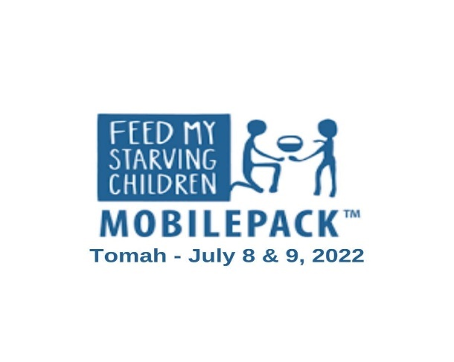

FEED MY STARVING CHILDREN: August 19!

Coon Valley and Middle Coon Valley Lutheran Churches are partnering for a ONE DAY service opportunity in Chanhassen, MN!

You are welcome to participate in this one-day service opportunity!

**How it works:**

Pastor Meg Hoversten and another driver will be transporting volunteers on August 19.

**On Saturday, August 19, volunteers will leave from Middle Coon Valley** at 8:00 a.m. and return to Middle Coon Valley by 6:00 p.m. From 11:30 a.m. until 1:15 p.m. volunteers will pack mobile meals that will be sent around the globe to nourish hungry people.

Please contact Jamie to register or for more information! Registration deadline is August 9.

ONLINE GIVING

There are several ways you may get your offerings to the church. You may mail it to the church office, P.O. Box 280. Or use one of our eGiving options. 1) You may go to our website and click the Donate button at the top. 2) Give through the mobile app Vanco Mobile. Please let Jamie know if you need assistance in any way. Thank you for your support!

PARTICIPATE IN OUR WORSHIP SERVICES FROM HOME

**Facebook:** Services are live streamed, recorded and available Sunday mornings on the CVLC Facebook page.

**YouTube:** Subscribe to our page!

**Our Website:** [www.coonvalleylutheranchurch.org](http://www.coonvalleylutheranchurch.org)

VERNON COMMUNICATIONS TO CANCEL CHURCH CHANNEL 15

Vernon Communications channel 15 will no longer be airing church services. The last day to view this channel is on July 31st. Vernon Communications however has reached out to area churches and will be donating a tablet to our church to be used by members to watch church services online. We have not yet received the tablet but once we do it will be available to borrow. Please contact Jamie for more information or if you are interested in using the tablet!

GIVING OPPORTUNITIES

Below is a list of the many funds you may wish to give to.

**GENERAL FUND**- Church operating expenses.

**BUILDING FUND** -Building and grounds projects, currently includes the Parking Lot Fund.

**MEMORIAL FUND**-Used for the life and ministry of the church as determined by Council.

**SHEPHERD FUND**-Funds for church & community members in need.

**CEMETERY**-Maintenance of the grounds.

**WELCA**-Woman of the ELCA includes Quilting and Kitchen funds.

**SUNDAY SCHOOL**-Teaching materials

**PRAYER SHAWL MINISTRY**-Supplies for the making of prayer shawls and prayer squares.

**YOUTH FUND**-Funds to pay for Mission Trips

**ENDOWMENT**-Only interest income may be used for community outreach, missions of ELCA, Capital Improvements.

**RUDIE BIBLE FUND**-Supply Bibles to youth.

LITTLE FREE PANTRY

The Knutson Memorial Library has set up a “Little Free Pantry.” The pantry is stocked with canned and boxed food, personal care items such as toothpaste, soap and deodorant and is free to the community. The location is currently just inside the doors of the library. In the summer it is placed outside the entrance. We are happy to see that people are using this service. At this time, the library has restocked it, however, we will need to ask for donations to continue. If you care to donate any items for the free pantry, please drop them off at the library. Thank you for supporting this cause!

VOLUNTEERS NEEDED!

We are seeking volunteers who are able to help livestream our worship service on Sunday mornings. You do not need any special skills to volunteer. We just need someone to point the camera in the right direction 😊 You will be trained how to use the new camera system (it is very easy.) If you are able, please contact Jamie.



EXPLORER DAY AT SUGAR CREEK

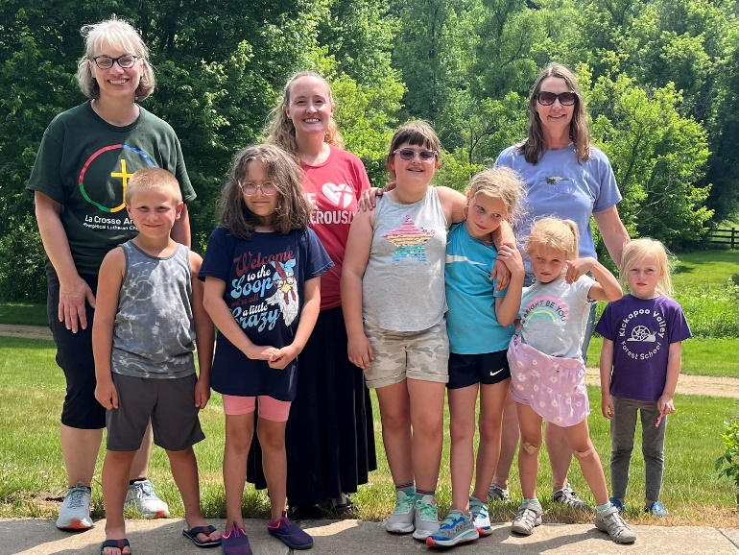

On Monday June 19th we ventured to Sugar Creek Bible Camp for a fun filled day. Youth participated in worship, Bible Study, games, a craft and horseback riding.

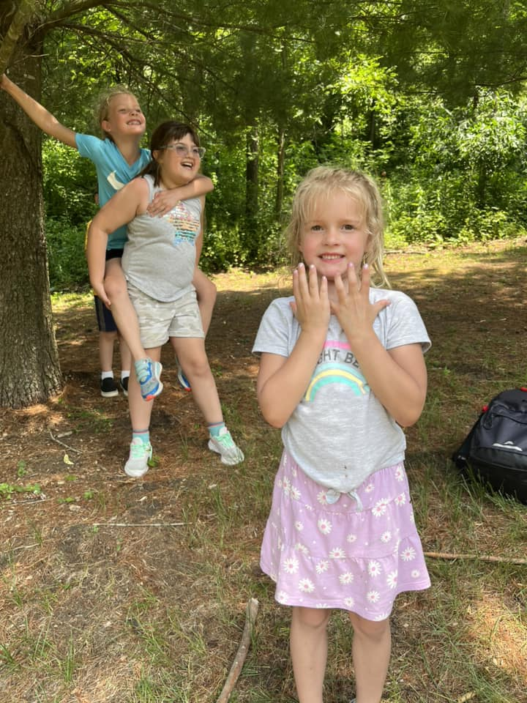

Kristina, Deanna & Karly

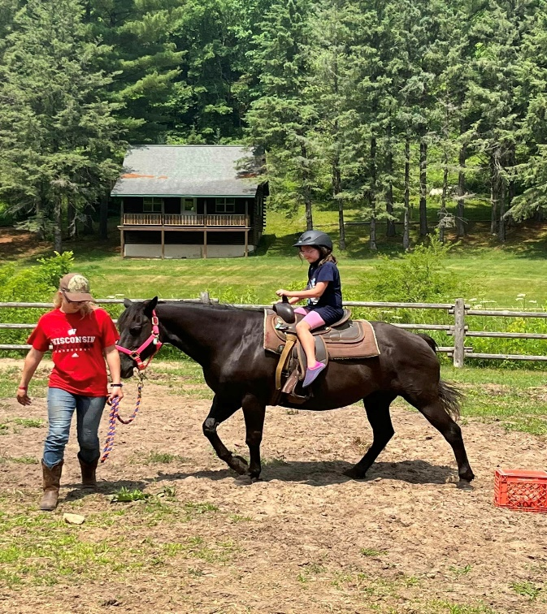

Kaitlin on horseback!

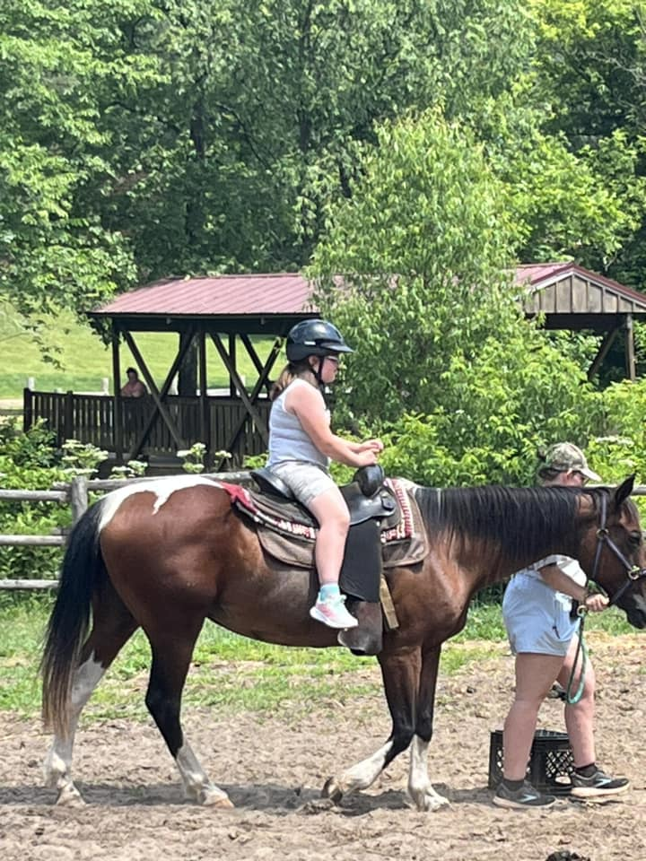

Deanna on horseback!

WELCA NEWS

At our July 20 meeting, the Rebecca Circle treated us to fresh fruit and lemon bars topped with snow (powdered sugar) in keeping with their theme, “Snowflakes in July.” The program followed with Kay Nelson telling us all about snowflakes – what they’re made of, how they’re formed, quotes about snowflakes and advice from snowflakes. We then heard from surprise guest, Mackenzie Morey, the reigning Snowflake Queen. She told us about the application and interview process and the crowning ceremony. We also learned the history of the ski jump and the activities she’s been involved in. All in all, it was a very enlightening program. Thank you Rebecca Circle and thank you to the paying hostesses for the day: Sherry Rainey, Jenna Klum, Beverly Bagstad, Jackie Jorgenson, Tammy Haakenson.

On August 17 we plan to spend our morning cleaning, sorting, polishing and whatever else needs doing. It will be reminiscent of the annual cleaning days we’ve had in the past. Remember, “many hands make light work.” We will finish with a POTLUCK and a feeling of accomplishment.

A ***HUGE*** thank you to Deb Holen who volunteered to be our Vice President and to Eunice Quast for volunteering to be our Mission Action Chairperson. We have been without these positions for some time and are grateful for their commitment.

Even though we’ve been sweltering in the summer heat, Fall is just around the corner and it is time to be thinking about Lutheran World Relief kits. The Sunday School and one of our Circles have already committed to making some school kits and we would, once again, like to involve the congregation.



WELCA will provide the bags for school kits and a list of items needed are available. We will also accept monetary donations and other kits as well. Please see the WELCA yearbook for more options and talk to Eunice if you have any questions.

At our Community Corn Roast, the Sunday School kids will be selling knit caps made by Betty Nelson, the consummate knitter. You might not think so, but it won’t be long before you will want to keep warm instead of cool and these hats will provide just that. There is a variety of colors and patterns to choose from and they will be reasonably priced. Thank you Betty for supporting our Sunday School.

During this time of transition, it is important that we support each other and that includes WELCA. Please consider joining us on the third Thursday of the month at 10 am for coffee, fun, inspiration and camaraderie. We would truly love to see you. We live in a fast paced world but we hope you could set aside about two hours a month to include us in your busy life.

DATES TO REMEMBER

Tues., Aug. 8, 5-7:30pm – Community Corn Roast

Thurs., Aug. 17, 10am, WELCA – “Let’s Clean”

Hostess: POTLUCK. Paying Hostesses: Carol Urbanek, Candice Herman, Ellen Runice, Mathea Lewandowski, Elissa Kinstler

LOOKING AHEAD

Thurs., Sept. 21, 10am, WELCA – General Board presents program. Hostess: Rachel Strangstalien. Paying Hostesses: Cindy Gartner, Tina Schweitzer, Marilyn Lee, Hanna Lobeck

Sat., Oct. 14, 7-11am – LWR semi will be at Good Shepherd Church in La Crosse to receive kits, etc.

God Bless, Ellie Brye, President

**ATTENDANCE & OFFERING**

|  |  |  |  |
| --- | --- | --- | --- |
| **2023** | **June** |  | **2023 YTD** |
| **Total Offerings** | $12,654.38 |  | $92,450.97 |
| **Expenses** | $20,173.49 |  | $107,673.40 |
| **Balance/Shortfall** | **-$7,519.11** |  | **-$15,222.4** |
| **Parsonage Int. Fund Transfer** | $0 |  | $0 |
| **Building Fund Transfer** | $0 |  | $0 |
| **Memorial Fund**  **Transfer** | $0 |  | $0 |

**5/21 – 9a:** 98; **Offering:** $1,667.64

**5/28 – 9a:** 57; **Offering:** $3,437.84

**6/4 – 10a:** 60; **Offering:** $3,121.60

**6/11 – 9a:** 64; **Offering:** $2,647.71

**6/18 – 9a:** 86; **Offering:** $3,519.05

**6/25 – 9a:** 83; **Offering:** $2,639.13

**7/2 – 9a:** 74; **Offering:** $4,351.05

**7/9 – 9a:** 79; **Offering:** $3,387.37

**7/16 – 9a:** 129; **Offering:** $4,238.71

**7/23 – 10a:** 61; **Offering:** $2,331.47

**\*\***Approximately **$4,280.00 a week** is needed to meet operating expenses.

**General Fund Balance:** 6/30/23: $14,886.79

**Memorial Fund Balance:**6/30/23: $51,268.01

**Building Fund Balance:** 6/30/23: $32,786.00

**CD Interest Balance:** 6/30/23: $19,959.60

**Shepherd Fund Balance:** 6/30/23: $1,360.13

BAPTISMS

Gracen Klum

FUNERALS

7/1- Robert Pederson

7/15-Molly Olson

7/19-Carliss Larson

MEMORIALS

**Nancy Stuempges**

Youth Fund: $20.00

**Eleanor Bagstad**

Building Fund: $20.00

**Sharon Stendahl**

Memorial Fund: $360.00

Building Fund: $20.00

Endowment: $20.00

**Robert Pederson**

Building Fund: $20.00

Memorial Fund: $35.00

Endowment: $20.00

**Molly Olson**

Shepherd Fund $25.00

**YEAR-TO-DATE BALANCE**

PRAYER GROUP

The Prayer Group continues to pray for the church, the congregation and our extended family and friends.

**† *Our church staff***

**† *Our members*:** Corrine Appleman, Beverly Bagstad, Clifford Bakkum, Richard Brose, Herby Cornell, Jeanne Ebli, Kira Foster, Phyllis Galstad, Bonnie Holey, Becky Ihle, Donna Ihle, Verlin Ihle, Alan Jacobson, Todd King, Margaret Lee, Russell Lee, Aaron Leisso, Larry Lichtie, Cindy Manske, Aaron Marx, Frank Mathison, Bud Miyamoto, Marianne Mhyre, LuEtta Nelson, Monte Nelson, Romaine Nelson, Sandy Nelson, Eunice Quast, Jojo Satona, Mary Schultz, Billie Slater, LaVonne Stendahl, Patty Stuempges, Joyce Temp, Teri Tomten.

**† *Our members who are currently in health care facilities & Assisted Living*:** Tip Bagstad, Inez Beck, Rachel Berg, Evelyn Dahlen, Joanne Fletcher, Erma Graupe, Lenore Henley, Carl Holte, Sylvester King Jr., Jim Knutson, Bob Moilien, Irene Nestingen, Cathy Ofte, Annie Olson, Beatrice Olson (Alden), Betty Sanders.

**† *Those who grieve:*** Family and friends of Edwin Geise, Robert Pederson, Molly Olson, Carliss Larson

**† *Family and friends of members***

**† *Local Military:***Austin Holen

**† *All those affected by the COVID-19 virus***

**DAILY BIBLE READINGS**

**WEEK OF AUGUST 6**

**SUNDAY** Isaiah 55:1-5 *Eat and drink that which truly satisfies*

Psalm 145:8-9, 14-21 *You open wide your hand*

Or Genesis 32:22-31 *Jacob receives a blessing from God*

Psalm 17:1-7, 15 *I shall see your face*

Romans 9:1-5 *The glory of God’s people in Israel*

Matthew 14:13-21 *Jesus feeds 5000*

**MONDAY** Deuteronomy 8:1-10 *God will feed the people*

**TUESDAY** Deuteronomy 26:1-15 *A tithe from God’s harvest*

**WEDNESDAY** Matthew 15:32-39 *Jesus feeds 5000*

**THURSDAY** Exodus 16:2-15, 31-35 *God feeds the people manna*

**FRIDAY** Acts 2:37-47 *The believers breaking bread*

**SATURDAY** Psalm 78:1-8, 17-29 *God fed the people manna*

**WEEK OF AUGUST 13**

**SUNDAY** 1 Kings 19:9-18 *Elijah on Mount Horeb*

Psalm 85:8-13 *I will listen*

Or Genesis 37:1-4, 12-28 *Joseph sold by his brother*

Psalm 105:1-6, 16-22, 45b *Remembering Joseph*

Romans 10:5-15 *The word of faith*

Matthew 14:22-33 *Jesus walking on the sea*

**MONDAY** Genesis 7:11—8:5 *God saves Noah from the flood*

**TUESDAY** Genesis 19:15-29 *God saves Lot from Sodom and Gomorrah*

**WEDNESDAY** Matthew 8:23-27 *Jesus stills the storm*

**THURSDAY** Job 36:24-33; 37:14-24 *The waters of God’s creation*

**FRIDAY** Romans 9:14-29 *God’s wrath, God’s mercy*

**SATURDAY** Psalm 18:1-19 *God saves me from the waters*

**WEEK OF AUGUST 20**

**SUNDAY** Isaiah 56:1, 6-8 *A house of prayer for all peoples*

Psalm 67 *Let all the peoples praise God*

Or Genesis 45:1-15  *Joseph reconciles with his brothers*

Psalm 133 *How good it is to live in unity*

Romans 11:1-2a, 29-32 *God’s mercy to all, Jew and Gentile*

Matthew 15:[10-20] 21-28 *The Canaanite woman’s daughter is healed*

**MONDAY** 2 Kings 5:1-14 *The foreigner Naaman is healed*

**TUESDAY** Isaiah 66:18-23 *All nations shall come to worship*

**WEDNESDAY** Matthew 8:1-13 *Jesus heals many people*

**THURSDAY** Acts 15:1-21 *The believing Jews accept the Gentiles*

**FRIDAY** Romans 11:13-29 *God saves Jews and Gentiles*

**SATURDAY** Psalm 87 *Foreigners praising God in Zion*

**WEEK OF AUGUST 27**

**SUNDAY** Isaiah 51:1-6 *God’s enduring salvation*

Psalm 138 *O LORD, your love endures forever*

*or* Exodus 1:8—2:10 *Pharaoh’s daughter takes Moses as her son*

Psalm 124 *We have escaped like a bird*

Romans 12:1-8 *One body in Christ, with gifts that differ*

Matthew 16:13-20 *The profession of Peter’s faith*

**MONDAY** 1 Samuel 7:3-13 *Samuel raises the Ebenezer stone*

**TUESDAY** Deuteronomy 32:18-20, 28-39*Praise the rock that is God*

**WEDNESDAY** Matthew 26:6-13 *A woman anoints Jesus with oil*

**THURSDAY** Isaiah 28:14-22 *God lays a cornerstone in Zion*

**FRIDAY** Romans 9:30—10:4 *Christ the stumbling stone*

**SATURDAY** Psalm 18:1-3, 20-32 *God the Rock*

**Moving? New contact information? Please update the church office.**

**Thank you!**

Please use our correct mailing address when sending us mail.

P.O. Box 280

Thank you!

Visit our website: coonvalleylutheranchurch.org to sign-up to receive our newsletter via email!

**THE CARILLON**

VOL. 52 August 2023 No. 6

Coon Valley Lutheran Church, ELCA 1005 Central Avenue, P.O. Box 280

Coon Valley, WI 54623

Office Phone (608)452-3772

www.coonvalleylutheranchurch.org

Office Administrator: Jamie Thomas, [jamiel@mwt.net](mailto:jamiel@mwt.net), Cell Phone: 608-317-0007

Office Hours: Tuesday 9:00am-11:30am, Wednesday-Thursday 9:00am-3:00pm

Treasurer: Becky Lusk, [treasurer1005@mwt.net](mailto:treasurer1005@mwt.net)

Organist: Mary Schultz

Indoor Custodian: Tracy Stellner

Church Council President: Glen Hoff

Vice President: Steve Pauloski; Secretary: Amanda Buros

Paul Bahr, Janice Bender, Debbie Holen, Mark Hutson, Mike Lusk, Ron Moilien

**Worship Schedule**

**9:00am (see the calendar for change in service times)**

|  |  |  |  |  |  |  |
| --- | --- | --- | --- | --- | --- | --- |
| August 2023 | | | | | | |
| **Sunday** | **Monday** | **Tuesday** | **Wednesday** | **Thursday** | **Friday** | **Saturday** |
|  |  |  |  |  |  |  |
| Related image |  | **1**  **10:00a-**Ruth Circle | **2** | **3**  **6:00p-**Rebecca Circle | **4** | **5** |
| **6**  **10:00a-**Worship with Holy Communion-Pr. Meg Hoversten  **5:15-7:30p-**VBS | **7**  **5:15-7:30p-**VBS | **8**  **5:00-7:30p-**Corn Roast  **5:00-6:30p-**VBS  **5:45p-**VBS Closing Program | **9**  **9:00a-**Quilting | **10**  **6:00p-**Church Council | **11** | **12** |
| **13**  **9:00a-**Worship with Holy Communion with Pr. Barbara Bruneau | **14** | **15**  **Carillon Deadline** | **16** | **17**  **10:00a-**WELCA | **18** | **19** |
| **20**  **9:00a-**Outdoor Worship with Matt Marshall | **21** | **22**  **9:00a-**Naomi Circle | **23** | **24** | **25** | **26** |
| **27**  **9:00a-**Worship with Matt Marshall | **28** | **29** | **30**  **9:00a-**Quilting | **31** |  | **Office Hours:**  **Tues 9a-11:30a**  **Wed 9a-3:00p**  **Thurs 9a-3:00p** |