COON VALLEY LUTHERAN CHURCH
“We are a family of God, striving to enrich
the lives of all through the love of Christ.”
PRELUDE MUSIC
BELLS
WELCOME and ANNOUNCEMENTS

LIGHTING OF THE ADVENT WREATH

We praise you, O God, for this evergreen crown
that marks our days of preparation for Christ’s advent.
As we light the first candle on this wreath,
rouse us from sleep, that we may be ready to greet our Lord
when he comes with all the saints and angels.
Enlighten us with your grace,
and prepare our hearts to welcome him with joy.
Grant this through Christ our Lord,
whose coming is certain and whose day draws near.
Amen.
GATHERING HYMN ELW (red hymnal) #266 All Earth Is Hopeful vs. 3 & 4

PRAYER OF THE DAY
Stir up your power, Lord Christ, and come. By your merciful protection save us from the threatening dangers of our sins, and enlighten our walk in the way of your salvation, for you live and reign with the Father and the Holy Spirit, one God, now and forever. Amen.

GREET THE WORD- ACS (purple hymnal) #1012 sung 3 times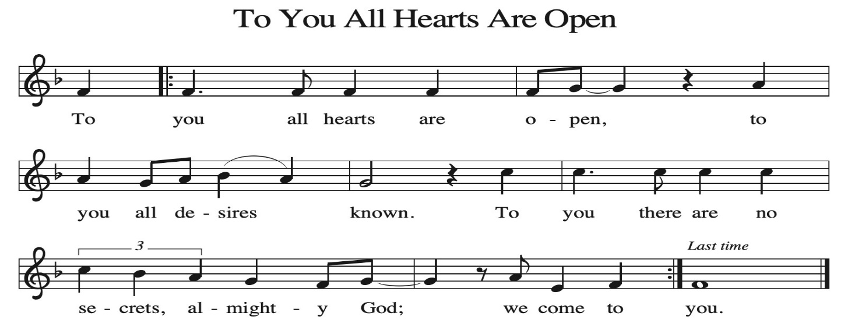
~ Proclamation of the WORD ~ (Scripture insert)
God speaks to us in scripture reading, preaching, and song.

GOSPEL: MATTHEW 1: 1-18

The Gospel of the Lord. Praise to you, O Christ.

SERMON Rev. Meg Hoversten

HYMN of the DAY ELW (red hymnal) #669 Rise Up, O Saints of God!

APOSTLES’ CREED ELW (red hymnal) Page 105

PRAYERS of INTERCESSION
Petitions end: God of grace…hear our prayer.

PASSING OF THE PEACE
Please be aware of those who may not be comfortable shaking hands. You may also share the peace sign. Or any other contactless gesture that you are comfortable with.

OFFERING & SOLO

OFFERTORY ELW (red hymnal) #186 Create in Me a Clean Heart, O Lord

OFFERTORY PRAYER
Nourishing God, you are water in the wilderness and streams in the desert. Through this meal, satisfy our parched places, that we may rejoice and be for the world signs of your kingdom come. Amen.

THANKSGIVING FOR THE WORD
O God of justice and love, we give thanks to you that you illumine our way through life with the words of your Son. Give us the light we need, awaken us to the needs of others, and at the end bring all the world to your feast; through Jesus Christ, our Savior and Lord, to whom, with you and the Holy Spirit, be honor and glory forever. Amen.

THE LORD’S PRAYER
~ SENDING ~
God blesses us and sends us in mission to the world
BLESSING
May God who comes among us, Father, ☩ Son, and Holy Spirit, grant you patience in waiting, peace in the darkness, and good news to share today and always. Amen.

BELLS
SENDING HYMN ELW (red hymnal) #290 Go Tell It on the Mountain

DISMISSAL
Go in peace. Keep awake.
Thanks be to God.

POSTLUDE

Reprinted / podcast / streamed with permission under ONE LICENSE #A-738444. All rights reserved.



Coon Valley Lutheran Church
The First Sunday in the Season of Advent
November 30, 2025
10:30 a.m.

~Bulletins are in honor of the 80th birthday of Dave Verse on Dec. 3!

Usher: Matt White
Attendance & Offering Last Sunday: 116; $3,343.27
Sunday School Attendance: 10


Scan this code with your phone to contribute electronically with Vanco.

SCHEDULE
TUESDAY: 9:00a/Pastor’s Text Study; 10:00a/Ruth Circle
THURSDAY: 10:00a/Bible Study
FRIDAY: Pastor Ben’s sabbath
SATURDAY: 2:00-5:00p/Road to Bethlehem @ Sugar Creek
NEXT SUNDAY: 9:00a/Worship with Holy Communion; New Member Service 10:15a/Sunday School & Coffee Fellowship, Nominating Committee; 6:00-7:30p/Confirmation
Coon Valley Lutheran Church
www.coonvalleylutheranchurch.org
Pastor: Rev. Benjamin Morris, Office 452-3772/Cell 608-406-1556, pastor@coonvalleylutheranchurch.org
Office Administrator: Jamie Thomas, office@coonvalleylutheranchurch.org
Office Hours: Tuesday, Wednesday 9:00a-4:00p; Thursday 9:00a-3:30p
Office 452-3772/Cell 317-0007
Treasurer: Becky Lusk, treasurer@coonvalleylutheranchurch.org
Organist: Mary Schultz
Indoor Custodian: Tracy Stellner

~Remember "Thumbs Up" When you come up for communion if you would like a gluten free wafer, give the pastor a thumbs up as you approach. As you approach the wine server, give him or her a thumbs up to receive grape juice instead of wine.

GOSPEL: MATTHEW 1:1-18
¹ An account of the genealogy of Jesus the Messiah, the son of David, the son of Abraham.
² Abraham was the father of Isaac, and Isaac the father of Jacob, and Jacob the father of Judah and his brothers,
³ and Judah the father of Perez and Zerah by Tamar, and Perez the father of Hezron, and Hezron the father of Aram,
⁴and Aram the father of Aminadab, and Aminadab the father of Nahshon, and Nahshon the father of Salmon,
⁵ and Salmon the father of Boaz by Rahab, and Boaz the father of Obed by Ruth, and Obed the father of Jesse,
⁶ and Jesse the father of King David.
And David was the father of Solomon by the wife of Uriah,
⁷ and Solomon the father of Rehoboam, and Rehoboam the father of Abijah, and Abijah the father of Asaph,
⁸ and Asaph the father of Jehoshaphat, and Jehoshaphat the father of Joram, and Joram the father of Uzziah,
⁹ and Uzziah the father of Jotham, and Jotham the father of Ahaz, and Ahaz the father of Hezekiah,
¹⁰ and Hezekiah the father of Manasseh, and Manasseh the father of Amos, and Amos the father of Josiah,
¹¹ and Josiah the father of Jechoniah and his brothers, at the time of the deportation to Babylon.

¹² And after the deportation to Babylon: Jechoniah was the father of Salathiel, and Salathiel the father of Zerubbabel,
¹³ and Zerubbabel the father of Abiud, and Abiud the father of Eliakim, and Eliakim the father of Azor,
¹⁴ and Azor the father of Zadok, and Zadok the father of Achim, and Achim the father of Eliud,
¹⁵ and Eliud the father of Eleazar, and Eleazar the father of Matthan, and Matthan the father of Jacob,
¹⁶ and Jacob the father of Joseph the husband of Mary, who bore Jesus, who is called the Messiah.
¹⁷ So all the generations from Abraham to David are fourteen generations; and from David to the deportation to Babylon, fourteen generations; and from the deportation to Babylon to the Messiah, fourteen generations.
¹⁸ Now the birth of Jesus the Messiah took place in this way. When his mother Mary had been engaged to Joseph, but before they lived together, she was found to be pregnant from the Holy Spirit.
The Gospel of the Lord. Praise to you, O Christ.

*We are always happy to include you and our CVLC family in our prayers. If you feel your name, or the name of a family member can be added or removed from this list please contact Jamie. Thank you!

We remember in prayer:
† Those hospitalized this past week
† Our members whose names we lift up in prayer today: Corrine Appleman, Beverly Bagstad, Clifford Bakkum, Pastor Barbara Bruneau, Herby Cornell, Marie Egge, Gloria Galstad, Kira Hoff, Becky Ihle, Donna Ihle, Ray Ihle, Eddie Kanieski, Todd King, Margaret Lee, Russell Lee, Aaron Leisso, Aaron Marx, LuEtta Nelson, Romaine Nelson, Lisa Olson, Sandra Onshus, Elaine Proksch, Eunice Quast, Lori Roach, Jojo Satona, Heidi Saupe, Bob Schulze, Mary Schultz, LaVonne Stendahl, Krin (Dreves) Stendalen, Joyce Temp, Teri Tomten, Dave Verse, Jan Verse, Renita Williamson
† Our members who are currently in health care facilities & Assisted Living:
Tip Bagstad, Rachel Berg, Carl Daffinrud, Jeanne Ebli, Carl Holte, Bob Moilien, Geri Nestingen, Irene Nestingen, Cathy Ofte, Annie Olson, Beatrice Olson (Alden),
Ellen Runice, Orrin Stakston.
† Those who grieve: Family & Friends of Mike Kellogg
† Our members who are currently home bound
† All those in need of God’s healing and help
† Family and friends of our members
† Local Military: Alex Hendrickson

