COON VALLEY LUTHERAN CHURCH

**“We are a family of God, striving to enrich**

**the lives of all through the love of Christ.”**

PRELUDE MUSIC Mary Schultz

BELLS

WELCOME and ANNOUNCEMENTS

Thanksgiving for Baptism

Blessed be the holy Trinity, ☩ one God, the fountain of living water, the rock who gave us birth, our light and our salvation. **Amen.**

Joined to Christ in the waters of baptism, we are clothed with God’s mercy and forgiveness. Let us give thanks for the gift of baptism.

We give you thanks, O God, for in the beginning you created us in your image and placed us in a well-watered garden. In the desert, you promised pools of water for the parched, and you gave us water from the rock. When we did not know the way, you sent the Good Shepherd to lead us to still waters. At the cross, you washed us from Jesus’ wounded side, and on this day, you shower us again with the water of life.

We praise you for your salvation through water, for the water in this font, and for all water everywhere.

Bathe us in your forgiveness, grace, and love. Satisfy all who thirst, and give us the life only you can give.

To you be given honor and praise through Jesus Christ, our living water, in the unity of the Holy Spirit, now and forever.

**Amen.**

GATHERING HYMN ELW (red hymnal) #532 Gather Us In

PRAYER OF THE DAY

God of promise, **You stayed the hand of Abraham and fulfilled the promise you made to him, that he would father a great nation. Keep your promises to us, that we become inheritors of eternal life. Amen.**

CHILDREN’S TIME

GREET THE WORD- ACS (purple hymnal) #1012 sung 3 times

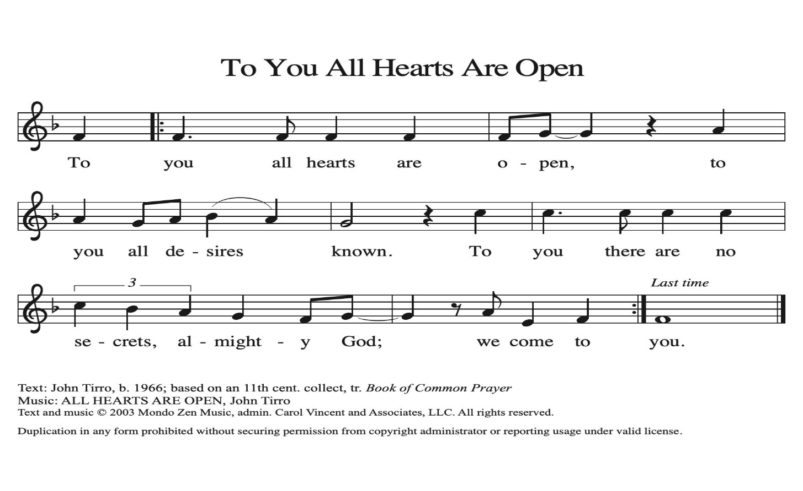

**~ Proclamation of the WORD ~** (Scripture insert)

**God speaks to us in scripture reading, preaching, and song.**

Genesis 21:1-3; 22:1-14 (read responsively)

SERMON Rev. Benjamin Morris

HYMN of the DAY ACS (purple hymnal) #1004 Faith Begins by Letting Go

APOSTLES’ CREED ELW (red hymnal) Page 105

PRAYERS of INTERCESSION

Petitions end: God of grace…**receive our prayer.**

PASSING OF THE PEACE

*Please be aware of those who may not be comfortable shaking hands. You may also share the peace sign. Or any other contactless gesture that you are comfortable with.*

OFFERING & SOLO Mary Schultz

OFFERTORY ELW (red hymnal) #186 Create in Me a Clean Heart, O Lord

OFFERTORY PRAYER

Lord of the harvest, **we return to you a portion of what you have given to us.**

**Turn us to set our hope not on the uncertainty of riches, but on you, who richly provides for us. Multiply what we have gathered to bless all who are suffering and in need, through Jesus Christ our Lord. Amen.**

THE GREAT THANKSGIVING (Spoken)

The Lord be with you. **And also with you.**

Lift up your hearts. **We lift them to the Lord.**

Let us give thanks to the Lord our God.

**It is right to give him thanks and praise.**

THE LORD’S PRAYER

COMMUNION & SOLO Mary Schultz

POST-COMMUNION PRAYER

O God, **through this meal you have strengthened us and appointed us to be your servants. Send us to do good and to share our possessions with all in need. We ask this in Jesus’ name. Amen.**

**~ SENDING ~**

**God blesses us and sends us in mission to the world**

BLESSING

The God of righteousness, who gives justice to the oppressed, who gives food to the hungry, who sets the prisoners free, ☩ bless you now and forever. **Amen.**

BELLS

SENDING HYMN ELW (red hymnal) #726 Light Dawns on a Weary World

DISMISSAL

Go in peace. Do not lose heart.

**Thanks be to God**

POSTLUDE Mary Schultz

Reprinted / podcast / streamed with permission under ONE LICENSE #A-738444. All rights reserved.

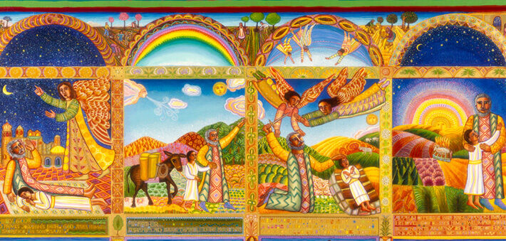

COON VALLEY LUTHERAN CHURCH

The Fourteenth Sunday of Pentecost

September 14, 2025

~Bulletins are in memory of DeVerne Seland

**Coffee Servers:** Gwen Bahr, Rachel Pederson

**Usher:** Dave Marsh

**Reader:** Bruce King

**Altar Guild:** Jane Simmons

**Communion Servers:** Ray Williamson, Kim Cade

**Attendance & Offering Last Sunday:** 107;$5,029.26

Farmer’s Market Last Sunday: $91.00

Scan this code with your phone to contribute electronically with Vanco.

**SCHEDULE**

**MONDAY: Carillon Deadline**

**TUESDAY: 9:00a/**Pastor’s Text Study

**THURSDAY: 10:00a/**WELCA; **6:00p/**Church Council

**FRIDAY:** Pastor Ben’s sabbath

**SATURDAY: 11:00a/**Chaseburg Area Cancer Walk

**NEXT SUNDAY: 9:00a/**Worship; **10:00a/**Coffee Fellowship, Farmer’s Market; **10:15-11:30a/**Sunday School; **6:00-7:30p/**Confirmation

**Coon Valley Lutheran Church**

[**www.coonvalleylutheranchurch.org**](http://www.coonvalleylutheranchurch.org)

**Pastor:** Rev. Benjamin Morris, Office 452-3772/Cell 608-406-1556, [pastor@coonvalleylutheranchurch.org](mailto:pastor@coonvalleylutheranchurch.org)

**Office Administrator:** Jamie Thomas, [office@coonvalleylutheranchurch.org](mailto:office@coonvalleylutheranchurch.org)

**Office Hours: Tuesday, Thursday 9:00a-4:00p; Wednesday 9:00a-2:30p**

Office452-3772/Cell 317-0007

**Treasurer:** Becky Lusk, <treasurer@coonvalleylutheranchurch.org>

**Organist:** Mary Schultz

**Indoor Custodian:** Tracy Stellner

~Remember **"Thumbs Up"** When you come up for communion if you would like a **gluten free wafer**, give the pastor a thumbs up as you approach. As you approach the wine server, give him or her a thumbs up to receive **grape juice** instead of wine.

**Genesis 21:1-3; 22:1-14**

  1 The Lord dealt with Sarah as he had said, and the Lord did for Sarah as he had promised. 2 Sarah conceived and bore Abraham a son in his old age, at the time of which God had spoken to him. 3 Abraham gave the name Isaac to his son whom Sarah bore him.  
  
  1 After these things God tested Abraham. He said to him, “Abraham!” And he said, “Here I am.” 2 He said, “Take your son, your only son Isaac, whom you love, and go to the land of Moriah and offer him there as a burnt offering on one of the mountains that I shall show you.” 3 So Abraham rose early in the morning, saddled his donkey, and took two of his young men with him and his son Isaac; he cut the wood for the burnt offering and set out and went to the place in the distance that God had shown him. 4 On the third day Abraham looked up and saw the place far away. 5 Then Abraham said to his young men, “Stay here with the donkey; the boy and I will go over there; we will worship, and then we will come back to you.” 6 Abraham took the wood of the burnt offering and laid it on his son Isaac, and he himself carried the fire and the knife. And the two of them walked on together. 7 Isaac said to his father Abraham, “Father!” And he said, “Here I am, my son.” He said, “The fire and the wood are here, but where is the lamb for a burnt offering?” 8 Abraham said, “God himself will provide the lamb for a burnt offering, my son.” And the two of them walked on together.  
  9 When they came to the place that God had shown him, Abraham built an altar there and laid the wood in order. He bound his son Isaac and laid him on the altar on top of the wood. 10 Then Abraham reached out his hand and took the knife to kill his son. 11 But the angel of the Lord called to him from heaven and said, “Abraham, Abraham!” And he said, “Here I am.” 12 He said, “Do not lay your hand on the boy or do anything to him, for now I know that you fear God, since you have not withheld your son, your only son, from me.” 13 And Abraham looked up and saw a ram, caught in a thicket by its horns. Abraham went and took the ram and offered it up as a burnt offering instead of his son. 14 So Abraham called that place “The Lord will provide,” as it is said to this day, “On the mount of the Lord it shall be provided.”

Word of God. Word of Life. **Thanks be to God.**

*\*We are always happy to include you and our CVLC family in our prayers. If you feel your name, or the name of a family member can be added or removed from this list please contact Jamie.* *Thank you!*

**We remember in prayer:**

**†** *Those hospitalized this past week:* Orrin Stakston

**†** *Our members whose names we lift up in prayer today:* Corrine Appleman, Beverly Bagstad, Clifford Bakkum, Pastor Barbara Bruneau, Herby Cornell, Marie Egge, Kira Hoff, Becky Ihle, Donna Ihle, Ray Ihle, Todd King, Mike Kellogg, Margaret Lee, Russell Lee, Aaron Leisso, Aaron Marx, LuEtta Nelson,Romaine Nelson, Lisa Olson, Sandra Onshus, Elaine Proksch, Eunice Quast, Lori Roach, Ellen Runice*,* Jojo Satona, Bob Schulze, Mary Schultz, LaVonne Stendahl, Krin (Dreves) Stendalen, Teri Tomten, Betty Williamson, Renita Williamson

**†** *Our members who are currently in health care facilities & Assisted Living:*

Tip Bagstad, Rachel Berg, Carl Daffinrud, Evelyn Dahlen, Jeanne Ebli, Gloria Galstad,

Carl Holte, Bob Moilien, Pauline Moilien, Geri Nestingen, Irene Nestingen, Cathy Ofte, Annie Olson, Beatrice Olson (Alden), Orrin Stakston, Joyce Temp.

**†** *Those who grieve**:* Family and friends of Lenore Henley

**†** *Our members who are currently home bound*

**†** *All those in need of God’s healing and help*

**†** *Family and friends of our members*

**†** *Local Military:*Alex Hendrickson