COON VALLEY LUTHERAN CHURCH
December 28, 2025 9:00am
“We are a family of God, striving to enrich
the lives of all through the love of Christ.”
PRELUDE MUSIC
BELLS
WELCOME and ANNOUNCEMENTS

CONFESSION & FORGIVENESS
Blessed be the holy Trinity, ☩ one God, Wonderful Counselor,
Mighty Savior, Prince of Peace.
Amen.
Trusting in God’s steadfast love and faithfulness,
let us confess our sin.
Silence is kept for reflection.
Reconciling God,
we yearn for your presence to transform our grief, pain, and despair.
We confess that we have not always prepared room in our hearts for your love; we have not always recognized your presence among us; we have not always embraced your message of peace. We cry out, weary with the burden of violence, oppression, and fear. We confess our failure to make room for those seeking refuge; our participation in violent systems
that harm your innocent ones; our reluctance to embody your good news.
Be born in us today and teach us to sing the joyful song of your salvation.
Amen.
God’s grace upon grace flows over you.
☩ Christ’s presence redeems the whole creation.
Your sins are forgiven. Let the earth rejoice and be glad!
Amen.

GATHERING HYMN ELW (red hymnal) #279 O Little Town of Bethlehem
PRAYER OF THE DAY
O Lord God, you know that we cannot place our trust in our own powers. As you protected the infant Jesus, so defend us and all the needy from harm and adversity, through Jesus Christ, our Savior and Lord, who lives and reigns with you and the Holy Spirit, one God, now and forever. Amen.

GREET THE WORD- ACS (purple hymnal) #1012 sung 3 times
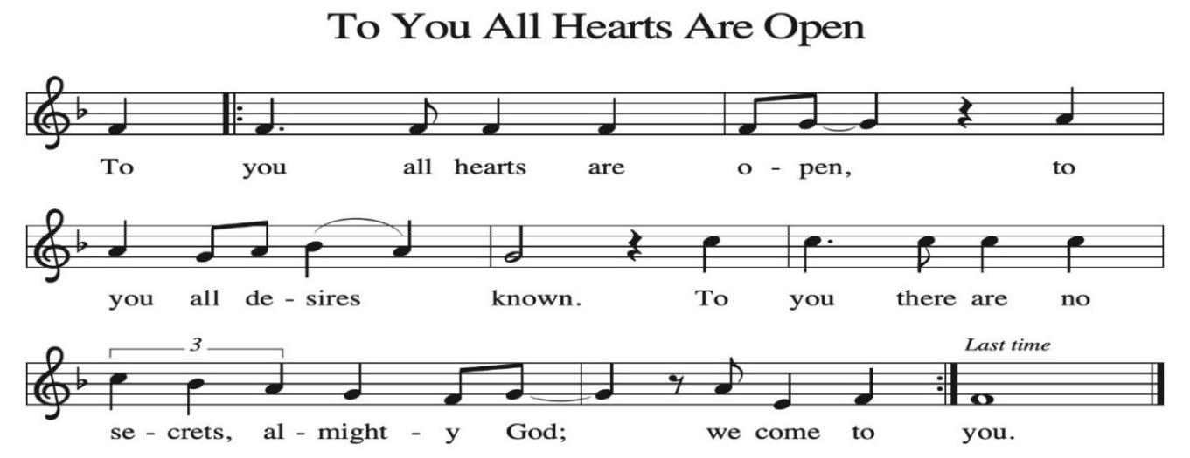

~ Proclamation of the WORD ~ (Scripture insert)
God speaks to us in scripture reading, preaching, and song.

GOSPEL: Matthew 2:13-23
The Gospel of the Lord. Praise to you, O Christ.
SERMON Rev. Ben Morris

HYMN of the DAY ELW (red hymnal) #296 What Child Is This

APOSTLES’ CREED ELW (red hymnal) Page 105

PRAYERS of INTERCESSION
Petitions end: Hear us, O God…..Your mercy is great.

PASSING OF THE PEACE
Please be aware of those who may not be comfortable shaking hands. You may also share the peace sign. Or any other contactless gesture that you are comfortable with.

OFFERING & SOLO Coventry Carol David Schultz
OFFERTORY ELW (red hymnal) #186 Create in Me a Clean Heart, O Lord

OFFERTORY PRAYER
God of glory, great are your wonders among us and many are the blessings you bestow. Use us and these your gifts for the needs of the world,
that all the ends of the earth may rejoice in your saving grace, through Christ our Savior. Amen.

THANKSGIVING FOR THE WORD
O God of justice and love, we give thanks to you that you illumine our way through life with the words of your Son. Give us the light we need, awaken us to the needs of others, and at the end bring all the world to your feast; through Jesus Christ, our Savior and Lord, to whom, with you and the Holy Spirit, be honor and glory forever. Amen.

THE LORD’S PRAYER

~ SENDING ~
God blesses us and sends us in mission to the world

BLESSING
The triune God, glorious Mystery, holy Incarnate One, abiding Comforter,
☩ bless you with endless grace, peace, and joy. Amen.

BELLS
SENDING HYMN ELW (red hymnal) #288 Good Christian Friends, Rejoice

DISMISSAL
Glory to God in the highest!
And peace to God’s people on earth!
Go in joy. Embody God’s redeeming grace.
Thanks be to God.

POSTLUDE

Reprinted / podcast / streamed with permission under ONE LICENSE #A-738444. All rights reserved.

Coon Valley Lutheran Church
The First Sunday of Christmas
December 28, 2025
9:00 a.m.

~Bulletins and flowers are in memory of Melanie Role

Usher: Cody Strangstalien
Reader: Rachel Pederson


Scan this code with your phone to contribute electronically with Vanco.

SCHEDULE
TODAY: 9:00a/Worship; 10:30a/Pastor Ben Worship at Middle Coon Valley
NEXT SUNDAY: 9:00a/Worship with Holy Communion; 10:15a/Coffee Fellowship

Please note office hours during the Christmas season.The office will be closed Dec. 22-Jan. 3 for our holiday break! The office will resume normal hours beginning Jan. 6. In the event of an emergency please contact Pastor Ben Morris at 608-406-1556. Thank you for this time away with family!

Offering envelopes are available. They are located on a table in the Library. Please pick them up for family, friends or neighbors!

The last day to submit offering for 2025 is Today during worship. Thank you for your continued support!
Coon Valley Lutheran Church
www.coonvalleylutheranchurch.org
Pastor: Rev. Benjamin Morris, Office 452-3772/Cell 608-406-1556, pastor@coonvalleylutheranchurch.org
Office Administrator: Jamie Thomas, office@coonvalleylutheranchurch.org
Office Hours: Tuesday, Wednesday, Thursday 9:00a-4:00p
Office 452-3772/Cell 317-0007
Treasurer: Becky Lusk, treasurer@coonvalleylutheranchurch.org
Organist: Mary Schultz
Indoor Custodian: Tracy Stellner

Remember "Thumbs Up" When you come up for communion if you would like a gluten free wafer, give the wafer server a thumbs up as you approach. As you approach the wine server, give him or her a thumbs up to receive grape juice instead of wine.
Dec. 29

GOSPEL: Matthew 2:13-23
¹³ Now after they had left, an angel of the Lord appeared to Joseph in a dream and said, “Get up, take the child and his mother, and flee to Egypt, and remain there until I tell you, for Herod is about to search for the child, to destroy him.”
¹⁴ Then Joseph got up, took the child and his mother by night, and went to Egypt
¹⁵ and remained there until the death of Herod. This was to fulfill what had been spoken by the Lord through the prophet, “Out of Egypt I have called my son.”
¹⁶ When Herod saw that he had been tricked by the magi, he was infuriated, and he sent and killed all the children in and around Bethlehem who were two years old or under, according to the time that he had learned from the magi.
¹⁷ Then what had been spoken through the prophet Jeremiah was fulfilled:
¹⁸ “A voice was heard in Ramah,
wailing and loud lamentation,
Rachel weeping for her children;
she refused to be consoled, because they are no more.”
¹⁹ When Herod died, an angel of the Lord suddenly appeared in a dream to Joseph in Egypt and said,
²⁰ “Get up, take the child and his mother, and go to the land of Israel, for those who were seeking the child’s life are dead.”
²¹ Then Joseph got up, took the child and his mother, and went to the land of Israel.
²² But when he heard that Archelaus was ruling Judea in place of his father Herod, he was afraid to go there. And after being warned in a dream, he went away to the district of Galilee.
²³ There he made his home in a town called Nazareth, so that what had been spoken through the prophets might be fulfilled, “He will be called a Nazarene.”
The Gospel of the Lord. Praise to you, O Christ.

*We are always so happy to include you and our CVLC family in our prayers. If you feel your name, or the name of a family member can be added or removed from this list please contact Jamie. Thank you!

We remember in prayer:
† Those hospitalized this past week
† Our members whose names we lift up in prayer today: Corrine Appleman, Beverly Bagstad, Clifford Bakkum, Pastor Barbara Bruneau, Herby Cornell, Rita Erlandson, Gloria Galstad, Kira Hoff, Becky Ihle, Donna Ihle, Ray Ihle, Eddie Kanieski, Todd King, Margaret Lee, Russell Lee, Aaron Leisso, Aaron Marx, LuEtta Nelson, Romaine Nelson, Sandra Onshus, Elaine Proksch, Eunice Quast, Lori Roach, Jojo Satona, Heidi Saupe, Mary Schultz, LaVonne Stendahl, Krin (Dreves) Stendalen, Joyce Temp, Teri Tomten, Maggie Traastad, Renita Williamson
† Our members who are currently in health care facilities & Assisted Living:
Tip Bagstad, Rachel Berg, Carl Daffinrud, Jeanne Ebli, Carl Holte, Bob Moilien, Geri Nestingen, Irene Nestingen, Cathy Ofte, Annie Olson, Beatrice Olson (Alden),
Ellen Runice, Bob & Evelyn Schulze.
† Those who grieve
† Our members who are currently home bound
† All those in need of God’s healing and help
† Family and friends of our members
† Local Military: Alex Hendrickson

