COON VALLEY LUTHERAN CHURCH
“We are a family of God, striving to enrich
the lives of all through the love of Christ.”
PRELUDE MUSIC
BELLS
WELCOME and ANNOUNCEMENTS

THANKSGIVING FOR BAPTISM
Alleluia! Christ is risen.
Christ is risen indeed. Alleluia!
Salvation belongs to our God who is seated on the throne
and to the Lamb!
Amen.
Let us give thanks for the gifts of baptism.
Water may be poured into the font as the presiding minister continues.
Merciful God,
you are the one who was, who is, and who is to come.
You lead us beside still waters.
We thank you for the waters of creation:
morning dew, gentle rain, roaring waves.
We thank you for the waters that nourish us.
Blessed are you.
You guide us to springs of the water of life.
Jesus Christ, you are the faithful witness
who accompanies us on our journeys.
We give you thanks for your life-giving death and resurrection.
We praise you for joining us in joy and sorrow.
Blessed are you.
You guide us to springs of the water of life.
Holy Spirit, you anoint our head with oil and our cup overflows.
Break down barriers that divide us.
Fill us with the breath of peace.
Blessed are you.
You guide us to springs of the water of life.
Holy One, we thank you for the gifts and grace of baptism,
and for making us a new creation.
We join with saints and angels, giving you honor and praise,
now and forever.
Amen.

GATHERING HYMN ELW (red hymnal) #382 Christ Is Risen! Alleluia!
PRAYER OF THE DAY
God of resurrection, Your son, Jesus, awed his followers by appearing among them. With awe we also celebrate his resurrection and rejoice in eternal life. Amen.
GREET THE WORD- ACS (purple hymnal) #976 Sung 1 time
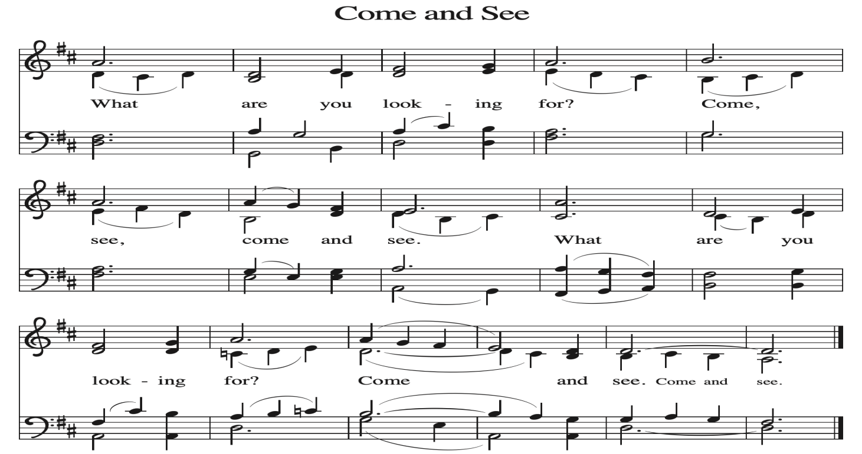
~ Proclamation of the WORD ~ (Scripture insert)
God speaks to us in scripture reading, preaching, and song.

GOSPEL READING: JOHN 20:19-31
The Gospel of the Lord. Praise to you, O Christ.
SERMON Rev. Benjamin Morris

HYMN of the DAY ELW (red hymnal) #389 Christ Is Alive! Let Christians Sing

NICENE CREED ELW (red hymnal) Page 104

PRAYERS of INTERCESSION
Petitions end: Merciful God,....receive our prayer.

PASSING OF THE PEACE
Please be aware of those who may not be comfortable shaking hands. You may also share the peace sign. Or any other contactless gesture that you are comfortable with.

OFFERING & SOLO
OFFERTORY ELW (red hymnal) #186 Create in Me a Clean Heart, O Lord

OFFERTORY PRAYER
Merciful God, accept the fruits of our labor, gathered to give you glory.
You have set a table before us, a glimpse of that great day when we will hunger and thirst no more. Nourish us with the body and blood of Jesus,
that goodness and mercy may follow us and bless the world you love.
In the name of Jesus, Amen.

THE LORD’S PRAYER

COMMUNION and SOLO

POST-COMMUNION PRAYER and BLESSING
Holy One, through this meal you have made your home among us
and are making all things new. Send us now to speak peace to anxious hearts,
to love our enemies, and to bring your healing to the nations. In the name of Jesus,
Amen.
~ SENDING ~
God blesses us and sends us in mission to the world
BLESSING
God Almighty, who is the beginning and the end, Jesus Christ, the firstborn of the dead,
and the Spirit, our advocate and peace, ☩ bless you now and forever. Amen.

BELLS
SENDING HYMN ELW (red hymnal) #388 Be Not Afraid - Sung 4 times

DISMISSAL
Go in peace. Praise the Lord. Alleluia! Thanks be to God. Alleluia!

POSTLUDE
Reprinted / podcast / streamed with permission under ONE LICENSE #A-738444. All rights reserved

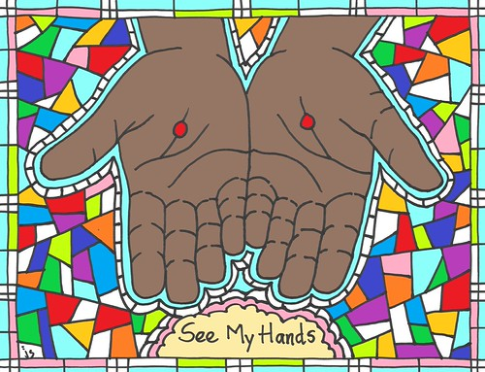

COON VALLEY LUTHERAN CHURCH
Sunday, April 12, 2026
Second Sunday of Easter

~Bulletins and flowers are in memory of Melanie Role

Piano/Organ: Aaron Stakston
Usher: Matt White
Reader: Amy Stakston-Wiedemann
Altar Guild: Jane Simmons
Communion Servers: Kevin King,
Attendance & Offering Last Sunday: 9:00a/200; $6,697.27
Attendance & Offering April 2: 7pm/55; $548.00
Attendance & Offering April 3: 7pm/52; $463.00

Scan this code with your phone to contribute electronically with Vanco.

SCHEDULE
TODAY: 10:15am/Finance Committee, Sunday School, Coffee Fellowship, Carillon Deadline
TUESDAY: 9:00a-Noon/Pastor’s text study
WEDNESDAY: 5:00-7:00p/Table Together Community Meal
THURSDAY: 10:00a/WELCA; 6:00p/Church Council; No Bible Study
FRIDAY: Pastor Ben’s sabbath
SATURDAY: 8:00a-3:00p/WELCA Spring Convention @ CVLC
NEXT SUNDAY: 9:00a/Worship; 10:15a/Sunday School, Coffee Fellowship; 3:00p/Pre-Assembly Caucus @ Our Savior’s West Salem
Coon Valley Lutheran Church
www.coonvalleylutheranchurch.org
Pastor: Rev. Benjamin Morris, Office 452-3772/Cell 608-406-1556, pastor@coonvalleylutheranchurch.org
Office Administrator: Jamie Thomas, office@coonvalleylutheranchurch.org
Office Hours: Tuesday & Wednesday 9:00-4:00p; Thursday 9:00a-3:30p
Office 452-3772/Cell 317-0007
Treasurer: Becky Lusk, treasurer@coonvalleylutheranchurch.org
Organist:
Indoor Custodian: Tracy Stellner

GOSPEL: John 20:19-31
¹⁹ When it was evening on that day, the first day of the week, and the doors were locked where the disciples were, for fear of the Jews, Jesus came and stood among them and said, “Peace be with you.” ²⁰ After he said this, he showed them his hands and his side. Then the disciples rejoiced when they saw the Lord. ²¹ Jesus said to them again, “Peace be with you. As the Father has sent me, so I send you.” ²² When he had said this, he breathed on them and said to them, “Receive the Holy Spirit. ²³ If you forgive the sins of any, they are forgiven them; if you retain the sins of any, they are retained.”
²⁴ But Thomas (who was called the Twin), one of the twelve, was not with them when Jesus came. ²⁵ So the other disciples told him, “We have seen the Lord.” But he said to them, “Unless I see the mark of the nails in his hands and put my finger in the mark of the nails and my hand in his side, I will not believe.”
²⁶ A week later his disciples were again in the house, and Thomas was with them. Although the doors were shut, Jesus came and stood among them and said, “Peace be with you.” ²⁷ Then he said to Thomas, “Put your finger here and see my hands. Reach out your hand and put it in my side. Do not doubt but believe.” ²⁸ Thomas answered him, “My Lord and my God!” ²⁹ Jesus said to him, “Have you believed because you have seen me? Blessed are those who have not seen and yet have come to believe.”
³⁰ Now Jesus did many other signs in the presence of his disciples that are not written in this book. ³¹ But these are written so that you may continue to believe that Jesus is the Messiah, the Son of God, and that through believing you may have life in his name.
The Gospel of the Lord. Praise to you, O Christ.

Remember "Thumbs Up" When you come up for communion if you would like a gluten free wafer, give the wafer server a thumbs up as you approach. As you approach the wine server, give him or her a thumbs up to receive grape juice instead of wine.

*We are always so happy to include you and our CVLC family in our prayers. If you feel your name, or the name of a family member can be added or removed from this list please contact Jamie. Thank you!

We remember in prayer:
† Those hospitalized this past week: Margaret Lee
† Our members whose names we lift up in prayer today: Corrine Appleman, Beverly Bagstad, Clifford Bakkum, Pastor Barbara Bruneau, Ellie Brye, Herby Cornell, Rita Erlandson, Gloria Galstad, Kira Hoff, Becky Ihle, Donna Ihle, Ray Ihle, Todd King, Jon Larson, Margaret Lee, Russell Lee, Aaron Leisso, Aaron Marx, LuEtta Nelson, Romaine Nelson, Sandra Onshus, Elaine Proksch, Eunice Quast, Lori Roach, Jojo Satona, Heidi Saupe, LaVonne Stendahl, Krin (Dreves) Stendalen, Joyce Temp, Teri Tomten, Renita Williamson
† Our members who are currently in health care facilities & Assisted Living:
Tip Bagstad, Rachel Berg, Carl Daffinrud, Jeanne Ebli, Carl Holte, Bob Moilien, Geri Nestingen, Irene Nestingen, Cathy Ofte, Annie Olson, Beatrice Olson (Alden),
Elaine Proksch, Ellen Runice, Bob & Evelyn Schulze, Orrin Stakston.
† Those who grieve: Family and friends of Mary Schultz
† Our members who are currently home bound
† All those in need of God’s healing and help
† Family and friends of our members
† Local Military: Alex Hendrickson

