COON VALLEY LUTHERAN CHURCH
“We are a family of God, striving to enrich
the lives of all through the love of Christ.”
PRELUDE MUSIC Mary Schultz
BELLS
WELCOME and ANNOUNCEMENTS

CONFESSION & FORGIVENESS
Blessed be the holy Trinity, ☩ one God,
who forgives all our sin,
whose mercy endures forever.
Amen.
Let us confess our sin in the presence of God
and of one another.
Silence is kept for reflection.
Faithful God,
you have shown us the ways of your heart,
yet we stray from your paths.
We are stuck in sinful systems of oppression
and do not embrace the freedom
of your faithful promises.
We ignore our neighbors.
We exploit the earth.
We reject your abundance,
trusting our impulses instead of your steadfast love.
Repair our relationships,
restore what we have broken,
renew our hearts,
and bring us to new life.
Amen.
Hear the good news:
God the Faithful One loves you,
☩ in Christ Jesus your sins are forgiven,
and by the power of the Holy Spirit you are set free.
Amen.

GATHERING HYMN ELW (red hymnal) #880 O God Beyond All Praising

PRAYER OF THE DAY
God of hope, how often have we found ourselves in exile, separated from your presence! Restore us, and let us find you when we seek you. Amen.
GREET THE WORD- ACS (purple hymnal) #1012 sung 3 times
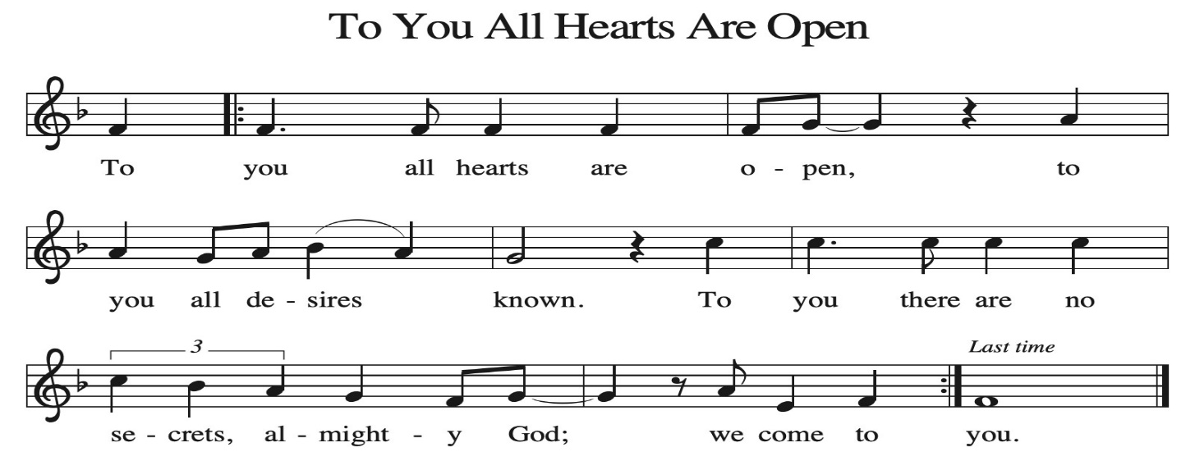
~ Proclamation of the WORD ~ (Scripture insert)
God speaks to us in scripture reading, preaching, and song.

JEREMIAH 23:1-6; 29:1, 4-14

SERMON Rev. Benjamin Morris

HYMN of the DAY ELW (red hymnal) #865 Praise, My Soul, the King of Heaven

APOSTLES’ CREED ELW (red hymnal) Page 105

PRAYERS of INTERCESSION
Petitions end: Hear us, O God…your mercy is great.

PASSING OF THE PEACE
Please be aware of those who may not be comfortable shaking hands. You may also share the peace sign. Or any other contactless gesture that you are comfortable with.

OFFERING & SOLO Mary Schultz


OFFERTORY ELW (red hymnal) #186 Create in Me a Clean Heart, O Lord

OFFERTORY PRAYER
God of healing and hope, you bless those who are hungry, promising to fill them with good things. Fulfill that promise through us and these your gifts. Nourish us with the abundance of your feast and unite us into the blessed body of Jesus Christ our Savior, now and forever. Amen.

THANKSGIVING FOR THE WORD
O God of justice and love, we give thanks to you that you illumine our way through life with the words of your Son. Give us the light we need, awaken us to the needs
of others, and at the end bring all the world to your feast; through Jesus Christ, our Savior and Lord, to whom, with you and the Holy Spirit, be honor and glory forever. Amen.

THE LORD’S PRAYER

~ SENDING ~
God blesses us and sends us in mission to the world
BLESSING
The love of God the Sovereign strengthen you, God the Son save you, and God the Holy Spirit anoint you for the work ahead. The holy Trinity bless you ☩ and grant you a faithful and courageous heart now and forever. Amen.

BELLS
SENDING HYMN ELW (red hymnal) #781 Children of the Heavenly Father

DISMISSAL
Go in peace. Share the harvest.
Thanks be to God.

POSTLUDE Mary Schultz

Reprinted / podcast / streamed with permission under ONE LICENSE #A-738444. All rights reserved.

COON VALLEY LUTHERAN CHURCH
Christ the King
NOVEMBER 23, 2025

~Bulletins are in memory of Lisa Thomas

Coffee Servers: Susan Strangstalien, Pam Olson
Usher: Dave Marsh
Reader: Julie Nelson
Attendance & Offering Last Sunday: 116; $3,699.07
Sunday School Attendance: 10


Scan this code with your phone to contribute electronically with Vanco.

SCHEDULE
TUESDAY: 9:00a/Pastor’s Text Study
WEDNESDAY: Office Closed door open 9am-1pm for pie drop off for Westby Thanksgiving Dinner; 7:00p/Thanks. Eve worship & Pie Fest
THURSDAY: Happy Thanksgiving-Office Closed
NEXT SUNDAY: 9:00a/Social Ministry; 10:30a/Worship with Pr. Meg Hoversten;
Coon Valley Lutheran Church
www.coonvalleylutheranchurch.org
Pastor: Rev. Benjamin Morris, Office 452-3772/Cell 608-406-1556, pastor@coonvalleylutheranchurch.org
Office Administrator: Jamie Thomas, office@coonvalleylutheranchurch.org
Office Hours: Tuesday, Wednesday 9:00a-4:00p; Thursday 9:00a-3:30p
Office 452-3772/Cell 317-0007
Treasurer: Becky Lusk, treasurer@coonvalleylutheranchurch.org
Organist: Mary Schultz
Indoor Custodian: Tracy Stellner

No Sunday School, Coffee Fellowship

~Remember "Thumbs Up" When you come up for communion if you would like a gluten free wafer, give the pastor a thumbs up as you approach. As you approach the wine server, give him or her a thumbs up to receive grape juice instead of wine.

Jeremiah 23:1-6; 29:1, 4-14
23 Woe to the shepherds who destroy and scatter the sheep of my pasture! says the Lord.
² Therefore thus says the Lord, the God of Israel, concerning the shepherds who shepherd my people: It is you who have scattered my flock and have driven them away, and you have not attended to them. So I will attend to you for your evil doings, says the Lord.
³ Then I myself will gather the remnant of my flock out of all the lands where I have driven them, and I will bring them back to their fold, and they shall be fruitful and multiply.
⁴ I will raise up shepherds over them who will shepherd them, and they shall no longer fear or be dismayed, nor shall any be missing, says the Lord.
⁵ The days are surely coming, says the Lord, when I will raise up for David a righteous Branch, and he shall reign as king and deal wisely and shall execute justice and righteousness in the land.
⁶ In his days Judah will be saved, and Israel will live in safety. And this is the name by which he will be called: “The Lord is our righteousness.”
29 These are the words of the letter that the prophet Jeremiah sent from Jerusalem to the remaining elders among the exiles and to the priests, the prophets, and all the people whom Nebuchadnezzar had taken into exile from Jerusalem to Babylon.
⁴ Thus says the Lord of hosts, the God of Israel, to all the exiles whom I have sent into exile from Jerusalem to Babylon:
⁵ Build houses and live in them; plant gardens and eat what they produce.
⁶ Take wives and have sons and daughters; take wives for your sons, and give your daughters in marriage, that they may bear sons and daughters; multiply there, and do not decrease.
⁷ But seek the welfare of the city where I have sent you into exile, and pray to the Lord on its behalf, for in its welfare you will find your welfare.
⁸ For thus says the Lord of hosts, the God of Israel: Do not let the prophets and the diviners who are among you deceive you, and do not listen to your dreams that you dream,
⁹ for it is a lie that they are prophesying to you in my name; I did not send them, says the Lord.
¹⁰ For thus says the Lord: Only when Babylon’s seventy years are completed will I visit you, and I will fulfill to you my promise and bring you back to this place.
¹¹ For surely I know the plans I have for you, says the Lord, plans for your welfare and not for harm, to give you a future with hope.
¹² Then when you call upon me and come and pray to me, I will hear you.
¹³ When you search for me, you will find me; if you seek me with all your heart,
¹⁴ I will let you find me, says the Lord, and I will restore your fortunes and gather you from all the nations and all the places where I have driven you, says the Lord, and I will bring you back to the place from which I sent you into exile.
Word of God. Word of Life. Thanks be to God.

*We are always happy to include you and our CVLC family in our prayers. If you feel your name, or the name of a family member can be added or removed from this list please contact Jamie. Thank you!

We remember in prayer:
† Those hospitalized this past week; Larry Strangstalien, Mary Schultz
† Our members whose names we lift up in prayer today: Corrine Appleman, Beverly Bagstad, Clifford Bakkum, Pastor Barbara Bruneau, Herby Cornell, Marie Egge, Gloria Galstad, Kira Hoff, Becky Ihle, Donna Ihle, Ray Ihle, Eddie Kanieski, Todd King, Margaret Lee, Russell Lee, Aaron Leisso, Aaron Marx, LuEtta Nelson, Romaine Nelson, Lisa Olson, Sandra Onshus, Elaine Proksch, Eunice Quast, Lori Roach, Jojo Satona, Heidi Saupe, Bob Schulze, Mary Schultz, LaVonne Stendahl, Krin (Dreves) Stendalen, Joyce Temp, Teri Tomten, Dave Verse, Jan Verse, Renita Williamson
† Our members who are currently in health care facilities & Assisted Living:
Tip Bagstad, Rachel Berg, Carl Daffinrud, Jeanne Ebli, Carl Holte, Bob Moilien, Geri Nestingen, Irene Nestingen, Cathy Ofte, Annie Olson, Beatrice Olson (Alden),
Ellen Runice, Orrin Stakston.
† Those who grieve
† Our members who are currently home bound
† All those in need of God’s healing and help
† Family and friends of our members
† Local Military: Alex Hendrickson

