COON VALLEY LUTHERAN CHURCH

**“We are a family of God, striving to enrich**

**the lives of all through the love of Christ.”**

PRELUDE MUSIC

BELLS

WELCOME and ANNOUNCEMENTS

CONFESSION AND FORGIVENESS

In the name of the Father, and of the ☩ Son, and of the Holy Spirit.

**Amen.**

Baptized into Christ, let us confess our sin.

*Silence is kept for reflection.*

Merciful God,

**you free us to love others,** **but we neglect our neighbors and follow our own way.** **You lead us by the Spirit of joy and peace,** **but we turn away from the abundant life you offer.** **You surround us with patience, kindness,**

**and generosity,** **but we grow weary in doing what is right.** **In your mercy, forgive us.** **Do not give up on us.** **Heal us, break our bonds,** **and show us the path of life.** **Amen.**

You belong to Christ Jesus and you are God’s children through faith. In the cross of ☩ Christ, and through the power of the Holy Spirit, your sins are forgiven.

Clothed with Christ, you are a new creation.

**Amen.**

GATHERING HYMN ELW (red hymnal) #556 Morning Has Broken

GREETING and PRAYER of the DAY

The grace of our Lord Jesus Christ, the love of God, and the communion of the Holy Spirit be with you all. **And also with you.**

PRAYER OF THE DAY

O God, **judge eternal, you love justice and hate oppression, and you call us to share your zeal for truth. Give us courage to take our stand with all victims of bloodshed and greed, and, following your servants and prophets, to look to the pioneer and perfecter of our faith, your Son, Jesus Christ, our Savior and Lord. Amen.**

**~ WORD ~** (Scripture insert)

**God speaks to us in scripture reading, preaching, and song.**

FIRST READING: Isaiah 58:9b-14

PSALM: 103:1-8 (read responsively)

SECOND READING: Hebrews 12:18-29

The Holy Gospel according to St. Luke the thirteenth chapter

**Glory to you, O Lord.**

GOSPEL: Luke 13:10-17

The Gospel of the Lord! **Praise to you, O Christ!**

SERMON Rev. Benjamin Morris

HYMN of the DAY ACS (purple hymnal) #977 Look Who Gathers at Christ’s Table

PRAYER OF GODSPEED FOR ALEX HENDRICKSON

PRAYERS of INTERCESSION

Petitions end: Hear us, O God…**Your mercy is great.**

PASSING OF THE PEACE

*Please be aware of those who may not be comfortable shaking hands. You may also share the peace sign. Or any other contactless gesture that you are comfortable with.*

OFFERING & OFFERING SONG

OFFERTORY PRAYER

Creator God, **in your wisdom you bring forth all that is good** **and the harvest is plentiful.** **Strengthen us at your table with these gifts of the earth** **and our labor,** **that we may work for the good of all; through Jesus Christ, our Savior.** **Amen.**

THANKSGIVING FOR THE WORD

O God of justice and love, we give thanks to you that you illumine our way through life with the words of your Son. Give us the light we need, awaken us to the needs

of others, and at the end bring all the world to your feast; through Jesus Christ, our Savior and Lord, to whom, with you and the Holy Spirit, be honor and glory forever. **Amen.**

THE LORD’S PRAYER

**~ SENDING ~**

**God blesses us and sends us in mission to the world**

BLESSING

The love of God abound in you; the grace of our Savior Jesus Christ fill your hearts;

and the life of the Spirit ☩ bless you and give you peace.

**Amen.**

BELLS

SENDING HYMN ELW (red hymnal) #858 Praise to the Lord, the Almighty

DISMISSAL

Go in peace. Live by the Spirit. **Thanks be to God.**

POSTLUDE

Reprinted / podcast / streamed with permission under ONE LICENSE #A-738444. All rights reserved.

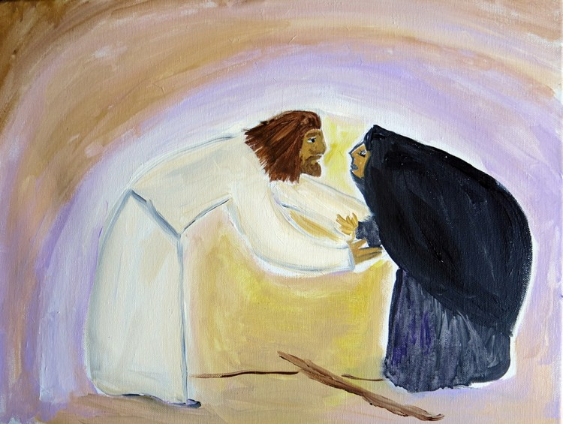

COON VALLEY LUTHERAN CHURCH

The Tenth Sunday of Pentecost

August 17, 2025

**Usher:** Tim Hatlan

**Reader:** Alex Henrickson

**Attendance & Offering Last Sunday:** 64;$3,983.47

Farmer’s Market Last Sunday: $62.00

Scan this code with your phone to contribute electronically with Vanco.

**SCHEDULE**

**TUESDAY: 9:00a/**Pastor’s Text Study

**THURSDAY: 10:00a/**WELCA; **6:00p/**Church Council

**FRIDAY:** Pastor Ben’s sabbath

**SATURDAY:** Coon Valley Heritage Day; Parade walkers meet up @ church **9:00am**

**NEXT SUNDAY: 9:00a/**Worship with Community Conversation following

**Coon Valley Lutheran Church**

[**www.coonvalleylutheranchurch.org**](http://www.coonvalleylutheranchurch.org)

**Pastor:** Rev. Benjamin Morris, Office 452-3772/Cell 608-406-1556, [pastor@coonvalleylutheranchurch.org](mailto:pastor@coonvalleylutheranchurch.org)

**Office Administrator:** Jamie Thomas, [office@coonvalleylutheranchurch.org](mailto:office@coonvalleylutheranchurch.org)

**Office Hours: Tuesday, Wednesday 9:00a-3:00p**

Office452-3772/Cell 317-0007

**Treasurer:** Becky Lusk, <treasurer@coonvalleylutheranchurch.org>

**Organist:** Mary Schultz

**Indoor Custodian:** Tracy Stellner

~Remember **"Thumbs Up"** When you come up for communion if you would like a **gluten free wafer**, give the pastor a thumbs up as you approach. As you approach the wine server, give him or her a thumbs up to receive **grape juice** instead of wine.

**First Reading: Isaiah 58:9b-14**

9b If you remove the yoke from among you,  
  the pointing of the finger, the speaking of evil,  
 10 if you offer your food to the hungry  
  and satisfy the needs of the afflicted,  
 then your light shall rise in the darkness  
  and your gloom be like the noonday.  
 11 The Lord will guide you continually  
  and satisfy your needs in parched places  
  and make your bones strong,  
 and you shall be like a watered garden,  
  like a spring of water  
  whose waters never fail.  
 12 Your ancient ruins shall be rebuilt;  
  you shall raise up the foundations of many generations;  
 you shall be called the repairer of the breach,  
  the restorer of streets to live in.  
  
 13 If you refrain from trampling the Sabbath,  
  from pursuing your own interests on my holy day;  
 if you call the Sabbath a delight  
  and the holy day of the Lord honorable;  
 if you honor it, not going your own ways,  
  serving your own interests or pursuing your own affairs;  
 14 then you shall take delight in the Lord,  
  and I will make you ride upon the heights of the earth;  
 I will feed you with the heritage of your ancestor Jacob,  
  for the mouth of the Lord has spoken.

Word of God. Word of Life. **Thanks be to God.**

**Psalm 103:1-8 (read responsively)**

1 Bless the Lord, O my soul,  
  and all that is within me, bless God’s holy name.  
 2 **Bless the Lord, O my soul,**  
  **and forget not all God’s benefits—**  
 3 who forgives all your sins  
  and heals all your diseases;  
 4 **who redeems your life from the grave**  
  **and crowns you with steadfast love and mercy;**  
 5 who satisfies your desires with good things  
  so that your youth is renewed like an eagle’s.  
 6 **O Lord, you provide vindication**  
  **and justice for all who are oppressed.**  
 7 You made known your ways to Moses  
  and your works to the children of Israel.  
 8 **Lord, you are full of compassion and mercy,**  
  **slow to anger and abounding in steadfast love.**

**Second Reading: Hebrews 12:18-29**

18 You have not come to something that can be touched, a blazing fire, and darkness, and gloom, and a tempest, 19 and the sound of a trumpet, and a voice whose words made the hearers beg that not another word be spoken to them. 20 (For they could not endure the order that was given, “If even an animal touches the mountain, it shall be stoned to death.” 21 Indeed, so terrifying was the sight that Moses said, “I tremble with fear.”) 22 But you have come to Mount Zion and to the city of the living God, the heavenly Jerusalem, and to innumerable angels in festal gathering, 23 and to the assembly of the firstborn who are enrolled in heaven, and to God the judge of all, and to the spirits of the righteous made perfect, 24 and to Jesus, the mediator of a new covenant, and to the sprinkled blood that speaks a better word than the blood of Abel.  
  25 See that you do not refuse the one who is speaking, for if they did not escape when they refused the one who warned them on earth, how much less will we escape if we reject the one who warns from heaven! 26 At that time his voice shook the earth, but now he has promised, “Yet once more I will shake not only the earth but also the heaven.” 27 This phrase, “Yet once more,” indicates the removal of what is shaken—that is, created things—so that what cannot be shaken may remain. 28 Therefore, since we are receiving a kingdom that cannot be shaken, let us show gratitude, by which we may offer to God an acceptable worship with reverence and awe, 29 for indeed our God is a consuming fire.

Word of God. Word of Life. **Thanks be to God.**

The Holy Gospel according to St. Luke the thirteenth chapter

**Glory to you, O Lord.**

**Gospel: Luke 13:10-17**

10 Now [Jesus] was teaching in one of the synagogues on the Sabbath. 11 And just then there appeared a woman with a spirit that had crippled her for eighteen years. She was bent over and was quite unable to stand up straight. 12 When Jesus saw her, he called her over and said, “Woman, you are set free from your ailment.” 13 When he laid his hands on her, immediately she stood up straight and began praising God. 14 But the leader of the synagogue, indignant because Jesus had cured on the Sabbath, kept saying to the crowd, “There are six days on which work ought to be done; come on those days and be cured and not on the Sabbath day.” 15 But the Lord answered him and said, “You hypocrites! Does not each of you on the Sabbath untie his ox or his donkey from the manger and lead it to water? 16 And ought not this woman, a daughter of Abraham whom Satan bound for eighteen long years, be set free from this bondage on the Sabbath day?” 17 When he said this, all his opponents were put to shame, and the entire crowd was rejoicing at all the wonderful things being done by him.

*The Gospel of the Lord.* ***Praise to you, O Christ.***

*\*We are always happy to include you and our CVLC family in our prayers. If you feel your name, or the name of a family member can be added or removed from this list please contact Jamie.* *Thank you!*

**We remember in prayer:**

**†** *Those hospitalized this past week*

**†** *Our members whose names we lift up in prayer today:* Corrine Appleman, Beverly Bagstad, Clifford Bakkum, Pastor Barbara Bruneau, Herby Cornell, Marie Egge, Kira Hoff, Becky Ihle, Donna Ihle, Ray Ihle, Todd King, Mike Kellogg, Margaret Lee, Russell Lee, Aaron Leisso, Colleen Lusk, Aaron Marx, LuEtta Nelson,Romaine Nelson, Lisa Olson, Sandra Onshus, Elaine Proksch, Eunice Quast, Lori Roach, Ellen Runice*,* Jojo Satona, Bob Schulze, Mary Schultz, LaVonne Stendahl, Krin (Dreves) Stendalen, Joyce Temp, Teri Tomten, Renita Williamson

**†** *Our members who are currently in health care facilities & Assisted Living:*

Tip Bagstad, Rachel Berg, Carl Daffinrud, Evelyn Dahlen, Jeanne Ebli, Lenore Henley, Carl Holte, Bob Moilien, Pauline Moilien, Geri Nestingen, Irene Nestingen, Cathy Ofte, Annie Olson, Beatrice Olson (Alden), Joyce Temp.

**†** *Those who grieve**:* Family and friends of Verlin Ihle

**†** *Our members who are currently home bound*

**†** *All those in need of God’s healing and help*

**†** *Family and friends of our members*