COON VALLEY LUTHERAN CHURCH
“We are a family of God, striving to enrich
the lives of all through the love of Christ.”
PRELUDE MUSIC
BELLS
WELCOME and ANNOUNCEMENTS

THANKSGIVING FOR BAPTISM
Alleluia! Christ is risen.
Christ is risen indeed. Alleluia!
Salvation belongs to our God who is seated on the throne
and to the Lamb!
Amen.
Let us give thanks for the gifts of baptism.
Water may be poured into the font as the presiding minister continues.
Merciful God,
you are the one who was, who is, and who is to come.
You lead us beside still waters.
We thank you for the waters of creation:
morning dew, gentle rain, roaring waves.
We thank you for the waters that nourish us (local waters may be named).
Blessed are you.
You guide us to springs of the water of life.
Jesus Christ, you are the faithful witness
who accompanies us on our journeys.
We give you thanks for your life-giving death and resurrection.
We praise you for joining us in joy and sorrow.
Blessed are you.
You guide us to springs of the water of life.
Holy Spirit, you anoint our head with oil and our cup overflows.
Break down barriers that divide us.
Fill us with the breath of peace.
Blessed are you.
You guide us to springs of the water of life.
Holy One, we thank you for the gifts and grace of baptism,
and for making us a new creation.
We join with saints and angels, giving you honor and praise,
now and forever.
Amen.
GATHERING HYMN ELW (red hymnal) #453 Baptized and Set Free

HOLY BAPTISM ELW (red hymnal) Page 227
PRAYER OF THE DAY
God of love, with praise we celebrate Jesus, who humbled himself so that every knee should bend and every tongue confess that Jesus Christ is Lord. Amen.
GREET THE WORD- ACS (purple hymnal) #976 Sung 1 time
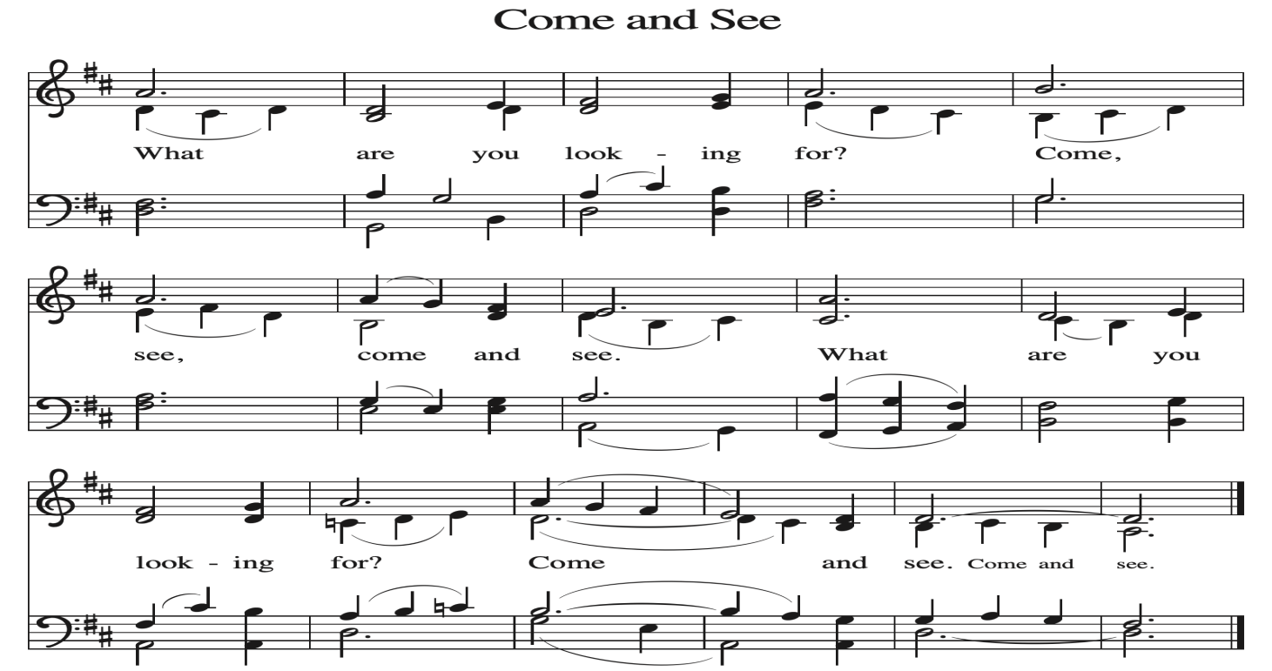
~ Proclamation of the WORD ~ (Scripture insert)
God speaks to us in scripture reading, preaching, and song.

READING: Philippians 2:1-13
Word of God. Word of Life. Thanks be to God.
SERMON Rev. Benjamin Morris

HYMN of the DAY ELW (red hymnal) #597 My Hope Is Built on Nothing Less

HIGH SCHOOL GRADUATE BLESSING

PRAYERS of INTERCESSION
Petitions end: Merciful God,..receive our prayer.

PASSING OF THE PEACE
Please be aware of those who may not be comfortable shaking hands. You may also share the peace sign. Or any other contactless gesture that you are comfortable with.

OFFERING & SOLO
OFFERTORY ELW (red hymnal) #186 Create in Me a Clean Heart, O Lord

OFFERTORY PRAYER
Merciful God, accept the fruits of our labor, gathered to give you glory.
You have set a table before us, a glimpse of that great day when we will hunger and thirst no more. Nourish us with the body and blood of Jesus,
that goodness and mercy may follow us and bless the world you love.
In the name of Jesus, Amen.

THANKSGIVING FOR THE WORD
O God of justice and love, we give thanks to you that you illumine our way through life with the words of your Son. Give us the light we need, awaken us to the needs of others, and at the end bring all the world to your feast; through Jesus Christ, our Savior and Lord, to whom, with you and the Holy Spirit, be honor and glory forever. Amen.

THE LORD’S PRAYER
~ SENDING ~
God blesses us and sends us in mission to the world
BLESSING
God Almighty, who is the beginning and the end, Jesus Christ, the firstborn of the dead,
and the Spirit, our advocate and peace, ☩ bless you now and forever. Amen.

BELLS
SENDING HYMN ELW (red hymnal) #732 Borning Cry

DISMISSAL
Go in peace. Praise the Lord. Alleluia! Thanks be to God. Alleluia!

POSTLUDE

Reprinted / podcast / streamed with permission under ONE LICENSE #A-738444. All rights reserved


COON VALLEY LUTHERAN CHURCH
High School Senior Blessing
Seventh Sunday of Easter
Sunday, May 17, 2026

~Bulletins are in memory of Ella Jacobson & Olga Stakston

~We welcome into our congregation the newly baptized Cameron Michael son of Christopher & Cecelia Friedman.

Coffee Servers: Worship Committee
Piano/Organ: Aaron Stakston
Usher: Brian Strangstalien
Reader: Steve Pauloski
Attendance & Offering Last Sunday: 9:00a/115; $4,023.07

Scan this code with your phone to contribute electronically with Vanco.

SCHEDULE
TODAY: 10:15am/Coffee Fellowship
TUESDAY: 9:00a-Noon/Pastor’s text study
WEDNESDAY: 5:00-7:00p/A Table Together Community Meal
THURSDAY: No Bible Study; 10:00a/WELCA; 6:00p/Church Council
FRIDAY: Pastor Ben’s sabbath
NEXT SUNDAY: 9:00a/Worship; 10:15a/Coffee Fellowship; 10:30a/Pr. Ben worship at Middle Coon Valley

Coon Valley Lutheran Church
www.coonvalleylutheranchurch.org
Pastor: Rev. Benjamin Morris, Office 452-3772/Cell 608-406-1556, pastor@coonvalleylutheranchurch.org
Office Administrator: Jamie Thomas, office@coonvalleylutheranchurch.org
Office Hours: Thursday 9:00a-2:30p
Office 452-3772/Cell 317-0007
Treasurer: Becky Lusk, treasurer@coonvalleylutheranchurch.org
Organist:
Indoor Custodian: Tracy Stellner

Philippians 2:1-13
2 If, then, there is any comfort in Christ, any consolation from love, any partnership in the Spirit, any tender affection and sympathy,
² make my joy complete: be of the same mind, having the same love, being in full accord and of one mind.
³ Do nothing from selfish ambition or empty conceit, but in humility regard others as better than yourselves.
⁴ Let each of you look not to your own interests but to the interests of others.
⁵ Let the same mind be in you that was in Christ Jesus,
⁶ who, though he existed in the form of God, did not regard equality with God as something to be grasped,
⁷ but emptied himself, taking the form of a slave, assuming human likeness. And being found in appearance as a human,
⁸ he humbled himself and became obedient to the point of death—
even death on a cross.

⁹ Therefore God exalted him even more highly and gave him the name
that is above every other name,
¹⁰ so that at the name given to Jesus every knee should bend,
in heaven and on earth and under the earth,
¹¹ and every tongue should confess that Jesus Christ is Lord, to the glory of God the Father.
¹² Therefore, my beloved, just as you have always obeyed me, not only in my presence but much more now in my absence, work on your own salvation with fear and trembling,
¹³ for it is God who is at work in you, enabling you both to will and to work for his good pleasure.
Word of God. Word of Life. Thanks be to God.

Remember "Thumbs Up" When you come up for communion if you would like a gluten free wafer, give the wafer server a thumbs up as you approach. As you approach the wine server, give him or her a thumbs up to receive grape juice instead of wine.

*If you would like communion brought to you, please let the usher know as they are dismissing people into the communion line.

*We are always so happy to include you and our CVLC family in our prayers. If you feel your name, or the name of a family member can be added or removed from this list please contact Jamie. Thank you!

We remember in prayer:
† Those hospitalized this past week:
† Our members whose names we lift up in prayer today: Corrine Appleman, Beverly Bagstad, Clifford Bakkum, Pastor Barbara Bruneau, Ellie Brye, Herby Cornell, Gloria Galstad, Kira Hoff, Becky Ihle, Donna Ihle, Ray Ihle, Margaret Lee, Russell Lee, Aaron Leisso, Aaron Marx, LuEtta Nelson, Romaine Nelson, Sandra Onshus, Elaine Proksch, Eunice Quast, Lori Roach, Jojo Satona, Heidi Saupe, Orrin Stakston, LaVonne Stendahl, Krin (Dreves) Stendalen, Joyce Temp, Jamie Thomas, Teri Tomten, Renita Williamson
† Our members who are currently in health care facilities & Assisted Living:
Tip Bagstad, Rachel Berg, Carl Daffinrud, Jeanne Ebli, Carl Holte, Patty Helgerson, Bob Moilien, Geri Nestingen, Irene Nestingen, Cathy Ofte, Annie Olson, Beatrice Olson (Alden), Elaine Proksch, Ellen Runice, Bob & Evelyn Schulze.
† Those who grieve: Family and friends of Jon Larson & Todd King
† Our members who are currently home bound
† All those in need of God’s healing and help
† All those affected by recent storms
† Family and friends of our members
† Local Military: Alex Hendrickson

