COON VALLEY LUTHERAN CHURCH

**“We are a family of God, striving to enrich**

**the lives of all through the love of Christ.”**

PRELUDE MUSIC Mary Schultz

BELLS

WELCOME and ANNOUNCEMENTS

Thanksgiving for Baptism

Blessed be the holy Trinity, ☩ one God, the fountain of living water, the rock who gave us birth, our light and our salvation. **Amen.**

Joined to Christ in the waters of baptism, we are clothed with God’s mercy and forgiveness. Let us give thanks for the gift of baptism.

We give you thanks, O God, for in the beginning you created us in your image and placed us in a well-watered garden. In the desert, you promised pools of water for the parched, and you gave us water from the rock. When we did not know the way, you sent the Good Shepherd to lead us to still waters. At the cross, you washed us from Jesus’ wounded side, and on this day, you shower us again with the water of life.

We praise you for your salvation through water, for the water in this font, and for all water everywhere.

Bathe us in your forgiveness, grace, and love. Satisfy all who thirst, and give us the life only you can give.

To you be given honor and praise through Jesus Christ, our living water, in the unity of the Holy Spirit, now and forever.

**Amen.**

GATHERING HYMN ELW (red hymnal) #836 Joyful, Joyful We Adore Thee

PRAYER OF THE DAY

Grand designer of all things, **the light and darkness, the dome in the midst of waters, the sky and dry land, the vegetation, the seasons, the swarms of living creatures, birds and great sea monsters, creeping things and wild animals, and us; all these were brought into being with a word on your lips. And it was good. Amen.**

GREET THE WORD- ACS (purple hymnal) #1012 sung 3 times

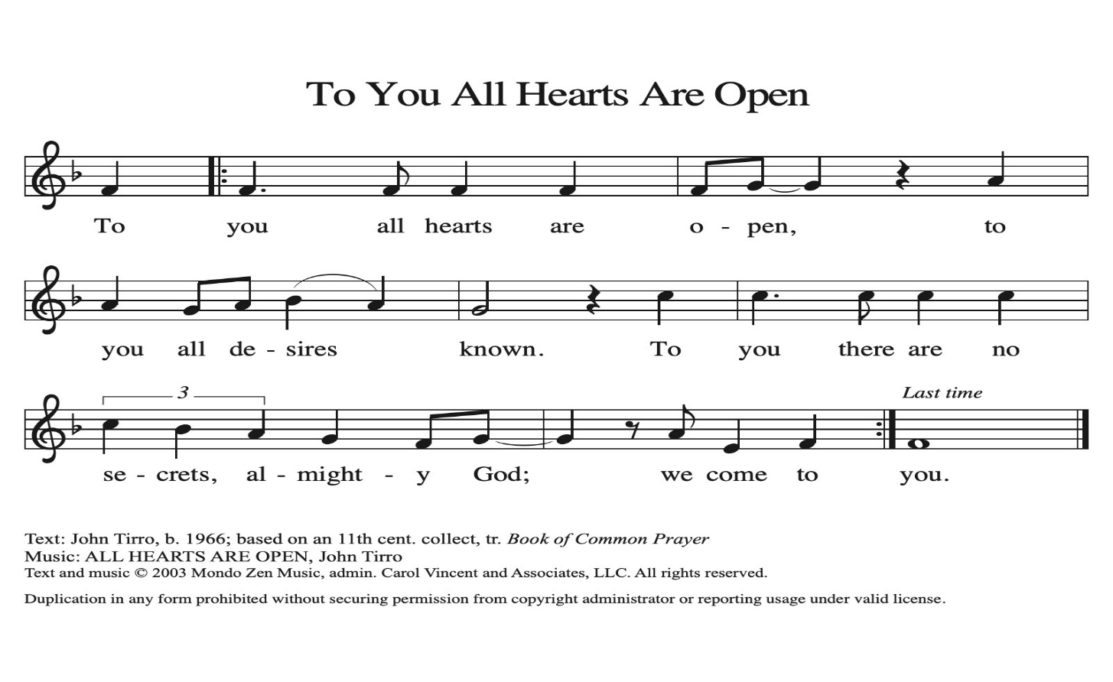

**~ Proclamation of the WORD ~** (Scripture insert)

**God speaks to us in scripture reading, preaching, and song.**

Genesis 1:1—2:4a (read responsively)

CHILDREN’S TIME

SERMON Rev. Benjamin Morris

HYMN of the DAY WOV (blue hymnal) #767 All Things Bright and Beautiful

BEGINNING OF SCHOOL YEAR BLESSING

PRAYERS of INTERCESSION

Petitions end: God of grace…**receive our prayer.**

PASSING OF THE PEACE

*Please be aware of those who may not be comfortable shaking hands. You may also share the peace sign. Or any other contactless gesture that you are comfortable with.*

OFFERING & SOLO Mary Schultz

OFFERTORY ELW (red hymnal) #186 Create in Me a Clean Heart, O Lord

OFFERTORY PRAYER

Lord of the harvest, **we return to you a portion of what you have given to us.**

**Turn us to set our hope not on the uncertainty of riches, but on you, who richly provides for us. Multiply what we have gathered to bless all who are suffering and in need, through Jesus Christ our Lord. Amen.**

THE GREAT THANKSGIVING (Spoken)

The Lord be with you. **And also with you.**

Lift up your hearts. **We lift them to the Lord.**

Let us give thanks to the Lord our God.

**It is right to give him thanks and praise.**

THE LORD’S PRAYER

COMMUNION & SOLO Mary Schultz

POST-COMMUNION PRAYER

O God, **through this meal you have strengthened us and appointed us to be your servants. Send us to do good and to share our possessions with all in need. We ask this in Jesus’ name. Amen.**

**~ SENDING ~**

**God blesses us and sends us in mission to the world**

BLESSING

The God of righteousness, who gives justice to the oppressed, who gives food to the hungry, who sets the prisoners free, ☩ bless you now and forever. **Amen.**

BELLS

SENDING HYMN ACS (purple hymnal) #1063 God of the Fertile Fields

DISMISSAL

Go in peace. Do not lose heart.

**Thanks be to God**

POSTLUDE Mary Schultz

Reprinted / podcast / streamed with permission under ONE LICENSE #A-738444. All rights reserved.

Genesis 1:1-25

Illustrate the verses Genesis 1:1-25 using a vivid, fluid and translucent watercolor technique that predominantly uses the earth tones like chestnut, moss green and along with deep tones of blue for the sky. The image should depict the seven days of creation from these verses. Start with the initial void, follow through the separation of light and darkness, the creation of sky, land, water, plants, the sun and moon, and finally the creation of fish and birds. Prioritize the use of flowing, loose brush strokes to simulate the look and feel of watercolors.

COON VALLEY LUTHERAN CHURCH

The Thirteenth Sunday of Pentecost

September 7, 2025

~Bulletins are in honor of the 40th Anniversary of Mike & Becky Lusk!

**Coffee Servers:** Ellie Brye, Karen McGarvey

**Usher:** Barry Bergum

**Reader:** Nancy King

**Altar Guild:** Karen McGarvey

**Communion Servers:** Patty Nelson, Amy Stakston-Wiedemann

**Attendance & Offering Last Sunday:** 45;$4,999.41

Farmer’s Market Last Sunday: $127.00

Scan this code with your phone to contribute electronically with Vanco.

**SCHEDULE**

**MONDAY: 9:00a/**Naomi Circle

**TUESDAY: 9:00a/**Pastor’s Text Study; **5:00p/**Worship Committee

**WEDNESDAY: 9:00a/**Quilting

**THURSDAY: 10:00a/**Bible Study

**FRIDAY:** Pastor Ben’s sabbath

**NEXT SUNDAY: 9:00a/**Worship with Holy Communion; **10:00a/**Coffee Fellowship, Farmer’s Market; **10:15-11:30a/**Sunday School; **10:30-11:30a/**Confirmation Orientation; **Last day to bring school supplies**

**Coon Valley Lutheran Church**

[**www.coonvalleylutheranchurch.org**](http://www.coonvalleylutheranchurch.org)

**Pastor:** Rev. Benjamin Morris, Office 452-3772/Cell 608-406-1556, [pastor@coonvalleylutheranchurch.org](mailto:pastor@coonvalleylutheranchurch.org)

**Office Administrator:** Jamie Thomas, [office@coonvalleylutheranchurch.org](mailto:office@coonvalleylutheranchurch.org)

**Office Hours: Tuesday, Wednesday, Thursday 9:00a-2:30p**

Office452-3772/Cell 317-0007

**Treasurer:** Becky Lusk, <treasurer@coonvalleylutheranchurch.org>

**Organist:** Mary Schultz

**Indoor Custodian:** Tracy Stellner

~Remember **"Thumbs Up"** When you come up for communion if you would like a **gluten free wafer**, give the pastor a thumbs up as you approach. As you approach the wine server, give him or her a thumbs up to receive **grape juice** instead of wine.

**GENESIS 1:1—2:4a (read responsively)**

**1**When God began to create the heavens and the earth, **2**the earth was complete chaos, and darkness covered the face of the deep, while a wind from God swept over the face of the waters. **3**Then God said, “Let there be light,” and there was light. **4**And God saw that the light was good, and God separated the light from the darkness. **5**God called the light Day, and the darkness he called Night.

**And there was evening and there was morning, the first day.**

**6**And God said, “Let there be a dome in the midst of the waters, and let it separate the waters from the waters.” **7**So God made the dome and separated the waters that were under the dome from the waters that were above the dome. And it was so. **8**God called the dome Sky.

**And there was evening and there was morning, the second day.**

**9**And God said, “Let the waters under the sky be gathered together into one place, and let the dry land appear.” And it was so. **10**God called the dry land Earth, and the waters that were gathered together he called Seas. And God saw that it was good. **11**Then God said, “Let the earth put forth vegetation: plants yielding seed and fruit trees of every kind on earth that bear fruit with the seed in it.” And it was so. **12**The earth brought forth vegetation: plants yielding seed of every kind and trees of every kind bearing fruit with the seed in it.

**And God saw that it was good. 13And there was evening and there was morning, the third day.**

**14**And God said, “Let there be lights in the dome of the sky to separate the day from the night, and let them be for signs and for seasons and for days and years, **15**and let them be lights in the dome of the sky to give light upon the earth.” And it was so. **16**God made the two great lights—the greater light to rule the day and the lesser light to rule the night—and the stars. **17**God set them in the dome of the sky to give light upon the earth, **18**to rule over the day and over the night, and to separate the light from the darkness.

**And God saw that it was good. 19And there was evening and there was morning, the fourth day.**

**20**And God said, “Let the waters bring forth swarms of living creatures, and let birds fly above the earth across the dome of the sky.” **21**So God created the great sea monsters and every living creature that moves, of every kind, with which the waters swarm and every winged bird of every kind.

**And God saw that it was good. 22God blessed them, saying, “Be fruitful and multiply and fill the waters in the seas, and let birds multiply on the earth.” 23And there was evening and there was morning, the fifth day.**

**24**And God said, “Let the earth bring forth living creatures of every kind: cattle and creeping things and wild animals of the earth of every kind.” And it was so. **25**God made the wild animals of the earth of every kind and the cattle of every kind and everything that creeps upon the ground of every kind.

**And God saw that it was good.**

**26**Then God said, “Let us make humans in our image, according to our likeness, and let them have dominion over the fish of the sea and over the birds of the air and over the cattle and over all the wild animals of the earthand over every creeping thing that creeps upon the earth.”

**27So God created humansin his image,  
    in the image of God he created them;   
    male and female he created them.**

**28**God blessed them, and God said to them, “Be fruitful and multiply and fill the earth and subdue it and have dominion over the fish of the sea and over the birds of the air and over every living thing that moves upon the earth.” **29**God said, “See, I have given you every plant yielding seed that is upon the face of all the earth and every tree with seed in its fruit; you shall have them for food. **30**And to every beast of the earth and to every bird of the air and to everything that creeps on the earth, everything that has the breath of life, I have given every green plant for food.” And it was so. **31**

**God saw everything that he had made, and indeed, it was very good. And there was evening and there was morning, the sixth day.**

**2**Thus the heavens and the earth were finished and all their multitude. **2**On the sixth day God finished the work that he had done, and he rested on the seventh day from all the work that he had done. **3**So God blessed the seventh day and hallowed it, because on it God rested from all the work that he had done in creation.

**4**These are the generations of the heavens and the earth when they were created.

Word of God. Word of Life. **Thanks be to God.**

*\*We are always happy to include you and our CVLC family in our prayers. If you feel your name, or the name of a family member can be added or removed from this list please contact Jamie.* *Thank you!*

**We remember in prayer:**

**†** *Those hospitalized this past week*

**†** *Our members whose names we lift up in prayer today:* Corrine Appleman, Beverly Bagstad, Clifford Bakkum, Pastor Barbara Bruneau, Herby Cornell, Marie Egge, Kira Hoff, Becky Ihle, Donna Ihle, Ray Ihle, Todd King, Mike Kellogg, Margaret Lee, Russell Lee, Aaron Leisso, Aaron Marx, LuEtta Nelson,Romaine Nelson, Lisa Olson, Sandra Onshus, Elaine Proksch, Eunice Quast, Lori Roach, Ellen Runice*,* Jojo Satona, Bob Schulze, Mary Schultz, LaVonne Stendahl, Krin (Dreves) Stendalen, Teri Tomten, Betty Williamson, Renita Williamson

**†** *Our members who are currently in health care facilities & Assisted Living:*

Tip Bagstad, Rachel Berg, Carl Daffinrud, Evelyn Dahlen, Jeanne Ebli, Gloria Galstad, Lenore Henley, Carl Holte, Bob Moilien, Pauline Moilien, Geri Nestingen, Irene Nestingen, Cathy Ofte, Annie Olson, Beatrice Olson (Alden), Orrin Stakston, Joyce Temp.

**†** *Those who grieve**:* Family and friends of Verlin Ihle

**†** *Our members who are currently home bound*

**†** *All those in need of God’s healing and help*

**†** *Family and friends of our members*

**†** *Local Military:*Alex Hendrickson