COON VALLEY LUTHERAN CHURCH

**“We are a family of God, striving to enrich**

**the lives of all through the love of Christ.”**

PRELUDE MUSIC Mary Schultz

BELLS

WELCOME and ANNOUNCEMENTS

CONFESSION & FORGIVENESS

Blessed be the holy Trinity, ☩ one God,

our maker, our helper, and our keeper.

**Amen.**

Trusting in God’s mercy, let us confess our sin

in the presence of God and of one another.

*Silence is kept for reflection.*

Merciful and loving God,

**we are hard-hearted people.**

**We trample on the needy.**

**We grumble about your grace to others.**

**We turn away from the poor.**

**Have mercy on us and forgive our sins.**

**Rejoice over us as ones who were lost**

**and have been found.**

**Amen.**

Even when we are faithless, God remains faithful.

Jesus Christ came into the world to save sinners.

You who were lost have been found.

In the name of ☩ Jesus, your sins are forgiven!

**Amen.**

GATHERING HYMN ACS (purple hymnal) #1097 Ten Thousand Reasons

PRAYER OF THE DAY

God of all people, **you remembered your children who were enslaved in Egypt, and by the power of your name you set them free. Remember us and free us from slavery to sin by the power of your name. Amen.**

GREET THE WORD- ACS (purple hymnal) #1012 sung 3 times

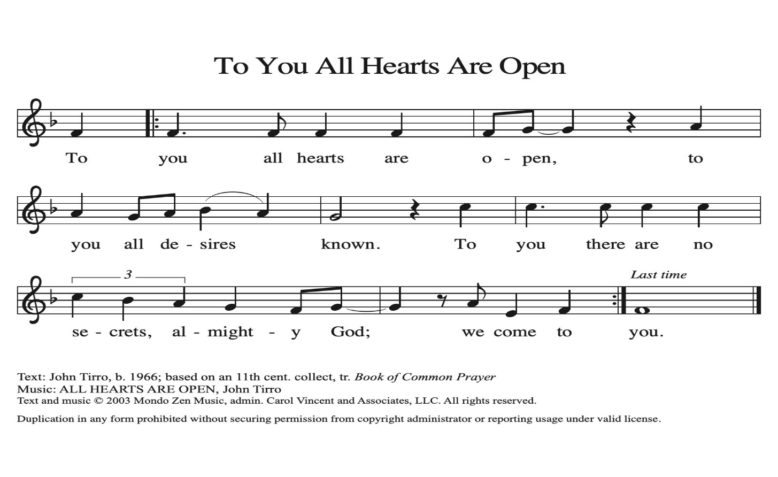

**~ Proclamation of the WORD ~** (Scripture insert)

**God speaks to us in scripture reading, preaching, and song.**

Exodus 2:23-25; 3:1-15; 4:10-17

CHILDREN’S TIME

SERMON Rev. Benjamin Morris

HYMN of the DAY ELW (red hymnal) #831 The God of Abraham Praise vs 1-4

APOSTLES’ CREED ELW (red hymnal) Page 105

PRAYERS of INTERCESSION

Petitions end: God of grace…**receive our prayer.**

PASSING OF THE PEACE

*Please be aware of those who may not be comfortable shaking hands. You may also share the peace sign. Or any other contactless gesture that you are comfortable with.*

OFFERING & SOLO Mary Schultz

OFFERTORY ELW (red hymnal) #186 Create in Me a Clean Heart, O Lord

OFFERTORY PRAYER

Lord of the harvest, **we return to you a portion of what you have given to us.**

**Turn us to set our hope not on the uncertainty of riches, but on you, who richly provides for us. Multiply what we have gathered to bless all who are suffering and in need, through Jesus Christ our Lord. Amen.**

THANKSGIVING FOR THE WORD

O God of justice and love, we give thanks to you that you illumine our way through life with the words of your Son. Give us the light we need, awaken us to the needs

of others, and at the end bring all the world to your feast; through Jesus Christ, our Savior and Lord, to whom, with you and the Holy Spirit, be honor and glory forever. **Amen.**

THE LORD’S PRAYER

**~ SENDING ~**

**God blesses us and sends us in mission to the world**

BLESSING

The God of righteousness, who gives justice to the oppressed, who gives food to the hungry, who sets the prisoners free, ☩ bless you now and forever. **Amen.**

BELLS

SENDING HYMN ELW (red hymnal) #831 The God of Abraham Praise vs 5-8

DISMISSAL

Go in peace. Do not lose heart.

**Thanks be to God**

POSTLUDE Mary Schultz

Reprinted / podcast / streamed with permission under ONE LICENSE #A-738444. All rights reserved.

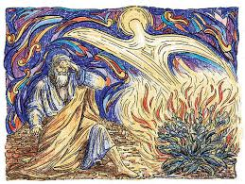

COON VALLEY LUTHERAN CHURCH

The Sixteenth Sunday of Pentecost

September 28, 2025

**Coffee Servers:** Corrine Amunndson, Jan Ihle

**Usher:** Josh Kinstler

**Reader:** Deb Holen

**Attendance & Offering Last Sunday:** 76; offering will be reported next week

Farmer’s Market Last Sunday: $39.00

Sunday School Attendance: 12

Scan this code with your phone to contribute electronically with Vanco.

**SCHEDULE**

**TUESDAY: 9:00a/**Pastor’s Text Study

**THURSDAY: 10:00a/**Bible Study; **6:00p/**Rebecca Circle

**FRIDAY:** Pastor Ben’s sabbath

**NEXT SUNDAY: 9:00a/**Worship with Holy Communion; **10:00a/**Coffee Fellowship, Farmer’s Market; **10:15-11:30a/**Sunday School; **6:00p/**Confirmation

**Coon Valley Lutheran Church**

[**www.coonvalleylutheranchurch.org**](http://www.coonvalleylutheranchurch.org)

**Pastor:** Rev. Benjamin Morris, Office 452-3772/Cell 608-406-1556, [pastor@coonvalleylutheranchurch.org](mailto:pastor@coonvalleylutheranchurch.org)

**Office Administrator:** Jamie Thomas, [office@coonvalleylutheranchurch.org](mailto:office@coonvalleylutheranchurch.org)

**Office Hours: Tuesday, Thursday 9:00a-4:00p; Wednesday 9:00a-2:30p**

Office452-3772/Cell 317-0007

**Treasurer:** Becky Lusk, <treasurer@coonvalleylutheranchurch.org>

**Organist:** Mary Schultz

**Indoor Custodian:** Tracy Stellner

~Remember **"Thumbs Up"** When you come up for communion if you would like a **gluten free wafer**, give the pastor a thumbs up as you approach. As you approach the wine server, give him or her a thumbs up to receive **grape juice** instead of wine.

**Exodus 2:23-25; 3:1-15; 4:10-17**

**23**After a long time the king of Egypt died. The Israelites groaned under their slavery and cried out. Their cry for help rose up to God from their slavery. **24**God heard their groaning, and God remembered his covenant with Abraham, Isaac, and Jacob. **25**God looked upon the Israelites, and God took notice of them.

**3**Moses was keeping the flock of his father-in-law Jethro, the priest of Midian; he led his flock beyond the wilderness and came to Mount Horeb, the mountain of God. **2**There the angel of the Lord appeared to him in a flame of fire out of a bush; he looked, and the bush was blazing, yet it was not consumed. **3**Then Moses said, “I must turn aside and look at this great sight and see why the bush is not burned up.” **4**When the Lord saw that he had turned aside to see, God called to him out of the bush, “Moses, Moses!” And he said, “Here I am.” **5**Then he said, “Come no closer! Remove the sandals from your feet, for the place on which you are standing is holy ground.” **6**He said further, “I am the God of your father, the God of Abraham, the God of Isaac, and the God of Jacob.” And Moses hid his face, for he was afraid to look at God.

**7**Then the Lord said, “I have observed the misery of my people who are in Egypt; I have heard their cry on account of their taskmasters. Indeed, I know their sufferings, **8**and I have come down to deliver them from the Egyptians and to bring them up out of that land to a good and spacious land, to a land flowing with milk and honey, to the country of the Canaanites, the Hittites, the Amorites, the Perizzites, the Hivites, and the Jebusites. **9**The cry of the Israelites has now come to me; I have also seen how the Egyptians oppress them. **10**Now go, I am sending you to Pharaoh to bring my people, the Israelites, out of Egypt.” **11**But Moses said to God, “Who am I that I should go to Pharaoh and bring the Israelites out of Egypt?” **12**He said, “I will be with you, and this shall be the sign for you that it is I who sent you: when you have brought the people out of Egypt, you shall serve God on this mountain.”

**13**But Moses said to God, “If I come to the Israelites and say to them, ‘The God of your ancestors has sent me to you,’ and they ask me, ‘What is his name?’ what shall I say to them?” **14**God said to Moses, “I am who I am.” He said further, “Thus you shall say to the Israelites, ‘I am has sent me to you.’ ” **15**God also said to Moses, “Thus you shall say to the Israelites, ‘The Lord, the God of your ancestors, the God of Abraham, the God of Isaac, and the God of Jacob, has sent me to you’:

This is my name forever,  
and this my title for all generations.

**10**But Moses said to the Lord, “O my Lord, I have never been eloquent, neither in the past nor even now that you have spoken to your servant, but I am slow of speech and slow of tongue.” **11**Then the Lord said to him, “Who gives speech to mortals? Who makes them mute or deaf, seeing or blind? Is it not I, the Lord? **12**Now go, and I will be with your mouth and teach you what you are to speak.” **13**But he said, “O my Lord, please send someone else.” **14**Then the anger of the Lord was kindled against Moses, and he said, “What of your brother Aaron, the Levite? I know that he can speak well; even now he is coming out to meet you, and when he sees you his heart will be glad. **15**You shall speak to him and put the words in his mouth, and I will be with your mouth and with his mouth and will teach you what you shall do. **16**He indeed shall speak for you to the people; he shall serve as a mouth for you, and you shall serve as God for him. **17**Take in your hand this staff, with which you shall perform the signs.”

Word of God. Word of Life. **Thanks be to God.**

*\*We are always happy to include you and our CVLC family in our prayers. If you feel your name, or the name of a family member can be added or removed from this list please contact Jamie.* *Thank you!*

**We remember in prayer:**

**†** *Those hospitalized this past week*

**†** *Our members whose names we lift up in prayer today:* Corrine Appleman, Beverly Bagstad, Clifford Bakkum, Pastor Barbara Bruneau, Herby Cornell, Marie Egge, Gloria Galstad, Kira Hoff, Becky Ihle, Donna Ihle, Ray Ihle, Eddie Kanieski, Todd King, Mike Kellogg, Margaret Lee, Russell Lee, Aaron Leisso, Aaron Marx, LuEtta Nelson,Romaine Nelson, Lisa Olson, Sandra Onshus, Elaine Proksch, Eunice Quast, Lori Roach, Ellen Runice*,* Jojo Satona, Bob Schulze, Mary Schultz, LaVonne Stendahl, Krin (Dreves) Stendalen, Teri Tomten, Dave Verse, Jan Verse, Renita Williamson

**†** *Our members who are currently in health care facilities & Assisted Living:*

Tip Bagstad, Rachel Berg, Carl Daffinrud, Evelyn Dahlen, Jeanne Ebli,

Carl Holte, Bob Moilien, Pauline Moilien, Geri Nestingen, Irene Nestingen, Cathy Ofte, Annie Olson, Beatrice Olson (Alden), Orrin Stakston, Joyce Temp.

**†** *Those who grieve**:* Family and friends of Betty Williamson & Lenore Henley

**†** *Our members who are currently home bound*

**†** *All those in need of God’s healing and help*

**†** *Family and friends of our members*

**†** *Local Military:*Alex Hendrickson