COON VALLEY LUTHERAN CHURCH
“We are a family of God, striving to enrich
the lives of all through the love of Christ.”
PRELUDE MUSIC
BELLS
WELCOME and ANNOUNCEMENTS

LIGHTING OF THE ADVENT WREATH
We praise you, O God, for this evergreen crown
that marks our days of preparation for Christ’s advent.
As we light the first candle on this wreath,
rouse us from sleep, that we may be ready to greet our Lord
when he comes with all the saints and angels.
Enlighten us with your grace,
and prepare our hearts to welcome him with joy.
Grant this through Christ our Lord,
whose coming is certain and whose day draws near.
Amen.
GATHERING HYMN ELW (red hymnal) #257 O Come, O Come, Emmanuel
PRAYER OF THE DAY
God of breath, you promised new life to your people in exile by breathing into a valley full of dry bones. Breathe new life into us, so that we might live passionately for you. Amen.
GREET THE WORD- ACS (purple hymnal) #1012 sung 3 times
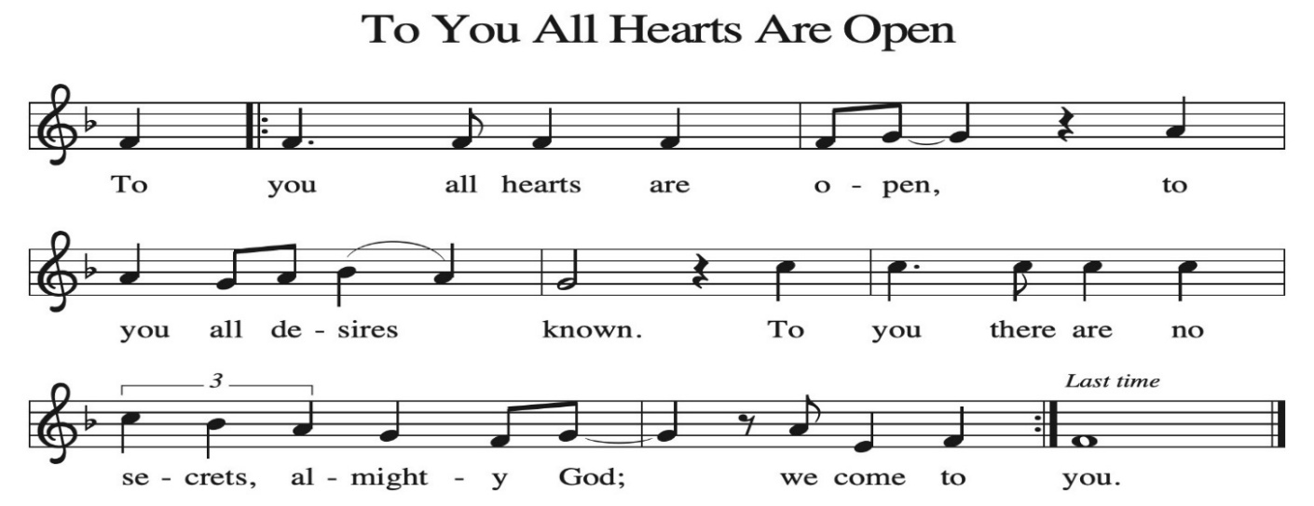

~ Proclamation of the WORD ~ (Scripture insert)
God speaks to us in scripture reading, preaching, and song.

GOSPEL: EZEKIEL 37:1-14

The Gospel of the Lord. Praise to you, O Christ.

SERMON Rev. Ben Morris

HYMN of the DAY ELW (red hymnal) #452 Awake, O Sleeper, Rise from Death

NEW MEMBER WELCOME-See insert

PRAYERS of INTERCESSION
Petitions end: God of grace…hear our prayer.

PASSING OF THE PEACE
Please be aware of those who may not be comfortable shaking hands. You may also share the peace sign. Or any other contactless gesture that you are comfortable with.

OFFERING & SOLO

OFFERTORY ELW (red hymnal) #186 Create in Me a Clean Heart, O Lord

OFFERTORY PRAYER
Nourishing God, you are water in the wilderness and streams in the desert. Through this meal, satisfy our parched places, that we may rejoice and be for the world signs of your kingdom come. Amen.

THE GREAT THANKSGIVING (Spoken)
The Lord be with you. And also with you.
Lift up your hearts. We lift them to the Lord.
Let us give thanks to the Lord our God.
It is right to give him thanks and praise.

THE LORD’S PRAYER

COMMUNION & SOLO

POST-COMMUNION PRAYER
God our host, at this table you have fed us with joy and gladness. Send us forth, eager to share the feast, welcome the stranger, and bear good fruit in the name of Jesus.
Amen.

~ SENDING ~
God blesses us and sends us in mission to the world

BLESSING
May God who comes among us, Father, ☩ Son, and Holy Spirit, grant you patience in waiting, peace in the darkness, and good news to share today and always. Amen.

BELLS
SENDING HYMN ELW (red hymnal) #264 Prepare the Royal Highway

DISMISSAL
Go in peace. Keep awake.
Thanks be to God.

POSTLUDE

Reprinted / podcast / streamed with permission under ONE LICENSE #A-738444. All rights reserved.



Coon Valley Lutheran Church
The Second Sunday in the Season of Advent
New Member Welcome
December 7, 2025
9:00 a.m.

~Bulletins are in honor of the 14th birthday of Alexis White
~We welcome into our congregation all new members joining us today!

Coffee Servers: Pam Pauloski, Stephanie Proksch
Usher: Josh Kinstler
Greeter: Ron Moilien
Reader: Mark Hutson
Altar Guild: Sarah Ofte
Communion Servers: Ray Williamson, Julie Nelson
Attendance & Offering Last Sunday: 34; $1,975.37
Thanksgiving Eve: 30; $448.00-to Bethel Butikk


Scan this code with your phone to contribute electronically with Vanco.

SCHEDULE
TODAY: 10:00a/New Member Coffee & Cake after worship; 10:15-12:30p/Sunday School Practice and Christmas Party;
6:00-7:30p/Confirmation
MONDAY: Carillon Deadline
TUESDAY: 9:00a/Pastor’s Text Study
THURSDAY: 10:00a/Bible Study
FRIDAY: Pastor Ben’s sabbath
NEXT SUNDAY: 9:00a/Worship with Holy Communion; Sunday School Christmas Program; 10:15a/Sunday School & Coffee Fellowship, Finance Committee; Giving Tree gifts due
Coon Valley Lutheran Church
www.coonvalleylutheranchurch.org
Pastor: Rev. Benjamin Morris, Office 452-3772/Cell 608-406-1556, pastor@coonvalleylutheranchurch.org
Office Administrator: Jamie Thomas, office@coonvalleylutheranchurch.org
Office Hours: Tuesday, Wednesday 9:00a-4:00p; Thursday 9:00a-3:30p
Office 452-3772/Cell 317-0007
Treasurer: Becky Lusk, treasurer@coonvalleylutheranchurch.org
Organist: Mary Schultz
Indoor Custodian: Tracy Stellner

~Remember "Thumbs Up" When you come up for communion if you would like a gluten free wafer, give the pastor a thumbs up as you approach. As you approach the wine server, give him or her a thumbs up to receive grape juice instead of wine.

Ezekiel 37:1-14
37 The hand of the Lord came upon me, and he brought me out by the spirit of the Lord and set me down in the middle of a valley; it was full of bones.
² He led me all around them; there were very many lying in the valley, and they were very dry.
³ He said to me, “Mortal, can these bones live?” I answered, “O Lord God, you know.”
⁴ Then he said to me, “Prophesy to these bones and say to them: O dry bones, hear the word of the Lord.
⁵ Thus says the Lord God to these bones: I will cause breath to enter you, and you shall live.
⁶ I will lay sinews on you and will cause flesh to come upon you and cover you with skin and put breath in you, and you shall live, and you shall know that I am the Lord.”
⁷ So I prophesied as I had been commanded, and as I prophesied, suddenly there was a noise, a rattling, and the bones came together, bone to its bone.
⁸ I looked, and there were sinews on them, and flesh had come upon them, and skin had covered them, but there was no breath in them.
⁹ Then he said to me, “Prophesy to the breath, prophesy, mortal, and say to the breath: Thus says the Lord God: Come from the four winds, O breath, and breathe upon these slain, that they may live.”
¹⁰ I prophesied as he commanded me, and the breath came into them, and they lived and stood on their feet, a vast multitude.
¹¹ Then he said to me, “Mortal, these bones are the whole house of Israel. They say, ‘Our bones are dried up, and our hope is lost; we are cut off completely.’
¹² Therefore prophesy and say to them: Thus says the Lord God: I am going to open your graves and bring you up from your graves, O my people, and I will bring you back to the land of Israel.
¹³ And you shall know that I am the Lord when I open your graves and bring you up from your graves, O my people.
¹⁴ I will put my spirit within you, and you shall live, and I will place you on your own soil; then you shall know that I, the Lord, have spoken and will act, says the Lord.”
Word of God. Word of Life. Thanks be to God.

*We are always happy to include you and our CVLC family in our prayers. If you feel your name, or the name of a family member can be added or removed from this list please contact Jamie. Thank you!

We remember in prayer:
† Those hospitalized this past week
† Our members whose names we lift up in prayer today: Corrine Appleman, Beverly Bagstad, Clifford Bakkum, Pastor Barbara Bruneau, Herby Cornell, Gloria Galstad, Kira Hoff, Becky Ihle, Donna Ihle, Ray Ihle, Eddie Kanieski, Todd King, Margaret Lee, Russell Lee, Aaron Leisso, Aaron Marx, LuEtta Nelson, Romaine Nelson, Lisa Olson, Sandra Onshus, Elaine Proksch, Eunice Quast, Lori Roach, Jojo Satona, Heidi Saupe, Bob Schulze, Mary Schultz, LaVonne Stendahl, Krin (Dreves) Stendalen, Joyce Temp, Teri Tomten, Renita Williamson
† Our members who are currently in health care facilities & Assisted Living:
Tip Bagstad, Rachel Berg, Carl Daffinrud, Jeanne Ebli, Carl Holte, Bob Moilien, Geri Nestingen, Irene Nestingen, Cathy Ofte, Annie Olson, Beatrice Olson (Alden),
Ellen Runice.
† Those who grieve: Family & Friends of Mike Kellogg
† Our members who are currently home bound
† All those in need of God’s healing and help
† Family and friends of our members
† Local Military: Alex Hendrickson

Presentation of New Members
Dear friends, we give thanks for the gift of baptism and for these people, one with us in the body of Christ, whom we welcome as new members into the life and ministry of this congregation.

Introduction of New Members

Apostles’ Creed
With the whole church, let us confess our faith.
I believe in God, the Father almighty,
creator of heaven and earth.
I believe in Jesus Christ, God’s only Son, our Lord,
who was conceived by the Holy Spirit,
born of the virgin Mary,
suffered under Pontius Pilate,
was crucified, died, and was buried;
he descended to the dead.*
On the third day he rose again;
he ascended into heaven,
he is seated at the right hand of the Father,
and he will come to judge the living and the dead.
I believe in the Holy Spirit,
the holy catholic church,
the communion of saints,
the forgiveness of sins,
the resurrection of the body,
and the life everlasting. Amen.

Address and Questions
The presiding minister addresses those being welcomed.
In baptism, we are welcomed into the body of Christ and sent to share in the mission of God. We are called to live among God’s faithful people, to hear the word of God and share in the Lord’s supper, to proclaim the good news of God in Christ through word and deed, to serve all people, following the example of Jesus, and to strive for justice and peace in all the earth.
Sisters and brothers in Christ,
do you intend to continue in the covenant of your baptism
among God’s people in this place?
Those being welcomed respond.
I do, and I ask God to help and guide me.
The minister addresses the assembly.
People of God,
do you promise to support and pray for these new members in their life in Christ?
We do, and we ask God to help and guide us.

Welcome
Those being welcomed face the assembly. A representative of the congregation addresses the assembly.
Let us welcome these sisters and brothers in Christ to this community of faith.
We rejoice with you in the life of baptism.
Together we will give thanks and praise to God
and proclaim the good news to all the world.

