COON VALLEY LUTHERAN CHURCH
“We are a family of God, striving to enrich
the lives of all through the love of Christ.”
PRELUDE MUSIC
BELLS
WELCOME and ANNOUNCEMENTS

CONFESSION AND FORGIVENESS
Blessed be the holy Trinity, ☩ one God,
the Creator of heaven and earth,
the Word who spoke life into being,
the Wind stirring the waters.
Amen.
Let us turn in confession to the one who knows us completely.
Silence is kept for reflection.
Mighty God, lover of justice,
you call us to life in community,
but we have served our own interests
at the expense of our neighbors.
We have sown deceit where honesty was needed.
We say the right words,
but our hearts are far from you.
Turn us to seek your face.
Knit us together and give us the mind of Christ,
that we may do justice, love mercy,
and walk humbly with you, our God.
Amen.
The former things have passed away,
and new things God now declares:
Like a spring of water that never fails,
God covers you in the righteousness of Christ,
and forgives your sin in ☩ Jesus’ name.
May the Spirit give you strength to live for others,
and bless you with the gift of peace.
Amen.

GATHERING HYMN ELW (red hymnal) #858 Praise to the Lord, the Almighty
PRAYER OF THE DAY
Patient God, Your son, Jesus, expressed anger at abuses and injustice. Help us to show concern, not apathy, for injustice in our world, and teach us to make right all that may be wrong. Amen.
GREET THE WORD- ACS (purple hymnal) #976
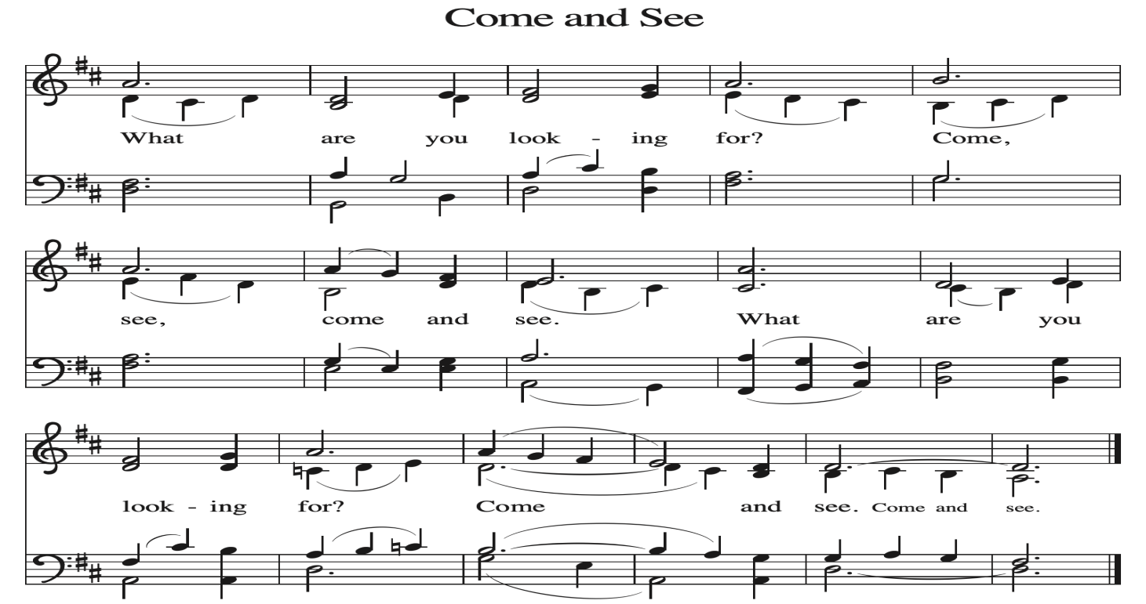
~ Proclamation of the WORD ~ (Scripture insert)
God speaks to us in scripture reading, preaching, and song.

GOSPEL READING: JOHN 2:13-25
The Gospel of the Lord. Praise to you, O Christ.
SERMON Rev. Ben Morris

HYMN of the DAY ACS (purple hymnal) #1062 Build a Longer Table

APOSTLES’ CREED ELW (red hymnal) Page 105

PRAYERS of INTERCESSION
Petitions end: Merciful God....Receive our prayer.

PASSING OF THE PEACE
Please be aware of those who may not be comfortable shaking hands. You may also share the peace sign. Or any other contactless gesture that you are comfortable with.

OFFERING & SOLO

OFFERTORY ELW (red hymnal) #186 Create in Me a Clean Heart, O Lord

OFFERTORY PRAYER
God of majesty, no eye has seen, no ear has heard what you have prepared for those who love you, yet in this meal you reveal the wideness of your mercy.
Use what we have gathered to feed us with the reign of God come near,
Jesus Christ, our Savior and Lord. Amen.

THANKSGIVING FOR THE WORD
O God of justice and love, we give thanks to you that you illumine our way through life with the words of your Son. Give us the light we need, awaken us to the needs of others, and at the end bring all the world to your feast; through Jesus Christ, our Savior and Lord, to whom, with you and the Holy Spirit, be honor and glory forever. Amen.

THE LORD’S PRAYER
~ SENDING ~
God blesses us and sends us in mission to the world

BLESSING
May the triune God, who has put a new song in your mouth and tuned your heart for praise ☩ bless you now and forever. Amen.

BELLS
SENDING HYMN ELW (red hymnal) #652 Built on a Rock

DISMISSAL
Go in peace. Do justice. Love mercy.
Thanks be to God.

POSTLUDE

Reprinted / podcast / streamed with permission under ONE LICENSE #A-738444. All rights reserved.

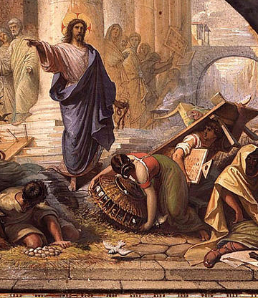

COON VALLEY LUTHERAN CHURCH
Sunday, January 18, 2026
Second Sunday after Epiphany

~Bulletins are in honor of Darik Moilien’s 21st birthday!

Coffee Servers: Heather Wichman, Jan Verse
Usher: Phil Moilien
Reader: Deb Holen
Attendance & Offering Last Sunday: 9:00a/80; $3,638.77
Sunday School Attendance Last Sunday: 6


Scan this code with your phone to contribute electronically with Vanco.

SCHEDULE
TODAY: 9:00a/Worship; 10:15a/Coffee Fellowship, Sunday School, Men’s Club Meeting; No Confirmation
TUESDAY: 9:00a/Pastor’s Text Study
WEDNESDAY: 5:00-7:00p/A Table Together Community Meal
THURSDAY: 10:00a/Bible Study
FRIDAY: Pastor Ben’s sabbath
NEXT SUNDAY: 10:00a/Worship; 10:00a/Sunday School; 11:00a/Annual Meeting & Potluck

Offering envelopes are available. They are located on a table in the Library. Please pick them up for family, friends or neighbors!
Coon Valley Lutheran Church
www.coonvalleylutheranchurch.org
Pastor: Rev. Benjamin Morris, Office 452-3772/Cell 608-406-1556, pastor@coonvalleylutheranchurch.org
Office Administrator: Jamie Thomas, office@coonvalleylutheranchurch.org
Office Hours: Tuesday & Wednesday 9:00-4:00p; Thursday 9:00a-3:30p
Office 452-3772/Cell 317-0007
Treasurer: Becky Lusk, treasurer@coonvalleylutheranchurch.org
Organist: Mary Schultz
Indoor Custodian: Tracy Stellner

Remember "Thumbs Up" When you come up for communion if you would like a gluten free wafer, give the wafer server a thumbs up as you approach. As you approach the wine server, give him or her a thumbs up to receive grape juice instead of wine.

GOSPEL: John 2:13-25
¹³ The Passover of the Jews was near, and Jesus went up to Jerusalem.
¹⁴ In the temple he found people selling cattle, sheep, and doves and the money changers seated at their tables.
¹⁵ Making a whip of cords, he drove all of them out of the temple, with the sheep and the cattle. He also poured out the coins of the money changers and overturned their tables.
¹⁶ He told those who were selling the doves, “Take these things out of here! Stop making my Father’s house a marketplace!”
¹⁷ His disciples remembered that it was written, “Zeal for your house will consume me.”
¹⁸ The Jews then said to him, “What sign can you show us for doing this?”
¹⁹ Jesus answered them, “Destroy this temple, and in three days I will raise it up.”
²⁰ The Jews then said, “This temple has been under construction for forty-six years, and will you raise it up in three days?”
²¹ But he was speaking of the temple of his body.
²² After he was raised from the dead, his disciples remembered that he had said this, and they believed the scripture and the word that Jesus had spoken.
²³ When he was in Jerusalem during the Passover festival, many believed in his name because they saw the signs that he was doing.
²⁴ But Jesus on his part would not entrust himself to them, because he knew all people
²⁵ and needed no one to testify about anyone, for he himself knew what was in everyone.
The Gospel of the Lord. Praise to you, O Christ.

*We are always so happy to include you and our CVLC family in our prayers. If you feel your name, or the name of a family member can be added or removed from this list please contact Jamie. Thank you!

We remember in prayer:
† Those hospitalized this past week
† Our members whose names we lift up in prayer today: Corrine Appleman, Beverly Bagstad, Clifford Bakkum, Pastor Barbara Bruneau, Ellie Brye, Herby Cornell, Rita Erlandson, Gloria Galstad, Kira Hoff, Becky Ihle, Donna Ihle, Ray Ihle, Eddie Kanieski, Todd King, Margaret Lee, Russell Lee, Aaron Leisso, Aaron Marx, LuEtta Nelson, Romaine Nelson, Sandra Onshus, Elaine Proksch, Eunice Quast, Lori Roach, Jojo Satona, Heidi Saupe, Mary Schultz, Orrin Stakston, LaVonne Stendahl, Krin (Dreves) Stendalen, Joyce Temp, Teri Tomten, Renita Williamson
† Our members who are currently in health care facilities & Assisted Living:
Tip Bagstad, Rachel Berg, Carl Daffinrud, Jeanne Ebli, Carl Holte, Bob Moilien, Geri Nestingen, Irene Nestingen, Cathy Ofte, Annie Olson, Beatrice Olson (Alden),
Ellen Runice, Bob & Evelyn Schulze.
† Those who grieve
† Our members who are currently home bound
† All those in need of God’s healing and help
† Family and friends of our members
† Local Military: Alex Hendrickson

