COON VALLEY LUTHERAN CHURCH
“We are a family of God, striving to enrich
the lives of all through the love of Christ.”

PRELUDE MUSIC Mary Schultz
BELLS
WELCOME and ANNOUNCEMENTS

Thanksgiving for Baptism
Blessed be the holy Trinity, ☩ one God, the fountain of living water, the rock who gave us birth, our light and our salvation. Amen.

Joined to Christ in the waters of baptism, we are clothed with God’s mercy and forgiveness. Let us give thanks for the gift of baptism.

We give you thanks, O God, for in the beginning you created us in your image and placed us in a well-watered garden. In the desert, you promised pools of water for the parched, and you gave us water from the rock. When we did not know the way, you sent the Good Shepherd to lead us to still waters. At the cross, you washed us from Jesus’ wounded side, and on this day, you shower us again with the water of life.

We praise you for your salvation through water, for the water in this font, and for all water everywhere.
Bathe us in your forgiveness, grace, and love. Satisfy all who thirst, and give us the life only you can give.

To you be given honor and praise through Jesus Christ, our living water, in the unity of the Holy Spirit, now and forever.
Amen.

GATHERING HYMN ELW (red hymnal) #815 I Want to Walk as a Child of the Light

PRAYER OF THE DAY
God of all people, show us how to let justice roll down like waters, and righteousness like an every-flowing stream. Create justice and righteousness in us, that all may rejoice in your blessings. Amen.

GREET THE WORD- ACS (purple hymnal) #1012 sung 3 times
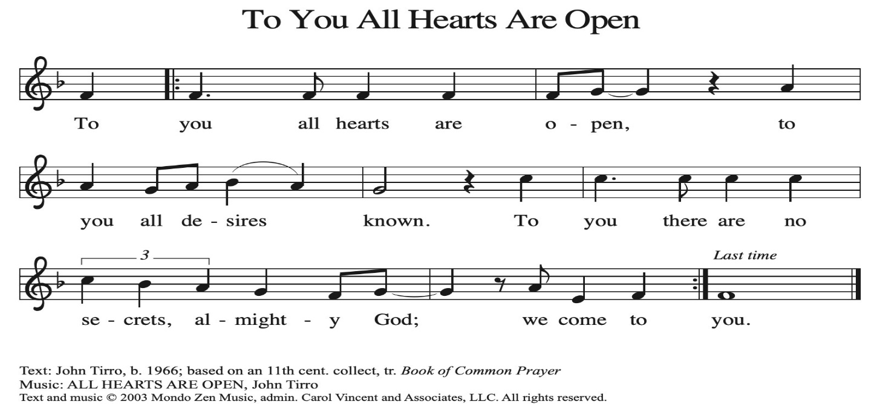
~ Proclamation of the WORD ~ (Scripture insert)
God speaks to us in scripture reading, preaching, and song.

Amos 1:1-2; 5:14-15, 21-24
SERMON Rev. Benjamin Morris

HYMN of the DAY ELW (red hymnal) #723 Canticle of the Turning

APOSTLES’ CREED ELW (red hymnal) Page 105

BLESSING OF THE QUILTS

PRAYERS of INTERCESSION
Petitions end: Hear us O God…your mercy is great.

PASSING OF THE PEACE
Please be aware of those who may not be comfortable shaking hands. You may also share the peace sign. Or any other contactless gesture that you are comfortable with.

OFFERING & SOLO Mary Schultz
OFFERTORY ELW (red hymnal) #186 Create in Me a Clean Heart, O Lord
OFFERTORY PRAYER
God of healing and hope, you bless those who are hungry, promising to fill them with good things. Fulfill that promise through us and these your gifts.
Nourish us with the abundance of your feast and unite us into the blessed body of Jesus Christ our Savior, now and forever. Amen.

THE GREAT THANKSGIVING (Spoken)
The Lord be with you. And also with you.
Lift up your hearts. We lift them to the Lord.
Let us give thanks to the Lord our God.
It is right to give him thanks and praise.

THE LORD’S PRAYER

COMMUNION & SOLO Mary Schultz

POST-COMMUNION PRAYER
God of field and flower, wheat and grape, you have nourished us with the bread of heaven that gives life to the world. Strengthened by the body and blood of your Son, send us out to gather your good gifts for all who hunger and thirst, and embolden us to love and serve in Christ’s name. Amen.

~ SENDING ~
God blesses us and sends us in mission to the world
BLESSING
The love of God the Sovereign strengthen you, God the Son save you,
and God the Holy Spirit anoint you for the work ahead. The holy Trinity bless you ☩
and grant you a faithful and courageous heart now and forever. Amen.

BELLS
SENDING HYMN ELW (red hymnal) #756 Eternal Father, Strong to Save

DISMISSAL
Go in peace. Share the harvest.
Thanks be to God.

POSTLUDE Mary Schultz
Reprinted / podcast / streamed with permission under ONE LICENSE #A-738444. All rights reserved.

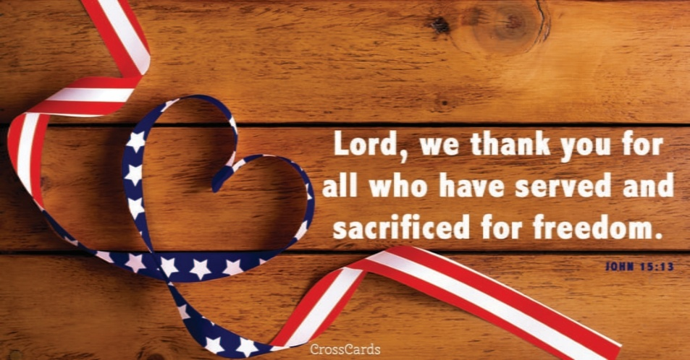
COON VALLEY LUTHERAN CHURCH
The Season of Pentecost
Veteran’s Day & Quilt Blessing
NOVEMBER 9, 2025

Coffee Servers: Kim Cade, Mary Bakkum
Usher: Phil Moilien
Altar Guild: Jane Simmons, Karen McGarvey
Communion Servers: Amy Stakston-Wiedemann, Julie Nelson
Reader: Glen Hoff
Attendance & Offering Last Sunday: 121; $4,140.42
Sunday School Attendance: 10


Scan this code with your phone to contribute electronically with Vanco.

SCHEDULE
TODAY: 10:00a/New Member Meeting
TUESDAY: 5:00p/Worship Committee
WEDNESDAY: 9:00a/Quilting
THURSDAY: 10:00a/Bible Study
FRIDAY: Pastor Ben’s sabbath; Carillon Deadline
NEXT SUNDAY: 9:00a/Worship; 10:00a/Sunday School, Coffee Fellowship, Retro Dinner Meeting
Coon Valley Lutheran Church
www.coonvalleylutheranchurch.org
Pastor: Rev. Benjamin Morris, Office 452-3772/Cell 608-406-1556, pastor@coonvalleylutheranchurch.org
Office Administrator: Jamie Thomas, office@coonvalleylutheranchurch.org
Office Hours: Tuesday, Wednesday 9:00a-4:00p; Thursday 9:00a-3:30p
Office 452-3772/Cell 317-0007
Treasurer: Becky Lusk, treasurer@coonvalleylutheranchurch.org
Organist: Mary Schultz
Indoor Custodian: Tracy Stellner

~Remember "Thumbs Up" When you come up for communion if you would like a gluten free wafer, give the pastor a thumbs up as you approach. As you approach the wine server, give him or her a thumbs up to receive grape juice instead of wine.

Amos 1:1-2; 5:14-15, 21-24
1 The words of Amos, who was among the shepherds of Tekoa, which he saw concerning Israel in the days of King Uzziah of Judah and in the days of King Jeroboam son of Joash of Israel, two years before the earthquake.
² And he said:
The Lord roars from Zion
and utters his voice from Jerusalem;
the pastures of the shepherds wither,
and the top of Carmel dries up.
¹⁴ Seek good and not evil,
that you may live,
and so the Lord, the God of hosts, will be with you,
just as you have said.
¹⁵ Hate evil and love good,
and establish justice in the gate;
it may be that the Lord, the God of hosts,
will be gracious to the remnant of Joseph.

²¹ I hate, I despise your festivals,
and I take no delight in your solemn assemblies.
²² Even though you offer me your burnt offerings and grain offerings,
I will not accept them,
and the offerings of well-being of your fatted animals
I will not look upon.
²³ Take away from me the noise of your songs;
I will not listen to the melody of your harps.
²⁴ But let justice roll down like water
and righteousness like an ever-flowing stream.

Word of God. Word of Life. Thanks be to God.

*We are always happy to include you and our CVLC family in our prayers. If you feel your name, or the name of a family member can be added or removed from this list please contact Jamie. Thank you!

We remember in prayer:
† Those hospitalized this past week: Mike Kellogg
† Our members whose names we lift up in prayer today: Corrine Appleman, Beverly Bagstad, Clifford Bakkum, Pastor Barbara Bruneau, Herby Cornell, Marie Egge, Gloria Galstad, Kira Hoff, Becky Ihle, Donna Ihle, Ray Ihle, Eddie Kanieski, Todd King, Mike Kellogg, Margaret Lee, Russell Lee, Aaron Leisso, Aaron Marx, LuEtta Nelson, Romaine Nelson, Lisa Olson, Sandra Onshus, Elaine Proksch, Eunice Quast, Lori Roach, Jojo Satona, Heidi Saupe, Bob Schulze, Mary Schultz, LaVonne Stendahl, Krin (Dreves) Stendalen, Joyce Temp, Teri Tomten, Dave Verse, Jan Verse, Renita Williamson
† Our members who are currently in health care facilities & Assisted Living:
Tip Bagstad, Rachel Berg, Carl Daffinrud, Jeanne Ebli, Carl Holte, Bob Moilien, Geri Nestingen, Irene Nestingen, Cathy Ofte, Annie Olson, Beatrice Olson (Alden),
Ellen Runice, Orrin Stakston.
† Those who grieve: Family and friends of Pauline Moilien, Evelyn Dahlen, Betty Williamson & Lenore Henley.
† Our members who are currently home bound
† All those in need of God’s healing and help
† Family and friends of our members
† Local Military: Alex Hendrickson

