| The Carillon | |
| --- | --- |
| Page 1 | September, 2021 |

Dear Siblings in Christ,

As I watched the water rise in Coon Valley and surrounding areas this past Saturday, my heart ached with yours. The ballpark had just this Summer become a central gathering place once again for fun, families and sportsmanship. The Park had once again become green and basements had just been redone. The rain was falling too fast, too soon.

And then, there were community members filling sandbags to protect the American Legion, neighbors calling neighbors, family members taking loved ones to higher ground, and through it all—so many prayers ascending.

There are floods of water and then there are floods of another kind. What I will remember about last Saturday’s flood are neighbors helping neighbors, our friends at Middle Coon Valley who partnered with us to have Vacation Bible School. I will remember the dozens and dozens of donated ears of corn from Traastad Produce, saved for the corn roast by being planted on a hillside in the valley. I will remember members of our congregation making last-minute decisions about whether the weather would cooperate to allow us to gather for what was a delicious meal served with heaping amounts of care and love for our neighbor.

Floods…In our July Council meeting minutes which are included in this month’s Carillon, you will notice that our Council had the opportunity to vote on recommendations from our Endowment Committee. The Endowment is one of the gifts that allows us to be financially generous beyond ourselves all year through. One of the recipients of a gift from our Endowment this year is Lucy Hardie, our Seminarian who will begin her Senior Year at Wartburg Seminary in September. Lucy will be Ordained as a Pastor in the ELCA next Summer most likely and her Ordination will be held at our Church.

We know from experience that love and care will bring the ballpark and basements back into shape. We know by the promise of Christ that a new day will prevail. Thank you for being the Church and bearing witness to the abundant grace of God, poured out upon us through the flood waters of Baptism.

With my gratitude and prayers for you,

Pastor Julie

**[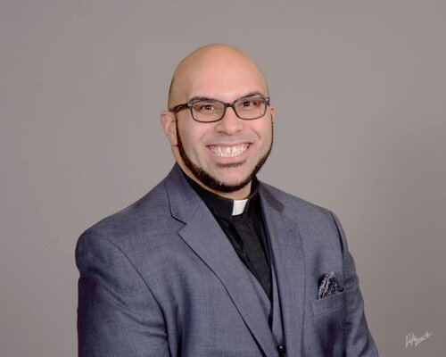](https://lacrosseareasynod.org/events/bishop-installation-service)Welcome, Bishop-Elect Malpica!**

Bishop-Elect Felix Malpica will be Installed as the next Bishop of the La Crosse Area Synod of the ELCA on Sunday, September 26 at 4:00 p.m. with ELCA Bishop Elizabeth Eaton Presiding over the Installation.

The service of Installation will be livestreamed for all on the La Crosse Area Synod website: <http://www.lacrosseareasynod.org>.

MCj03226430000[1]JULY CHURCH COUNCIL HIGHLIGHTS

The CVLC Council met on July 15th at 6:00 p.m.

*Treasurer’s Report: was presented by Nancy King. Report accepted.

*Ministry Minutes: Pastor Julie completed a Pandemic Pondering Exercise with the Council and members shared their responses.

*Education: Amanda reported that the committee is planning Sunday School to start on Sept. 12. Sunday School will take place from 9-10am. 3yr olds-3rd grade will be team taught. The 4th-5th graders will be taught by Maggie Traastad and the 6th graders will be taught by Mike Lusk. A Facebook group will be created for parents. The Christmas Program is planned for Dec. 19th. Bella Grethel will be playing piano for the younger grades.

*High School Youth: A meeting for parents will be on Aug. 1st after church for those interested in the National Youth Gathering.

*Men’s Club: Glen reported that the Cookout went well and the event broke even. The group decided not to have the event on Father’s Day again.

*Property and Grounds: Brian S. reported that a plumber was hired to go through the pipe with a camera. The plumber suggested fixing the pipe from the street to the sidewalk when County Rd. P is redone. This road repair is scheduled for July-August of 2022. Brian is working on fixing the rain runoff issue in the boiler room with cement. There was discussion of painting the Sunday School hallway downstairs.

*Worship: Nancy presented recommendations from the Worship Committee for COVID protocols. A motion was passed to approve new protocols. (These protocols were published in the August 2021 Carillon).

*Endowment Committee: The Committee met to review the annual distribution from the Endowment Fund. The principal amount in the fund is $208,898 with $19,764.83 of interest available. The Committee recommended distributing $8,000 at this time. The following recommendation was approved by the Council: Capital Improvements-$3,200 for the parking lot fund; Youth Ministry allocation-$400 Life Group and $1200 for the 2022 National Youth Gathering; Ministry of the ELCA allocation-$1600 ELCA benevolence payment; Community Outreach allocation-$500 to Shepherd Fund, $500 Westby School District delinquent lunch accounts, $600 Coon Valley Fire Department.

*Next Council Meeting will be August 12th at 6:00pm.

MCj02119730000[1]

The meeting adjourned at 7:30pm followed by the Lord’s Prayer.

Sarah Ofte,

Council Secretary

SUGAR CREEK BIBLE CAMP

**Annual Quilt Auction, 5k Fun Run/Trail Walk & Craft Fair**

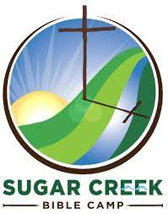**September 11 @ 8:00am - 2:00pm**

* [**« Drugan’s Golf Outing**](http://wp.sugarcreekbiblecamp.org/?tribe_events=dragons-gold-outing)

**50 Year Celebration Service »**Come to Sugar Creek for great food, delightful fellowship and a fabulous auction! You never know what treasure you might find at a Sugar Creek Auction: sports memorabilia, furniture, antiques, crafts, rummage items, and of course, *beautiful quilts*! **Come early for our trail run/walk 5k and enjoy exploring the beautiful trails that run through our valley! This year we will also host a Crafters’ Fair featuring the finest of our local artisans. This day is our biggest fundraiser of the year:** your support allows Sugar Creek to continue their valuable ministry! **Auction starts at 10 a.m.** We hope to see you here!

SUNDAY SCHOOL TO BEGIN SEPTEMBER 12th AT 9:00am!

The Education Committee and the Sunday School teachers have been working on the plan for our return to in-person Sunday School in September.  We had lots of good suggestions and ideas and some very thoughtful discussions.  We have made some slight adjustments for Sunday School this year.  We wanted to provide detailed information for you as we get closer to starting Sunday School:

* Sunday School will begin on Sunday, September 12th with Rally Sunday – all the kids will be together to introduce them back to in-person Sunday School, sing some songs and provide treats.  We will then break into class groups to help them become familiar with their new class structure.
* Sunday school with be held from 9:00am to 10:00am –NOTE!  this is a change in time from previous years.
* At this time, we will ask that students and teachers wear masks to protect our children as they are not yet eligible for the vaccine. Going forward, Sunday School will work with Church Council and monitor the requirements of Westby School District. We will adjust as needed or warranted.
* 3-year-olds to 3rd graders will be together in one class that will be held in the open area downstairs outside the Sunday School rooms.  The teachers will use a team teacher approach to teach, much like what was being done this past spring.  Teachers are:  Sarah Leisso, Sara Lieurance, Kari Coaty, Amy Stakston-Wiedemann, Renita Williamson, Mel Marsh and Nancy Rogers.
* 4th and 5th graders will be in a class together that will be held in the youth room.  Teacher will be Maggie Traastad.
* 6th graders will be upstairs in the library/sanctuary/classroom.  Teacher will be Mike Lusk.
* We have created a CVLC Sunday School Facebook page to help communicate Sunday School information with parents and members.
* We are going to ask parents to complete a Release Form for their child(ren) for taking pictures to post on Facebook.  This will go in the Carillon.
* We tentatively scheduled the Sunday School Christmas program for Sunday, December 19th

We are looking forward to being able to be able to return to Sunday School. If you have any questions for concerns, please reach out to me or Pastor Julie.

Thank you,

Maggie Traastad

Sunday School Coordinator



BLOOD DRIVE

Our blood drive on August 23rd collected 46 units of blood for the American Red Cross! A huge thank you to the volunteers that helped. Pam Olson, Suzanne Strangstalien, Carl Holte, Paul Bahr, Mark Hutson and Bruce Olson. Thank you also to Kwik Trip for the donation of milk and to Thrivent for their contribution.

A big thank you also to Mike Lusk for organizing the blood drive!

7th and 8th GRADE CONFIRMATION ORIENTATION SEPTEMBER 12!

An orientation to Confirmation for all students entering Grades 7 and 8 in September will be held at 9:15 a.m. Sunday, September 12! We will meet in the upstairs Lounge/Library. One Adult member of each household is requested to attend with their student(s). If you are not able to attend the meeting, please contact Pastor Julie so you are sure to receive the information. Confirmation will begin Wednesday, September 15 at 5:00 p.m.!

If you are entering Grade 7 or 8 and did not receive a letter about Confirmation from Pastor Julie, please contact her before September 12. Thank you!



AFFIRMATION OF BAPTISM (CONFIRMATION) SERVICE: 10:30 a.m. SEPTEMBER 26!

We will be celebrating the Affirmation of Baptism of these 9th Grade students in worship on Sunday, September 26: Kaden Michael Gartner, Gavin David Larson, William Matthew Leisso, Mackenzie Alexa Morey and Livvy Lee Nelson!

Students and parents have been invited to be guests of a special banquet which will be held on Wednesday, September 22, at 6:00 p.m. in our Fellowship Hall!

A Confirmation service rehearsal will take place after school and before the Banquet on September 22. Students, please plan to come to Church on the bus after school. A snack will be served prior to rehearsal.

Students and parents, please let Pastor Julie know right away if you are not able to attend the rehearsal or meal on September 22 and also, please make sure to send Pastor Julie the Bible verse(s) you have chosen.

CALLING ALL 8TH -12TH GRADE STUDENTS! OUR NEXT NATIONAL YOUTH GATHERING MEETING WILL BE **SEPTEMBER 19 AT 9:15 A.M.!**

JOIN YOUR FRIENDS FOR THE NATIONAL YOUTH GATHERING, JULY 24-28. 2022 IN MINNEAPOLIS, MN. IT WILL BE AN EVENT YOU WILL NOT WANT TO MISS!!

The ELCA's National Youth Gathering takes place every three years in a city around the U.S. The next Youth Gathering is scheduled to take place in Minneapolis, MN, July 24-28, 2022! The Youth Gathering is a transformational experience of fun, inspiring worship, music, speakers and service in our host city!

Information that was distributed at our August 1st meeting has been sent to all 8th through 12th Grade families via email. **Our first deposit of $75.00 is due September 10**. We do not wish for cost to prohibit anyone from attending the Gathering. Please see Pastor Julie for information regarding confidential scholarships.

**Where can I find more information? Come to the September 19 meeting, contact Pastor Julie, or visit the Youth Gathering website:** [www.elca.org/YouthGathering](http://www.elca.org/YouthGathering)

CVLCIS SEEKING A VOLUNTEER CHOIR DIRECTOR

Please note this opportunity to lead wonderful people in making a joyful noise! For more information or to indicate interest, please contact Karen Rude, Chair of the Personnel and Worship Committee or Pastor Julie.

**Job Description Volunteer Choir Director**

Reports to Pastor and Worship Committee

1. **General Summary of Position**

The Volunteer choir director is responsible for directing the Senior Choir and providing the worship service and special services with appropriate musical selections.

1. **Required Skills and/or Experience**
2. Experience in choral directing in a small congregation preferred.
3. Knowledge of appropriate church music
4. Provide good interpersonal and organizational skills
5. **Major Duties and Responsibilities**
6. Rehearse the Senior Choir weekly September – May.
7. Choose appropriate choral music for weekly worship services and special services.
8. Work cooperatively with Organist, Pastor and Worship Committee in selection of choir anthems.
9. Be an active member of the Worship Committee.
10. Actively recruit new members to the Senior Choir, respect singer’s abilities and know how to communicate with them.
11. Purchase and maintain all music and music supplies for the choir, limiting expenditures to amount specified in the church budget.
12. **Hours**

Weekly rehearsals and performances.



FELLOWSHIP HALL CEILING REPLACEMENT

Thank you to all who showed up on Saturday, July 31 to help with the replacement of ceiling tiles in the fellowship Hall! Monte Nelson, Carl Holte, Steve Nelson, Karen Bergum, Jay Strangstalien, Brian Strangstalien, Cody Strangstalien, Riley Strangstalien, Ray Williamson, Bruce King and Nancy King.

SUNDAY SCHOOL PAINTING

A big thank you to Mike, Tom and Todd Brye for volunteering their time to paint the Sunday School hallway. They painted the dark panel walls a beautiful beige color. Next time you see the Brye’s thank them for their generous donation of time!

GIVING OPPORTUNITIES

There are several different funds that you may wish to give to for memorials or just general giving.

**GENERAL FUND**- Church operating expenses.

**BUILDING FUND** -Building and grounds projects, currently includes the Parking Lot Fund.

**MEMORIAL FUND**-Used for the life and ministry of the church as determined by Council.

**SHEPHERD FUND**-Funds for church & community members in need.

**CEMETERY**-Maintenance of the grounds.

**WELCA**-Woman of the ELCA includes Quilting and Kitchen funds.

**SUNDAY SCHOOL**-Teaching materials

**PRAYER SHAWL MINISTRY**-Supplies for the making of prayer shawls and prayer squares.

**YOUTH FUND**-Funds to pay for Mission Trips

**ENDOWMENT**-Only interest income may be used for community outreach, missions of ELCA, Capital Improvements.

**RUDIE BIBLE FUND**-Supply Bible’s to youth

CORN ROAST 2021

Thank you to all who contributed to the Corn Roast on August 10th!  Even though we had to hold it indoors due to the threat of rain, it was a great success!

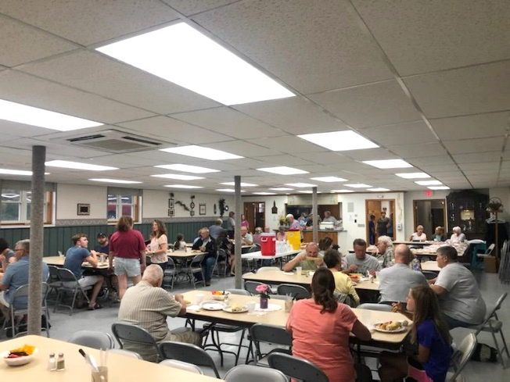

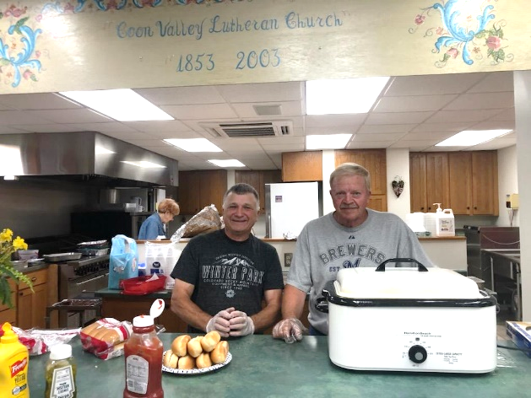

Pat Cade and Dennis Olson serving hot dogs!

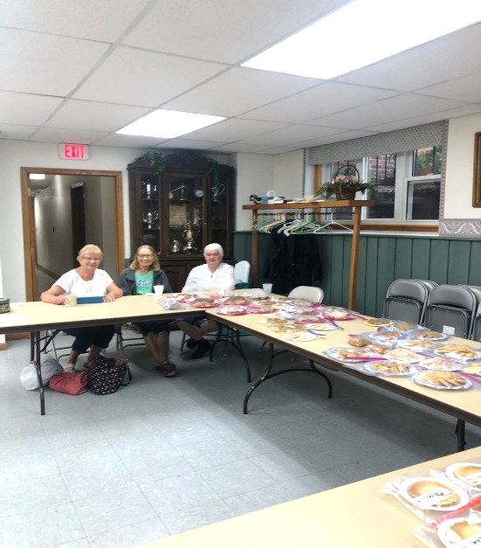

Jean Gronvold, Corrine Nelson, LuEtta Nelson selling baked goods for the WELCA bake sale.

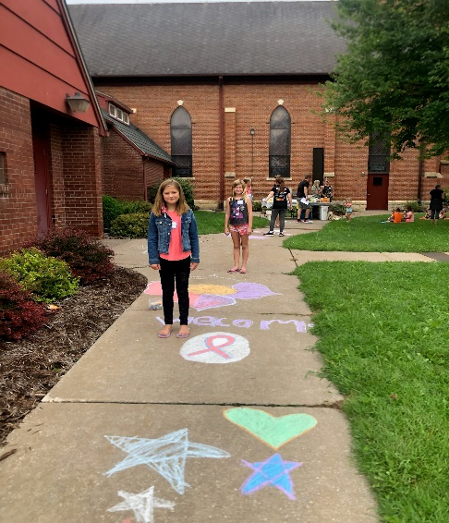VACATION BIBLE SCHOOL

VBS was held on August 8th, 9th & 10th in partnership with Middle Coon Valley Lutheran Church. We had 15 youth attend! Children learned Bible stories, created a craft, sang and played games. Thank you to Pastor Julie, Pastor Meg and Lori Nestingen and many parent volunteers for organizing VBS!

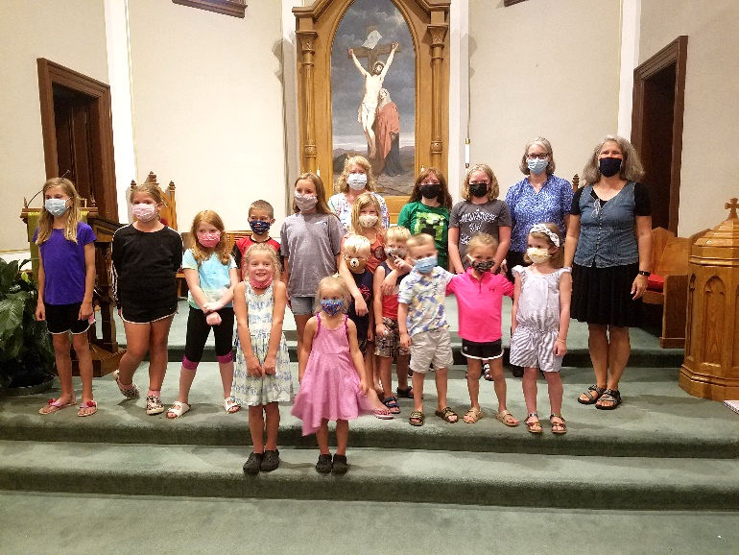

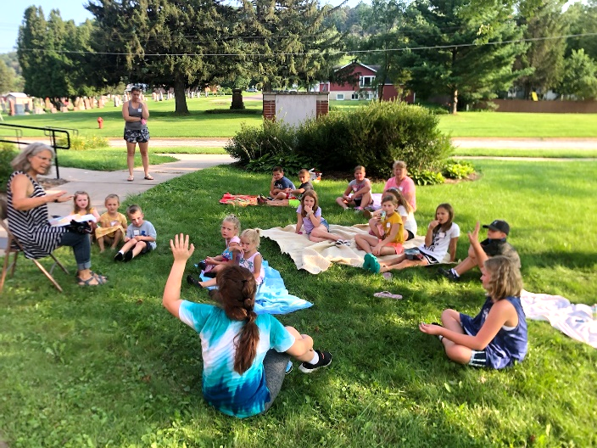

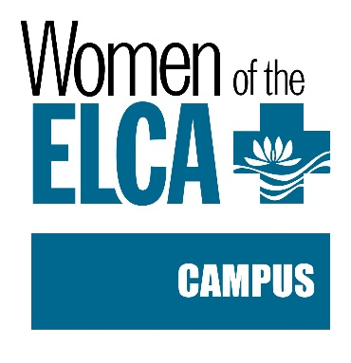WELCA NEWS

You can’t keep a busy woman down! That is our earnest prayer for our dear president, Ellie Brye. We hope you will be back on your feet in a very quick manner! Our August 19th meeting was led by the Elizabeth Circle. Cindy Manske gave devotions. Karen McGarvey introduced their guest speaker Karen Bernau, our Coon Valley librarian. She shared with us all the wonderful opportunities the library has to offer. Please stop in and partake of some of them as we are so fortunate to have this in our community. We sang “I Love To Tell The Story.”

Servers for the day were Jan Verse and Nancy Rogers.

Paying hostesses were Stephanie Marshall, Becky Lusk, Cindy Gartner, Kay Bjornstad and Judy Stakston.

Big thank you for all the wonderful baked goods that you so generously brought for the bake sale at the Corn Roast, so appreciated!

We look forward to our meeting on September 16th. We will be honoring our quilters, the prayer shawl group and prayer chain ministry.

The Quilters are in dire need of new flat queen size sheets for the backing on their quilts. If you would like to purchase one for them it is truly a wonderful gift.

Servers for September are Pauline Moilien and Joyce Temp.

Paying hostesses are: Doris Martin, Geri Leum, Cheryl Morgan, Janine Morey and Barbara Williams.

As summer draws to an end and fall is upon us won’t you please come join us? This is for “ALL” the women of the church. We need some young women to join us! We would love to have you participate and see our group grow.

DATES TO REMEMBER

Thursday, September 16th WELCA at 1:30 pm

Wednesday, September 22nd Confirmation Banquet 6:00 pm

Wednesday, September 29th Chili & Chicken Soup Supper 4:00-7:00 pm raffle tickets will soon be ready to purchase for some lovely prizes. Thank you to Inez Beck for her donation of the raffle tickets!

Friday, October 1st is the deadline to bring school supplies.

God’s Blessings to you all,

Nancy Rogers

Vice President

WELCA CHILI & CHICKEN SOUP SUPPER and RAFFLE: Wednesday, Sept. 29 ~ 4:00-7:00 PM

It’s back for 2021! Come join us whether you like it “hot’” or prefer the soothing taste of chicken soup, you will want to attend the WELCA supper & raffle, on the 29th. Everyone is welcome. Cost is $8.00 for adults, $4.00 for children 6-12 and children 5 and under are free. Watch for a chance to buy raffle tickets!



**ATTENDANCE & OFFERING**

|  |  |  |  |
| --- | --- | --- | --- |
| **2021** | **July** |  | **2021 YTD** |
| **Total Offerings** | $13,844.47 |  | $106,372.47 |
| **Expenses** | $16,781.80 |  | $110,951.86 |
| **Balance/Shortfall** | **-$2,937.33** |  | **-$4,579.39** |
| **Parsonage Int. Fund Transfer** | $0 |  | $0 |
| **Building Fund Transfer** | $0 |  | $857.31 |
| **Memorial Fund**  **Transfer** | $0 |  | $0 |

**7/25 – 9a:** 92; **Offering:** $2,712.47

**8/1 – 9a:** 82; **Offering:** $3,200.88

**8/8 – 9a:** 36; **Offering:** $2,855.88

**8/15 – 9a:** 94; **Offering:** $3,785.88

**8/22 –9a:** 53; **Offering:** $2,598.88

**\*\***Approximately **$3,925.00 a week** is needed to meet operating expenses.

**General Fund Balance:** 7/31/21: $39,691.25

**Memorial Fund Balance:**7/31/21: $43,676.79

**Building Fund Balance:** 7/31/21: $40,207.56

**CD Interest Balance:** 7/31/21: $18,928.73

BAPTISM

**Jack Jeffrey Fencl**

MEMORIALS

**Alice Daughtridge**

Memorial Fund: $165.00

ONLINE GIVING

There are several ways you may get your offerings to the church. You may simply mail it to the church office, P.O. Box 280. Or use one of our eGiving options. 1) You may go to our website and click the Donate button at the top. 2) Give through the mobile app Give Plus. 3) Use our text-to-give option, simply text a dollar amount to 866-374-6997. Please let Jamie know if you need assistance in any way with these options. Thank you for your support!



Doing your shopping on **Amazon**? Please go to [www.smile.amazon.com](http://www.smile.amazon.com), enter ***Coon Valley Congregation*** do your shopping and **Amazon Smile** will donate a small percentage to our church!

**YEAR-TO-DATE BALANCE**

PRAYER GROUP

The Prayer Group continues to pray for the church, the congregation and our extended family and friends.

**† *Our church staff***

**† *Our members*:** Beverly Bagstad, Eleanor Bagstad, Tip Bagstad, Clifford Bakkum, Inez Beck, Kristin Boettcher, Ellie Brye, Jeanne Ebli, Rod Erlandson, Kira Foster, Lucy Hardie, Bonnie Holey, Becky Ihle, Jan Ihle, Verlin Ihle, Jim Knutson, Paul Kogut, Margaret Leen Russell Lee, Aaron Leisso, Larry Lichtie, Gerri Leum, Cindy Manske, Aaron Marx, Frank Mathison, Judy Mathison, Skyler Midtlien, Bud Miyamoto, Bobby Morin, Romaine Nelson, Sandy Nelson, Cathy Ofte, Lisa Olson, Eunice Quast, Jojo Satona, Mary Schultz, Billie Slater, Janaya Stakston, LaVonne Stendahl, Floyd Storey, Nancy Stuempges, Joyce Temp, Lanny Westphal.

**† *Our members who are currently in health care facilities*:** Rachel Berg, Evelyn Dahlen, Joanne Fletcher, Erma Graupe, Sylvester King Jr., Irene Larson, Glen Marshall, Irene Nestingen, Tim Ofte, Beatrice Olson (Alden), Beatrice Olson (Leonard), Edie Peterson, Betty Sanders.

**† *Those who grieve:*** Nancy Rogers and family in the death of her mother Lois Frahm; Family and friends of Jon Lee; Betty Jorgenson and family in the death of her mother Alice Daughtridge

**† *Family and friends of members***

**† *Local Military:***Austin Holen

**† *All those affected by the COVID-19 virus***

2021/22 REGISTRATION FORM

SUNDAY SCHOOL

“Where the Bible comes alive”

**WHEN:** Sunday School begins on RALLY SUNDAY Sept. 12

**TIME:**  9:00-10:00 AM

**WHO:** age 3 (on or before Sept. 1) through 6th grade

**COST:** There is no fee

NAME___________________________________ Grade____

NAME___________________________________ Grade____

NAME___________________________________ Grade____

ADDRESS________________________________

PHONE #_______________________

EMAIL ________________________

“I give my son/daughter permission to attend the COON VALLEY LUTHERAN CHURCH Sunday School program for the 2021/22 year.”

_____________________________________________

Signature of parent(s)

“I give Coon Valley Lutheran Church permission to share pictures of my son/daughter to the CVLC website, CVLC and CVLC Sunday School Facebook pages.

____________________ Parent Initials

Any special needs or concerns we should know about your children? (please list below):

**DAILY BIBLE READINGS**

**WEEK OF SEPTEMBER 5**

**SUNDAY** Isaiah 35:4-7a *God comes with healing*

Psalm 146 *Praising the LORD*

*or* Proverbs 22:1-2, 8-9, 22-23 *Sayings concerning a good name*

Psalm 125 *Trusting in God*

James 2:1-10 [11-13] 14-17 *Faith without works is dead*

Mark 7:24-37 *Christ heals a little girl and a deaf man*

**MONDAY** Joshua 6:1-21 *The Israelites conquer Jericho*

**TUESDAY** Joshua 8:1-22 *The Israelites conquer Ai*

**WEDNESDAY** Matthew 17:14-21 *Healing by faith*

**THURSDAY** Judges 15:9-20 *Samson slays the Philistines*

**FRIDAY** Hebrews 11:29—12:2 *The heroes of faith*

**SATURDAY** Isaiah 38:10-20 *Prayer for health*

**WEEK OF SEPTEMBER 12**

**SUNDAY** Isaiah 50:4-9a *The servant is vindicated by God*

Psalm 116:1-9 *I will walk in God’s presence*

*or* Proverbs 1:20-33 *Wisdom’s rebuke to the foolish*

Psalm 19 *The law is just and rejoices the heart*

*Or* Wisdom 7:26—8:1 *The one who lives with wisdom*

James 3:1-12 *Dangers of the unbridled tongue*

Mark 8:27-38 *Peter’s confession of faith*

**MONDAY** 1 Kings 13:1-10 *Obeying the word of God*

**TUESDAY** 1 Kings 13:11-25 *Disobeying the word of God*

**WEDNESDAY** John 7:25-36 *Jesus the Messiah*

**THURSDAY** Isaiah 10:12-20 *Evil will be destroyed*

**FRIDAY** James 2:17-26 *The works of faith*

**SATURDAY** Psalm 119:169-176 *God’s law my delight*

**WEEK OF SEPTEMBER 19**

**SUNDAY** Jeremiah 11:18-20 *The prophet is like a lamb*

*Or* Wisdom 1:16-2:1, 12-22 *The righteous shall live*

Psalm 54 *God is my helper*

*Or* Proverbs 31:10-31 *The capable wife*

Psalm 1 *Delight in God’s law*

James 3:13—4:3, 7-8a *The wisdom from above*

Mark 9:30-37 *Prediction of the passion*

**MONDAY** 2 Kings 5:1-13 *The girl servant saves her master*

**TUESDAY** 2 Kings 11:21—12:16 *The boy king repairs the temple*

**WEDNESDAY** John 8:21-38 *Being disciples of Jesus*

**THURSDAY** Jeremiah 1:4-10 *God calls Jeremiah while in the womb*

**FRIDAY** James 4:8—5:6 *Draw near to God*

**SATURDAY** Psalm 139:1-18 *God formed me in my mother’s womb*

**WEEK OF SEPTEMBER 26**

**SUNDAY** Numbers 11:4-6, 10-16, 24-29 *The spirit upon seventy elders*

Psalm 19:7-14 *The law gives light*

*or* Esther 7:1-6, 9-10; 9:20-22 *Esther’s intercession*

Psalm 124 *We have escaped like a bird*

James 5:13-20 *Prayer and anointing in the community*

Mark 9:38-50 *Warnings to those who obstruct faith*

**MONDAY** Exodus 18:13-27 *Moses appoints judges to keep peace*

**TUESDAY** Deuteronomy 1:1-18 *Moses charges the judges*

**WEDNESDAY** Matthew 5:13-20 *You are salt and light*

**THURSDAY** Zechariah 10:1-12 *God will gather the people*

**FRIDAY** Acts 4:13-31 *The believers pray for boldness*

**SATURDAY** Psalm 5 *Lead me in righteousness*



**Moving? New contact information? Please update the church office.**

**Thank you!**

Please use our correct mailing address when sending us mail.

P.O. Box 280

Thank you!

Visit our website: coonvalleylutheranchurch.org to sign-up to receive our newsletter via email!

**THE CARILLON**

VOL. 50 September, 2021 No. 9

Coon Valley Lutheran Church, ELCA 1005 Central Avenue, P.O. Box 280

Coon Valley, WI 54623

Office Phone (608)452-3772

www.coonvalleylutheranchurch.org

Pastor: Rev. Julie Wollman, [pastorjulie@mwt.net](mailto:pastorjulie@mwt.net), Home phone 634-3797

Office Administrator: Jamie Thomas, [jamiel@mwt.net](mailto:jamiel@mwt.net), Cell Phone: 608-317-0007

Office Hours: Tuesday 9am-2:30pm; Wednesday & Thursday 9am-4pm

Treasurer: Becky Lusk, [treasurer1005@mwt.net](mailto:treasurer1005@mwt.net)

Organist: Mary Schultz

Indoor Custodian: Tracy Stellner

Choir Director:

Church Council President: Nancy King

Vice President: Ray Williamson; Secretary: Sarah Ofte

Amanda Buros, Glen Hoff, Debbie Holen, Carl Holte,

Andrea Stakston, Brian Strangstalien

**Worship Schedule Sunday 9:00 am (5th)**

**8:00 & 10:30 am (12th, 19th, 26th)**

**Sunday School 9:00 am (12th, 19th, 26th)**

|  |  |  |  |  |  |  |
| --- | --- | --- | --- | --- | --- | --- |
| September 2021 | | | | | | |
| **Sunday** | **Monday** | **Tuesday** | **Wednesday** | **Thursday** | **Friday** | **Saturday** |
| Three Sunflowers Clipart Free PNG Image｜Illustoon |  |  | **1** | **2**  **7:00p-**Rebecca Circle | **3** | **4** |
| **5**  **9:00a-** Worship with Holy Communion | **6**  **Labor Day- Office closed**  Pr. Julie’s Sabbath | **7** | **8**  **9:00a-**Quilting | **9** | **10**  **Youth Gathering deposit due!** | **11**  **9a-2:00p**  Sugar Creek Quilt & Antique Auction  **1:00p-**Funeral |
| **12**  **8:00 & 10:30a-**Worship with Holy Communion  **9:00a-**Sunday School Rally Day  **9:15a-**Confimation Orientation | **13**  Pr. Julie’s Sabbath  **6:00p-**Finance Committee | **14**  **5:30p-**Worship Committee | **15**  **5:00p-**Confirmation  **Carillon Deadline** | **16**  **1:30p-**WELCA  **6:00p**-Church  Council | **17**  Wedding Rehearsal | **18**  Johnson/McCutcheon Wedding |
| **19**  **8:00 & 10:30a-**Worship  **9:15a-**Youth Gathering Meeting | **20**  Pr. Julie’s Sabbath | **21** | **22**  **3:45-**Confirmation rehearsal (9th Graders)  **6:00p-**Confirmation Banquet | **23** | **24** | **25**  **11a-**Chaseburg Sole Burner |
| **26**  **8:00 & 10:30a-**Worship; 9th Grade Confirmation at 10:30  **9:00a-**Sunday School  **4:00p­-**Bishop Malpica’s Installation-available via livestream | **27**  Pr. Julie’s Sabbath | **28** | **29**  **4:00-7:00p-**Chili & Chicken Soup Supper & Raffle | **30** |  | Back To School Clipart February - Clip Art Teacher Apple , Free ... |