COON VALLEY LUTHERAN CHURCH
“We are a family of God, striving to enrich
the lives of all through the love of Christ.”
PRELUDE MUSIC
BELLS
WELCOME and ANNOUNCEMENTS

CONFESSION & FORGIVENESS
Blessed be the holy Trinity, ☩ one God, who forgives all our sin, whose mercy endures forever.
Amen.
Let us confess our sin before God, who removes our guilt and blots out all offenses.
Silence is kept for reflection.
Gracious God,
have mercy on us according to your steadfast love.
For seeking worldly delights that deceive us and dishonor you:
Gracious God,
have mercy on us according to your steadfast love.
For desiring self-reliance instead of hungering for your word:
Gracious God,
have mercy on us according to your steadfast love.
For failing to recognize your coming reign,
and for hindering the work of the Spirit: Gracious God,
have mercy on us according to your steadfast love.
For drawing from the well of self-serving ambition,
and for disdaining the living water Christ offers: Gracious God,
have mercy on us according to your steadfast love.
For disregarding voices from the margin,
and for distrusting signs of your healing and hope in the world:
Gracious God,
have mercy on us according to your steadfast love.
For dwelling in tombs of self-pity and discontent,
and for disregarding Christ’s call to come forth to life:
Gracious God,
have mercy on us according to your steadfast love.
God’s steadfast love, grace, and forgiveness abound.
Through faith, the free gift of God,
you have been clothed in the righteousness of Christ.
In the name of ☩ Jesus Christ, your sins are forgiven.
The Spirit of the One who raised Christ from the dead
dwells in you,
pours God’s love into your hearts,
and gives you life and peace.
Amen.
GATHERING HYMN ELW (red hymnal) #556 Morning Has Broken
PRAYER OF THE DAY
Holy God, we, like Peter, often turn our backs on you. Forgive us and show us a new way to live, walking boldly and passionately toward you. Amen.
GREET THE WORD- ACS (purple hymnal) #976 Sung 1 time
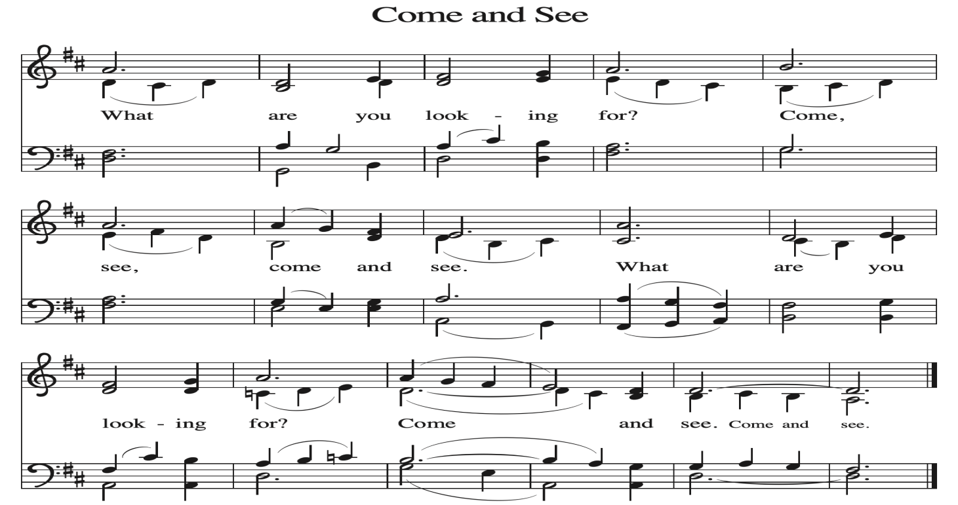
~ Proclamation of the WORD ~ (Scripture insert)
God speaks to us in scripture reading, preaching, and song.

GOSPEL READING: JOHN 18: 12-27
The Gospel of the Lord. Praise to you, O Christ.

SERMON Rev. Benjamin Morris

HYMN of the DAY ELW (red hymnal) #338 Beneath the Cross of Jesus

APOSTLES’ CREED ELW (red hymnal) Page 10

PRAYERS of INTERCESSION
Petitions end: Hear us, O God....Your mercy is great.

PASSING OF THE PEACE
Please be aware of those who may not be comfortable shaking hands. You may also share the peace sign or any other contactless gesture that you are comfortable with.

OFFERING & SOLO
OFFERTORY ELW (red hymnal) #186 Create in Me a Clean Heart, O Lord

OFFERTORY PRAYER
O God, maker of heaven and earth, your steadfast love embraces all creation. You send rain and sunshine to nourish the earth and bring forth its bounty.
Through these gifts of bread and wine, draw us into the death and life of your Son, who calls us to bear witness to his saving work. We ask this in Jesus’ name. Amen.

THANKSGIVING FOR THE WORD
O God of justice and love, we give thanks to you that you illumine our way through life with the words of your Son. Give us the light we need, awaken us to the needs of others, and at the end bring all the world to your feast; through Jesus Christ, our Savior and Lord, to whom, with you and the Holy Spirit, be honor and glory forever. Amen.

THE LORD’S PRAYER

~ SENDING ~
God blesses us and sends us in mission to the world
BLESSING
Receive the blessing of the holy Trinity: God, who calls all things into existence, Jesus Christ, who redeems us, and the Holy Spirit, whose breath sustains creation, ☩ bless you now and always. Amen.

BELLS
SENDING HYMN ELW (red hymnal) #536 God Be with You Till We Meet Again

DISMISSAL
Go in peace. Believe the good news. Thanks be to God.

POSTLUDE

Reprinted / podcast / streamed with permission under ONE LICENSE #A-738444. All rights reserved



COON VALLEY LUTHERAN CHURCH
Sunday, March 15, 2026
Fourth Sunday in Lent

~Bulletins are in honor of the 9th birthday of Karly Thomas!

Piano/Organ: Aaron Stakston
Usher: Phil Moilien
Reader: Kelly Strangstalien
Attendance & Offering Last Sunday: 9:00a/cancelled; $1,576.06
Sunday School Attendance Last Sunday: cancelled
Attendance & Offering Wednesday March 11: 7pm/43; $402.00

Scan this code with your phone to contribute electronically with Vanco.

SCHEDULE
TODAY: 8:00a/Social Ministry Committee; 10am/Retro Committee;
4:00p/ Interfaith Peace & Prayer Service @ Mary of the Angels Chapel-La Crosse
TUESDAY: 9:00a-Noon/Pastor’s text study
WEDNESDAY: 9:00a/Quilting; 4:30-6:30p/Men’s Club Fish Fry; 7:00p/Lenten Worship
THURSDAY: 10:00a/Bible Study
FRIDAY: Pastor Ben’s sabbath
NEXT SUNDAY: 9:00a/Palm Sunday Worship; Sunday School Sings; 10:15a/Sunday School, Coffee Fellowship
Coon Valley Lutheran Church
www.coonvalleylutheranchurch.org
Pastor: Rev. Benjamin Morris, Office 452-3772/Cell 608-406-1556, pastor@coonvalleylutheranchurch.org
Office Administrator: Jamie Thomas, office@coonvalleylutheranchurch.org
Office Hours: Tuesday & Wednesday 9:00-4:00p; Thursday 9:00a-3:30p
Office 452-3772/Cell 317-0007
Treasurer: Becky Lusk, treasurer@coonvalleylutheranchurch.org
Organist:
Indoor Custodian: Tracy Stellner

Remember "Thumbs Up" When you come up for communion if you would like a gluten free wafer, give the wafer server a thumbs up as you approach. As you approach the wine server, give him or her a thumbs up to receive grape juice instead of wine.

GOSPEL: John 18:12-27
¹² So the soldiers, their officer, and the Jewish police arrested Jesus and bound him.
¹³ First they took him to Annas, who was the father-in-law of Caiaphas, the high priest that year.
¹⁴ Caiaphas was the one who had advised the Jews that it was better to have one person die for the people.
¹⁵ Simon Peter and another disciple followed Jesus. Since that disciple was known to the high priest, he went with Jesus into the courtyard of the high priest,
¹⁶ but Peter was standing outside at the gate. So the other disciple, who was known to the high priest, went out, spoke to the woman who guarded the gate, and brought Peter in.
¹⁷ The woman said to Peter, “You are not also one of this man’s disciples, are you?” He said, “I am not.”
¹⁸ Now the slaves and the police had made a charcoal fire because it was cold, and they were standing around it and warming themselves. Peter also was standing with them and warming himself.
¹⁹ Then the high priest questioned Jesus about his disciples and about his teaching.
²⁰ Jesus answered, “I have spoken openly to the world; I have always taught in synagogues and in the temple, where all the Jews come together. I have said nothing in secret.
²¹ Why do you ask me? Ask those who heard what I said to them; they know what I said.”
²² When he had said this, one of the police standing nearby struck Jesus on the face, saying, “Is that how you answer the high priest?”
²³ Jesus answered, “If I have spoken wrongly, testify to the wrong. But if I have spoken rightly, why do you strike me?”
²⁴ Then Annas sent him bound to Caiaphas the high priest.
²⁵ Now Simon Peter was standing and warming himself. They asked him, “You are not also one of his disciples, are you?” He denied it and said, “I am not.”
²⁶ One of the slaves of the high priest, a relative of the man whose ear Peter had cut off, asked, “Did I not see you in the garden with him?”
²⁷ Again Peter denied it, and at that moment the cock crowed.
The Gospel of the Lord. Praise to you, O Christ.

*We are always so happy to include you and our CVLC family in our prayers. If you feel your name, or the name of a family member can be added or removed from this list please contact Jamie. Thank you!

We remember in prayer:
† Those hospitalized this past week
† Our members whose names we lift up in prayer today: Corrine Appleman, Beverly Bagstad, Clifford Bakkum, Pastor Barbara Bruneau, Ellie Brye, Herby Cornell, Rita Erlandson, Gloria Galstad, Kira Hoff, Becky Ihle, Donna Ihle, Ray Ihle, Todd King, Margaret Lee, Russell Lee, Aaron Leisso, Aaron Marx, LuEtta Nelson, Romaine Nelson, Sandra Onshus, Elaine Proksch, Eunice Quast, Lori Roach, Jojo Satona, Heidi Saupe, LaVonne Stendahl, Krin (Dreves) Stendalen, Joyce Temp, Teri Tomten, Renita Williamson
† Our members who are currently in health care facilities & Assisted Living:
Tip Bagstad, Rachel Berg, Carl Daffinrud, Jeanne Ebli, Carl Holte, Bob Moilien, Geri Nestingen, Irene Nestingen, Cathy Ofte, Annie Olson, Beatrice Olson (Alden),
Elaine Proksch, Ellen Runice, Bob & Evelyn Schulze, Orrin Stakston.
† Those who grieve: Family and friends of Mary Schultz
† Our members who are currently home bound
† All those in need of God’s healing and help
† Family and friends of our members
† Local Military: Alex Hendrickson

