COON VALLEY LUTHERAN CHURCH
“We are a family of God, striving to enrich
the lives of all through the love of Christ.”
PRELUDE MUSIC
BELLS
WELCOME and ANNOUNCEMENTS

LIGHTING OF THE ADVENT WREATH
We praise you, O God, for this evergreen crown
that marks our days of preparation for Christ’s advent.
As we light four candles on this wreath,
rouse us from sleep, that we may be ready to greet our Lord
when he comes with all the saints and angels.
Enlighten us with your grace,
and prepare our hearts to welcome him with joy.
Grant this through Christ our Lord,
whose coming is certain and whose day draws near.
Amen.

GATHERING HYMN ELW (red hymnal) #257 O Come, O Come, Emmanuel vs.6-8
PRAYER OF THE DAY
God of all time, your Word became flesh and walked among us. Receive our gratitude and awe for all that you have done through Jesus Christ our Lord. Amen.
GREET THE WORD- ACS (purple hymnal) #1012 sung 3 times
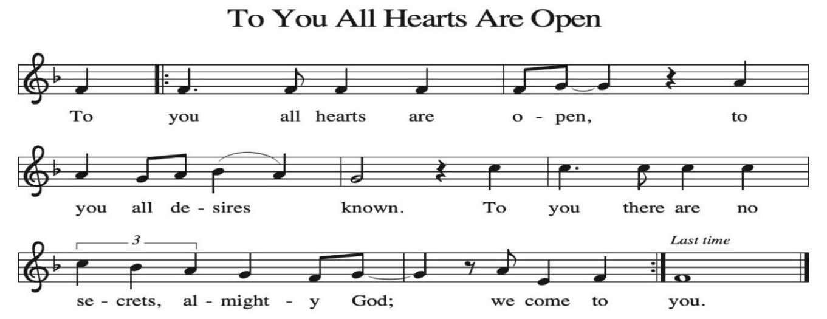

~ Proclamation of the WORD ~ (Scripture insert)
God speaks to us in scripture reading, preaching, and song.

JOHN 1:1-18
The Gospel of the Lord. Praise to you, O Christ.
SERMON Rev. Ben Morris

HYMN of the DAY ELW (red hymnal) #292 Love Has Come

APOSTLES’ CREED ELW (red hymnal) Page 105
I believe in God, the Father Almighty,
Creator of Heaven and earth;
I believe in Jesus Christ, God’s only Son Our Lord,
who was conceived by the Holy Spirit,
born of the Virgin Mary,
suffered under Pontius Pilate,
was crucified, died, and was buried;
he descended to the dead.
On the third day he rose again;
he ascended into heaven,
he is seated at the right hand of the Father,
and he will come to judge the living and the dead.
I believe in the Holy Spirit,
the holy catholic church,
the communion of saints,
the forgiveness of sins,
the resurrection of the body,
and the life everlasting. Amen.

PRAYERS of INTERCESSION
Petitions end: God of grace…hear our prayer.

PASSING OF THE PEACE
Please be aware of those who may not be comfortable shaking hands. You may also share the peace sign. Or any other contactless gesture that you are comfortable with.

OFFERING & SOLO

OFFERTORY ELW (red hymnal) #186 Create in Me a Clean Heart, O Lord

OFFERTORY PRAYER
Nourishing God, you are water in the wilderness and streams in the desert. Through this meal, satisfy our parched places, that we may rejoice and be for the world signs of your kingdom come. Amen.

THANKSGIVING FOR THE WORD
O God of justice and love, we give thanks to you that you illumine our way through life with the words of your Son. Give us the light we need, awaken us to the needs of others, and at the end bring all the world to your feast; through Jesus Christ, our Savior and Lord, to whom, with you and the Holy Spirit, be honor and glory forever. Amen.

THE LORD’S PRAYER

~ SENDING ~
God blesses us and sends us in mission to the world

BLESSING
May God who comes among us, Father, ☩ Son, and Holy Spirit, grant you patience in waiting, peace in the darkness, and good news to share today and always. Amen.

BELLS
SENDING HYMN ELW (red hymnal) #272 Lo, How a Rose E’er Blooming

DISMISSAL
Go in peace. Keep awake.
Thanks be to God.

POSTLUDE

Reprinted / podcast / streamed with permission under ONE LICENSE #A-738444. All rights reserved.



Coon Valley Lutheran Church
The Fourth Sunday in the Season of Advent
December 21, 2025
9:00 a.m.

~Bulletins are in memory of Maline Stakston from Garland & Karen McGarvey

Usher: Steve Nelson
Reader: Mike Fencl
Attendance & Offering Last Sunday: 109; $6,029.06
Sunday School Attendance Last Sunday: 15


Scan this code with your phone to contribute electronically with Vanco.

SCHEDULE
WEDNESDAY: 4:00p/Christmas Eve Worship
THURSDAY: 9:00a/Christmas Day Worship with Holy Communion
FRIDAY: Pastor Ben’s sabbath
NEXT SUNDAY: 9:00a/Worship; 10:30a/Pr. Ben Worship at Middle Coon Valley; No Coffee Fellowship, No Sunday School; Last Day to submit offerings for 2025.

Coon Valley Lutheran Church
www.coonvalleylutheranchurch.org
Pastor: Rev. Benjamin Morris, Office 452-3772/Cell 608-406-1556, pastor@coonvalleylutheranchurch.org
Office Administrator: Jamie Thomas, office@coonvalleylutheranchurch.org
Office Hours: Tuesday, Wednesday 9:00a-4:00p; Thursday 9:00a-3:30p
Office 452-3772/Cell 317-0007
Treasurer: Becky Lusk, treasurer@coonvalleylutheranchurch.org
Organist: Mary Schultz
Indoor Custodian: Tracy Stellner

~Remember "Thumbs Up" When you come up for communion if you would like a gluten free wafer, give the pastor a thumbs up as you approach. As you approach the wine server, give him or her a thumbs up to receive grape juice instead of wine.

Gospel Reading: John 1:1-18
1 In the beginning was the Word, and the Word was with God, and the Word was God.
² He was in the beginning with God.
³ All things came into being through him, and without him not one thing came into being. What has come into being
⁴ in him was life, and the life was the light of all people.
⁵ The light shines in the darkness, and the darkness did not overtake it.
⁶ There was a man sent from God whose name was John.
⁷ He came as a witness to testify to the light, so that all might believe through him.
⁸ He himself was not the light, but he came to testify to the light.
⁹ The true light, which enlightens everyone, was coming into the world.
¹⁰ He was in the world, and the world came into being through him, yet the world did not know him.
¹¹ He came to what was his own, and his own people did not accept him.
¹² But to all who received him, who believed in his name, he gave power to become children of God,
¹³ who were born, not of blood or of the will of the flesh or of the will of man, but of God.
¹⁴ And the Word became flesh and lived among us, and we have seen his glory, the glory as of a father’s only son, full of grace and truth.
¹⁵ (John testified to him and cried out, “This was he of whom I said, ‘He who comes after me ranks ahead of me because he was before me.’ ”)
¹⁶ From his fullness we have all received, grace upon grace.
¹⁷ The law indeed was given through Moses; grace and truth came through Jesus Christ.
¹⁸ No one has ever seen God. It is the only Son, himself God, who is close to the Father’s heart, who has made him known.
The Gospel of the Lord. Praise to you, O Christ.

*We are always happy to include you and our CVLC family in our prayers. If you feel your name, or the name of a family member can be added or removed from this list please contact Jamie. Thank you!

We remember in prayer:
† Those hospitalized this past week
† Our members whose names we lift up in prayer today: Corrine Appleman, Beverly Bagstad, Clifford Bakkum, Pastor Barbara Bruneau, Herby Cornell, Rita Erlandson, Gloria Galstad, Kira Hoff, Becky Ihle, Donna Ihle, Ray Ihle, Eddie Kanieski, Todd King, Margaret Lee, Russell Lee, Aaron Leisso, Aaron Marx, LuEtta Nelson, Romaine Nelson, Sandra Onshus, Elaine Proksch, Eunice Quast, Lori Roach, Jojo Satona, Heidi Saupe, Mary Schultz, LaVonne Stendahl, Krin (Dreves) Stendalen, Joyce Temp, Teri Tomten, Maggie Traastad, Renita Williamson
† Our members who are currently in health care facilities & Assisted Living:
Tip Bagstad, Rachel Berg, Carl Daffinrud, Jeanne Ebli, Carl Holte, Bob Moilien, Geri Nestingen, Irene Nestingen, Cathy Ofte, Annie Olson, Beatrice Olson (Alden),
Ellen Runice, Bob & Evelyn Schulze.
† Those who grieve
† Our members who are currently home bound
† All those in need of God’s healing and help
† Family and friends of our members
† Local Military: Alex Hendrickson

