| The Carillon | |
| --- | --- |
| Page 1 | September, 2023 |



WELCOME INTERIM PASTOR JIM SCAIFE!

We are pleased to announce that Pr. Jim Scaife will be serving as our Interim Pastor beginning on September 5th. Our first service with him will be on Sunday September 10th at 8:00 & 10:00am. Please join us for this special service and help us welcome Pastor Jim to Coon Valley!



SEPTEMBER PROVIDES OPPORTUNITIES FOR WORSHIP AND FELLOWSHIP!

**Sunday, September 3—**10:00 a.m. Worship & Holy Communion with Pr. Meg Hoversten

**Sunday, September 10—Fall Schedule begins!** 8:00 a.m. and 10:00 a.m. Worship with Holy Communion; 9:00 a.m. Sunday School and Coffee Fellowship; 10:00 a.m. Sunday School Installation

**Sunday, September 17—**8:00 a.m. and 10:00 a.m. Worship; 9:00 a.m. Sunday School and Coffee Fellowship

**Sunday, September 24—**8:00 a.m. and 10:00 a.m. Worship; 9:00 a.m. Sunday School and Coffee Fellowship

*Please note that our worship schedule has changed to two services at 8:00 & 10:00 a.m. beginning on Sept. 10th!

Sunday School Begins September 10!

All students Age 3 (On or before September 1) through Grade 6 are invited to join us for a whole new year of fun, faith and friends! We will gather at 9:00 a.m. in the Sunday School hallway which is located downstairs and through our fellowship hall. Our teachers have special activities planned to welcome you on Rally Sunday (September 10) and we hope you will join us! Please register your student(s) for Sunday School by returning the enclosed registration form to the Parish Office on or before the first day of Sunday School. The registration form is also available for print on our website: www.coonvalleylutheranchurch.org.

We can’t wait to see you at Sunday School!

Sunday School Teacher Installation: September 10th at 10:00 a.m.!

We give thanks to God for our Sunday School Teachers and Guides who give of their time and talents to share their love for Jesus with our students and families. Sunday School Teachers, please join us as you are able for the service of Installation which will be held at our 10:00 a.m. worship service on September 10th!

MCj03226430000[1]JULY CHURCH COUNCIL HIGHLIGHTS

**\*Treasurer’s Report:** Presented by Becky Lusk. Report accepted. A motion was passed to transfer our current Parsonage CD into a higher interest rate CD.

**\*Property & Grounds:** New screens were installed. Deb Holen cleaned up the back stairways. Paul updated lights. A bat house will be installed.

**\*Discussion Items:**

**-**Review of the July 5th exit interview with Pastor Julie was done.

-Vernon Communications is discontinuing Church channel on July 31.

-Discussion of July 16th Worship plans and recognition ceremony.

-Discussion on livestreaming, opening the safe and unlocking the building for worship were discussed.

**\*Pastor Julie’s Ministry Transition:**

-Pulpit Supply and Emergency Pastoral Coverage and Synod Guidelines

-Steve P. made a motion to pay the top recommended dollar for all services, motion passed.

-Confirmation Ministry-Mike Lusk will connect with Pr. Julie on notes and requirements and make a list of additional needs and volunteers to support teaching. A letter will be sent to parents and students.

-Pr. Julie will provide a template for upcoming bulletins for Sunday services.

-Lay Ministers to bring home Communion. Pr. Julie will put out the request for lay ministers to assist in the interim time.

-Vacation Bible School-CVLC will pay $400 of the cost for VBS counselors. Volunteers needed for snacks and being onsite.

-National Youth Gathering July 16-20, 2024 New Orleans-Pr. Meg will hold registration for the Gathering on behalf of CVLC. The next Valley Youth Meeting is August 13th at 10:30 in person or Zoom at Middle Coon Valley.

-Cooperation agreement with Middle Coon Valley-open to interim/future pastor.

-Sound System for Outdoor Worship-Contact Karen Rude for training.

-Plan for Pr. Julie’s final week in the office include visits, funeral, bulletins, keys and credit cards.

**\*New Business:**

-Pastor Julie’s Vacation time/Insurance coverage. A motion passed to cover Pr. Julie’s insurance benefits through August 31st. and cover vacation time for 3 remaining weeks, ending August 6th.

-Worship & Sunday School Survey Results and recommendations from Worship Committee.

Survey results were reviewed by Council.

Worship Committee recommended to move to two services at 8:00am & 10:00am with Sunday School and Coffee Fellowship at 9:00am. Motion passed.

-Request for use of Church Organ

A motion passed to allow Eunice Quast and Bella Grethel to utilize the church organ for practice.

-Long-Range Planning Notes shared with Council for review.

-175th Anniversary of Coon Valley Celebration. Deb will contact Pr. Meg about the service. The Event will be held 2024 Father’s Day weekend.

**\*The next meeting** will be August 10th at 6:00pm.

The meeting adjourned followed by the Lord’s Prayer.

Respectfully Submitted, Amanda Buros

NEW OFFICE HOURS

Thank you for your flexibility with our summer office hours so that I may spend more time at home with my girls. My new office hours will be effective the week of September 4th and will be: Tuesday, Wednesday & Thursday 9:00am-2:30pm. Beginning the week of September 18th hours will change to Tuesday & Thursday 9:00am-4:00pm and Wednesday 9:00am-2:30pm. I will also spend time working from home as well. Thank you! Jamie

BLOOD DRIVE

Our next blood drive is scheduled for Monday, September 11th from 1-6pm. The current supply of blood is critically low! Visit [redcrossblood.org](https://d.docs.live.net/a077a1d88e72bfe6/Documents/Newsletter/redcrossblood.org) to schedule an appointment or call Mike Lusk to set up an appointment or to volunteer to help with the drive. After your donation, you will receive refreshments.



CONFIRMATION

Confirmation is set to begin in October! With the hiring of an Interim Pastor, changes with confirmation will come. Parents and students, stay tuned for more information coming your way in September!

WELCA CHILI & CHICKEN SOUP SUPPER and RAFFLE: Wednesday, Sept. 27 ~ 4:00-7:00 PM

Come join us for chili or chicken soup at the WELCA supper & raffle. Everyone is welcome. Cost is $8.00 for adults, $5.00 for children 6-12 and children 5 and under are free. Watch for a chance to buy raffle tickets!

CHASEBURG SOLE BURNER

The 2023 Chaseburg Sole Burner will be on Saturday, September 23. CVLC will again walk as a team under the name the Coon Valley Lutheran Holy Strollers. Please visit the website to sign up to walk or to donate to our team. You may also sign up by contacting Pam Olson. As the event approaches Pam will be available in September to help get everyone signed up. Join us for this great cause! <https://secure.acsevents.org/site/STR?pg=entry&fr_id=100726>

GIVING OPPORTUNITIES

Below is a list of the many funds you may wish to give to.

**GENERAL FUND**- Church operating expenses.

**BUILDING FUND** -Building and grounds projects, currently includes the Parking Lot Fund.

**MEMORIAL FUND**-Used for the life and ministry of the church as determined by Council.

**SHEPHERD FUND**-Funds for church & community members in need.

**CEMETERY**-Maintenance of the grounds.

**WELCA**-Woman of the ELCA includes Quilting and Kitchen funds.

**SUNDAY SCHOOL**-Teaching materials

**PRAYER SHAWL MINISTRY**-Supplies for the making of prayer shawls and prayer squares.

**YOUTH FUND**-Funds to pay for Mission Trips

**ENDOWMENT**-Only interest income may be used for community outreach, missions of ELCA, Capital Improvements.

**RUDIE BIBLE FUND**-Supply Bibles to youth.

PARTICIPATE IN OUR WORSHIP SERVICES FROM HOME

**Facebook:** Services are live streamed, recorded and available Sunday mornings on the CVLC Facebook page.

**YouTube:** Subscribe to our page!

**Our Website:** [www.coonvalleylutheranchurch.org](http://www.coonvalleylutheranchurch.org)

VOLUNTEERS NEEDED!

We are seeking volunteers who are able to help livestream our worship service on Sunday mornings. You do not need any special skills to volunteer. We just need someone to point the camera in the right direction 😊 You will be trained how to use the new camera system (it is very easy.) If you are able, please contact Jamie.

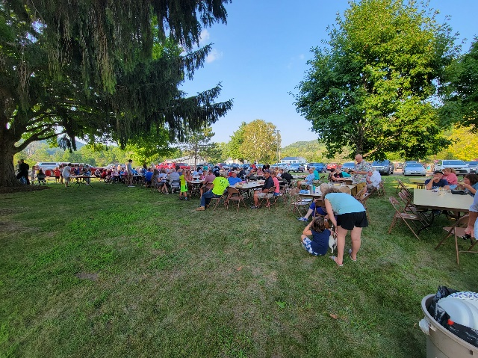VACATION BIBLE SCHOOL & CORN ROAST THANK YOU!

Thank you to all for making our VBS and Community Corn Roast joyful events to remember! Thank you to Kevin and Maggie Traastad for donating 25 dozen ears of sweet corn to the Corn Roast! Thank you to Janice Bender for organizing our volunteers and thank you to all who roasted, baked, boiled, brought, or ate the delicious food and treats! It was a wonderful community event!

Thank you to our Vacation Bible School Counselors for bringing their energy, enthusiasm and love for God and God’s people to our VBS in the Valley! Thank you to the Wichman family for the treats for the campers and counselors! Thank you to the parents and students who made our three days a fun, faith-filled adventure! Thank you to Pr. Meg Hoversten and Middle Coon Valley Lutheran for your partnership with VBS! Both these events require lots of hands-on support. Thank you all for your faithful partnership in these and all the ministries we share!

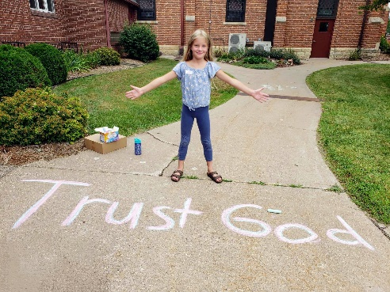

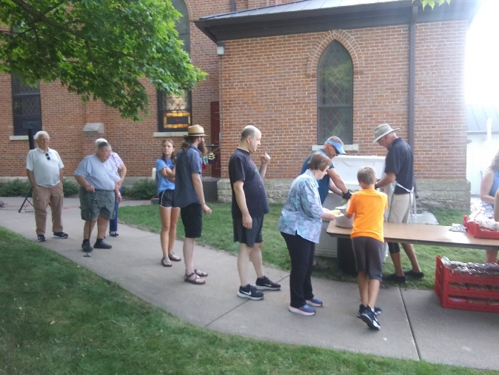

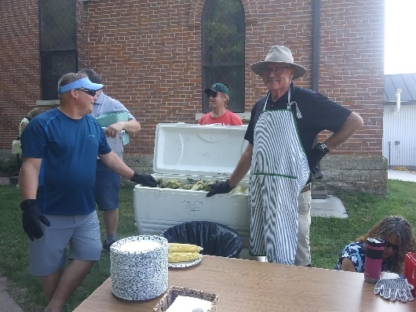

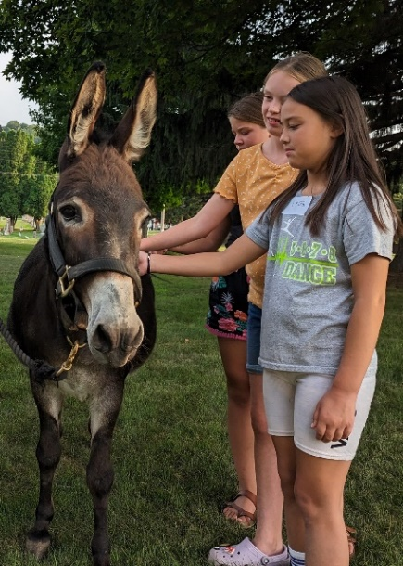

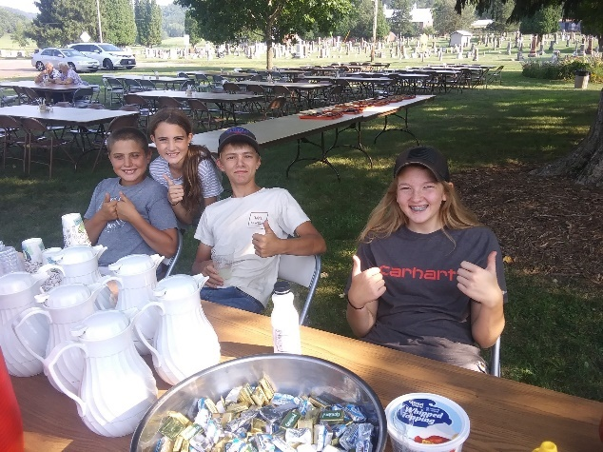



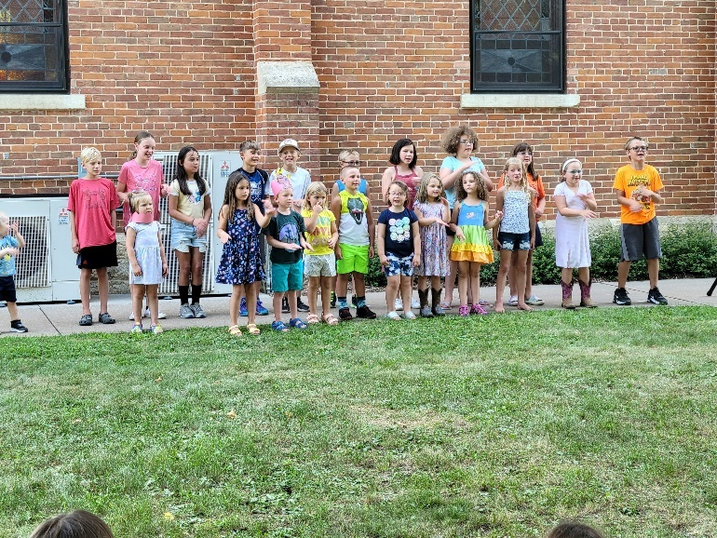

ONLINE GIVING

There are several ways you may get your offerings to the church. You may mail it to the church office, P.O. Box 280. Or use one of our eGiving options. 1) You may go to our website and click the Donate button at the top. 2) Give through the mobile app Vanco Mobile. Please let Jamie know if you need assistance in any way. Thank you for your support!

SUGAR CREEK BIBLE CAMP

QUILT AUCTION

**Saturday, September 9 @ 8:00am - 2:00pm**

* [**« Drugan’s Golf Outing**](http://wp.sugarcreekbiblecamp.org/?tribe_events=dragons-gold-outing)

Come to Sugar Creek for great food, delightful fellowship and a fabulous auction! You never know what treasure you might find at a Sugar Creek Auction: sports memorabilia, furniture, antiques, crafts, rummage items, and of course, *beautiful quilts*! **Come early for our trail run/walk 5k and enjoy exploring the beautiful trails that run through our valley! This year we will also host a Crafters’ Fair featuring the finest of our local artisans. This day is our biggest fundraiser of the year:** your support allows Sugar Creek to continue their valuable ministry! **Auction starts at 10 a.m.** We hope to see you here!



THANK YOU TO RAY IHLE!

A big thanks to Ray for painting our sign board with the correct worship times!

KWIK TRIP GIFT CARDS SUPPORT CVLC YOUTH

Purchase Kwik Trip cards! We are able to purchase these cards for a discount, plus an additional 10% of in-store purchases is given to the church Youth Mission Trip Fund. Purchase them as gifts, to tell someone thank you or purchase to use for your own needs including gas, milk, bread and much more. Email Jamie to sign up [jamiel@mwt.net](mailto:jamiel@mwt.net). Or sign up on the order form in the church entrance or near the church office. Help us support our CVLC Youth!

WELCA NEWS

Our August 17 meeting opened with a short business meeting at which time we voted to pay for shipping costs for the LWR kits.

The Chili/Chicken Soup Supper and Raffle will take place on Wednesday, September 27. If you would like to donate a prize for the raffle, please let Deb Holen know. Tickets will be on sale during September and we hope you will support this important fund raiser.

In October, the North Ridge Circle will present the program featuring Mary Beth Smith from “Leather ‘N Lace.” She will bring her accordion and give us a history of her instrument and play and sing for us. At the end of the year, North Ridge Circle will disband with only three active members left. This will leave only three Circles within WELCA, down from nine. If you have never been in a Circle, now would be a good time to gather a few friends and form a new group or join an existing Circle. Circles have played an important role in WELCA for many years and we hope to see them continue. Bible study, coffee, fellowship, projects and forming lasting friendships are all part of belonging to a Circle.

After concluding our business, our members washed windows and sorted and organized a storeroom. Thank you so much for all who helped. This productive morning concluded with a potluck lunch. It was a good day!!!



DATES TO REMEMBER

Thurs., Sept. 21, 10am, WELCA – General Board presents program honoring our ministries. Hostess: Rachel Strangstalien.

Paying Hostesses: Cindy Gartner, Tina Schweitzer, Marilyn Lee, Hanna Lobeck.

Wed., Sept. 27, 4-7pm – Chili/Chicken Soup and Raffle.

LOOKING AHEAD

Sat., Oct. 14, 7-11am – LWR semi will be at Good Shepherd Lutheran Church in La Crosse to receive kits, etc.

Thurs., Oct. 19, 10am, WELCA – North Ridge Circle presents program – Mary Beth Smith from “Leather ‘N Lace.” Hostess: Deb Holen.

Paying Hostesses: Natasha Olerud, Marcine Nelson, Cathy Foster, Kathy Nelson.

SUNDAY MORNING COFFEE SERVERS

Sept. 3 No Coffee

Sept. 10 Stephanie Lee, TBA

Sept. 17 Rita Erlandson, Linda Servais

Sept. 24 H.S. Youth

God Bless, Ellie Brye, President

**\*** Just a reminder - we are still collecting school supplies and other kits, or monetary donations until September 10th.



**ATTENDANCE & OFFERING**

|  |  |  |  |
| --- | --- | --- | --- |
| **2023** | **July** |  | **2023 YTD** |
| **Total Offerings** | $14,402.91 |  | $106,853.88 |
| **Expenses** | $14,627.71 |  | $122,250.31 |
| **Balance/Shortfall** | **-$224.80** |  | **-$15,396.4** |
| **Parsonage Int. Fund Transfer** | $0 |  | $0 |
| **Building Fund Transfer** | $1,000.00 |  | $0 |
| **Memorial Fund**  **Transfer** | $0 |  | $0 |

**7/30 – 9a:** 60; **Offering:** $3,263.07

**8/6 – 10a:** 70; **Offering:** $3,803.66

**8/13 – 9a:** 55; **Offering:** $2,472.48

**8/20 – 9a:** 53; **Offering:** $1,588.48

**8/27 – 9a:** 64; **Offering:** $2,002.37

**\*\***Approximately **$4,280.00 a week** is needed to meet operating expenses.

**General Fund Balance:** 7/31/23: $14,990.77

**Memorial Fund Balance:**7/31/23: $51,668.01

**Building Fund Balance:** 7/31/23: $32,046.08

**CD Interest Balance:** 7/31/23: $20,111.45

**Shepherd Fund Balance:** 7/31/23: $990.01

FUNERALS

8/12- Patricia Stuempges

8/12-Donald Dunnum

MEMORIALS

**Patricia Stuempges**

Memorial Fund: $10.00

Sunday School: $30.00

Parking Lot Fund: $20.00

Endowment Fund: $20.00

**Sharon Stendahl**

Memorial Fund: $25.00

**Edwin Giese**

Memorial Fund: $20.00

**Molly Olson**

Memorial Fund $25.50

**Tilmer Ofte**

Memorial Fund: $500.00

Endowment Fund: $400.00

**YEAR-TO-DATE BALANCE**

PRAYER GROUP

The Prayer Group continues to pray for the church, the congregation and our extended family and friends.

**† *Our church staff***

**† *Our members*:** Corrine Appleman, Beverly Bagstad, Clifford Bakkum, Richard Brose, Herby Cornell, Jeanne Ebli, Kira Foster, Phyllis Galstad, Bonnie Holey, Becky Ihle, Donna Ihle, Verlin Ihle, Alan Jacobson, Todd King, Margaret Lee, Russell Lee, Aaron Leisso, Larry Lichtie, Cindy Manske, Aaron Marx, Frank Mathison, Bud Miyamoto, Marianne Mhyre, LuEtta Nelson, Monte Nelson, Romaine Nelson, Sandy Nelson, Eunice Quast, Jojo Satona, Mary Schultz, Billie Slater, LaVonne Stendahl, Joyce Temp, Teri Tomten.

**† *Our members who are currently in health care facilities & Assisted Living*:** Tip Bagstad, Inez Beck, Rachel Berg, Evelyn Dahlen, Joanne Fletcher, Erma Graupe, Lenore Henley, Carl Holte, Sylvester King Jr., Jim Knutson, Bob Moilien, Irene Nestingen, Cathy Ofte, Annie Olson, Beatrice Olson (Alden), Betty Sanders.

**† *Those who grieve:*** Family and friends of Patty Stuempges

**† *Family and friends of members***

**† *Local Military***

**† *All those affected by the COVID-19 virus***



**CVLC 2023/24**

**SUNDAY SCHOOL STAFF**

**COORDINATOR:**

Maggie Traastad 452-3804

**TREASURER:** Gwen Bahr 452-3697

**3 YEAR-OLDS thru**  **4th GRADE:**

Renita Williamson 452-3393

Amy Stakston-Wiedemann 452-2377/606-3629

Kari Coaty  (608) 769-0335

**5th GRADE** Maggie Traastad 452-3804

**6th GRADE:** Dave Schultz 715-308-0575

2023/24 REGISTRATION FORM

SUNDAY SCHOOL

“Where the Bible comes alive”

**WHEN:** Sunday School begins on RALLY SUNDAY Sept. 10

**TIME:**  9:00-9:55 AM

**WHO:** age 3 (on or before Sept. 1) through 6th grade

**COST:** There is no fee

NAME___________________________________ Grade____

NAME___________________________________ Grade____

NAME___________________________________ Grade____

ADDRESS________________________________

PHONE #_______________________

EMAIL ________________________

“I give my son/daughter permission to attend the COON VALLEY LUTHERAN CHURCH Sunday School program for the 2023/24 year.”

_____________________________________________

Signature of parent(s)

“I give Coon Valley Lutheran Church permission to share pictures of my son/daughter to the CVLC website, CVLC and CVLC Sunday School Facebook pages.

____________________ Parent Initials

Any special needs or concerns we should know about your children? (please list below):

**DAILY BIBLE READINGS**

**WEEK OF SEPTEMBER 3**

**SUNDAY** Jeremiah 15:15-21 *God fortifies the prophet*

Psalm 26:1-8 *Your love is before my eyes*

*or* Exodus 3:1-15 *From the blazing bush God calls Moses*

Psalm 105:1-6, 23-26, 45c *Remembering Moses*

Romans 12:9-21 *Live in harmony*

Matthew 16:21-28 *The rebuke to Peter*

**MONDAY** 2 Samuel 11:2-26 *David sins*

**TUESDAY** 2 Samuel11:27b-12:15 *Nathan rebukes David*

**WEDNESDAY** Matthew 12:22-32 *Jesus comes to cast out Satan*

**THURSDAY** Jeremiah 17:5-18 *The vindication of the righteous*

**FRIDAY** Revelation 3:1-13 *Rewarding those with endurance*

**SATURDAY** Psalm 17 *The righteous shall see God*

**WEEK OF SEPTEMBER 10**

**SUNDAY** Ezekiel 33:7-11 *The prophet’s responsibility*

Psalm 119:33-40 *The path of your commandments*

*or* Exodus 12:1-14 *The passover*

Psalm 149 *Sing praise in the congregation*

Romans 13:8-14 *Live honorably as in the day*

Matthew 18:15-20 *reconciliation in the community of faith*

**MONDAY** Leviticus 4:27-31, 5:14-16 *Atoning for sin in the community*

**TUESDAY** Deuteronomy 17:2-13 *Punishment for sin in the community*

**WEDNESDAY** Matthew 21:18-22 *Jesus teaches about communal prayer*

**THURSDAY** Leviticus 16:1-5, 20-28 *The scapegoat cleanses the community*

**FRIDAY** Romans 13:1-7 *Obeying authority*

**SATURDAY** Psalm 119:65-72 *The law humbles me*

**WEEK OF SEPTEMBER 17**

**SUNDAY** Genesis 50:15-21 *Joseph reconciles with his brothers*

Psalm 103[1-7] 8-13 *The LORD is full of compassion and mercy*

*or* Exodus 14:19-31 *Israel’s deliverance at the Red Sea*

Psalm 114 *Tremble, O earth*

Or Exodus 15:1b, 20-21 *The LORD triumphed gloriously*

Romans 14:1-12 *Diversity in the community of faith*

Matthew 18:21-35 *A parable of forgiveness*

**MONDAY** Genesis 37:12-36 *Joseph’s brothers sin against him*

**TUESDAY** Genesis 41:53—42:17 *Joseph acts harshly against them*

**WEDNESDAY** Matthew 6:7-15 *Forgiving one another*

**THURSDAY** Genesis 45:1-20 *Joseph forgives his brothers*

**FRIDAY** Romans 14:13—15:2 *Building each other up*

**SATURDAY** Psalm 133 *How good it is to live in unity*

**WEEK OF SEPTEMBER 24**

**SUNDAY** Jonah 3:10—4:11 *God’s concern for Nineveh*

Psalm 145:1-8 *The LORD is slow to anger*

*or* Exodus 16:2-15 *Manna and quails in the wilderness*

Psalm 105:1-6, 37-45 *Remembering the wilderness*

Philippians 1:21-30 *Standing firm in the gospel*

Matthew 20:1-16 *The parable of the vineyard workers*

**MONDAY** Genesis 27:1-29 *The younger son gets the blessing*

**TUESDAY** Genesis 28:10-17 *God blesses the runaway Jacob*

**WEDNESDAY** Matthew 19:23-30 *The last will be first*

**THURSDAY** Isaiah 41:1-13 *God will be with the last*

**FRIDAY** Romans 16:1-20 *Workers in the church of Rome*

**SATURDAY** Psalm 106:1-12 *God’s mercy*

**WEEK OF SEPTEMBER 27**

**SUNDAY** Ezekiel 18:1-4, 25-32 *The fairness of God’s way*

Psalm 25:1-9 *God’s compassion and love*

*Or* Exodus 17:1-7 *Water from the rock*

Philippians 2:1-13 *Christ humbles to the pint of death*

Matthew 21:23-32 *A parable of doing God’s will*

**MONDAY**Judges 16:1-22 *Samson asked about his strength*

**TUESDAY** Judges 16:23-31 *Samson prays to do God’s will*

**WEDNESDAY** Matthew 9:2-8 *Jesus’ authority*

**THURSDAY** Joshua 4:1-10, 19-24 *Joshua leads the people God’s way*

**FRIDAY** Philippians 1:3-30 *Proclaiming Christ*

**SATURDAY** Psalm 28 *Prayer to do God’s will*

\

**Moving? New contact information? Please update the church office.**

**Thank you!**

Please use our correct mailing address when sending us mail.

P.O. Box 280

Thank you!

Visit our website: coonvalleylutheranchurch.org to sign-up to receive our newsletter via email!

**THE CARILLON**

VOL. 52 September 2023 No. 7

Coon Valley Lutheran Church, ELCA 1005 Central Avenue, P.O. Box 280

Coon Valley, WI 54623

Office Phone (608)452-3772

www.coonvalleylutheranchurch.org

❑ Interim Pastor: Jim Scaife, 608-452-3772

Office Administrator: Jamie Thomas, [jamiel@mwt.net](mailto:jamiel@mwt.net), Office: 608-452-3772

Cell Phone: 608-317-0007

Office Hours: Tuesday, Wednesday, Thursday 9:00am-2:30pm

Treasurer: Becky Lusk, [treasurer1005@mwt.net](mailto:treasurer1005@mwt.net)

Organist: Mary Schultz

Indoor Custodian: Tracy Stellner

Church Council President: Glen Hoff

Vice President: Steve Pauloski; Secretary: Amanda Buros

Paul Bahr, Janice Bender, Debbie Holen, Mark Hutson, Mike Lusk, Ron Moilien

**Worship Schedule**

**8:00 & 10:00 a.m. (see the calendar for change in service times)**

**Sunday School**

**9:00 a.m.**

|  |  |  |  |  |  |  |
| --- | --- | --- | --- | --- | --- | --- |
| September 2023 | | | | | | |
| **Sunday** | **Monday** | **Tuesday** | **Wednesday** | **Thursday** | **Friday** | **Saturday** |
|  |  |  |  |  | **1** | **2** |
| **3**  **10:00a-** Worship with Holy Communion-Pr. Meg Hoversten | **4**  **Labor Day- Office closed** | **5**  **9:00a-**Naomi Circle  **10:00a-**Ruth Circle | **6** | **7**  **6:00p-**Rebecca Circle | **8** | **9**  **9a-2:00p**  Sugar Creek Quilt & Antique Auction |
| **10**  **8:00 & 10:00a-**Worship with Holy Communion; Sunday School Staff Installation @ 10am  **9:00a-**Sunday School Rally Day; Coffee Fellowship  **LAST DAY TO BRING SCHOOL SUPPLIES!** | **11**  **1:00-6:00p-**Blood Drive | **12**  **5:00p-**Worship Committee | **13**  **9:00a-**Quilting | **14**  **6:00p**-Church  Council  **Carillon Deadline** | **15** | **16** |
| **17**  **8:00 & 10:00a-**Worship  **9:00a-**Sunday School; Coffee Fellowship | **18** | **19** | **20** | **21**  **10:00a-**WELCA | **22** | **23**  **11:00a-**Chaseburg Sole Burner |
| **24**  **8:00 & 10:00a-**Worship  **9:00a-**Sunday School; Coffee Fellowship | **25** | **26** | **27**  **4:00-7:00p-**Chili & Chicken Soup Supper & Raffle | **28** | **29** | **30**  Welcome back to Sunday School! , King of Kings Lutheran Church, Clifton  Park, September 10 2023 | AllEvents.in |