COON VALLEY LUTHERAN CHURCH
“We are a family of God, striving to enrich
the lives of all through the love of Christ.”
PRELUDE MUSIC Mary Schultz
BELLS
WELCOME and ANNOUNCEMENTS

Thanksgiving for Baptism
Blessed be the holy Trinity, ☩ one God, the fountain of living water, the rock who gave us birth, our light and our salvation. Amen.

Joined to Christ in the waters of baptism, we are clothed with God’s mercy and forgiveness. Let us give thanks for the gift of baptism.

We give you thanks, O God, for in the beginning you created us in your image and placed us in a well-watered garden. In the desert, you promised pools of water for the parched, and you gave us water from the rock. When we did not know the way, you sent the Good Shepherd to lead us to still waters. At the cross, you washed us from Jesus’ wounded side, and on this day, you shower us again with the water of life.

We praise you for your salvation through water, for the water in this font, and for all water everywhere.
Bathe us in your forgiveness, grace, and love. Satisfy all who thirst, and give us the life only you can give.

To you be given honor and praise through Jesus Christ, our living water, in the unity of the Holy Spirit, now and forever.
Amen.

GATHERING HYMN ELW (red hymnal) #427 For All Your Saints, O Lord

PRAYER OF THE DAY
Almighty God, you have knit your people together in one communion in the mystical body of your Son, Jesus Christ our Lord. Grant us grace to follow your blessed saints in lives of faith and commitment, and to know the inexpressible joys you have prepared for those who love you, through Jesus Christ, our Savior and Lord, who lives and reigns with you and the Holy Spirit, one God, now and forever. Amen

GREET THE WORD- ACS (purple hymnal) #1012 sung 3 times
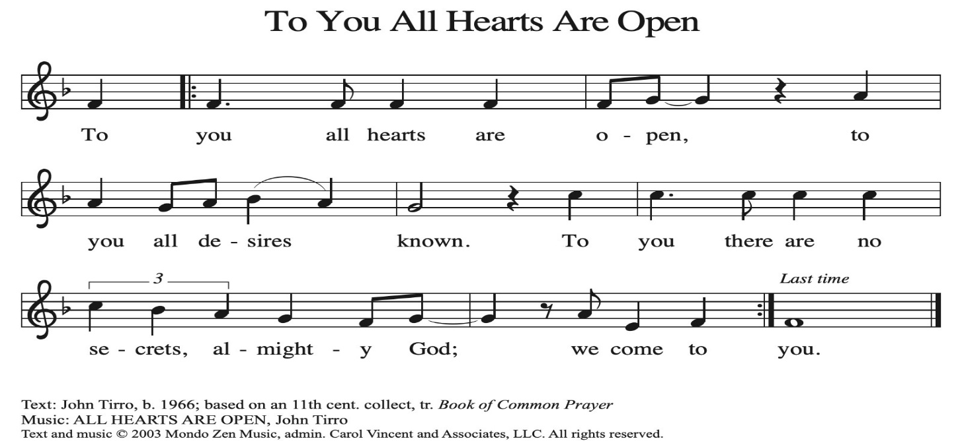
~ Proclamation of the WORD ~ (Scripture insert)
God speaks to us in scripture reading, preaching, and song.

1 KINGS 19:1-14
Word of God. Word of Life. Thanks be to God.
GOSPEL READING: LUKE 6:20-31
The Gospel of the Lord. Praise to you, O Christ.

SUNDAY SCHOOL CHILDREN SING

SERMON Rev. Benjamin Morris

HYMN of the DAY ELW (red hymnal) #424 Ye Watchers and Ye Holy Ones

LITANY OF THE SAINTS-on insert
Reading of names and ringing of bell
Invitation to light candle

PRAYERS of INTERCESSION
Petitions end: Hear us, O God.…Your mercy is great.

PASSING OF THE PEACE
Please be aware of those who may not be comfortable shaking hands. You may also share the peace sign. Or any other contactless gesture that you are comfortable with.

OFFERING & SOLO Behold the Host Arrayed in White Brian Rude
OFFERTORY ELW (red hymnal) #186 Create in Me a Clean Heart, O Lord
OFFERTORY PRAYER
God of healing and hope, you bless those who are hungry, promising to fill them with good things. Fulfill that promise through us and these your gifts. Nourish us with the abundance of your feast and unite us into the blessed body of Jesus Christ our Savior, now and forever. Amen.

THE GREAT THANKSGIVING (Spoken)
The Lord be with you. And also with you.
Lift up your hearts. We lift them to the Lord.
Let us give thanks to the Lord our God.
It is right to give him thanks and praise.

THE LORD’S PRAYER

COMMUNION & SOLO Mary Schultz

POST-COMMUNION PRAYER
God of field and flower, wheat and grape, you have nourished us with the bread of heaven that gives life to the world. Strengthened by the body and blood of your Son, send us out to gather your good gifts for all who hunger and thirst, and embolden us to love and serve in Christ’s name. Amen.
~ SENDING ~
God blesses us and sends us in mission to the world
BLESSING
The love of God the Sovereign strengthen you, God the Son save you, and God the Holy Spirit anoint you for the work ahead. The holy Trinity bless you ☩ and grant you a faithful and courageous heart now and forever. Amen.

BELLS
SENDING HYMN ELW (red hymnal) #422 For All the Saints vs 1,2,6,7
DISMISSAL
Go in peace. Share the harvest.
Thanks be to God

POSTLUDE Mary Schultz
Reprinted / podcast / streamed with permission under ONE LICENSE #A-738444. All rights reserved.

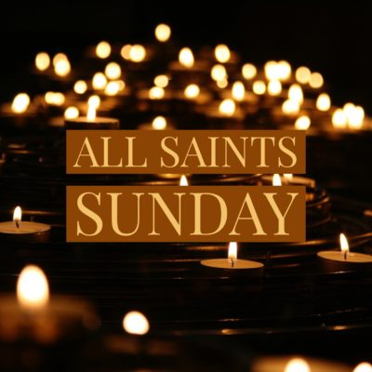

COON VALLEY LUTHERAN CHURCH
ALL SAINTS SUNDAY
NOVEMBER 2, 2025

~Bulletins are in honor of the 70th birthday of Ray Williamson!

Coffee Servers: Karen Bergum, Tammy Haakenson
Usher: Mike Lusk
Altar Guild: Julie Nelson, Heather & Deanna Wichman
Communion Servers: Laura Hofslien, Patty Nelson
Reader: Jane Simmons
Attendance & Offering Last Sunday: 89; $2,603.27
Farmer’s Market Last Sunday: $7.00
Sunday School Attendance: 9


Scan this code with your phone to contribute electronically with Vanco.

SCHEDULE
TODAY: 6:00p/Confirmation
MONDAY: 9:00a/Naomi Circle
TUESDAY: 9:00a/Pastor’s Text Study; 10:30a/Ruth Circle
THURSDAY: 10:00a/Bible Study; 6:00p/Rebecca Circle
FRIDAY: Pastor Ben’s sabbath
NEXT SUNDAY: 9:00a/Worship with Holy Communion; Quilt Blessing 10:00a/Sunday School, Coffee Fellowship, New Member Meeting
Coon Valley Lutheran Church
www.coonvalleylutheranchurch.org
Pastor: Rev. Benjamin Morris, Office 452-3772/Cell 608-406-1556, pastor@coonvalleylutheranchurch.org
Office Administrator: Jamie Thomas, office@coonvalleylutheranchurch.org
Office Hours: Tuesday, Wednesday 9:00a-4:00p; Thursday 9:00a-3:30p
Office 452-3772/Cell 317-0007
Treasurer: Becky Lusk, treasurer@coonvalleylutheranchurch.org
Organist: Mary Schultz
Indoor Custodian: Tracy Stellner

~Remember "Thumbs Up" When you come up for communion if you would like a gluten free wafer, give the pastor a thumbs up as you approach. As you approach the wine server, give him or her a thumbs up to receive grape juice instead of wine.

First Reading: 1 Kings 19:1-14
19 Ahab told Jezebel all that Elijah had done and how he had killed all the prophets with the sword. ² Then Jezebel sent a messenger to Elijah, saying, “So may the gods do to me and more also, if I do not make your life like the life of one of them by this time tomorrow.” ³ Then he was afraid; he got up and fled for his life and came to Beer-sheba, which belongs to Judah; he left his servant there.
⁴ But he himself went a day’s journey into the wilderness and came and sat down under a solitary broom tree. He asked that he might die, “It is enough; now, O Lord, take away my life, for I am no better than my ancestors.” ⁵ Then he lay down under the broom tree and fell asleep. Suddenly an angel touched him and said to him, “Get up and eat.” ⁶ He looked, and there at his head was a cake baked on hot stones and a jar of water. He ate and drank and lay down again. ⁷ The angel of the Lord came a second time, touched him, and said, “Get up and eat, or the journey will be too much for you.” ⁸ He got up and ate and drank; then he went in the strength of that food forty days and forty nights to Horeb the mount of God. ⁹ At that place he came to a cave and spent the night there.
Then the word of the Lord came to him, saying, “What are you doing here, Elijah?” ¹⁰ He answered, “I have been very zealous for the Lord, the God of hosts, for the Israelites have forsaken your covenant, thrown down your altars, and killed your prophets with the sword. I alone am left, and they are seeking my life, to take it away.”
¹¹ He said, “Go out and stand on the mountain before the Lord, for the Lord is about to pass by.” Now there was a great wind, so strong that it was splitting mountains and breaking rocks in pieces before the Lord, but the Lord was not in the wind, and after the wind an earthquake, but the Lord was not in the earthquake, ¹² and after the earthquake a fire, but the Lord was not in the fire, and after the fire a sound of sheer silence. ¹³ When Elijah heard it, he wrapped his face in his mantle and went out and stood at the entrance of the cave. Then there came a voice to him that said, “What are you doing here, Elijah?” ¹⁴ He answered, “I have been very zealous for the Lord, the God of hosts, for the Israelites have forsaken your covenant, thrown down your altars, and killed your prophets with the sword. I alone am left, and they are seeking my life, to take it away.”
Word of God. Word of Life. Thanks be to God.

Gospel: Luke 6:20-31
²⁰ Then [Jesus] looked up at his disciples and said:
“Blessed are you who are poor,
for yours is the kingdom of God.
²¹ “Blessed are you who are hungry now,
for you will be filled.
“Blessed are you who weep now,
for you will laugh.
²² “Blessed are you when people hate you and when they exclude you, revile you, and defame you on account of the Son of Man. ²³ Rejoice on that day and leap for joy, for surely your reward is great in heaven, for that is how their ancestors treated the prophets.
²⁴ “But woe to you who are rich,
for you have received your consolation.
²⁵ “Woe to you who are full now,
for you will be hungry.
“Woe to you who are laughing now,
for you will mourn and weep.
²⁶ “Woe to you when all speak well of you, for that is how their ancestors treated the false prophets.
²⁷ “But I say to you who are listening: Love your enemies; do good to those who hate you; ²⁸ bless those who curse you; pray for those who mistreat you. ²⁹ If anyone strikes you on the cheek, offer the other also, and from anyone who takes away your coat do not withhold even your shirt. ³⁰ Give to everyone who asks of you, and if anyone takes away what is yours, do not ask for it back again. ³¹ Do to others as you would have them do to you.”
The Gospel of the Lord. Praise to you, O Christ.

*We are always happy to include you and our CVLC family in our prayers. If you feel your name, or the name of a family member can be added or removed from this list please contact Jamie. Thank you!

We remember in prayer:
† Those hospitalized this past week: Ellen Runice, Orrin Stakston
† Our members whose names we lift up in prayer today: Corrine Appleman, Beverly Bagstad, Clifford Bakkum, Pastor Barbara Bruneau, Herby Cornell, Marie Egge, Gloria Galstad, Kira Hoff, Becky Ihle, Donna Ihle, Ray Ihle, Eddie Kanieski, Todd King, Mike Kellogg, Margaret Lee, Russell Lee, Aaron Leisso, Aaron Marx, LuEtta Nelson, Romaine Nelson, Lisa Olson, Sandra Onshus, Elaine Proksch, Eunice Quast, Lori Roach, Jojo Satona, Heidi Saupe, Bob Schulze, Mary Schultz, LaVonne Stendahl, Krin (Dreves) Stendalen, Joyce Temp, Teri Tomten, Dave Verse, Jan Verse, Renita Williamson
† Our members who are currently in health care facilities & Assisted Living:
Tip Bagstad, Rachel Berg, Carl Daffinrud, Jeanne Ebli, Carl Holte, Bob Moilien, Geri Nestingen, Irene Nestingen, Cathy Ofte, Annie Olson, Beatrice Olson (Alden),
Ellen Runice, Orrin Stakston.
† Those who grieve: Family and friends of Pauline Moilien, Evelyn Dahlen, Betty Williamson & Lenore Henley.
† Our members who are currently home bound
† All those in need of God’s healing and help
† Family and friends of our members
† Local Military: Alex Hendrickson


All Saint’s 2025
Inez Beck September 10, 1934 ~ December 7, 2024
Francis “Frank” Mathison September 12, 1945 ~ December 19, 2024
Elnor Haugen July 7, 1923 ~ December 26, 2024
Betty Sanders February 26, 1928 ~ January 30, 2025
Hanna (Traastad) Lobeck December 6, 1944 ~ March 3, 2025
Francis Myran May 14, 1933 ~ March 21, 2025
Jeffrey Erickson March 18, 1950 ~ March 30, 2025
David Larson July 9, 1958 ~ May 24, 2025
Betty Nelson April 21, 1928 ~ June 13, 2025
Jeffrey Nestingen March 27, 1954 ~ June 8, 2025
Verlin Ihle April 17, 1937 ~ July 26, 2025
Lenore Henley February 6, 1926 ~ September 2, 2025
Betty Williamson January 16, 1935 ~ September 16, 2025
Mary Ann Dreves August 18, 1937 ~ August 20, 2025
Evelyn Dahlen April 12, 1929 ~ September 30, 2025
Pauline Moilien July 21, 1931 ~ October 4, 2025

LITANY OF THE SAINTS

Let us remember all the saints before God.

We praise and bless you, O holy Trinity. You have taught your church that it is an ageless communion of saints. We thank you for gathering those who faithfully waited in hope for the redemption you promised, and now for adding us who celebrate the love of your Christ for the redemption of the world. Prepare a place for us among those who are already with you. Help us remember them as an encouragement to saintly living, exciting us to love, in anticipation of an eternal reunion.

Christ says, take my yoke upon you, and learn from me;
for I am gentle and humble in heart,

and you will find rest for your souls.

For my yoke is easy, and my burden is light.

And you will find rest for your souls.

God of grace and glory, we remember before you today our brothers and sisters

Reading of names and ringing of bell

Heavenly Father, we rejoice with thanksgiving at these new saints you have claimed as your own, washed in the waters of baptism this year.

We thank you for Molly Mabel Vale and Aurora Lynn Buckmaster
Invitation to light a candle

