COON VALLEY LUTHERAN CHURCH
“We are a family of God, striving to enrich
the lives of all through the love of Christ.”
PRELUDE MUSIC
BELLS
WELCOME and ANNOUNCEMENTS

CONFESSION AND FORGIVENESS
Blessed be the holy Trinity, ☩ one God, whose compassion endures forever.
Amen.
Let us confess our sin to God.
Silence is kept for reflection.
Compassionate God,
we confess to you all our sins.
Our burden is heavy, and we cannot free ourselves.
In your mercy, call us back to you.
Your yoke is easy and your burden is light.
Restore us to dwell in your peace.
In Christ’s name we pray,
Amen.
Jesus says, “Come to me,
all you who are weary
and are carrying heavy burdens,
and I will give you rest.”
In the name of God,
Father, ☩ Son, and Holy Spirit,
your sins are forgiven.
Rest in God’s love.
Amen.

GATHERING HYMN ELW (red hymnal) #720 We Are Called

PRAYER OF THE DAY
O God, you give us your Son as the vine apart from whom we cannot live. Nourish our life in his resurrection, that we may bear the fruit of love and know the fullness of your joy, through Jesus Christ, our savior and Lord, who lives and reigns with you and the Holy Sport, one God, now and forever. AMEN.
GREET THE WORD- ACS (purple hymnal) #976 Sung 1 time
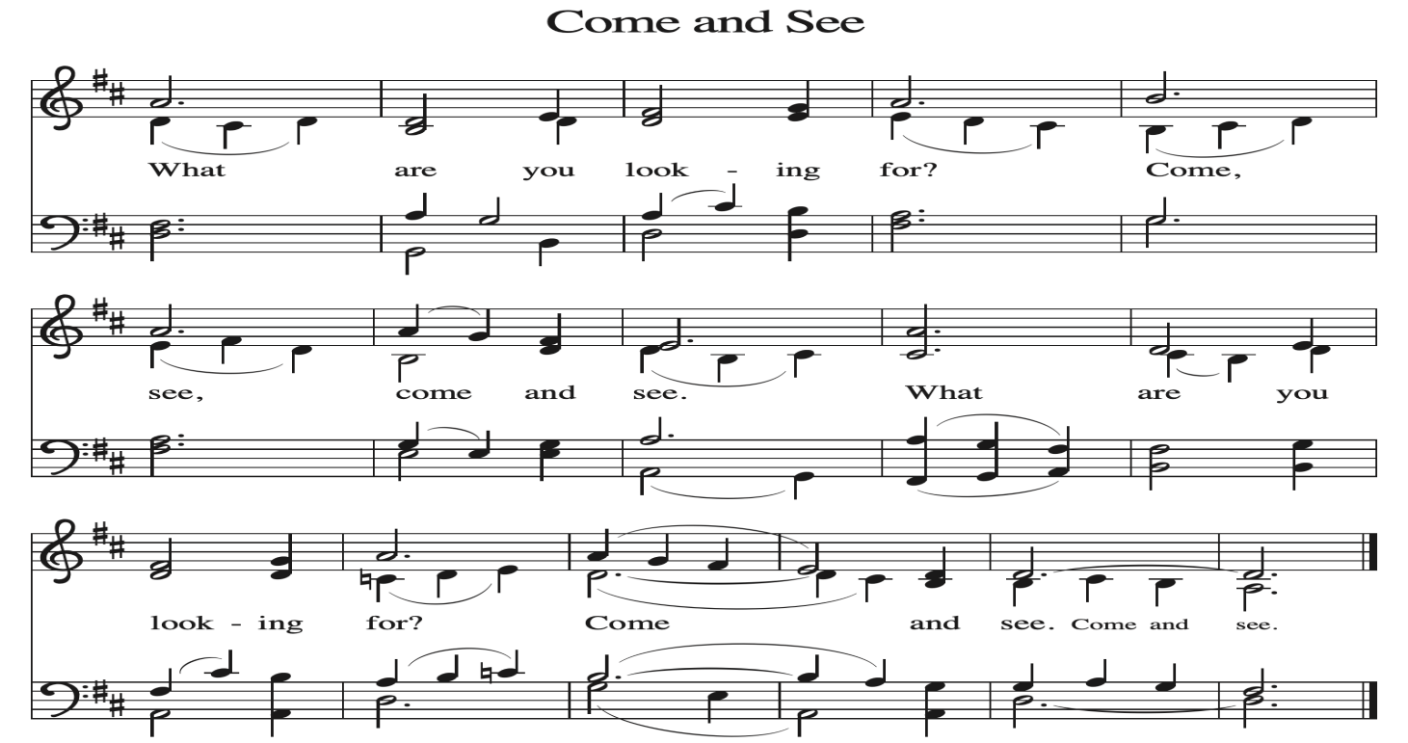
~ Proclamation of the WORD ~ (Scripture insert)
God speaks to us in scripture reading, preaching, and song.

FIRST READING: Genesis 12: 1-3
Word of God. Word of Life. Thanks be to God.

The Holy Gospel according to St. John the fifteenth chapter
Glory to you, O Lord.

GOSPEL READING: John 15: 13-16
The Gospel of the Lord. Praise to you, O Christ.

SERMON Rev. Benjamin Morris

HYMN of the DAY ELW (red hymnal) #843 Praise the One Who Breaks the Darkness

APOSTLES’ CREED ELW (red hymnal) Page 105
PRAYERS of INTERCESSION
Petitions end: Merciful God,...receive our prayer.
PASSING OF THE PEACE
Please be aware of those who may not be comfortable shaking hands. You may also share the peace sign. Or any other contactless gesture that you are comfortable with.

OFFERING & SOLO
OFFERTORY ELW (red hymnal) #186 Create in Me a Clean Heart, O Lord

OFFERTORY PRAYER
Loving God, we offer at your table the gifts of our hearts. Help us take heart in you and share freely of your love, so that all creation can taste your abundance. We ask this in the name of Jesus, through the Spirit abiding with us now and forever. Amen.

THE LORD’S PRAYER

COMMUNION

POST-COMMUNION PRAYER and BLESSING
Compassionate God, through the gifts of bread and wine our hearts are filled with the abundance of your love. Strengthen us that we, through this holy meal, may share your love freely, as you have shared with us. We ask this in the name of Jesus, through the Spirit nourishing us now and forever.
Amen.
~ SENDING ~
God blesses us and sends us in mission to the world
BLESSING
Creator, Redeemer, Sustainer, ☩ one God, bless, heal, and hold you
today and always. Amen.

BELLS
SENDING HYMN ELW (red hymnal) #611 I Heard the Voice of Jesus Say

DISMISSAL
Heaven has come near. Go, share the good news!
Thanks be to God.

POSTLUDE

Reprinted / podcast / streamed with permission under ONE LICENSE #A-738444. All rights reserved

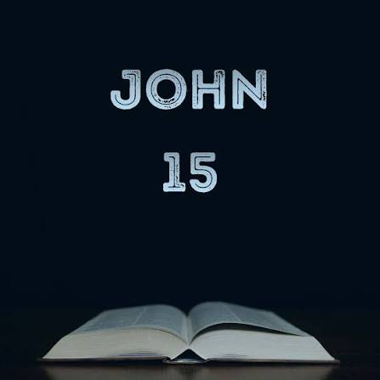

COON VALLEY LUTHERAN CHURCH
Eleventh Sunday of Pentecost
Sunday, August 9, 2026

First Reading: Genesis 12:1-3
12 Now the Lord said to Abram, “Go from your country and your kindred and your father’s house to the land that I will show you. ² I will make of you a great nation, and I will bless you and make your name great, so that you will be a blessing. ³ I will bless those who bless you, and the one who curses you I will curse, and in you all the families of the earth shall be blessed.”

Word of God. Word of Life. Thanks be to God.

The Holy Gospel according to St. John the fifteenth chapter
Glory to you, O Lord.

Gospel: John 15:13-16

¹³ No one has greater love than this, to lay down one’s life for one’s friends. ¹⁴ You are my friends if you do what I command you. ¹⁵ I do not call you servants any longer, because the servant does not know what the master is doing, but I have called you friends, because I have made known to you everything that I have heard from my Father. ¹⁶ You did not choose me, but I chose you. And I appointed you to go and bear fruit, fruit that will last, so that the Father will give you whatever you ask him in my name.
The Gospel of the Lord. Praise to you, O Christ.

~Bulletins are in memory of Roger & Corrine Nelson

Pianist/Organist: Aaron Stakston
Usher: Tim Hatlan
Reader: Sarah Ofte
Altar Guild: Sarah Ofte
Communion Servers: Cody Strangstalien &
Offering Counters: Cody Strangstalien &
Attendance & Offering Last Sunday: 81; $3,236.67


Scan this code with your phone to contribute electronically with Vanco.

SCHEDULE

TUESDAY: 9:00a/Pastor’s Text Study; 5:00-7:30p/Corn Roast
WEDNESDAY: 9:00a/Quilting
THURSDAY: 10:00a/Bible Study
FRIDAY: Pastor Ben’s Sabbath; Carillon Deadline
NEXT SUNDAY: 9:00a/Worship; 10:00a/Finance Committee

Coon Valley Lutheran Church
www.coonvalleylutheranchurch.org
Pastor: Rev. Benjamin Morris, Office 452-3772/Cell 608-406-1556, pastor@coonvalleylutheranchurch.org
Office Administrator: Jamie Thomas, office@coonvalleylutheranchurch.org
Office Hours: Tues. & Wed. 9a-3p
Office 452-3772
Treasurer: Becky Lusk, treasurer@coonvalleylutheranchurch.org
Organist:
Indoor Custodian: Tracy Stellner

*We are always so happy to include you and our CVLC family in our prayers. If you feel your name, or the name of a family member can be added or removed from this list please contact Jamie. Thank you!

We remember in prayer:
† Those hospitalized this past week
† Our members whose names we lift up in prayer today: Corrine Appleman, Beverly Bagstad, Clifford Bakkum, Pastor Barbara Bruneau, Ellie Brye, Herby Cornell, Ardell Daffinrud, Gloria Galstad, Kira Hoff, Becky Ihle, Donna Ihle, Ray Ihle, Julie Kruizenga, Margaret Lee, Russell Lee, Aaron Leisso, Aaron Marx, Bob Nelson, LuEtta Nelson, Julie Nelson, Romaine Nelson, Sandra Onshus, Elaine Proksch, Eunice Quast, Lori Roach, Jojo Satona, Heidi Saupe, Orrin Stakston, LaVonne Stendahl, Joyce Temp, Renita Williamson
† Our members who are currently in health care facilities & Assisted Living: Tip Bagstad, Carl Daffinrud, Jeanne Ebli, Carl Holte, Patty Helgerson, Bob Moilien, Geri Nestingen, Irene Nestingen, Cathy Ofte, Annie Olson, Beatrice Olson (Alden), Elaine Proksch, Ellen Runice, Bob & Evelyn Schulze.
† Those who grieve: Family and friends of Rachel Berg
† Our members who are currently home bound
† All those in need of God’s healing and help
† All those affected by recent storms
† Family and friends of our members
† Local Military: Alex Hendrickson

