COON VALLEY LUTHERAN CHURCH
“We are a family of God, striving to enrich
the lives of all through the love of Christ.”

PRELUDE Mary Schultz

~ GATHERING ~
The Holy Spirit calls us together as the people of God.
WELCOME and ANNOUNCEMENTS

CONFESSION AND FORGIVENESS
All may make the sign of the cross, the sign that is marked at baptism, as the presiding minister begins.
Blessed be the holy Trinity,+ one God, who greets us in this and every season,
whose word never fails, whose promise is sure. Amen.

Let us confess our sin in the presence of God
and of our neighbors.

Merciful God,
we confess that we have sinned.
We have hurt our community.
We have squandered your blessings.
We have hoarded your bounty.
In the name of Jesus,
forgive us and grant us your mercy.

Silence is kept for reflection.

God is a cup of cold water when we thirst.
God offers boundless grace when we fail.
Claim the gift of God's mercy:
you are freed and forgiven
in the name of + Jesus Christ. Amen.

GATHERING HYMN #876 Let the Whole Creation Cry

GREETING and PRAYER of the DAY
The grace of our Lord Jesus Christ, the love of God, and the Communion of the Holy Spirit be with you all. And also with you.

Loving God, you have baptized us into Christ’s death and resurrection, so that we may live new lives. Death no longer has dominion over us. Remind us again.. As we worship, speak your good news to us, so that we may follow Jesus with faith and courage, in the power of your Spirit. Amen.
~ WORD ~ (Scripture insert)
God speaks to us in scripture reading, preaching, and song.
FIRST READING: Genesis 2:18-21
PSALM 86:1-10 (Read Responsively)
SECOND READING: Romans 6:1b-11
Word of God. Word of Life. Thanks be to God.
GOSPEL: Matthew 10:24-39
After the Gospel is read…The Gospel of the Lord. Praise to you, O Christ.

SERMON

HYMN of the DAY (insert) His Eye Is On the Sparrow
(requested by Jean Gronvold and Judy Mathison)

~ RESPONSE TO THE WORD ~
The Holy Spirit calls us as a community to say what we believe,
reach out to each other and offer gifts and prayers for God’s purposes.

THE APOSTLES’ CREED
I believe in God, the Father Almighty,
Creator of Heaven and earth;
I believe in Jesus Christ, God’s only Son Our Lord,
who was conceived by the Holy Spirit,
born of the Virgin Mary,
suffered under Pontius Pilate,
was crucified, died, and was buried;
he descended to the dead.
On the third day he rose again;
he ascended into heaven,
he is seated at the right hand of the Father,
and he will come to judge the living and the dead.
I believe in the Holy Spirit,
the holy catholic church,
the communion of saints,
the forgiveness of sins,
the resurrection of the body,
and the life everlasting. Amen.

PRAYERS of INTERCESSION
God, in your mercy, hear our prayer.

THE LORD’S PRAYER
Our Father who art in heaven, hallowed be thy name, thy kingdom come, thy will be done, on earth as it is in heaven.
Give us this day our daily bread; and forgive us our trespasses,
as we forgive those who trespass against us;
and lead us not into temptation, but deliver us from evil.
For thine is the kingdom, and the power, and the glory,
forever and ever. Amen.

OFFERING and OFFERING SONG Build a Longer Table (On the back)

OFFERTORY PRAYER
God of field and forest, sea and sky, you are the giver of all good things.
Sustain us with these gifts of your creation, and multiply your graciousness in us, that the world may be fed with your love, through Jesus Christ, our Savior and Lord. Amen.
~SENDING ~
God blesses us and sends us in mission to the world.
BENEDICTION

BELLS

SENDING HYMN #781 Children of the Heavenly Father

DISMISSAL Go in peace. Serve our risen Lord. Thanks be to God. Alleluia!

POSTLUDE Mary Schultz

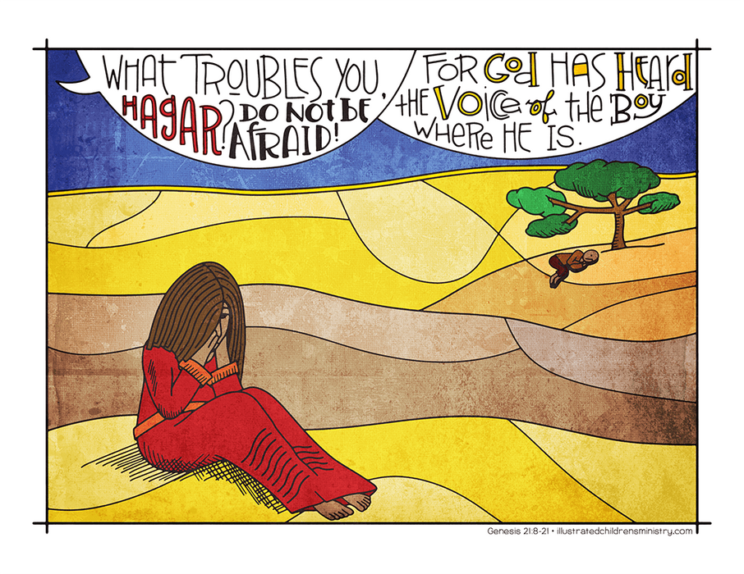

Coon Valley Lutheran Church
The Fourth Sunday after Pentecost
9:00 a.m.
June 25, 2023

~ Bulletins are in honor of the 63rd wedding Anniversary of Verlin & Jan Ihle & the Anniversary of Bjorn & Becky Ihle

Head Usher: Mike Lusk
Reader: Alex Hendrickson
Attendance & Offering Last Sunday: 9am/86; $3,519.05

SCHEDULE
WEDNESDAY: 9:00/Quilting
SUNDAY: 9:00a/Worship with Holy Communion

*Pastor Julie will be on vacation tomorrow, June 26-June 30th. In this time, please contact Jamie at one of the numbers below if there is an emergency. Thank you!

Coon Valley Lutheran Church
www.coonvalleylutheranchurch.org
Pastor: Rev. Julie Wollman, pastorjuliecvlc@gmail.com Home Phone 634-3797
Office Administrator: Jamie Thomas, jamiel@mwt.net
Office Hours: Tuesday 9:00a-11:30a; Wednesday & Thursday 9:00a-3:00p
Office 452-3772/Cell 317-0007
Treasurer: Becky Lusk, treasurer1005@mwt.net
Organist: Mary Schultz
Indoor Custodian: Tracy Stellner

FIRST READING: GENESIS 2:18-21
Then the Lord God said, “It is not good that the man should be alone; I will make him a helper as his partner.” So out of the ground the Lord God formed every animal of the field and every bird of the air, and brought them to the man to see what he would call them; and whatever the man called every living creature, that was its name. The man gave names to all cattle, and to the birds of the air, and to every animal of the field; but for the man there was not found a helper as his partner. So the Lord God caused a deep sleep to fall upon the man, and he slept; then he took one of his ribs and closed up its place with flesh.
Word of God. Word of Life. Thanks be to God.

PSALM 86: 1-10 (read responsively)
Incline your ear, O Lord, and answer me, for I am poor and needy.
Preserve my life, for I am devoted to you; save your servant who trusts in you. You are my God;
be gracious to me, O Lord, for to you do I cry all day long.
Gladden the soul of your servant, for to you, O Lord, I lift up my soul.
For you, O Lord, are good and forgiving, abounding in steadfast love to all who call on you.
Give ear, O Lord, to my prayer; listen to my cry of supplication.
In the day of my trouble I call on you, for you will answer me.
There is none like you among the gods, O Lord, nor are there any works like yours.
All the nations you have made shall come and bow down before you, O Lord, and shall glorify your name.
For you are great and do wondrous things; you alone are God.

SECOND READING: ROMANS 6:1b-11
Should we continue in sin in order that grace may abound? By no means! How can we who died to sin go on living in it? Do you not know that all of us who have been baptized into Christ Jesus were baptized into his death? Therefore we have been buried with him by baptism into death, so that, just as Christ was raised from the dead by the glory of the Father, so we too might walk in newness of life. For if we have been united with him in a death like his, we will certainly be united with him in a resurrection like his. We know that our old self was crucified with him so that the body of sin might be destroyed, and we might no longer be enslaved to sin. For whoever has died is freed from sin. But if we have died with Christ, we believe that we will also live with him. We know that Christ, being raised from the dead, will never die again; death no longer has dominion over him. The death he died, he died to sin, once for all; but the life he lives, he lives to God. So you also must consider yourselves dead to sin and alive to God in Christ Jesus.
Word of God. Word of Life. Thanks be to God.

GOSPEL READING: MATTHEW 10:24-39
“A disciple is not above the teacher, nor a slave above the master; it is enough for the disciple to be like the teacher, and the slave like the master. If they have called the master of the house Beelzebul, how much more will they malign those of his household! “So have no fear of them; for nothing is covered up that will not be uncovered, and nothing secret that will not become known. What I say to you in the dark, tell in the light; and what you hear whispered, proclaim from the housetops. Do not fear those who kill the body but cannot kill the soul; rather fear him who can destroy both soul and body in hell. Are not two sparrows sold for a penny? Yet not one of them will fall to the ground apart from your Father. And even the hairs of your head are all counted. So do not be afraid; you are of more value than many sparrows. “Everyone therefore who acknowledges me before others, I also will acknowledge before my Father in heaven; but whoever denies me before others, I also will deny before my Father in heaven. “Do not think that I have come to bring peace to the earth; I have not come to bring peace, but a sword. For I have come to set a man against his father, and a daughter against her mother, and a daughter-in-law against her mother-in-law; and one’s foes will be members of one’s own household. Whoever loves father or mother more than me is not worthy of me; and whoever loves son or daughter more than me is not worthy of me; and whoever does not take up the cross and follow me is not worthy of me. Those who find their life will lose it, and those who lose their life for my sake will find it.
The Gospel of the Lord. Praise to you, O Christ.
*We are always so happy to include you and our CVLC family in our prayers. If you feel your name, or the name of a family member can be removed from this list please contact Jamie. Thank you!

We remember in prayer:
† Those hospitalized this past week
† Our members whose names we lift up in prayer today: Corrine Appleman, Beverly Bagstad, Clifford Bakkum, Richard Brose, Jeanne Ebli, Kira Foster, Phyllis Galstad, Lucy Hardie, Bonnie Holey, Donna Ihle, Verlin Ihle, Alan Jacobson, Todd King, Mike Kellogg, Jim Knutson, Margaret Lee, Russell Lee, Aaron Leisso, Larry Lichtie, Cindy Manske, Aaron Marx, Frank Mathison, Bud Miyamoto, Marianne Myhre, LuEtta Nelson, Romaine Nelson, Sandy Nelson, Cathy Ofte, Lisa Olson, Sandra Onshus, Bob Pederson, Eunice Quast, Melanie Role, Jojo Satona, Mary Schultz, Billie Slater, LaVonne Stendahl, Suzanne Strangstalien, Patty Stuempges, Susan Syverson, Joyce Temp, Teri Tomten.
† Our members who are currently in health care facilities & Assisted Living: Tip Bagstad, Inez Beck, Rachel Berg, Evelyn Dahlen, Joanne Fletcher, Betty Gilbertson, Erma Graupe, Lenore Henley, Carl Holte, Sylvester King Jr., Bob Moilien, Irene Nestingen, Annie Olson, Beatrice Olson (Alden), Betty Sanders.
† Those who grieve: Becky Lusk and family in the death of her father Edwin Giese
† Our members who are currently home bound
† All those in need of God’s healing and help
† Family and friends of our members

