COON VALLEY LUTHERAN CHURCH
“We are a family of God, striving to enrich
the lives of all through the love of Christ.”
PRELUDE MUSIC
BELLS
WELCOME and ANNOUNCEMENTS

CONFESSION AND FORGIVENESS
Blessed be the holy Trinity, ☩ one God, who pours love into our hearts
and healing upon the earth. Amen.

Confident that God justifies us by grace through faith, let us confess our sin.
Silence is kept for reflection.
Compassionate God,
we confess that we struggle to embody your goodness in the world and in our own hearts. Creation groans from overuse. Jealousy and bitterness strain our relationships. Indifference keeps us from seeking justice.
Divisions disrupt your call to show genuine love to others. Turn our hearts back to you. Restore our world and reconcile us to one another. Renew us to live as your holy people, following the way of Jesus Christ. Amen.
Hear this good news:
We have peace with God through ☩ Jesus Christ, in whom there is no condemnation,
but only forgiveness and the promise of eternal life. Receive freely this healing gift of grace. Amen.

GATHERING HYMN ELW (red hymnal) #521 O Day of Rest and Gladness

PRAYER OF THE DAY
Lord God, your loving kindness always goes before us and follows after us. Summon us into your light and direct our steps in the ways of goodness that come through the cross of your Son, Jesus Christ, our Savior and Lord. Amen.

~ Proclamation of the WORD ~ (Scripture insert)
God speaks to us in scripture reading, preaching, and song.

FIRST READING: Genesis 41:14-36
Word of God. Word of Life. Thanks be to God.

GOSPEL ACCLAMATION- ELW (red hymnal) #174 Sung 2 times
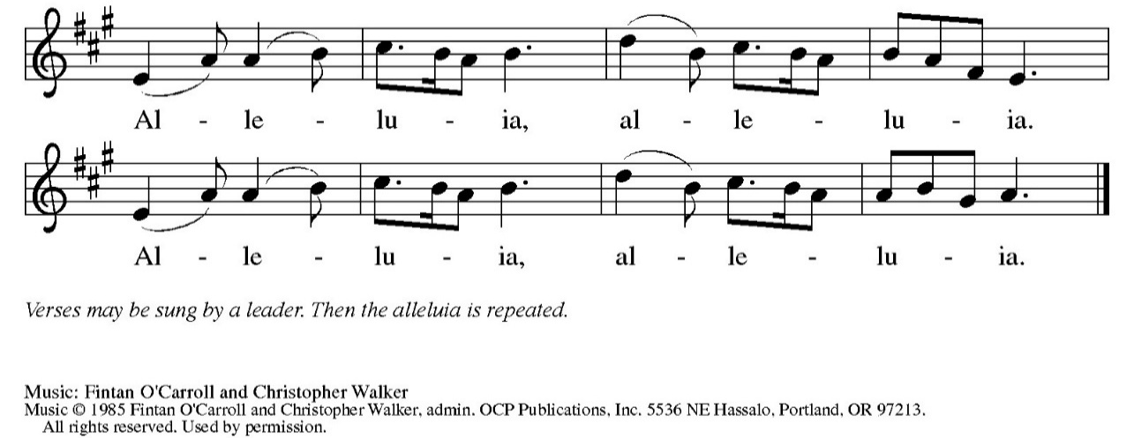

The Holy Gospel according to St. Luke the twelfth chapter
Glory to you, O Lord.

GOSPEL READING: Luke 12:16-21
The Gospel of the Lord. Praise to you, O Christ.

SERMON Rev. Benjamin Morris

HYMN of the DAY ELW (red hymnal) #689 Praise and Thanksgiving

APOSTLES’ CREED ELW (red hymnal) Page 105
PRAYERS of INTERCESSION
Petitions end: Hear us, O God,...Your mercy is great.

PASSING OF THE PEACE
Please be aware of those who may not be comfortable shaking hands. You may also share the peace sign. Or any other contactless gesture that you are comfortable with.

OFFERING & NOISY OFFERING (Sunday School) & SOLO
OFFERTORY ELW (red hymnal) #182 Let the Vineyards Be Fruitful
Let the vineyards be fruitful, Lord, and ﬁll to the brim our cup of blessing.
Gather a harvest from the seeds that were sown,
that we may be fed with the bread of life.
Gather the hopes and the dreams of all;
unite them with the prayers we offer now.
Grace our table with your presence,
and give us a foretaste of the feast to come.
Text © 1978 Lutheran Book of Worship, admin. Augsburg Fortress.
OFFERTORY PRAYER
God of creation, you send rain and the earth springs forth abundantly.
All blessings are from you; make us generous with what we have.
Use our gifts, our abilities, and our hearts in service to you and in love to our neighbors, today and always. Amen.

THE LORD’S PRAYER

~ SENDING ~
God blesses us and sends us in mission to the world
BLESSING
The God of grace ☩ bless you now and forever.
Amen

BELLS
SENDING HYMN ELW (red hymnal) #546 To Be Your Presence

DISMISSAL Go out in joy. Be led forth in peace. Thanks be to God.

POSTLUDE

Reprinted / podcast / streamed with permission under ONE LICENSE #A-738444. All rights reserved

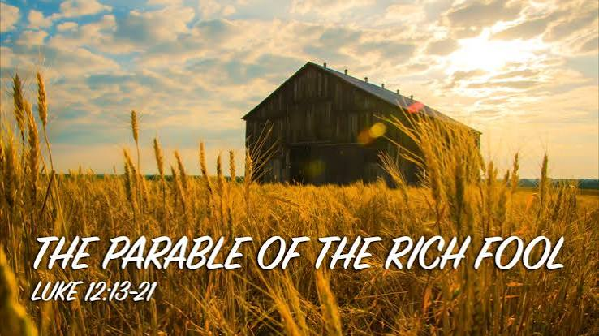
COON VALLEY LUTHERAN CHURCH
Twentyfirst Sunday of Pentecost
Sunday, October 18, 2026

Coffee Servers: Meatball Dinner
Offering Counters: Patty Nelson, Cody Strangstalien
Usher: Mike Lusk
Reader: Helen Haley
Attendance & Offering Last Sunday: 9:00a/86; $3,308.35
Sunday School Attendance last Sunday:9


Scan this code with your phone to contribute electronically with Vanco.

SCHEDULE

TODAY: 11:00a/Meatball Dinner; 6:00-7:30p/Confirmation
MONDAY: 1:00-6:00p/Blood Drive
TUESDAY: 9:00a/Pastor’s Text Study
WEDNESDAY: 5:00-7:00p/Table Together Community Meal
THURSDAY: 10:00a/Bible Study
FRIDAY: Pastor Ben’s Sabbath
NEXT SUNDAY: 10:30a/Worship with Pr. Meg Hoversten; 10:00a/Sunday School

Coon Valley Lutheran Church
www.coonvalleylutheranchurch.org
Pastor: Rev. Benjamin Morris, Office 452-3772/Cell 608-406-1556, pastor@coonvalleylutheranchurch.org
Office Administrator: Jamie Thomas, office@coonvalleylutheranchurch.org
Office Hours: Tues. -Thurs 9:00a-3:30p
Office 452-3772
Treasurer: Becky Lusk, treasurer@coonvalleylutheranchurch.org
Organist: Aaron Stakston
Indoor Custodian: Tracy Stellner

Genesis 41:14-36
¹⁴ Then Pharaoh sent for Joseph, and he was hurriedly brought out of the dungeon. When he had shaved himself and changed his clothes, he came in before Pharaoh. ¹⁵ And Pharaoh said to Joseph, “I had a dream, and there is no one who can interpret it. I have heard it said of you that when you hear a dream you can interpret it.” ¹⁶ Joseph answered Pharaoh, “It is not I; God will give Pharaoh a favorable answer.” ¹⁷ Then Pharaoh said to Joseph, “In my dream I was standing on the banks of the Nile, ¹⁸ and seven cows, fat and sleek, came up out of the Nile and fed in the reed grass. ¹⁹ Then seven other cows came up after them, poor, very ugly, and thin. Never had I seen such ugly ones in all the land of Egypt. ²⁰ The thin and ugly cows ate up the first seven fat cows, ²¹ but when they had eaten them no one would have known that they had done so, for they were still as ugly as before. Then I awoke. ²² I fell asleep a second time, and I saw in my dream seven ears of grain, full and good, growing on one stalk, ²³ and seven ears, withered, thin, and blighted by the east wind, sprouting after them, ²⁴ and the thin ears swallowed up the seven good ears. But when I told it to the magicians, there was no one who could explain it to me.”
²⁵ Then Joseph said to Pharaoh, “Pharaoh’s dreams are one and the same; God has revealed to Pharaoh what he is about to do. ²⁶ The seven good cows are seven years, and the seven good ears are seven years; the dreams are one. ²⁷ The seven lean and ugly cows that came up after them are seven years, as are the seven empty ears blighted by the east wind. They are seven years of famine. ²⁸ It is as I told Pharaoh; God has shown to Pharaoh what he is about to do. ²⁹ There will come seven years of great plenty throughout all the land of Egypt. ³⁰ After them there will arise seven years of famine, and all the plenty will be forgotten in the land of Egypt; the famine will consume the land. ³¹ The plenty will no longer be known in the land because of the famine that will follow, for it will be very grievous. ³² And the doubling of Pharaoh’s dream means that the thing is fixed by God, and God will shortly bring it about. ³³ Now therefore let Pharaoh select a man who is discerning and wise and set him over the land of Egypt. ³⁴ Let Pharaoh proceed to appoint overseers over the land and take one-fifth of the produce of the land of Egypt during the seven plenteous years. ³⁵ Let them gather all the food of these good years that are coming and lay up grain under the authority of Pharaoh for food in the cities, and let them keep it. ³⁶ That food shall be a reserve for the land against the seven years of famine that are to befall the land of Egypt, so that the land may not perish through the famine.”

Word of God. Word of Life. Thanks be to God.

The Holy Gospel according to St. Luke the twelfth chapter
Glory to you, O Lord.

GOSPEL: Luke 12:16-21

¹⁶ Then he told them a parable: “The land of a rich man produced abundantly. ¹⁷ And he thought to himself, ‘What should I do, for I have no place to store my crops?’ ¹⁸ Then he said, ‘I will do this: I will pull down my barns and build larger ones, and there I will store all my grain and my goods. ¹⁹ And I will say to my soul, Soul, you have ample goods laid up for many years; relax, eat, drink, be merry.’ ²⁰ But God said to him, ‘You fool! This very night your life is being demanded of you. And the things you have prepared, whose will they be?’ ²¹ So it is with those who store up treasures for themselves but are not rich toward God.”

The Gospel of the Lord. Praise to you, O Christ.

*We are always so happy to include you and our CVLC family in our prayers. If you feel your name, or the name of a family member can be added or removed from this list please contact Jamie. Thank you!

We remember in prayer:
† Those hospitalized this past week:
† Our members whose names we lift up in prayer today: Corrine Appleman, Beverly Bagstad, Clifford Bakkum, Pastor Barbara Bruneau, Ellie Brye, Herby Cornell, Ardell Daffinrud, Gloria Galstad, Kira Hoff, Becky Ihle, Donna Ihle, Ray Ihle, Julie Kruizenga, Margaret Lee, Russell Lee, Aaron Leisso, Aaron Marx, Bob Nelson, Julie Nelson, LuEtta Nelson, Mike Nelson, Romaine Nelson, Sandra Onshus, Elaine Proksch, Eunice Quast, Lori Roach, Jojo Satona, Heidi Saupe, Orrin Stakston, LaVonne Stendahl, Kevin Traastad, Renita Williamson
† Our members who are currently in health care facilities & Assisted Living: Tip Bagstad, Mike Brye, Carl Daffinrud, Jeanne Ebli, Carl Holte, Patty Helgerson, Bob Moilien, Geri Nestingen, Irene Nestingen, Cathy Ofte, Annie Olson, Beatrice Olson (Alden), Elaine Proksch, Ellen Runice, Bob & Evelyn Schulze.
† Those who grieve: Family and friends of Joyce Temp
† Our members who are currently home bound
† All those in need of God’s healing and help
† All those affected by recent storms
† Family and friends of our members
† Local Military: Alex Hendrickson

