COON VALLEY LUTHERAN CHURCH
“We are a family of God, striving to enrich
the lives of all through the love of Christ.”
PRELUDE MUSIC
BELLS
WELCOME and ANNOUNCEMENTS

THANKSGIVING FOR BAPTISM
Alleluia! Christ is risen.
Christ is risen indeed. Alleluia!
Salvation belongs to our God who is seated on the throne
and to the Lamb!
Amen.
Let us give thanks for the gifts of baptism.
Water may be poured into the font as the presiding minister continues.
Merciful God,
you are the one who was, who is, and who is to come.
You lead us beside still waters.
We thank you for the waters of creation:
morning dew, gentle rain, roaring waves.
We thank you for the waters that nourish us (local waters may be named).
Blessed are you.
You guide us to springs of the water of life.
Jesus Christ, you are the faithful witness
who accompanies us on our journeys.
We give you thanks for your life-giving death and resurrection.
We praise you for joining us in joy and sorrow.
Blessed are you.
You guide us to springs of the water of life.
Holy Spirit, you anoint our head with oil and our cup overflows.
Break down barriers that divide us.
Fill us with the breath of peace.
Blessed are you.
You guide us to springs of the water of life.
Holy One, we thank you for the gifts and grace of baptism,
and for making us a new creation.
We join with saints and angels, giving you honor and praise,
now and forever.
Amen.
GATHERING HYMN ELW (red hymnal) #657 Rise, O Sun of Righteousness
PRAYER OF THE DAY
God who calls us into service, transform us as you transformed Paul. Shape us into children who rejoice in knowing and proclaiming you to the world. Amen.
GREET THE WORD- ACS (purple hymnal) #976 Sung 1 time
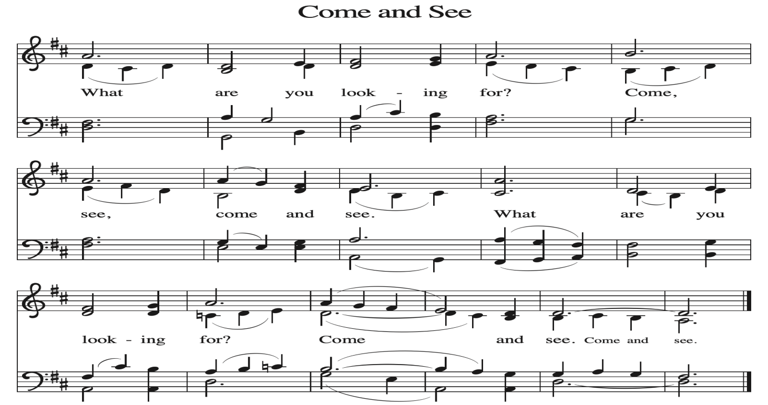
~ Proclamation of the WORD ~ (Scripture insert)
God speaks to us in scripture reading, preaching, and song.

READING: ACTS 9:1-19a
Word of God. Word of Life. Thanks be to God.
SERMON Rev. Benjamin Morris

HYMN of the DAY ELW (red hymnal) #793 Be Thou My Vision

NICENE CREED ELW (red hymnal) Page 104

PRAYERS of INTERCESSION
Petitions end: Merciful God,...receive our prayer.

PASSING OF THE PEACE
Please be aware of those who may not be comfortable shaking hands. You may also share the peace sign. Or any other contactless gesture that you are comfortable with.

OFFERING & SOLO
OFFERTORY ELW (red hymnal) #186 Create in Me a Clean Heart, O Lord

OFFERTORY PRAYER
Merciful God, accept the fruits of our labor, gathered to give you glory.
You have set a table before us, a glimpse of that great day when we will hunger and thirst no more. Nourish us with the body and blood of Jesus,
that goodness and mercy may follow us and bless the world you love.
In the name of Jesus, Amen.

THANKSGIVING FOR THE WORD
O God of justice and love, we give thanks to you that you illumine our way through life with the words of your Son. Give us the light we need, awaken us to the needs of others, and at the end bring all the world to your feast; through Jesus Christ, our Savior and Lord, to whom, with you and the Holy Spirit, be honor and glory forever. Amen.

THE LORD’S PRAYER

~ SENDING ~
God blesses us and sends us in mission to the world
BLESSING
God Almighty, who is the beginning and the end, Jesus Christ, the firstborn of the dead,
and the Spirit, our advocate and peace, ☩ bless you now and forever. Amen.

BELLS
SENDING HYMN ELW (red hymnal) #593 Drawn to the Light

DISMISSAL
Go in peace. Praise the Lord. Alleluia! Thanks be to God. Alleluia!

POSTLUDE

Reprinted / podcast / streamed with permission under ONE LICENSE #A-738444. All rights reserved



COON VALLEY LUTHERAN CHURCH
Sunday, April 26, 2026
Fourth Sunday of Easter

