COON VALLEY LUTHERAN CHURCH
January 4, 2026 9:00am
“We are a family of God, striving to enrich
the lives of all through the love of Christ.”
PRELUDE MUSIC
BELLS
WELCOME and ANNOUNCEMENTS

CONFESSION & FORGIVENESS
Blessed be the holy Trinity, ☩ one God, Wonderful Counselor,
Mighty Savior, Prince of Peace.
Amen.
Trusting in God’s steadfast love and faithfulness,
let us confess our sin.
Silence is kept for reflection.
Reconciling God,
we yearn for your presence to transform our grief, pain, and despair.
We confess that we have not always prepared room in our hearts for your love; we have not always recognized your presence among us; we have not always embraced your message of peace. We cry out, weary with the burden of violence, oppression, and fear. We confess our failure to make room for those seeking refuge; our participation in violent systems
that harm your innocent ones; our reluctance to embody your good news.
Be born in us today and teach us to sing the joyful song of your salvation.
Amen.
God’s grace upon grace flows over you.
☩ Christ’s presence redeems the whole creation.
Your sins are forgiven. Let the earth rejoice and be glad!
Amen.

GATHERING HYMN ELW (red hymnal) #302 As with Gladness Men of Old
PRAYER OF THE DAY
God of all people, You called many by name, asking them to follow Jesus and obey. Call us by name, and help us to follow and obey. Amen

GREET THE WORD- ACS (purple hymnal) #976
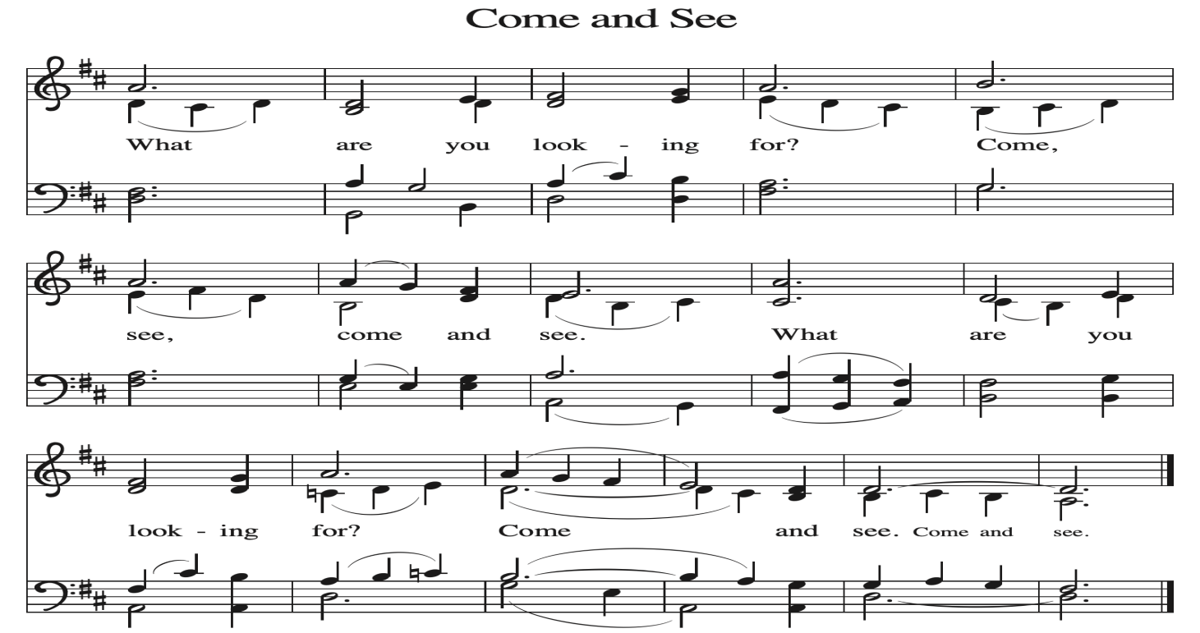
~ Proclamation of the WORD ~ (Scripture insert)
God speaks to us in scripture reading, preaching, and song.

GOSPEL READING: JOHN 1:35-51
The Gospel of the Lord. Praise to you, O Christ.
SERMON Rev. Ben Morris

HYMN of the DAY ELW (red hymnal) #798 Will You Come and Follow Me

APOSTLES’ CREED ELW (red hymnal) Page 105

PRAYERS of INTERCESSION
Petitions end: Hear us, O God……..Your mercy is great.

PASSING OF THE PEACE
Please be aware of those who may not be comfortable shaking hands. You may also share the peace sign. Or any other contactless gesture that you are comfortable with.

OFFERING & SOLO

OFFERTORY ELW (red hymnal) #186 Create in Me a Clean Heart, O Lord

OFFERTORY PRAYER
God of glory, great are your wonders among us and many are the blessings you bestow. Use us and these your gifts for the needs of the world,
that all the ends of the earth may rejoice in your saving grace, through Christ our Savior. Amen.

THE LORD’S PRAYER

COMMUNION and SOLO

POST-COMMUNION BLESSING and PRAYER
Incarnate God, you are among us at this table. May we treasure this gift and ponder in our hearts the mystery of your presence. Move us to discover the wonders of your love in the everyday moments of our lives, through Christ born in us.
Amen.

~ SENDING ~
God blesses us and sends us in mission to the world

BLESSING
The triune God, glorious Mystery, holy Incarnate One, abiding Comforter,
☩ bless you with endless grace, peace, and joy. Amen.

BELLS
SENDING HYMN ELW (red hymnal) #269 Once in Royal David’s City

DISMISSAL
Glory to God in the highest!
And peace to God’s people on earth!
Go in joy. Embody God’s redeeming grace.
Thanks be to God.

POSTLUDE

Reprinted / podcast / streamed with permission under ONE LICENSE #A-738444. All rights reserved.

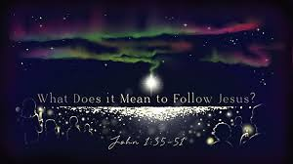

Coon Valley Lutheran Church
The Second Sunday of Christmas
January 4, 2026
9:00 a.m.

Coffee Servers: Kari Coaty, Sharon Holte
Usher: Tim Hatlan
Reader: Nancy King


Scan this code with your phone to contribute electronically with Vanco.

SCHEDULE
TODAY: 9:00a/Worship; 10:15a/Coffee Fellowship; 6:00p/Confirmation
MONDAY: Annual Report Deadline
TUESDAY: 9:00a/Pastor’s Text Study
THURSDAY: 10:00a/Bible Study
FRIDAY: Pastor Ben’s sabbath
NEXT SUNDAY: 9:00a/Worship with Holy Communion; 10:15a/Coffee Fellowship& Sunday School; Finance, Audit, Endowment & Retro Committee meetings

Offering envelopes are available. They are located on a table in the Library. Please pick them up for family, friends or neighbors!
Coon Valley Lutheran Church
www.coonvalleylutheranchurch.org
Pastor: Rev. Benjamin Morris, Office 452-3772/Cell 608-406-1556, pastor@coonvalleylutheranchurch.org
Office Administrator: Jamie Thomas, office@coonvalleylutheranchurch.org
Office Hours: Tuesday, 9:00-4:00p; Wednesday, 9a-2:30p; Thursday 9:00a-3:30p
Office 452-3772/Cell 317-0007
Treasurer: Becky Lusk, treasurer@coonvalleylutheranchurch.org
Organist: Mary Schultz
Indoor Custodian: Tracy Stellner

Remember "Thumbs Up" When you come up for communion if you would like a gluten free wafer, give the wafer server a thumbs up as you approach. As you approach the wine server, give him or her a thumbs up to receive grape juice instead of wine.

Jan. 4

GOSPEL: John 1:35-51
³⁵ The next day John again was standing with two of his disciples,
³⁶ and as he watched Jesus walk by he exclaimed, “Look, here is the Lamb of God!”
³⁷ The two disciples heard him say this, and they followed Jesus.
³⁸ When Jesus turned and saw them following, he said to them, “What are you looking for?” They said to him, “Rabbi” (which translated means Teacher), “where are you staying?”
³⁹ He said to them, “Come and see.” They came and saw where he was staying, and they remained with him that day. It was about four o’clock in the afternoon.
⁴⁰ One of the two who heard John speak and followed him was Andrew, Simon Peter’s brother.
⁴¹ He first found his brother Simon and said to him, “We have found the Messiah” (which is translated Anointed).
⁴² He brought Simon to Jesus, who looked at him and said, “You are Simon son of John. You are to be called Cephas” (which is translated Peter).
⁴³ The next day Jesus decided to go to Galilee. He found Philip and said to him, “Follow me.”
⁴⁴ Now Philip was from Bethsaida, the city of Andrew and Peter.
⁴⁵ Philip found Nathanael and said to him, “We have found him about whom Moses in the Law and also the Prophets wrote, Jesus son of Joseph from Nazareth.”
⁴⁶ Nathanael said to him, “Can anything good come out of Nazareth?” Philip said to him, “Come and see.”
⁴⁷ When Jesus saw Nathanael coming toward him, he said of him, “Here is truly an Israelite in whom there is no deceit!”
⁴⁸ Nathanael asked him, “Where did you get to know me?” Jesus answered, “I saw you under the fig tree before Philip called you.”
⁴⁹ Nathanael replied, “Rabbi, you are the Son of God! You are the King of Israel!”
⁵⁰ Jesus answered, “Do you believe because I told you that I saw you under the fig tree? You will see greater things than these.”
⁵¹ And he said to him, “Very truly, I tell you, you will see heaven opened and the angels of God ascending and descending upon the Son of Man.”
The Gospel of the Lord. Praise to you, O Christ.

*We are always so happy to include you and our CVLC family in our prayers. If you feel your name, or the name of a family member can be added or removed from this list please contact Jamie. Thank you!

We remember in prayer:
† Those hospitalized this past week
† Our members whose names we lift up in prayer today: Corrine Appleman, Beverly Bagstad, Clifford Bakkum, Pastor Barbara Bruneau, Herby Cornell, Rita Erlandson, Gloria Galstad, Kira Hoff, Becky Ihle, Donna Ihle, Ray Ihle, Eddie Kanieski, Todd King, Margaret Lee, Russell Lee, Aaron Leisso, Aaron Marx, LuEtta Nelson, Romaine Nelson, Sandra Onshus, Elaine Proksch, Eunice Quast, Lori Roach, Jojo Satona, Heidi Saupe, Mary Schultz, LaVonne Stendahl, Krin (Dreves) Stendalen, Joyce Temp, Teri Tomten, Maggie Traastad, Renita Williamson
† Our members who are currently in health care facilities & Assisted Living:
Tip Bagstad, Rachel Berg, Carl Daffinrud, Jeanne Ebli, Carl Holte, Bob Moilien, Geri Nestingen, Irene Nestingen, Cathy Ofte, Annie Olson, Beatrice Olson (Alden),
Ellen Runice, Bob & Evelyn Schulze.
† Those who grieve
† Our members who are currently home bound
† All those in need of God’s healing and help
† Family and friends of our members
† Local Military: Alex Hendrickson

