COON VALLEY LUTHERAN CHURCH
“We are a family of God, striving to enrich
the lives of all through the love of Christ.”
PRELUDE MUSIC
BELLS
WELCOME and ANNOUNCEMENTS

CONFESSION AND FORGIVENESS
Blessed be the holy Trinity, ☩ one God, whose compassion endures forever.
Amen.
Let us confess our sin to God.
Silence is kept for reflection.
Compassionate God,
we confess to you all our sins.
Our burden is heavy, and we cannot free ourselves.
In your mercy, call us back to you.
Your yoke is easy and your burden is light.
Restore us to dwell in your peace.
In Christ’s name we pray,
Amen.
Jesus says, “Come to me,
all you who are weary
and are carrying heavy burdens,
and I will give you rest.”
In the name of God,
Father, ☩ Son, and Holy Spirit,
your sins are forgiven.
Rest in God’s love.
Amen.

GATHERING HYMN ELW (red hymnal) #581 You Are Mine

PRAYER OF THE DAY
Teach us, good Lord God, to serve you as you deserve, to give and not to count the cost, to fight and not to heed the wounds, to toil and not to seek for rest, to labor and not to ask for reward, except that of knowing that we do your will, through Jesus Christ, our Savior and Lord. Amen.

GREET THE WORD- ACS (purple hymnal) #976 Sung 1 time
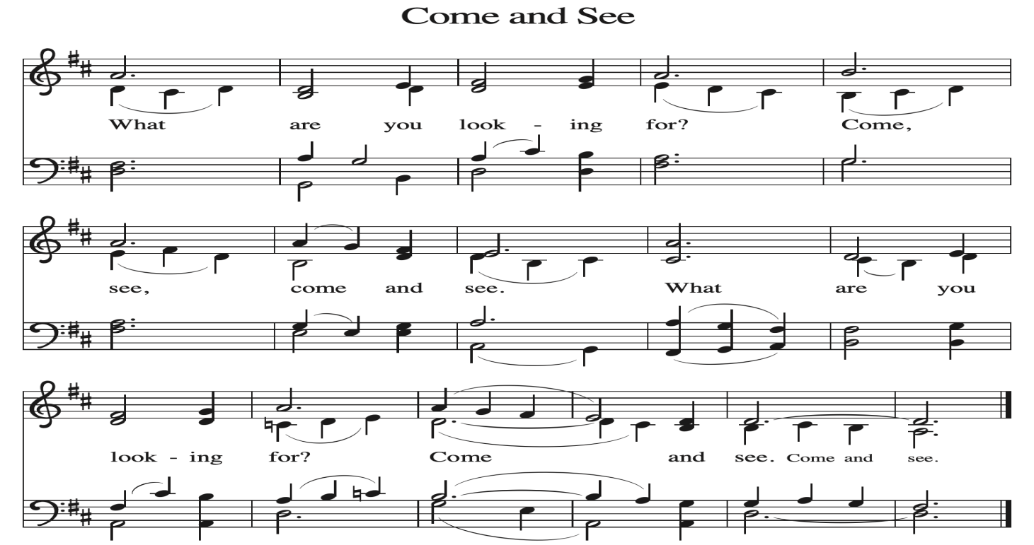
~ Proclamation of the WORD ~ (Scripture insert)
God speaks to us in scripture reading, preaching, and song.

FIRST READING: Romans 6:1-11

PSALM 69:7-10 (read responsively)

The Holy Gospel according to St. Matthew the tenth chapter
Glory to you, O Lord.

GOSPEL READING: Matthew 10:24-39
The Gospel of the Lord. Praise to you, O Christ.

SERMON Rev. Margaret Hoversten

HYMN of the DAY ELW (red hymnal) #781 Children of the Heavenly Father

APOSTLES’ CREED ELW (red hymnal) Page 105
PRAYERS of INTERCESSION
Petitions end: God of grace,...hear our prayer.

PASSING OF THE PEACE
Please be aware of those who may not be comfortable shaking hands. You may also share the peace sign. Or any other contactless gesture that you are comfortable with.

OFFERING & SOLO
OFFERTORY ELW (red hymnal) #186 Create in Me a Clean Heart, O Lord

OFFERTORY PRAYER
Loving God, we offer at your table the gifts of our hearts. Help us take heart in you and share freely of your love, so that all creation can taste your abundance. We ask this in the name of Jesus, through the Spirit abiding with us now and forever. Amen.

THANKSGIVING FOR THE WORD
O God of justice and love, we give thanks to you that you illumine our way through life with the words of your Son. Give us the light we need, awaken us to the needs of others, and at the end bring all the world to your feast; through Jesus Christ, our Savior and Lord, to whom, with you and the Holy Spirit, be honor and glory forever. Amen.

THE LORD’S PRAYER

~ SENDING ~
God blesses us and sends us in mission to the world
BLESSING
Creator, Redeemer, Sustainer, ☩ one God, bless, heal, and hold you
today and always. Amen.

BELLS
SENDING HYMN ELW (red hymnal) #537 On Our Way Rejoicing

DISMISSAL
Heaven has come near. Go, share the good news!
Thanks be to God.

POSTLUDE

Reprinted / podcast / streamed with permission under ONE LICENSE #A-738444. All rights reserved

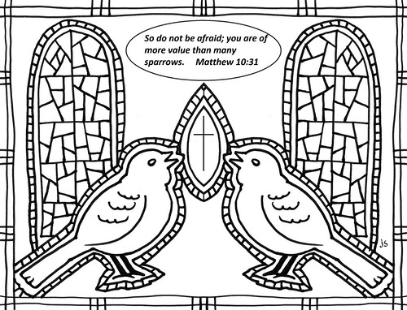

COON VALLEY LUTHERAN CHURCH
Fourth Sunday of Pentecost
Sunday, June 21, 2026

~Bulletins are in memory of Phillip Stakston and John Jacobson from Orrin & Becky Stakston

Piano/Organ: Aaron Stakston
Usher: Cody Strangstalien
Reader: Kevin King
Attendance & Offering Last Sunday: 9:00a/80; $5,038.07


Scan this code with your phone to contribute electronically with Vanco.

SCHEDULE

WEDNESDAY: 9:00a/Quilting
THURSDAY: No Bible Study
NEXT SUNDAY: 10:00a/Outdoor Worship at Veterans Memorial Park, Men’s Club Cookout to follow-Bring a chair for worship!

*Please note that Pastor Ben will be on vacation Friday June 19-Saturday June 27. During this time, please contact Jamie with any needs. 608-317-0007
Coon Valley Lutheran Church
www.coonvalleylutheranchurch.org
Pastor: Rev. Benjamin Morris, Office 452-3772/Cell 608-406-1556, pastor@coonvalleylutheranchurch.org
Office Administrator: Jamie Thomas, office@coonvalleylutheranchurch.org
Office Hours: Tues. 9a-1p, Wed. 9a-3p
Office 452-3772
Treasurer: Becky Lusk, treasurer@coonvalleylutheranchurch.org
Organist:
Indoor Custodian: Tracy Stellner

Romans 6:1-11

6 What then are we to say? Should we continue in sin in order that grace may increase? ² By no means! How can we who died to sin go on living in it? ³ Do you not know that all of us who were baptized into Christ Jesus were baptized into his death? ⁴ Therefore we were buried with him by baptism into death, so that, just as Christ was raised from the dead by the glory of the Father, so we also might walk in newness of life. ⁵ For if we have been united with him in a death like his, we will certainly be united with him in a resurrection like his. ⁶ We know that our old self was crucified with him so that the body of sin might be destroyed, so we might no longer be enslaved to sin. ⁷ For whoever has died is freed from sin. ⁸ But if we died with Christ, we believe that we will also live with him. ⁹ We know that Christ, being raised from the dead, will never die again; death no longer has dominion over him. ¹⁰ The death he died, he died to sin once for all, but the life he lives, he lives to God. ¹¹ So you also must consider yourselves dead to sin and alive to God in Christ Jesus.
Word of God. Word of Life. Thanks be to God.

Psalm 69:7-10 (read responsively)
⁷ It is for your sake that I have borne reproach,
that shame has covered my face.
⁸ I have become a stranger to my kindred,
an alien to my mother’s children.
⁹ It is zeal for your house that has consumed me;
the insults of those who insult you have fallen on me.
¹⁰ When I humbled my soul with fasting,
they insulted me for doing so.

GOSPEL: Matthew 10:24-39
²⁴ “A disciple is not above the teacher nor a slave above the master; ²⁵ it is enough for the disciple to be like the teacher and the slave like the master. If they have called the master of the house Beelzebul, how much more will they malign those of his household!
²⁶ “So have no fear of them, for nothing is covered up that will not be uncovered and nothing secret that will not become known. ²⁷ What I say to you in the dark, tell in the light, and what you hear whispered, proclaim from the housetops. ²⁸ Do not fear those who kill the body but cannot kill the soul; rather, fear the one who can destroy both soul and body in hell. ²⁹ Are not two sparrows sold for a penny? Yet not one of them will fall to the ground apart from your Father. ³⁰ And even the hairs of your head are all counted. ³¹ So do not be afraid; you are of more value than many sparrows.
³² “Everyone, therefore, who acknowledges me before others, I also will acknowledge before my Father in heaven, ³³ but whoever denies me before others, I also will deny before my Father in heaven.
³⁴ “Do not think that I have come to bring peace to the earth; I have not come to bring peace but a sword.
³⁵ For I have come to set a man against his father,
and a daughter against her mother,
and a daughter-in-law against her mother-in-law,
³⁶ and one’s foes will be members of one’s own household.
³⁷ “Whoever loves father or mother more than me is not worthy of me, and whoever loves son or daughter more than me is not worthy of me, ³⁸ and whoever does not take up the cross and follow me is not worthy of me. ³⁹ Those who find their life will lose it, and those who lose their life for my sake will find it.
The Gospel of the Lord. Praise to you, O Christ.

*We are always so happy to include you and our CVLC family in our prayers. If you feel your name, or the name of a family member can be added or removed from this list please contact Jamie. Thank you!

We remember in prayer:
† Those hospitalized this past week:
† Our members whose names we lift up in prayer today: Corrine Appleman, Beverly Bagstad, Clifford Bakkum, Pastor Barbara Bruneau, Ellie Brye, Herby Cornell, Ardell Daffinrud, Gloria Galstad, Kira Hoff, Becky Ihle, Donna Ihle, Ray Ihle, Margaret Lee, Russell Lee, Aaron Leisso, Aaron Marx, LuEtta Nelson, Romaine Nelson, Sandra Onshus, Elaine Proksch, Eunice Quast, Lori Roach, Jojo Satona, Heidi Saupe, Orrin Stakston, LaVonne Stendahl, Krin (Dreves) Stendalen, Joyce Temp, Jamie Thomas, Renita Williamson
† Our members who are currently in health care facilities & Assisted Living:
Tip Bagstad, Rachel Berg, Carl Daffinrud, Jeanne Ebli, Carl Holte, Patty Helgerson, Bob Moilien, Geri Nestingen, Irene Nestingen, Cathy Ofte, Annie Olson, Beatrice Olson (Alden), Elaine Proksch, Ellen Runice, Bob & Evelyn Schulze.
† Those who grieve: Family and friends of Helen Holen
† Our members who are currently home bound
† All those in need of God’s healing and help
† All those affected by recent storms
† Family and friends of our members
† Local Military: Alex Hendrickson

