COON VALLEY LUTHERAN CHURCH
“We are a family of God, striving to enrich
the lives of all through the love of Christ.”

~ GATHERING ~
The Holy Spirit calls us together as the people of God.
PRELUDE Mary Schultz
WELCOME and ANNOUNCEMENTS
CONFESSION AND FORGIVENESS
Blessed be the holy Trinity,+ one God, who greets us in this and every season,
whose word never fails, whose promise is sure. Amen.

Let us confess our sin in the presence of God and of our neighbors.

Merciful God,
we confess that we have sinned.
We have hurt our community.
We have squandered your blessings.
We have hoarded your bounty.
In the name of Jesus,
forgive us and grant us your mercy.

Silence is kept for reflection.

God is a cup of cold water when we thirst. God offers boundless grace when we fail. Claim the gift of God's mercy: you are freed and forgiven
in the name of + Jesus Christ. Amen.

GATHERING HYMN #632 O God, Our Help in Ages Past

GREETING and PRAYER of the DAY
The grace of our Lord Jesus Christ, the love of God, and the communion of the Holy Spirit be with you all. And also with you.

O God our defender, storms rage around and within us and cause us to be afraid. Rescue your people from despair, deliver your sons and daughters from fear, and preserve us in the faith of your Son, Jesus Christ, our Savior and Lord. Amen.

~ WORD ~ (Scripture insert)
God speaks to us in scripture reading, preaching, and song.
FIRST READING: 1 Kings 19:9-18
PSALM 85:8-13(Read responsively)
SECOND READING: Romans 10:5-15
GOSPEL: Matthew 14:22-33
Response after the Gospel reading: Praise to you, O Christ.

SERMON Pastor Barbara Bruneau
HYMN of the DAY #785 When Peace like a River

~ RESPONSE TO THE WORD ~
The Holy Spirit calls us as a community to say what we believe,
reach out to each other and offer gifts and prayers for God’s purposes.

THE APOSTLES’ CREED
I believe in God, the Father Almighty,
Creator of Heaven and earth;
I believe in Jesus Christ, God’s only Son Our Lord,
who was conceived by the Holy Spirit,
born of the Virgin Mary,
suffered under Pontius Pilate,
was crucified, died, and was buried;
he descended to the dead.
On the third day he rose again;
he ascended into heaven,
he is seated at the right hand of the Father,
and he will come to judge the living and the dead.
I believe in the Holy Spirit,
the holy catholic church,
the communion of saints,
the forgiveness of sins,
the resurrection of the body,
and the life everlasting. Amen.

PRAYERS of INTERCESSION
Petitions end: Hear us, O God…Your mercy is great.

OFFERING and OFFERING SONG #823 Praise the Lord! O Heavens

OFFERING PRAYER
God of field and forest, sea and sky, you are the giver of all good things.
Sustain us with these gifts of your creation, and multiply your graciousness in us, that the world may be fed with your love, through Jesus Christ, our Savior and Lord. Amen.

THE GREAT THANKSGIVING
The Lord be with you. And also with you.
Lift up your hearts. We lift them to the Lord.
Let us give thanks to the Lord our God.
It is right to give him thanks and praise.

WORDS OF INSTITUTION

THE LORD’S PRAYER
Our Father who art in heaven, hallowed be thy name, thy kingdom come, thy will be done, on earth as it is in heaven.
Give us this day our daily bread; and forgive us our trespasses,
as we forgive those who trespass against us;
and lead us not into temptation, but deliver us from evil.
For thine is the kingdom, and the power, and the glory,
forever and ever. Amen.

THE COMMUNION
Congregational hymns during distribution: #462, #465

POST-COMMUNION BLESSING and PRAYER
Blessed be your name, O God, for we have feasted on your Word,
Christ Jesus, the joy and delight of our hearts. Strengthened by this food, send us to gather the world to your banquet, where none are left out and all are satisfied. In Jesus' name we pray. Amen.
~SENDING ~
God blesses us and sends us in mission to the world.
BLESSING
The God who calls across the cosmos and speaks in the smallest seed
+ bless, keep, and sustain you now and to the end of the age. Amen.
BELLS

DISMISSAL Go in peace. Serve the Lord! Thanks be to God!
SENDING HYMN #756 Eternal Father, Strong to Save
POSTLUDE Mary Schultz
00000000000000000

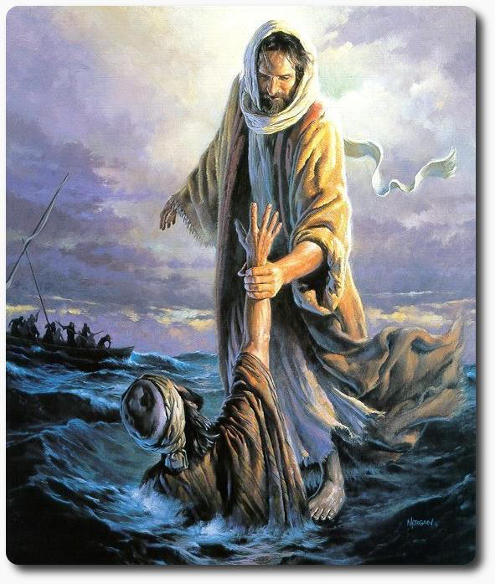

COON VALLEY LUTHERAN CHURCH
THE ELEVENTH SUNDAY IN PENTECOST
August 13, 2023
9:00 a.m.

Head Usher: Jan Bender
Reader: Bruce King
Altar Guild: Jane Simmons, Cindy Swartz
Communion Server: Steve Pauloski
Attendance & Offering Last Sunday: 70; $3,803.66

SCHEDULE
TUESDAY: Carillon Deadline
THURSDAY: 10:00a/WELCA
SUNDAY: 9:00a/Outdoor Worship with Matt Marshall

*In this time as we are without a pastor, if there is an emergency, please contact Jamie at one of the numbers listed below. Thank you!

Coon Valley Lutheran Church
www.coonvalleylutheranchurch.org
Office Administrator: Jamie Thomas, jamiel@mwt.net
Office Hours: Tuesday 9:00a-11:30a; Wednesday & Thursday 9:00a-3:00p
Office 452-3772/Cell 317-0007
Treasurer: Becky Lusk, treasurer1005@mwt.net
Organist: Mary Schultz
Indoor Custodian: Tracy Stellner

FIRST READING: 1 KINGS 19:9-18
At Horeb, the mount of God, Elijah came to a cave, and spent the night there. Then the word of the LORD came to him, saying, “What are you doing here, Elijah?” He answered, “I have been very zealous for the LORD, the God of hosts; for the Israelites have forsaken your covenant, thrown down your altars, and killed your prophets with the sword. I alone am left, and they are seeking my life, to take it away.” He said, “Go out and stand on the mountain before the LORD, for the LORD is about to pass by.” Now there was a great wind, so strong that it was splitting mountains and breaking rocks in pieces before the LORD, but the LORD was not in the wind; and after the wind an earthquake, but the LORD was not in the earthquake; and after the earthquake a fire, but the LORD was not in the fire; and after the fie a sound of sheer silence. When Elijah heard it, he wrapped his face in his mantle and went out and stood at the entrance of the cave. Then there came a voice to him that said, “What are you doing here, Elijah?” He answered, “I have been very zealous for the LORD, the God of hosts; for the Israelites have forsaken your covenant, thrown down your altars, and killed your prophets with the sword. I alone am left, and they are seeking my life, to take it away.” Then the LORD said to him, “Go, return on your way to the wilderness of Damascus; when you arrive, you shall anoint Hazael as king over Aram. Also you shall anoint Jehu son of Nimshi as king over Israel; and you shall anoint Elisha son of Shaphat of Abel-meholah as prophet in your place. Whoever escapes from the sword of Hazael, Jehu shall kill; and whoever escapes from the sword of Jehu, Elisha shall kill. Yet I will leave seven thousand in Israel, all the knees that have not bowed to Baal, and every mouth that has not kissed him.”
The Word of the Lord. Thanks be to God.

PSALM 85:8-13 (read responsively)
Let me hear what God the LORD will speak, for he will speak peace to his people, to his faithful, to those who turn to him in their hearts.
Surely, his salvation is at hand for those who fear him, that his glory may dwell in our land.
Steadfast love and faithfulness will meet; righteousness and peace will kiss each other.
Faithfulness will spring up from the ground, and righteousness will look down from the sky.
The LORD will give what is good, and our land will yield its increase.
Righteousness will go before him, and will make a path for his steps.

SECOND READING: ROMANS 10:5-15
Moses writes concerning the righteousness that comes from the law, that “the person who does these things will live by them.” But the righteousness that comes from faith says, “Do not say in your heart, ‘Who will ascend into heaven?” (that is, to bring Christ down) “or ‘Who will descend into the abyss?’” (that is, to bring Christ up from the dead). But what does it say? “The word is near you, on your lips and in your heart” (that is, the word of faith that we proclaim); because if you confess with your lips that Jesus is Lord and believe in your heart that God raised him from the dead, you will be saved. For one believes with the heart and so is justified, and one confesses with the mouth and so is saved. The scripture says, “No one who believes in him will be put to shame.” For there is no distinction between Jew and Greek; the same Lord is Lord of all and is generous to all who call on him. For, “Everyone who calls on the name of the Lord shall be saved.” But how are they to call on one in whom they have not believed? And how are they to believe in one of whom they have never heard? And how are they to hear without someone to proclaim him? And how are they to proclaim him unless they are sent? As it is written, “How beautiful are the feet of those who bring good news!”
The Word of the Lord. Thanks be to God.

GOSPEL READING: MATTHEW 14:22-33
Jesus made the disciples get into the boat and go on ahead to the other side of the Sea of Galilee, while he dismissed the crowds. And after he had dismissed the crowds, he went up the mountain by himself to pray. When evening came, he was there alone, but by this time the boat, battered by the waves, was far from the land, for the wind was against them. And early in the morning he came walking toward them on the sea. But when the disciples saw him walking on the sea, they were terrified, saying, “It is a ghost!” And they cried out in fear. But immediately Jesus spoke to them and said, “Take heart, it is I; do not be afraid.” Peter answered him, “Lord, if it is you, command me to come to you on the water.” He said, “Come.” So Peter got out of the boat, started walking on the water, and came toward Jesus. But when he noticed the strong wind, he became frightened, and beginning to sink, he cried out, “Lord, save me!” Jesus immediately reached out his hand and caught him, saying to him, “You of little faith, why did you doubt?” When they got into the boat, the wind ceased. And those in the boat worshiped him, saying, “Truly you are the Son of God.”
The Gospel of the Lord. Praise to you, O Christ.

*We are always so happy to include you and our CVLC family in our prayers. If you feel your name, or the name of a family member can be removed from this list please contact Jamie. Thank you!
We remember in prayer:
† Those hospitalized this past week
† Our members whose names we lift up in prayer today: Corrine Appleman, Beverly Bagstad, Clifford Bakkum, Richard Brose, Herby Cornell, Jeanne Ebli, Kira Foster, Phyllis Galstad, Bonnie Holey, Donna Ihle, Verlin Ihle, Alan Jacobson, Todd King, Mike Kellogg, Jim Knutson, Margaret Lee, Russell Lee, Aaron Leisso, Larry Lichtie, Cindy Manske, Aaron Marx, Frank Mathison, Bud Miyamoto, Marianne Myhre, LuEtta Nelson, Romaine Nelson, Sandy Nelson, Cathy Ofte, Lisa Olson, Sandra Onshus, Steve Pauloski, Eunice Quast, Melanie Role, Jojo Satona, Mary Schultz, Billie Slater, LaVonne Stendahl, Larry Strangstalien, Joyce Temp, Teri Tomten.
† Our members who are currently in health care facilities & Assisted Living: Tip Bagstad, Inez Beck, Rachel Berg, Evelyn Dahlen, Joanne Fletcher, Betty Gilbertson, Erma Graupe, Lenore Henley, Carl Holte, Sylvester King Jr., Bob Moilien, Irene Nestingen, Annie Olson, Beatrice Olson (Alden), Betty Sanders.
† Those who grieve: Family & friends of Patty Stuempges
† Our members who are currently home bound
† All those in need of God’s healing and help

