COON VALLEY LUTHERAN CHURCH
“We are a family of God, striving to enrich
the lives of all through the love of Christ.”

~ GATHERING ~
The Holy Spirit calls us together as the people of God.
PRELUDE MUSIC Mary Schultz

BELLS

WELCOME and ANNOUNCEMENTS

CONFESSION AND FORGIVENESS Page 94

GATHERING HYMN #631 Love Divine, All Loves Excelling

PRAYER OF THE DAY
Beloved God, from you come all things that are good. Lead us by the inspiration of your Spirit to know those things that are right, and by your merciful guidance, help us to do them, through Jesus Christ, our Savior and Lord.

10:00 a.m. INSTALLATION OF REV. JAMES SCAIFE AS INTERIM PASTOR
See insert

~ WORD ~ (Scripture insert)
God speaks to us in scripture reading, preaching, and song.
PSALM 80: 7-15 (Read responsively)
READING: Philippians 3:4b-14

SERMON

HYMN of the DAY #826 Thine the Amen

~ RESPONSE TO THE WORD ~
The Holy Spirit calls us as a community to say what we believe,
reach out to each other and offer gifts and prayers for God’s purposes.

PRAYERS of INTERCESSION
Petitions end: Lord in Your Mercy…Hear Our Prayer

OFFERING and OFFERING SONG #546 To Be Your Presence

OFFERING PRAYER
God of field and forest, sea and sky, you are the giver of all good things.
Sustain us with these gifts of your creation, and multiply your graciousness in us, that the world may be fed with your love, through Jesus Christ, our Savior and Lord. Amen.

PASSING OF THE PEACE
The Peace of Christ with you all. And also with you.

WORDS OF INSTITUTION

THE LORD’S PRAYER
Our Father who art in heaven, hallowed be thy name, thy kingdom come, thy will be done, on earth as it is in heaven.
Give us this day our daily bread; and forgive us our trespasses,
as we forgive those who trespass against us;
and lead us not into temptation, but deliver us from evil.
For thine is the kingdom, and the power, and the glory,
forever and ever. Amen.

THE COMMUNION
COMMUNION SOLO Mary Schultz

POST-COMMUNION BLESSING

PRAYER
Blessed be your name, O God, for we have feasted on your Word,
Christ Jesus, the joy and delight of our hearts. Strengthened by this food, send us to gather the world to your banquet, where none are left out and all are satisfied. In Jesus' name we pray. Amen.

~SENDING ~
God blesses us and sends us in mission to the world.
BLESSING

BELLS

SENDING HYMN #723 Canticle of the Turning

DISMISSAL Go in peace. Serve the Lord! Thanks be to God!

POSTLUDE Mary Schultz
00000000000000000

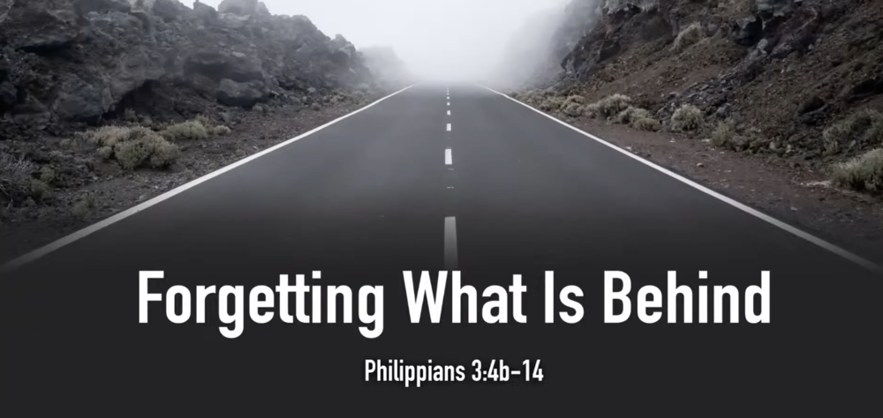

COON VALLEY LUTHERAN CHURCH
THE NINETEENTH SUNDAY OF PENTECOST
October 8, 2023
8:00 a.m. & 10:00 a.m.
Installation of Interim Pastor James Scaife

Coffee Servers: Ellie Brye, Carolyn Anderson
Altar Guild: 8:00/Karen McGarvey; 10:00/
Communion Servers: 8:00/Janice Bender; 10:00/Steve Pauloski
Head Usher: 8:00/Heather Wichman; 10:00/Jason Thomas
Reader: 8:00/Karen McGarvey; 10:00/Mark Hutson
Attendance & Offering Last Sunday: 8:00/52; 10:00/42 = 94
Offering: $2,659.84
Sunday School Attendance: 15

SCHEDULE
WEDNESDAY: 9:00a/Quilting
THURSDAY: 6:00p/Church Council
SATURDAY: 7:00-11a/Lutheran World Relief Boxcar
SUNDAY: 8:00 & 10:00a/Worship; 9:00a/Sunday School; Coffee Fellowship; Confirmation; 11:00a/Finance Committee; 11:00a/Men’s Club Meatball Dinner;
Fall Theological Conference

Coon Valley Lutheran Church
www.coonvalleylutheranchurch.org
Interim Pastor: Jim Scaife
Office Administrator: Jamie Thomas, jamiel@mwt.net
Office Hours: Tuesday, Wednesday, Thursday 9:00a-4:00p
Office 452-3772/Cell 317-0007
Treasurer: Becky Lusk, treasurer1005@mwt.net
Organist: Mary Schultz
Indoor Custodian: Tracy Stellner

PSALM 80:7-15 (read responsively)
Restore us, O God of hosts; let your face shine, that we may be saved.
You Brought a vine out of Egypt; you drove out the nations and planted it.
You cleared the ground for it; it took deep root and filled the land.
The mountains were covered with its shade, the mighty cedars with its branches;
It sent out its branches to the sea, and its shoots to the River.
Why then have you broken down its walls, so that all who pass along the way pluck its fruit?
The boar from the forest ravages it, and all that move in the field feed on it.
Turn again, O God of hosts; look down from heaven, and see; have regard for this vine, the stock that your right hand planted.

READING: PHILIPPIANS 3:4b-14
Paul writes: If anyone else has reason to be confident in the flesh, I have more: Circumcised on the eighth day, a member of the people of Israel, of the tribe of Benjamin, a Hebrew born of Hebrews; as to the law, a Pharisee; as to zeal, a persecutor of the church; as to righteousness under the law, blameless. Yet whatever gains I had, these I have come to regard as loss because of Christ. More than that, I regard everything as loss because of the surpassing value of knowing Christ Jesus my Lord. For his sake I have suffered the loss of all things, and I regard them as rubbish, in order that I may gain Christ and be found in him, not having a righteousness of my own that comes from the law, but one that comes through faith in Christ, the righteousness from God based on faith. I want to know Christ and the power of his resurrection and the sharing of his sufferings by becoming like him in his death, if somehow I may attain the resurrection from the dead. Not that I have already obtained this or have already reached the goal but I press on to make it my own, because Christ Jesus has made me his own. Beloved, I do not consider that I have made it my own; but this one thing I do: forgetting what lies behind and straining forward to what lies ahead, I press on toward the goal for the prize of the heavenly call of God in Christ Jesus.
The Word of the Lord. Thanks be to God.

*We are always so happy to include you and our CVLC family in our prayers. If you feel your name, or the name of a family member can be removed from this list please contact Jamie. Thank you!

We remember in prayer:
† Those hospitalized this past week: Verlin Ihle
† Our members whose names we lift up in prayer today: Corrine Appleman, Beverly Bagstad, Clifford Bakkum, Brian Berg, Richard Brose, Herby Cornell, Jeanne Ebli, Kira Foster, Phyllis Galstad, Jeri Harbaugh, Bonnie Holey, Donna Ihle, Alan Jacobson, Todd King, Mike Kellogg, Jim Knutson, Margaret Lee, Russell Lee, Aaron Leisso, Larry Lichtie, Aaron Marx, Frank Mathison, Bud Miyamoto, Marianne Myhre, LuEtta Nelson, Romaine Nelson, Sandy Nelson, Cathy Ofte, Lisa Olson, Sandra Onshus, Eunice Quast, Lori Roach, Melanie Role, Jojo Satona, Bob Schulze, Mary Schultz, Billie Slater, LaVonne Stendahl, Larry Strangstalien, Joyce Temp, Teri Tomten.
† Our members who are currently in health care facilities & Assisted Living: Tip Bagstad, Inez Beck, Rachel Berg, Evelyn Dahlen, Joanne Fletcher,
Betty Gilbertson, Erma Graupe, Lenore Henley, Carl Holte, Sylvester King Jr., Bob Moilien, Irene Nestingen, Annie Olson, Beatrice Olson (Alden), Betty Sanders.
† Those who grieve: Family and friends of Cindy Manske
† Our members who are currently home bound
† All those in need of God’s healing and help
† Family and friends of our members

