COON VALLEY LUTHERAN CHURCH
“We are a family of God, striving to enrich
the lives of all through the love of Christ.”
PRELUDE MUSIC
BELLS
WELCOME and ANNOUNCEMENTS

CONFESSION AND FORGIVENESS
Blessed be the holy Trinity,☩ one God, whose compassion endures forever.
Amen.
Let us confess our sin to God.
Silence is kept for reflection.
Compassionate God,
we confess to you all our sins.
Our burden is heavy, and we cannot free ourselves.
In your mercy, call us back to you.
Your yoke is easy and your burden is light.
Restore us to dwell in your peace.
In Christ’s name we pray,
Amen.
Jesus says, “Come to me,
all you who are weary
and are carrying heavy burdens,
and I will give you rest.”
In the name of God,
Father, ☩ Son, and Holy Spirit,
your sins are forgiven.
Rest in God’s love.
Amen.

GATHERING HYMN ELW (red hymnal) #Holy, Holy, Holy, Lord God Almighty
PRAYER OF THE DAY
God of heaven and earth, before the foundation of the universe and the beginning of time you are the triune God: Author of creation, eternal Word of salvation, life-giving Spirit of wisdom. Guide us to all truth by your Spirit, that we may proclaim all that Christ has revealed and rejoice in the glory he shares with us. Glory and praise to you, Father, Son, and Holy Spirit, now and forever. Amen.
GREET THE WORD- ACS (purple hymnal) #976 Sung 1 time
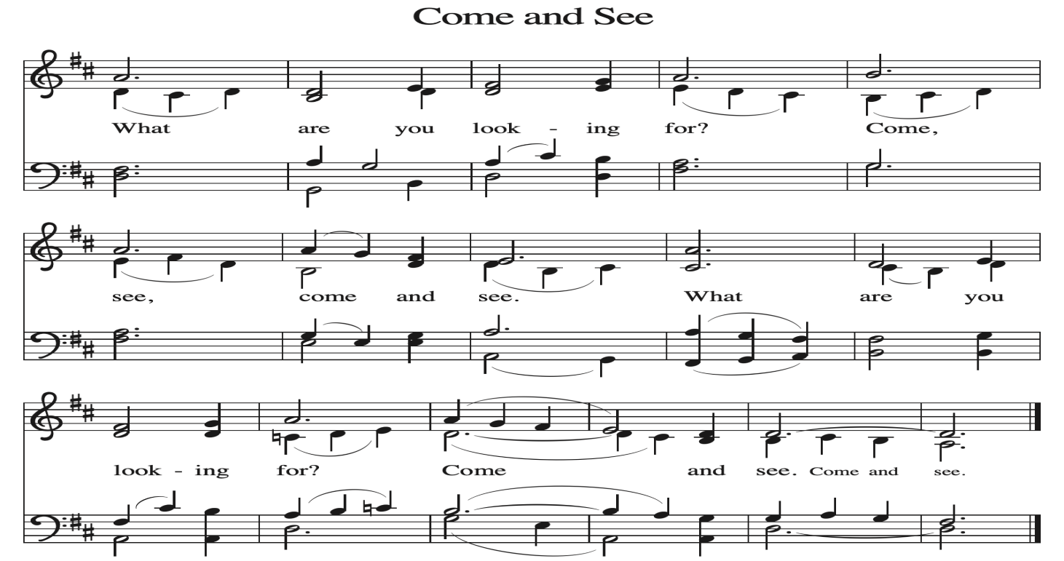
~ Proclamation of the WORD ~ (Scripture insert)
God speaks to us in scripture reading, preaching, and song.

GOSPEL READING: MATTHEW 28:16-20
The Gospel of the Lord. Praise to you, O Christ.

SERMON Rev. Benjamin Morris

HYMN of the DAY ELW (red hymnal) #665 Rise, Shine, You People!

NICENE CREED ELW (red hymnal) Page 104

PRAYERS of INTERCESSION
Petitions end: God of grace,...hear our prayer.

PASSING OF THE PEACE
Please be aware of those who may not be comfortable shaking hands. You may also share the peace sign. Or any other contactless gesture that you are comfortable with.

OFFERING & SOLO
OFFERTORY ELW (red hymnal) #186 Create in Me a Clean Heart, O Lord

OFFERTORY PRAYER
Loving God, we offer at your table the gifts of our hearts.
Help us take heart in you and share freely of your love,
so that all creation can taste your abundance.
We ask this in the name of Jesus,
through the Spirit abiding with us now and forever.
Amen.

THANKSGIVING FOR THE WORD
O God of justice and love, we give thanks to you that you illumine our way through life with the words of your Son. Give us the light we need, awaken us to the needs of others, and at the end bring all the world to your feast; through Jesus Christ, our Savior and Lord, to whom, with you and the Holy Spirit, be honor and glory forever. Amen.

THE LORD’S PRAYER

~ SENDING ~
God blesses us and sends us in mission to the world
BLESSING
Creator, Redeemer, Sustainer, ☩ one God, bless, heal, and hold you
today and always. Amen.

BELLS
SENDING HYMN ELW (red hymnal) #880 O God beyond All Praising

DISMISSAL
Heaven has come near. Go, share the good news!
Thanks be to God.

POSTLUDE

Reprinted / podcast / streamed with permission under ONE LICENSE #A-738444. All rights reserved



COON VALLEY LUTHERAN CHURCH
The Holy Trinity
Sunday, May 31, 2026

