COON VALLEY LUTHERAN CHURCH
“We are a family of God, striving to enrich
the lives of all through the love of Christ.”
PRELUDE MUSIC
BELLS
WELCOME and ANNOUNCEMENTS

THANKSGIVING FOR BAPTISM
Alleluia! Christ is risen.
Christ is risen indeed. Alleluia!
Salvation belongs to our God who is seated on the throne
and to the Lamb!
Amen.
Let us give thanks for the gifts of baptism.
Water may be poured into the font as the presiding minister continues.
Merciful God,
you are the one who was, who is, and who is to come.
You lead us beside still waters.
We thank you for the waters of creation:
morning dew, gentle rain, roaring waves.
We thank you for the waters that nourish us (local waters may be named).
Blessed are you.
You guide us to springs of the water of life.
Jesus Christ, you are the faithful witness
who accompanies us on our journeys.
We give you thanks for your life-giving death and resurrection.
We praise you for joining us in joy and sorrow.
Blessed are you.
You guide us to springs of the water of life.
Holy Spirit, you anoint our head with oil and our cup overflows.
Break down barriers that divide us.
Fill us with the breath of peace.
Blessed are you.
You guide us to springs of the water of life.
Holy One, we thank you for the gifts and grace of baptism,
and for making us a new creation.
We join with saints and angels, giving you honor and praise,
now and forever.
Amen.
GATHERING HYMN ELW (red hymnal) #504 A Mighty Fortress Is Our God
PRAYER OF THE DAY
God of the unknown, your mysteries are astounding. Give us knowledge where you see fit, and let us sit comfortably with that which we can never understand. Amen.
GREET THE WORD- ACS (purple hymnal) #976 Sung 1 time
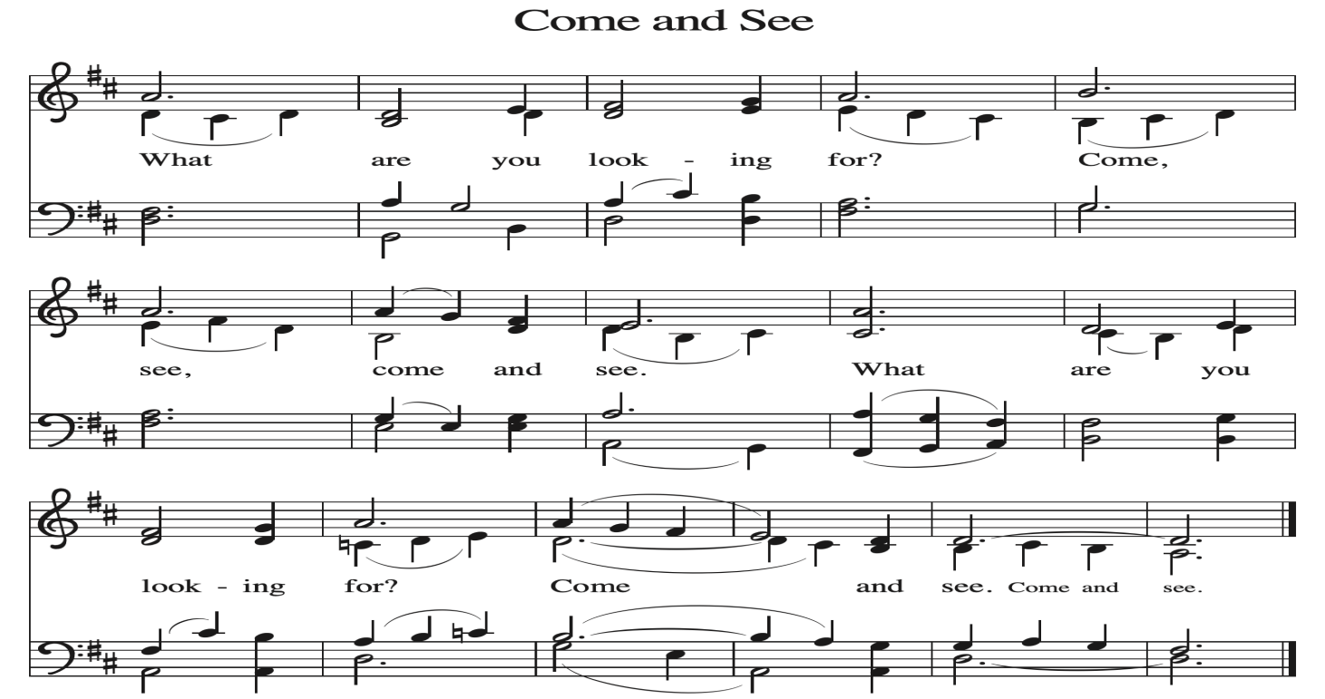
~ Proclamation of the WORD ~ (Scripture insert)
God speaks to us in scripture reading, preaching, and song.

READING: ACTS 17:16-31
Word of God. Word of Life. Thanks be to God.
SERMON Rev. Benjamin Morris

HYMN of the DAY ELW (red hymnal) #737 He Comes to Us as One Unknown

SERVICE OF AFFIRMATION OF BAPTSIM Page 234 ELW (red hymnal)
congregation responds with text in bold

PRAYERS of INTERCESSION
Petitions end: Merciful God,...receive our prayer.

PASSING OF THE PEACE
Please be aware of those who may not be comfortable shaking hands. You may also share the peace sign. Or any other contactless gesture that you are comfortable with.

OFFERING & SOLO
OFFERTORY ELW (red hymnal) #186 Create in Me a Clean Heart, O Lord

OFFERTORY PRAYER
Merciful God, accept the fruits of our labor, gathered to give you glory.
You have set a table before us, a glimpse of that great day when we will hunger and thirst no more. Nourish us with the body and blood of Jesus,
that goodness and mercy may follow us and bless the world you love.
In the name of Jesus, Amen.

THE LORD’S PRAYER

COMMUNION and SOLO

POST-COMMUNION PRAYER and BLESSING
Holy One, through this meal you have made your home among us
and are making all things new. Send us now to speak peace to anxious hearts,
to love our enemies, and to bring your healing to the nations. In the name of Jesus,
Amen.
~ SENDING ~
God blesses us and sends us in mission to the world
BLESSING
God Almighty, who is the beginning and the end, Jesus Christ, the firstborn of the dead,
and the Spirit, our advocate and peace, ☩ bless you now and forever. Amen.

BELLS
SENDING HYMN ELW (red hymnal) #543 Go, My Children, with My Blessing

DISMISSAL
Go in peace. Praise the Lord. Alleluia! Thanks be to God. Alleluia!
POSTLUDE

Reprinted / podcast / streamed with permission under ONE LICENSE #A-738444. All rights reserved



COON VALLEY LUTHERAN CHURCH
Sunday, May 3, 2026
Affirmation of Baptism
Fifth Sunday of Easter

~Bulletins are in memory of Robert Daffinrud

~Congratulations to our Confirmands: Rayah Rose Klum, Tyler John Marsh, Jaxon John Nelson, Riley Ray Strangstalien, Alexis Rose White, Dylan Thomas Wiedemann

Coffee Servers: Janelle Berg, Jana Urbanek
Piano/Organ: Aaron Stakston
Usher: Jon Holen
Reader: Karen McGarvey
Attendance & Offering Last Sunday: 9:00a/this will be reported next week

Scan this code with your phone to contribute electronically with Vanco.

SCHEDULE
TODAY: 10:15am/Sunday School, Coffee Fellowship
MONDAY: 9:00a/Naomi Circle
TUESDAY: 9:00a-Noon/Pastor’s text study; 10:30a/Ruth Circle
THURSDAY: 10:00a/Bible Study; 6:00p/Rebecca Circle
FRIDAY: Pastor Ben’s sabbath
NEXT SUNDAY: 9:00a/Worship with Holy Communion; Sunday School Sings 10:15a/Last day of Sunday School, Coffee Fellowship
Coon Valley Lutheran Church
www.coonvalleylutheranchurch.org
Pastor: Rev. Benjamin Morris, Office 452-3772/Cell 608-406-1556, pastor@coonvalleylutheranchurch.org
Office Administrator: Jamie Thomas, office@coonvalleylutheranchurch.org
Office Hours: Thursday 9:00a-2:30p
Office 452-3772/Cell 317-0007
Treasurer: Becky Lusk, treasurer@coonvalleylutheranchurch.org
Organist:
Indoor Custodian: Tracy Stellner

Remember "Thumbs Up" When you come up for communion if you would like a gluten free wafer, give the wafer server a thumbs up as you approach. As you approach the wine server, give him or her a thumbs up to receive grape juice instead of wine.

Acts 17:16-31
¹⁶ While Paul was waiting for them in Athens, he was deeply distressed to see that the city was full of idols.
¹⁷ So he argued in the synagogue with the Jews and the devout persons and also in the marketplace every day with those who happened to be there.
¹⁸ Also some Epicurean and Stoic philosophers debated with him. Some said, “What does this pretentious babbler want to say?” Others said, “He seems to be a proclaimer of foreign divinities.” (This was because he was telling the good news about Jesus and the resurrection.)
¹⁹ So they took him and brought him to the Areopagus and asked him, “May we know what this new teaching is that you are presenting?
²⁰ It sounds rather strange to us, so we would like to know what it means.”
²¹ Now all the Athenians and the foreigners living there would spend their time in nothing but telling or hearing something new.
²² Then Paul stood in front of the Areopagus and said, “Athenians, I see how extremely spiritual you are in every way.
²³ For as I went through the city and looked carefully at the objects of your worship, I found among them an altar with the inscription, ‘To an unknown god.’ What therefore you worship as unknown, this I proclaim to you.
²⁴ The God who made the world and everything in it, he who is Lord of heaven and earth, does not live in shrines made by human hands,
²⁵ nor is he served by human hands, as though he needed anything, since he himself gives to all mortals life and breath and all things.
²⁶ From one ancestor he made all peoples to inhabit the whole earth, and he allotted the times of their existence and the boundaries of the places where they would live,
²⁷ so that they would search for God and perhaps fumble about for him and find him—though indeed he is not far from each one of us.
²⁸ For ‘In him we live and move and have our being’; as even some of your own poets have said, ‘For we, too, are his offspring.’
²⁹ “Since we are God’s offspring, we ought not to think that the deity is like gold or silver or stone, an image formed by the art and imagination of mortals.
³⁰ While God has overlooked the times of human ignorance, now he commands all people everywhere to repent,
³¹ because he has fixed a day on which he will have the world judged in righteousness by a man whom he has appointed, and of this he has given assurance to all by raising him from the dead.”
Word of God. Word of Life. Thanks be to God.

*We are always so happy to include you and our CVLC family in our prayers. If you feel your name, or the name of a family member can be added or removed from this list please contact Jamie. Thank you!

We remember in prayer:
† Those hospitalized this past week:
† Our members whose names we lift up in prayer today: Corrine Appleman, Beverly Bagstad, Clifford Bakkum, Pastor Barbara Bruneau, Ellie Brye, Herby Cornell, Rita Erlandson, Gloria Galstad, Kira Hoff, Becky Ihle, Donna Ihle, Ray Ihle, Todd King, Jon Larson, Margaret Lee, Russell Lee, Aaron Leisso, Aaron Marx, LuEtta Nelson, Romaine Nelson, Sandra Onshus, Elaine Proksch, Eunice Quast, Lori Roach, Jojo Satona, Heidi Saupe, Orrin Stakston, LaVonne Stendahl, Krin (Dreves) Stendalen, Joyce Temp, Jamie Thomas, Teri Tomten, Renita Williamson
† Our members who are currently in health care facilities & Assisted Living:
Tip Bagstad, Rachel Berg, Carl Daffinrud, Jeanne Ebli, Carl Holte, Bob Moilien, Geri Nestingen, Irene Nestingen, Cathy Ofte, Annie Olson, Beatrice Olson (Alden),
Elaine Proksch, Ellen Runice, Bob & Evelyn Schulze.
† Those who grieve: Family and friends of Scott Strangstalien
† Our members who are currently home bound
† All those in need of God’s healing and help
† All those affected by recent storms
† Family and friends of our members
† Local Military: Alex Hendrickson

