COON VALLEY LUTHERAN CHURCH
“We are a family of God, striving to enrich
the lives of all through the love of Christ.”
PRELUDE MUSIC Mary Schultz
BELLS
WELCOME and ANNOUNCEMENTS

CONFESSION & FORGIVENESS
Blessed be the holy Trinity, ☩ one God,
our maker, our helper, and our keeper.
Amen.
Trusting in God’s mercy, let us confess our sin
in the presence of God and of one another.
Silence is kept for reflection.
Merciful and loving God,
we are hard-hearted people.
We trample on the needy.
We grumble about your grace to others.
We turn away from the poor.
Have mercy on us and forgive our sins.
Rejoice over us as ones who were lost
and have been found.
Amen.
Even when we are faithless, God remains faithful.
Jesus Christ came into the world to save sinners.
You who were lost have been found.
In the name of ☩ Jesus, your sins are forgiven!
Amen.

GATHERING HYMN ELW (red hymnal) #807 Come, Thou Fount of Every Blessing

PRAYER OF THE DAY
Mighty Lord, the splendor of Solomon’s temple cannot compare to the majesty of your heart. Show your heart in this place, that we might worship you with joy and gratitude. Amen.
GREET THE WORD- ACS (purple hymnal) #1012 sung 3 times
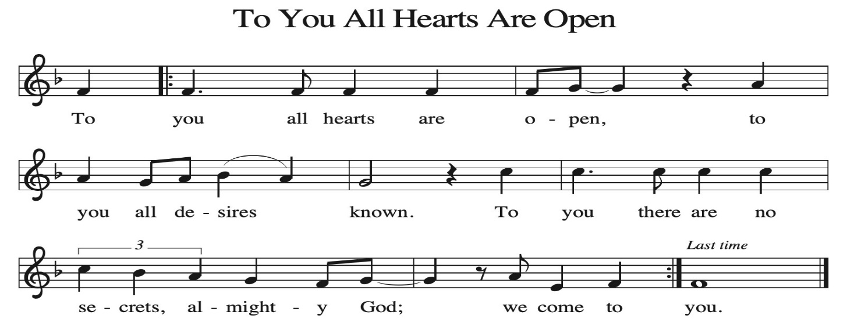
~ Proclamation of the WORD ~ (Scripture insert)
God speaks to us in scripture reading, preaching, and song.

1 SAMUEL 16: 1-13

SERMON Rev. Benjamin Morris

HYMN of the DAY ELW (red hymnal) #502 The King of Love My Shepherd Is

APOSTLES’ CREED ELW (red hymnal) Page 105

PRAYERS of INTERCESSION
Petitions end: God of grace…receive our prayer.

PASSING OF THE PEACE
Please be aware of those who may not be comfortable shaking hands. You may also share the peace sign. Or any other contactless gesture that you are comfortable with.
OFFERING & SOLO Mary Schultz

OFFERTORY ELW (red hymnal) #186 Create in Me a Clean Heart, O Lord

OFFERTORY PRAYER
Lord of the harvest, we return to you a portion of what you have given to us.
Turn us to set our hope not on the uncertainty of riches, but on you, who richly provides for us. Multiply what we have gathered to bless all who are suffering and in need, through Jesus Christ our Lord. Amen.

THANKSGIVING FOR THE WORD
O God of justice and love, we give thanks to you that you illumine our way through life with the words of your Son. Give us the light we need, awaken us to the needs
of others, and at the end bring all the world to your feast; through Jesus Christ, our Savior and Lord, to whom, with you and the Holy Spirit, be honor and glory forever. Amen.

THE LORD’S PRAYER

~ SENDING ~
God blesses us and sends us in mission to the world
BLESSING
The God of righteousness, who gives justice to the oppressed, who gives food to the hungry, who sets the prisoners free, ☩ bless you now and forever. Amen.

BELLS
SENDING HYMN ELW (red hymnal) #793 Be Thou My Vision

DISMISSAL
Go in peace. Do not lose heart.
Thanks be to God

POSTLUDE Mary Schultz

Reprinted / podcast / streamed with permission under ONE LICENSE #A-738444. All rights reserved.



COON VALLEY LUTHERAN CHURCH
The Nineteenth Sunday of Pentecost
October 19, 2025

~ Bulletins are in memory of Crystal Moilien on the 30th Wedding Anniversary of Ron & Crystal on Oct. 7

Usher: Cody Strangstalien
Reader: Michael Lieurance
Attendance & Offering Last Sunday: 102; $4,744.95
Farmer’s Market Last Sunday: $17.00
Sunday School Attendance: 5


Scan this code with your phone to contribute electronically with Vanco.

SCHEDULE
TUESDAY: 9:00a/Pastor’s Text Study
THURSDAY: 10:00a/Bible Study
FRIDAY: Pastor Ben’s sabbath
NEXT SUNDAY: 8:00a/Finance Committee; 9:00a/Worship; 10:00a/Sunday School, Coffee Fellowship; 6:00p/Confirmation

Coon Valley Lutheran Church
www.coonvalleylutheranchurch.org
Pastor: Rev. Benjamin Morris, Office 452-3772/Cell 608-406-1556, pastor@coonvalleylutheranchurch.org
Office Administrator: Jamie Thomas, office@coonvalleylutheranchurch.org
Office Hours: Tuesday, Wednesday 9:00a-4:00p; Thursday 9:00a-3:30p
Office 452-3772/Cell 317-0007
Treasurer: Becky Lusk, treasurer@coonvalleylutheranchurch.org
Organist: Mary Schultz
Indoor Custodian: Tracy Stellner

~Remember "Thumbs Up" When you come up for communion if you would like a gluten free wafer, give the pastor a thumbs up as you approach. As you approach the wine server, give him or her a thumbs up to receive grape juice instead of wine.
1 Samuel 16:1-13
16 The Lord said to Samuel, “How long will you grieve over Saul? I have rejected him from being king over Israel. Fill your horn with oil and set out; I will send you to Jesse the Bethlehemite, for I have provided for myself a king among his sons.” ² Samuel said, “How can I go? If Saul hears of it, he will kill me.” And the Lord said, “Take a heifer with you and say, ‘I have come to sacrifice to the Lord.’ ³ Invite Jesse to the sacrifice, and I will show you what you shall do, and you shall anoint for me the one whom I name to you.” ⁴ Samuel did what the Lord commanded and came to Bethlehem. The elders of the city came to meet him trembling and said, “Do you come peaceably?” ⁵ He said, “Peaceably. I have come to sacrifice to the Lord; sanctify yourselves and come with me to the sacrifice.” And he sanctified Jesse and his sons and invited them to the sacrifice.
⁶ When they came, he looked on Eliab and thought, “Surely his anointed is now before the Lord.” ⁷ But the Lord said to Samuel, “Do not look on his appearance or on the height of his stature, because I have rejected him, for the Lord does not see as mortals see; they look on the outward appearance, but the Lord looks on the heart.” ⁸ Then Jesse called Abinadab and made him pass before Samuel. He said, “Neither has the Lord chosen this one.” ⁹ Then Jesse made Shammah pass by. And he said, “Neither has the Lord chosen this one.” ¹⁰ Jesse made seven of his sons pass before Samuel, and Samuel said to Jesse, “The Lord has not chosen any of these.” ¹¹ Samuel said to Jesse, “Are all your sons here?” And he said, “There remains yet the youngest, but he is keeping the sheep.” And Samuel said to Jesse, “Send and bring him, for we will not sit down until he comes here.” ¹² He sent and brought him in. Now he was ruddy and had beautiful eyes and was handsome. The Lord said, “Rise and anoint him, for this is the one.” ¹³ Then Samuel took the horn of oil and anointed him in the presence of his brothers, and the spirit of the Lord came mightily upon David from that day forward. Samuel then set out and went to Ramah.
Word of God. Word of Life. Thanks be to God.

*We are always happy to include you and our CVLC family in our prayers. If you feel your name, or the name of a family member can be added or removed from this list please contact Jamie. Thank you!

We remember in prayer:
† Those hospitalized this past week
† Our members whose names we lift up in prayer today: Corrine Appleman, Beverly Bagstad, Clifford Bakkum, Pastor Barbara Bruneau, Herby Cornell, Marie Egge, Gloria Galstad, Kira Hoff, Becky Ihle, Donna Ihle, Ray Ihle, Eddie Kanieski, Todd King, Mike Kellogg, Margaret Lee, Russell Lee, Aaron Leisso, Aaron Marx, LuEtta Nelson, Romaine Nelson, Lisa Olson, Sandra Onshus, Elaine Proksch, Eunice Quast, Lori Roach, Jojo Satona, Heidi Saupe, Bob Schulze, Mary Schultz, LaVonne Stendahl, Krin (Dreves) Stendalen, Joyce Temp, Teri Tomten, Dave Verse, Jan Verse, Renita Williamson
† Our members who are currently in health care facilities & Assisted Living:
Tip Bagstad, Rachel Berg, Carl Daffinrud, Jeanne Ebli, Carl Holte, Bob Moilien, Geri Nestingen, Irene Nestingen, Cathy Ofte, Annie Olson, Beatrice Olson (Alden),
Ellen Runice, Orrin Stakston.
† Those who grieve: Family and friends of Pauline Moilien, Evelyn Dahlen, Betty Williamson & Lenore Henley.
† Our members who are currently home bound
† All those in need of God’s healing and help
† Family and friends of our members
† Local Military: Alex Hendrickson

