COON VALLEY LUTHERAN CHURCH
“We are a family of God, striving to enrich
the lives of all through the love of Christ.”
PRELUDE MUSIC Mary Schultz
BELLS
WELCOME and ANNOUNCEMENTS

CONFESSION & FORGIVENESS
Blessed be the holy Trinity, ☩ one God,
our maker, our helper, and our keeper.
Amen.
Trusting in God’s mercy, let us confess our sin
in the presence of God and of one another.
Silence is kept for reflection.
Merciful and loving God,
we are hard-hearted people.
We trample on the needy.
We grumble about your grace to others.
We turn away from the poor.
Have mercy on us and forgive our sins.
Rejoice over us as ones who were lost
and have been found.
Amen.
Even when we are faithless, God remains faithful.
Jesus Christ came into the world to save sinners.
You who were lost have been found.
In the name of ☩ Jesus, your sins are forgiven!
Amen.

GATHERING HYMN ELW (red hymnal) #838 Beautiful Savior

PRAYER OF THE DAY
Mighty Lord, the splendor of Solomon’s temple cannot compare to the majesty of your heart. Show your heart in this place, that we might worship you with joy and gratitude. Amen.
GREET THE WORD- ACS (purple hymnal) #1012 sung 3 times
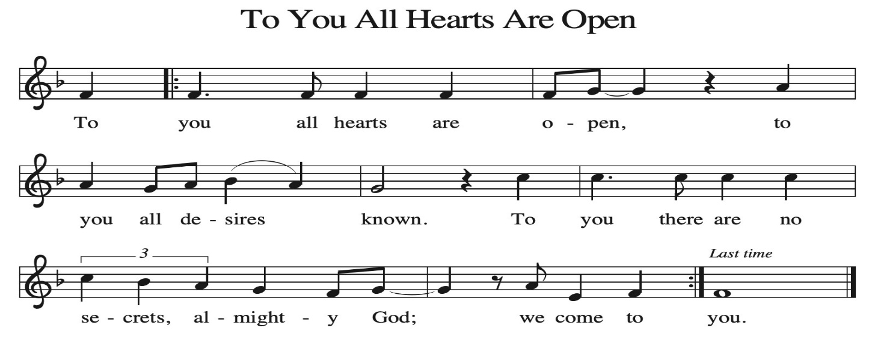
~ Proclamation of the WORD ~ (Scripture insert)
God speaks to us in scripture reading, preaching, and song.

1 KINGS 5:1-5; 8:1-13

CHILDREN’S TIME

SERMON Rev. Benjamin Morris

HYMN of the DAY ELW (red hymnal) #504 A Mighty Fortress Is Our God

APOSTLES’ CREED ELW (red hymnal) Page 105

PRAYERS of INTERCESSION
Petitions end: God of grace…receive our prayer.

PASSING OF THE PEACE
Please be aware of those who may not be comfortable shaking hands. You may also share the peace sign. Or any other contactless gesture that you are comfortable with.

OFFERING & SOLO Fughetta Deanna Wichman

OFFERTORY ELW (red hymnal) #186 Create in Me a Clean Heart, O Lord

OFFERTORY PRAYER
Lord of the harvest, we return to you a portion of what you have given to us.
Turn us to set our hope not on the uncertainty of riches, but on you, who richly provides for us. Multiply what we have gathered to bless all who are suffering and in need, through Jesus Christ our Lord. Amen.

THANKSGIVING FOR THE WORD
O God of justice and love, we give thanks to you that you illumine our way through life with the words of your Son. Give us the light we need, awaken us to the needs
of others, and at the end bring all the world to your feast; through Jesus Christ, our Savior and Lord, to whom, with you and the Holy Spirit, be honor and glory forever. Amen.

THE LORD’S PRAYER

~ SENDING ~
God blesses us and sends us in mission to the world
BLESSING
The God of righteousness, who gives justice to the oppressed, who gives food to the hungry, who sets the prisoners free, ☩ bless you now and forever. Amen.

BELLS
SENDING HYMN ELW (red hymnal) #517 Lord, Keep Us Steadfast in Your Word

DISMISSAL
Go in peace. Do not lose heart.
Thanks be to God

POSTLUDE Mary Schultz

Reprinted / podcast / streamed with permission under ONE LICENSE #A-738444. All rights reserved.

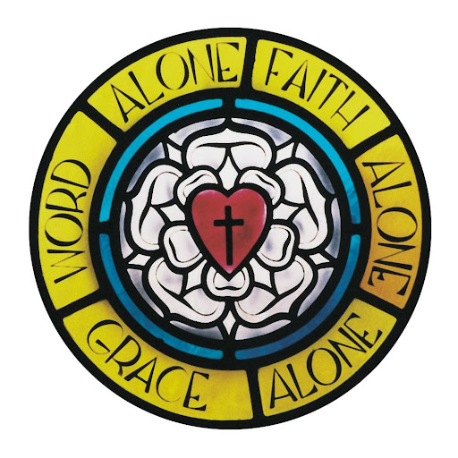
COON VALLEY LUTHERAN CHURCH
Reformation
October 26, 2025

Coffee Servers: Maggie Thompson, Cheryl Morey
Usher: Tim Hatlan
Reader: Sara Lieurance
Attendance & Offering Last Sunday: 101; $2,616.27
Farmer’s Market Last Sunday: $35.00
Sunday School Attendance: 13


Scan this code with your phone to contribute electronically with Vanco.

SCHEDULE
TODAY: 6:00p/Confirmation
TUESDAY: 9:00a/South Conference Pastor’s
WEDNESDAY: 9:00a/Quilting
THURSDAY: 10:00a/Bible Study
FRIDAY: Pastor Ben’s sabbath
NEXT SUNDAY: 9:00a/Worship with Holy Communion; 10:00a/Sunday School, Coffee Fellowship; 6:00p/Confirmation

Coon Valley Lutheran Church
www.coonvalleylutheranchurch.org
Pastor: Rev. Benjamin Morris, Office 452-3772/Cell 608-406-1556, pastor@coonvalleylutheranchurch.org
Office Administrator: Jamie Thomas, office@coonvalleylutheranchurch.org
Office Hours: Tuesday, Wednesday 9:00a-4:00p; Thursday 9:00a-3:30p
Office 452-3772/Cell 317-0007
Treasurer: Becky Lusk, treasurer@coonvalleylutheranchurch.org
Organist: Mary Schultz
Indoor Custodian: Tracy Stellner

~Remember "Thumbs Up" When you come up for communion if you would like a gluten free wafer, give the pastor a thumbs up as you approach. As you approach the wine server, give him or her a thumbs up to receive grape juice instead of wine.

1 Kings 5:1-5; 8:1-13

5 Now King Hiram of Tyre sent his servants to Solomon when he heard that they had anointed him king in place of his father, for Hiram had always been a friend to David. ² Solomon sent word to Hiram, saying, ³ “You know that my father David could not build a house for the name of the Lord his God because of the warfare with which his enemies surrounded him, until he put them under the soles of his feet. ⁴ But now the Lord my God has given me rest on every side; there is neither adversary nor misfortune. ⁵ So I intend to build a house for the name of the Lord my God, as the Lord said to my father David, ‘Your son, whom I will set on your throne in your place, shall build the house for my name.’

8 Then Solomon assembled the elders of Israel and all the heads of the tribes, the leaders of the ancestral houses of the Israelites, before King Solomon in Jerusalem, to bring up the ark of the covenant of the Lord out of the city of David, which is Zion. ² All the people of Israel assembled to King Solomon at the festival in the month Ethanim, which is the seventh month. ³ And all the elders of Israel came, and the priests carried the ark. ⁴ So they brought up the ark of the Lord, the tent of meeting, and all the holy vessels that were in the tent; the priests and the Levites brought them up. ⁵ King Solomon and all the congregation of Israel, who had assembled before him, were with him before the ark, sacrificing so many sheep and oxen that they could not be counted or numbered. ⁶ Then the priests brought the ark of the covenant of the Lord to its place, in the inner sanctuary of the house, the most holy place, underneath the wings of the cherubim. ⁷ For the cherubim spread out their wings over the place of the ark, so that the cherubim made a covering above the ark and its poles. ⁸ The poles were so long that the ends of the poles were seen from the holy place in front of the inner sanctuary, but they could not be seen from outside; they are there to this day. ⁹ There was nothing in the ark except the two tablets of stone that Moses had placed there at Horeb, where the Lord made a covenant with the Israelites when they came out of the land of Egypt. ¹⁰ And when the priests came out of the holy place, a cloud filled the house of the Lord, ¹¹ so that the priests could not stand to minister because of the cloud, for the glory of the Lord filled the house of the Lord.
¹² Then Solomon said,
“The Lord has said that he would dwell in thick darkness.
¹³ I have built you an exalted house,
a place for you to dwell forever.”
Word of God. Word of Life. Thanks be to God.

*We are always happy to include you and our CVLC family in our prayers. If you feel your name, or the name of a family member can be added or removed from this list please contact Jamie. Thank you!

We remember in prayer:
† Those hospitalized this past week: Mary Schultz
† Our members whose names we lift up in prayer today: Corrine Appleman, Beverly Bagstad, Clifford Bakkum, Pastor Barbara Bruneau, Herby Cornell, Marie Egge, Gloria Galstad, Kira Hoff, Becky Ihle, Donna Ihle, Ray Ihle, Eddie Kanieski, Todd King, Mike Kellogg, Margaret Lee, Russell Lee, Aaron Leisso, Aaron Marx, LuEtta Nelson, Romaine Nelson, Lisa Olson, Sandra Onshus, Elaine Proksch, Eunice Quast, Lori Roach, Jojo Satona, Heidi Saupe, Bob Schulze, Mary Schultz, LaVonne Stendahl, Krin (Dreves) Stendalen, Joyce Temp, Teri Tomten, Dave Verse, Jan Verse, Renita Williamson
† Our members who are currently in health care facilities & Assisted Living:
Tip Bagstad, Rachel Berg, Carl Daffinrud, Jeanne Ebli, Carl Holte, Bob Moilien, Geri Nestingen, Irene Nestingen, Cathy Ofte, Annie Olson, Beatrice Olson (Alden),
Ellen Runice, Orrin Stakston.
† Those who grieve: Family and friends of Pauline Moilien, Evelyn Dahlen, Betty Williamson & Lenore Henley.
† Our members who are currently home bound
† All those in need of God’s healing and help
† Family and friends of our members
† Local Military: Alex Hendrickson

