COON VALLEY LUTHERAN CHURCH
“We are a family of God, striving to enrich
the lives of all through the love of Christ.”
PRELUDE MUSIC Mary Schultz
BELLS
WELCOME and ANNOUNCEMENTS

CONFESSION & FORGIVENESS
Blessed be the holy Trinity, ☩ one God,
who forgives all our sin,
whose mercy endures forever.
Amen.
Let us confess our sin in the presence of God
and of one another.
Silence is kept for reflection.
Faithful God,
you have shown us the ways of your heart,
yet we stray from your paths.
We are stuck in sinful systems of oppression
and do not embrace the freedom
of your faithful promises.
We ignore our neighbors.
We exploit the earth.
We reject your abundance,
trusting our impulses instead of your steadfast love.
Repair our relationships,
restore what we have broken,
renew our hearts,
and bring us to new life.
Amen.
Hear the good news:
God the Faithful One loves you,
☩ in Christ Jesus your sins are forgiven,
and by the power of the Holy Spirit you are set free.
Amen.

GATHERING HYMN ELW (red hymnal) #449 We Know That Christ Is Raised

PRAYER OF THE DAY
God of light, there can be overwhelming obscurity in this world. But you shine your light and increase joy, and for your brilliance we are grateful. Amen.
BAPTISM Page 227 ELW (red hymnal)

GREET THE WORD- ACS (purple hymnal) #1012 sung 3 times
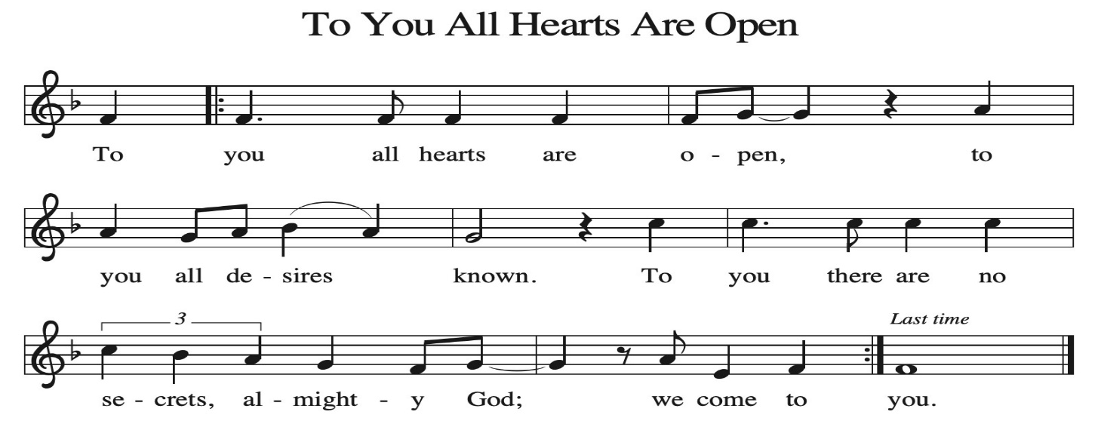
~ Proclamation of the WORD ~ (Scripture insert)
God speaks to us in scripture reading, preaching, and song.

ISAIAH 9: 1-7

SERMON Rev. Benjamin Morris

HYMN of the DAY ACS (purple hymnal) #1004 Faith Begins by Letting Go

APOSTLES’ CREED ELW (red hymnal) Page 105

PRAYERS of INTERCESSION
Petitions end: Hear us, O God…your mercy is great.

PASSING OF THE PEACE
Please be aware of those who may not be comfortable shaking hands. You may also share the peace sign. Or any other contactless gesture that you are comfortable with.

OFFERING & SOLO Mary Schultz

OFFERTORY ELW (red hymnal) #186 Create in Me a Clean Heart, O Lord

OFFERTORY PRAYER
God of healing and hope, you bless those who are hungry, promising to fill them with good things. Fulfill that promise through us and these your gifts. Nourish us with the abundance of your feast and unite us into the blessed body of Jesus Christ our Savior, now and forever. Amen.

THANKSGIVING FOR THE WORD
O God of justice and love, we give thanks to you that you illumine our way through life with the words of your Son. Give us the light we need, awaken us to the needs
of others, and at the end bring all the world to your feast; through Jesus Christ, our Savior and Lord, to whom, with you and the Holy Spirit, be honor and glory forever. Amen.

THE LORD’S PRAYER

~ SENDING ~
God blesses us and sends us in mission to the world
BLESSING
The love of God the Sovereign strengthen you, God the Son save you, and God the Holy Spirit anoint you for the work ahead. The holy Trinity bless you ☩ and grant you a faithful and courageous heart now and forever. Amen.

BELLS
SENDING HYMN ELW (red hymnal) #834 Immortal, Invisible, God Only Wise

DISMISSAL
Go in peace. Share the harvest.
Thanks be to God.

POSTLUDE Mary Schultz

Reprinted / podcast / streamed with permission under ONE LICENSE #A-738444. All rights reserved.

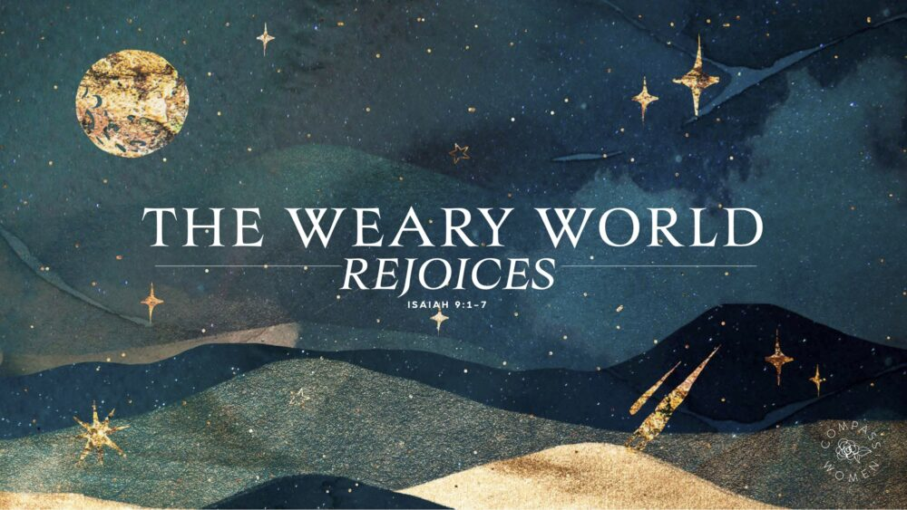
COON VALLEY LUTHERAN CHURCH
The Season of Pentecost
Baptism
NOVEMBER 16, 2025

~We welcome into our congregation Brooks Michael Thornton son of Benjamin & April
Coffee Servers: Janine Morey, Julie Nerison, Jennifer Johnson
Usher: Barry Bergum
Reader: Bruce King
Attendance & Offering Last Sunday: 102; $13,475.77
Sunday School Attendance:


Scan this code with your phone to contribute electronically with Vanco.

SCHEDULE
TODAY: 10:00a/Retro Dinner Meeting; 6:00p/Confirmation
TUESDAY: 9:00a/Pastor’s Text Study; 5:30p/Finance Committee
THURSDAY: 10:00a/WELCA; 6:00p/Church Council
FRIDAY: Pastor Ben’s sabbath
NEXT SUNDAY: 9:00a/Worship; 10:00a/Sunday School, Coffee Fellowship
Coon Valley Lutheran Church
www.coonvalleylutheranchurch.org
Pastor: Rev. Benjamin Morris, Office 452-3772/Cell 608-406-1556, pastor@coonvalleylutheranchurch.org
Office Administrator: Jamie Thomas, office@coonvalleylutheranchurch.org
Office Hours: Tuesday, Wednesday 9:00a-4:00p; Thursday 9:00a-3:30p
Office 452-3772/Cell 317-0007
Treasurer: Becky Lusk, treasurer@coonvalleylutheranchurch.org
Organist: Mary Schultz
Indoor Custodian: Tracy Stellner

~Remember "Thumbs Up" When you come up for communion if you would like a gluten free wafer, give the pastor a thumbs up as you approach. As you approach the wine server, give him or her a thumbs up to receive grape juice instead of wine.

Isaiah 9:1-7
9 But there will be no gloom for those who were in anguish. In the former time he brought into contempt the land of Zebulun and the land of Naphtali, but in the latter time he will make glorious the way of the sea, the land beyond the Jordan, Galilee of the nations.
² The people who walked in darkness
have seen a great light;
those who lived in a land of deep darkness—
on them light has shined.
³ You have multiplied exultation;
you have increased its joy;
they rejoice before you
as with joy at the harvest,
as people exult when dividing plunder.
⁴ For the yoke of their burden
and the bar across their shoulders,
the rod of their oppressor,
you have broken as on the day of Midian.
⁵ For all the boots of the tramping warriors
and all the garments rolled in blood
shall be burned as fuel for the fire.
⁶ For a child has been born for us,
a son given to us;
authority rests upon his shoulders,
and he is named
Wonderful Counselor, Mighty God,
Everlasting Father, Prince of Peace.
⁷ Great will be his authority,
and there shall be endless peace
for the throne of David and his kingdom.
He will establish and uphold it
with justice and with righteousness
from this time onward and forevermore.
The zeal of the Lord of hosts will do this.
Word of God. Word of Life. Thanks be to God.

*We are always happy to include you and our CVLC family in our prayers. If you feel your name, or the name of a family member can be added or removed from this list please contact Jamie. Thank you!

We remember in prayer:
† Those hospitalized this past week
† Our members whose names we lift up in prayer today: Corrine Appleman, Beverly Bagstad, Clifford Bakkum, Pastor Barbara Bruneau, Herby Cornell, Marie Egge, Gloria Galstad, Kira Hoff, Becky Ihle, Donna Ihle, Ray Ihle, Eddie Kanieski, Todd King, Margaret Lee, Russell Lee, Aaron Leisso, Aaron Marx, LuEtta Nelson, Romaine Nelson, Lisa Olson, Sandra Onshus, Elaine Proksch, Eunice Quast, Lori Roach, Jojo Satona, Heidi Saupe, Bob Schulze, Mary Schultz, LaVonne Stendahl, Krin (Dreves) Stendalen, Joyce Temp, Teri Tomten, Dave Verse, Jan Verse, Renita Williamson
† Our members who are currently in health care facilities & Assisted Living:
Tip Bagstad, Rachel Berg, Carl Daffinrud, Jeanne Ebli, Carl Holte, Bob Moilien, Geri Nestingen, Irene Nestingen, Cathy Ofte, Annie Olson, Beatrice Olson (Alden),
Ellen Runice, Orrin Stakston.
† Those who grieve
† Our members who are currently home bound
† All those in need of God’s healing and help
† Family and friends of our members
† Local Military: Alex Hendrickson

