COON VALLEY LUTHERAN CHURCH
“We are a family of God, striving to enrich
the lives of all through the love of Christ.”
PRELUDE MUSIC
BELLS
WELCOME and ANNOUNCEMENTS

We invite all children to come forward for the Thanksgiving for Baptism
THANKSGIVING FOR BAPTISM
Blessed be the holy Trinity, ☩ one God, the fountain of living water,
the rock who gave us birth, our light and our salvation. Amen.

Joined to Christ in the waters of baptism,
we are clothed with God's mercy and forgiveness.
Let us give thanks for the gift of baptism.

Water may be poured into the font as the presiding minister gives thanks.
We give you thanks, O God, for in the beginning your Spirit moved over the waters
and by your Word you created the world, calling forth life in which you took delight.

Through the waters of the flood you delivered Noah and his family. Through the sea you led your people Israel from slavery into freedom. At the river your Son was baptized by John and anointed with the Holy Spirit. By water and your Word you claim us as daughters and sons, making us heirs of your promise and servants of all.

We praise you for the gift of water that sustains life, and above all we praise you for the gift of new life in Jesus Christ. Shower us with your Spirit, and renew our lives with your forgiveness, grace, and love.

To you be given honor and praise through Jesus Christ our Lord in the unity of the Holy Spirit, now and forever. Amen.

GATHERING HYMN ELW (red hymnal) #456 Baptized in Water
PRAYER OF THE DAY
God of revelation, You made your son known at a wedding, a public celebration of love. Celebrate love with us by revealing Jesus in our midst. Amen.

GREET THE WORD- ACS (purple hymnal) #976
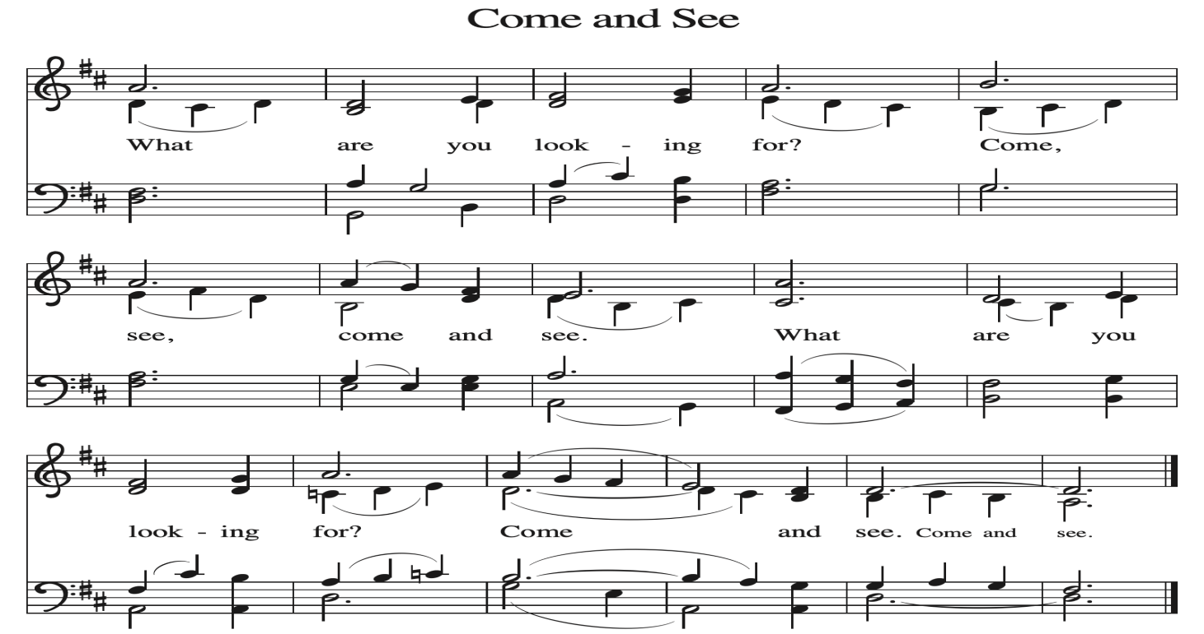
~ Proclamation of the WORD ~ (Scripture insert)
God speaks to us in scripture reading, preaching, and song.

GOSPEL READING: JOHN 2:1-11
The Gospel of the Lord. Praise to you, O Christ.
SERMON Rev. Ben Morris

HYMN of the DAY ELW (red hymnal) #461 All Who Hunger, Gather Gladly

APOSTLES’ CREED ELW (red hymnal) Page 105

PRAYERS of INTERCESSION
Petitions end: Merciful God....Receive our prayer.

PASSING OF THE PEACE
Please be aware of those who may not be comfortable shaking hands. You may also share the peace sign. Or any other contactless gesture that you are comfortable with.

OFFERING & SOLO

OFFERTORY ELW (red hymnal) #186 Create in Me a Clean Heart, O Lord

OFFERTORY PRAYER
God of majesty, no eye has seen, no ear has heard what you have prepared for those who love you, yet in this meal you reveal the wideness of your mercy.
Use what we have gathered to feed us with the reign of God come near,
Jesus Christ, our Savior and Lord. Amen.

THE LORD’S PRAYER

COMMUNION and SOLO

POST-COMMUNION BLESSING and PRAYER
Radiant God, we have seen your glory in the face of Jesus Christ.
In the sacrament of his body and blood you have drawn us to your heart.
Send us from this table with delight, that our lives may reflect the beauty of your love,
and bear witness to all we have seen and heard, through Jesus Christ, our Savior and Lord. Amen.

~ SENDING ~
God blesses us and sends us in mission to the world

BLESSING
May the triune God, who has put a new song in your mouth and tuned your heart for praise ☩ bless you now and forever. Amen.

BELLS
SENDING HYMN ELW (red hymnal) #434 Jesus Shall Reign

DISMISSAL
Go in peace. Do justice. Love mercy.
Thanks be to God.

POSTLUDE

Reprinted / podcast / streamed with permission under ONE LICENSE #A-738444. All rights reserved.

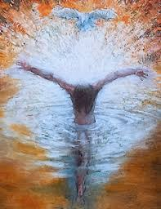

COON VALLEY LUTHERAN CHURCH
Sunday, January 11, 2026
Baptism of our Lord

~Bulletins are in honor of the 40th birthday of Brandon Williamson

Coffee Servers: Linda Pederson, Stephanie Marshall
Altar Guild: Jane Simmons
Communion Servers: Ray Williamson, Laura Hofslien
Usher: Mike Lusk
Reader: Ron Moilien
Attendance & Offering Last Sunday: 9:00a/109; $3,791.21
12/12-81, $3,552.74; 12/24-191, $3,253; 12/25-44, $675; 12/28-52, $3,515.63


Scan this code with your phone to contribute electronically with Vanco.

SCHEDULE
TODAY: 9:00a/Worship; 10:15a/Coffee Fellowship, Sunday School, Finance, Audit, Endowment, Retro Committee meetings
MONDAY: Carillon Deadline
TUESDAY: 9:00a/Pastor’s Text Study
WEDNESDAY: Quilting
THURSDAY: 10:00a/WELCA; 6:00p/Church Council
FRIDAY: Pastor Ben’s sabbath
NEXT SUNDAY: 9:00a/Worship; 10:15a/Coffee Fellowship & Sunday School; Men’s Club Meeting; 6:00p/Confirmation

Offering envelopes are available. They are located on a table in the Library. Please pick them up for family, friends or neighbors!
Coon Valley Lutheran Church
www.coonvalleylutheranchurch.org
Pastor: Rev. Benjamin Morris, Office 452-3772/Cell 608-406-1556, pastor@coonvalleylutheranchurch.org
Office Administrator: Jamie Thomas, office@coonvalleylutheranchurch.org
Office Hours: Tuesday & Wednesday 9:00-4:00p; Thursday 9:00a-3:30p
Office 452-3772/Cell 317-0007
Treasurer: Becky Lusk, treasurer@coonvalleylutheranchurch.org
Organist: Mary Schultz
Indoor Custodian: Tracy Stellner

Remember "Thumbs Up" When you come up for communion if you would like a gluten free wafer, give the wafer server a thumbs up as you approach. As you approach the wine server, give him or her a thumbs up to receive grape juice instead of wine.

GOSPEL: John 2:1-11
2 On the third day there was a wedding in Cana of Galilee, and the mother of Jesus was there.
² Jesus and his disciples had also been invited to the wedding.
³ When the wine gave out, the mother of Jesus said to him, “They have no wine.”
⁴ And Jesus said to her, “Woman, what concern is that to me and to you? My hour has not yet come.”
⁵ His mother said to the servants, “Do whatever he tells you.”
⁶ Now standing there were six stone water jars for the Jewish rites of purification, each holding twenty or thirty gallons.
⁷ Jesus said to them, “Fill the jars with water.” And they filled them up to the brim.
⁸ He said to them, “Now draw some out, and take it to the person in charge of the banquet.” So they took it.
⁹ When the person in charge tasted the water that had become wine and did not know where it came from (though the servants who had drawn the water knew), that person called the bridegroom
¹⁰ and said to him, “Everyone serves the good wine first and then the inferior wine after the guests have become drunk. But you have kept the good wine until now.”
¹¹ Jesus did this, the first of his signs, in Cana of Galilee and revealed his glory, and his disciples believed in him.
The Gospel of the Lord. Praise to you, O Christ.

*We are always so happy to include you and our CVLC family in our prayers. If you feel your name, or the name of a family member can be added or removed from this list please contact Jamie. Thank you!

We remember in prayer:
† Those hospitalized this past week
† Our members whose names we lift up in prayer today: Corrine Appleman, Beverly Bagstad, Clifford Bakkum, Pastor Barbara Bruneau, Ellie Brye, Herby Cornell, Rita Erlandson, Gloria Galstad, Kira Hoff, Becky Ihle, Donna Ihle, Ray Ihle, Eddie Kanieski, Todd King, Margaret Lee, Russell Lee, Aaron Leisso, Aaron Marx, LuEtta Nelson, Romaine Nelson, Sandra Onshus, Elaine Proksch, Eunice Quast, Lori Roach, Jojo Satona, Heidi Saupe, Mary Schultz, Orrin Stakston, LaVonne Stendahl, Krin (Dreves) Stendalen, Joyce Temp, Teri Tomten, Maggie Traastad, Renita Williamson
† Our members who are currently in health care facilities & Assisted Living:
Tip Bagstad, Rachel Berg, Carl Daffinrud, Jeanne Ebli, Carl Holte, Bob Moilien, Geri Nestingen, Irene Nestingen, Cathy Ofte, Annie Olson, Beatrice Olson (Alden),
Ellen Runice, Bob & Evelyn Schulze.
† Those who grieve
† Our members who are currently home bound
† All those in need of God’s healing and help
† Family and friends of our members
† Local Military: Alex Hendrickson

