COON VALLEY LUTHERAN CHURCH
“We are a family of God, striving to enrich
the lives of all through the love of Christ.”
PRELUDE MUSIC
BELLS
WELCOME and ANNOUNCEMENTS

CONFESSION AND FORGIVENESS
Blessed be the holy Trinity, ☩ one God, who pours love into our hearts
and healing upon the earth. Amen.

Confident that God justifies us by grace through faith, let us confess our sin.
Silence is kept for reflection.
Compassionate God,
we confess that we struggle to embody your goodness in the world and in our own hearts. Creation groans from overuse. Jealousy and bitterness strain our relationships. Indifference keeps us from seeking justice.
Divisions disrupt your call to show genuine love to others. Turn our hearts back to you. Restore our world and reconcile us to one another. Renew us to live as your holy people, following the way of Jesus Christ. Amen.
Hear this good news:
We have peace with God through ☩ Jesus Christ, in whom there is no condemnation,
but only forgiveness and the promise of eternal life. Receive freely this healing gift of grace. Amen.

GATHERING HYMN ELW (red hymnal) #681 We Plow the Fields and Scatter

PRAYER OF THE DAY
O Lord, maker of all things, you open your hand and satisfy the desire of every living creature. We praise you for crowning the fields with your blessings and enabling us once more to gather in the fruits of the earth. Teach us to use your gifts carefully, that our land may continue to yield its increase, through Jesus Chrust, our Savior and Lord. Amen.

~ Proclamation of the WORD ~ (Scripture insert)
God speaks to us in scripture reading, preaching, and song.

FIRST READING: Deuteronomy 6:1-9
Word of God. Word of Life. Thanks be to God.
PSALM: Psalm 51 (read responsively)
GREET THE WORD- ELW (red hymnal) #174 Sung 2 times
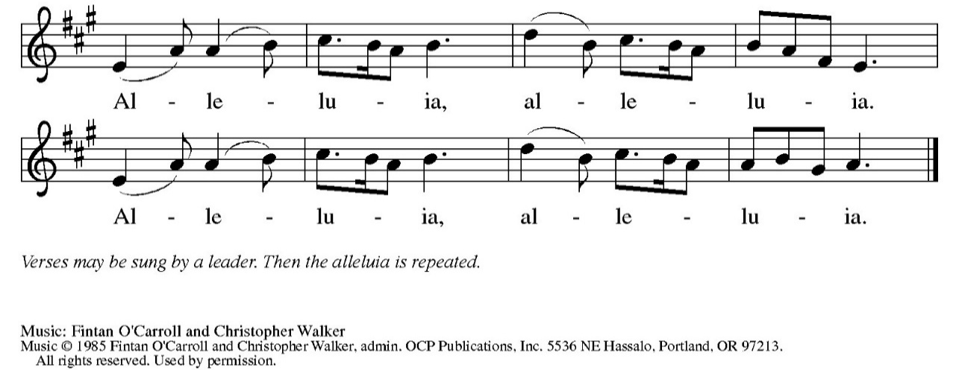

The Holy Gospel according to St. Matthew the sixth chapter
Glory to you, O Lord.

GOSPEL READING: Matthew 6: 1-24
The Gospel of the Lord. Praise to you, O Christ.

SERMON Rev. Benjamin Morris

HYMN of the DAY ACS (purple hymnal) #1043 Spirit, Open My Heart

APOSTLES’ CREED ELW (red hymnal) Page 105
PRAYERS of INTERCESSION
Petitions end: Hear us, O God,...Your mercy is great.

PASSING OF THE PEACE
Please be aware of those who may not be comfortable shaking hands. You may also share the peace sign. Or any other contactless gesture that you are comfortable with.

OFFERING & NOISY OFFERING (Sunday School) & SOLO
OFFERTORY ELW (red hymnal) #182 Let the Vineyards Be Fruitful
Let the vineyards be fruitful, Lord, and ﬁll to the brim our cup of blessing.
Gather a harvest from the seeds that were sown,
that we may be fed with the bread of life.
Gather the hopes and the dreams of all;
unite them with the prayers we offer now.
Grace our table with your presence,
and give us a foretaste of the feast to come.
Text © 1978 Lutheran Book of Worship, admin. Augsburg Fortress.
OFFERTORY PRAYER
God of creation, you send rain and the earth springs forth abundantly.
All blessings are from you; make us generous with what we have.
Use our gifts, our abilities, and our hearts in service to you and in love to our neighbors, today and always. Amen.

THE LORD’S PRAYER

COMMUNION & HYMNS ELW (red hymnal)
#195 Lamb of God
#479 We Come to the Hungry Feast
#487 What Feast of Love

POST-COMMUNION PRAYER and BLESSING
Sustaining God, with this bread and cup, you nourish us with mercy and abundant life. By your Spirit, send us from this table to serve a needy world.
Make us living signs of your liberation, healing, and love, following the way of Jesus, in whose name we pray. Amen.

~ SENDING ~
God blesses us and sends us in mission to the world
BLESSING
The God of grace ☩ bless you now and forever.
Amen

BELLS
SENDING HYMN ELW (red hymnal) #697 Just a Closer Walk with Thee

DISMISSAL Go out in joy. Be led forth in peace. Thanks be to God.

POSTLUDE

Reprinted / podcast / streamed with permission under ONE LICENSE #A-738444. All rights reserved

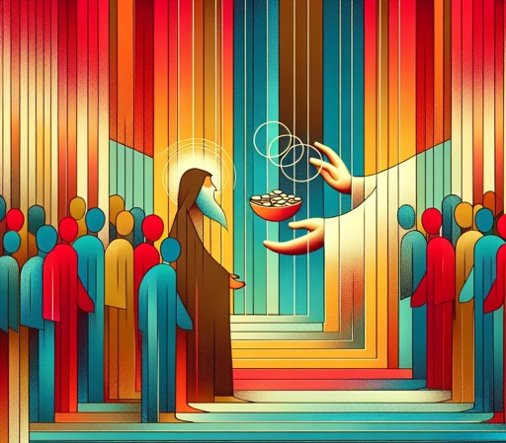

COON VALLEY LUTHERAN CHURCH
Nineteenth Sunday of Pentecost
Sunday, October 4, 2026

~Congregational meeting on Sunday Oct. 11. Please be in attendance for a short meeting after worship regarding the Parking Lot project.

~Remember "Thumbs Up" When you come up for communion if you would like a
gluten free wafer, give the pastor a thumbs up as you approach. As you approach the wine server, give him or her a thumbs up to receive grape juice instead of wine.

Pianist/Organist: Aaron Stakston
Usher: Dave Marsh
Reader: Mike Lusk
Altar Guild: Sarah Ofte
Communion Servers: Ray Williamson
Coffee Servers: Rachel Pederson, Gwen Bahr
Attendance & Offering Last Sunday: 85; $2,579.44


Scan this code with your phone to contribute electronically with Vanco.

SCHEDULE

MONDAY: 9:00a/Naomi Circle; Fall Theological Conference
TUESDAY: 10:30a/Ruth Circle; Fall Theological Conference
WEDNESDAY: 6:00p/Finance Committee
THURSDAY: 10:00a/Bible Study
FRIDAY: Pastor Ben’s Sabbath; 8:30a/WELCA Assemble LWR kits
NEXT SUNDAY: 9:00a/Worship with Holy Communion; Congregational Meeting 10:00a/Sunday School, Coffee Fellowship, Farmer’s Market; 6:00-7:30p/Confirmation
Coon Valley Lutheran Church
www.coonvalleylutheranchurch.org
Pastor: Rev. Benjamin Morris, Office 452-3772/Cell 608-406-1556, pastor@coonvalleylutheranchurch.org
Office Administrator: Jamie Thomas, office@coonvalleylutheranchurch.org
Office Hours: Tues. - Thur. 9a-2:30p
Office 452-3772
Treasurer: Becky Lusk, treasurer@coonvalleylutheranchurch.org
Organist: Aaron Stakston
Indoor Custodian: Tracy Stellner

FIRST READING: Deuteronomy 6:1-9
6 “Now this is the commandment—the statutes and the ordinances—that the Lord your God charged me to teach you to observe in the land that you are about to cross into and occupy, ² so that you and your children and your children’s children may fear the Lord your God all the days of your life and keep all his decrees and his commandments that I am commanding you, so that your days may be long. ³ Hear therefore, O Israel, and observe them diligently, so that it may go well with you and so that you may multiply greatly in a land flowing with milk and honey, as the Lord, the God of your ancestors, has promised you.
⁴ “Hear, O Israel: The Lord is our God, the Lord alone. ⁵ You shall love the Lord your God with all your heart and with all your soul and with all your might. ⁶ Keep these words that I am commanding you today in your heart. ⁷ Recite them to your children and talk about them when you are at home and when you are away, when you lie down and when you rise. ⁸ Bind them as a sign on your hand, fix them as an emblem on your forehead, ⁹ and write them on the doorposts of your house and on your gates.

Word of God. Word of Life. Thanks be to God.

Psalm 51 (Read responsively)
¹ Have mercy on me, O God, according to your steadfast love; according to your abundant mercy, blot out my transgressions.
² Wash me thoroughly from my iniquity, and cleanse me from my sin.
³ For I know my transgressions, and my sin is ever before me.
⁴ Against you, you alone, have I sinned and done what is evil in your sight,
so that you are justified in your sentence and blameless when you pass judgment.
⁵ Indeed, I was born guilty, a sinner when my mother conceived me.
⁶ You desire truth in the inward being; therefore teach me wisdom in my secret heart.
⁷ Purge me with hyssop, and I shall be clean; wash me, and I shall be whiter than snow.
⁸ Let me hear joy and gladness; let the bones that you have crushed rejoice.
⁹ Hide your face from my sins, and blot out all my iniquities.
¹⁰ Create in me a clean heart, O God, and put a new and right spirit within me.
¹¹ Do not cast me away from your presence, and do not take your holy spirit from me.
¹² Restore to me the joy of your salvation, and sustain in me a willing spirit.
¹³ Then I will teach transgressors your ways, and sinners will return to you.
¹⁴ Deliver me from bloodshed, O God, O God of my salvation, and my tongue will sing aloud of your deliverance.
¹⁵ O Lord, open my lips, and my mouth will declare your praise.
¹⁶ For you have no delight in sacrifice; if I were to give a burnt offering, you would not be pleased.
¹⁷ The sacrifice acceptable to God is a broken spirit; a broken and contrite heart, O God, you will not despise.
¹⁸ Do good to Zion in your good pleasure; rebuild the walls of Jerusalem;
¹⁹ then you will delight in right sacrifices, in burnt offerings and whole burnt offerings;
then bulls will be offered on your altar.

The Holy Gospel according to St. Matthew the sixth chapter
Glory to you, O Lord.

GOSPEL: Matthew 6:1-24
6 “Beware of practicing your righteousness before others in order to be seen by them, for then you have no reward from your Father in heaven.
² “So whenever you give alms, do not sound a trumpet before you, as the hypocrites do in the synagogues and in the streets, so that they may be praised by others. Truly I tell you, they have received their reward. ³ But when you give alms, do not let your left hand know what your right hand is doing, ⁴ so that your alms may be done in secret, and your Father who sees in secret will reward you.
⁵ “And whenever you pray, do not be like the hypocrites, for they love to stand and pray in the synagogues and at the street corners, so that they may be seen by others. Truly I tell you, they have received their reward. ⁶ But whenever you pray, go into your room and shut the door and pray to your Father who is in secret, and your Father who sees in secret will reward you.
⁷ “When you are praying, do not heap up empty phrases as the gentiles do, for they think that they will be heard because of their many words. ⁸ Do not be like them, for your Father knows what you need before you ask him.
⁹ “Pray, then, in this way:
Our Father in heaven,
may your name be revered as holy.
¹⁰ May your kingdom come.
May your will be done
on earth as it is in heaven.
¹¹ Give us today our daily bread.
¹² And forgive us our debts,
as we also have forgiven our debtors.
¹³ And do not bring us to the time of trial,
but rescue us from the evil one.
¹⁴ “For if you forgive others their trespasses, your heavenly Father will also forgive you, ¹⁵ but if you do not forgive others, neither will your Father forgive your trespasses.
¹⁶ “And whenever you fast, do not look somber, like the hypocrites, for they mark their faces to show others that they are fasting. Truly I tell you, they have received their reward. ¹⁷ But when you fast, put oil on your head and wash your face, ¹⁸ so that your fasting may be seen not by others but by your Father who is in secret, and your Father who sees in secret will reward you.
¹⁹ “Do not store up for yourselves treasures on earth, where moth and rust consume and where thieves break in and steal, ²⁰ but store up for yourselves treasures in heaven, where neither moth nor rust consumes and where thieves do not break in and steal. ²¹ For where your treasure is, there your heart will be also.
²² “The eye is the lamp of the body. So if your eye is healthy, your whole body will be full of light, ²³ but if your eye is unhealthy, your whole body will be full of darkness. If, then, the light in you is darkness, how great is the darkness!
²⁴ “No one can serve two masters, for a slave will either hate the one and love the other or be devoted to the one and despise the other. You cannot serve God and wealth.

The Gospel of the Lord. Praise to you, O Christ.

*We are always so happy to include you and our CVLC family in our prayers. If you feel your name, or the name of a family member can be added or removed from this list please contact Jamie. Thank you!

We remember in prayer:
† Those hospitalized this past week:
† Our members whose names we lift up in prayer today: Corrine Appleman, Beverly Bagstad, Clifford Bakkum, Pastor Barbara Bruneau, Ellie Brye, Herby Cornell, Ardell Daffinrud, Gloria Galstad, Kira Hoff, Becky Ihle, Donna Ihle, Ray Ihle, Julie Kruizenga, Margaret Lee, Russell Lee, Aaron Leisso, Aaron Marx, Bob Nelson, Julie Nelson, LuEtta Nelson, Mike Nelson, Romaine Nelson, Sandra Onshus, Elaine Proksch, Eunice Quast, Lori Roach, Jojo Satona, Heidi Saupe, Orrin Stakston, LaVonne Stendahl, Joyce Temp, Kevin Traastad, Renita Williamson
† Our members who are currently in health care facilities & Assisted Living: Tip Bagstad, Mike Brye, Carl Daffinrud, Jeanne Ebli, Carl Holte, Patty Helgerson, Bob Moilien, Geri Nestingen, Irene Nestingen, Cathy Ofte, Annie Olson, Beatrice Olson (Alden), Elaine Proksch, Ellen Runice, Bob & Evelyn Schulze.
† Those who grieve
† Our members who are currently home bound
† All those in need of God’s healing and help
† All those affected by recent storms
† Family and friends of our members
† Local Military: Alex Hendrickson

