COON VALLEY LUTHERAN CHURCH
“We are a family of God, striving to enrich
the lives of all through the love of Christ.”

PRELUDE Mary Schultz

~ GATHERING ~
The Holy Spirit calls us together as the people of God.
WELCOME and ANNOUNCEMENTS

CONFESSION AND FORGIVENESS

All may make the sign of the cross, the sign that is marked at baptism, as the presiding minister begins.

Blessed be the holy Trinity,+ one God, who greets us in this and every season,
whose word never fails, whose promise is sure. Amen.

Let us confess our sin in the presence of God and of our neighbors.

Silence is kept for reflection.

Most merciful God, we confess
that we have separated ourselves from you,
that we have not been mindful of your presence
or lived in your Spirit;
and in our isolation we have lived hurtfully.
We are sorry, and we humbly repent.
Forgive our sin, heal our hearts,
and restore us in your grace. Amen.

God is a cup of cold water when we thirst.
God offers boundless grace when we fail.
Claim the gift of God's mercy:
you are freed and forgiven
in the name of + Jesus Christ. Amen.

GATHERING HYMN #679 For the Fruit of All Creation

GREETING and PRAYER of the DAY
The grace of our Lord Jesus Christ, the love of God, and the Communion of the Holy Spirit be with you all. And also with you.

Almighty God, we thank you for planting in us the seed of your word. By your Holy Spirit help us to receive it with joy, live according to it, and grow in faith and hope and love, through Jesus Christ, our Savior and Lord.

~ WORD ~ (Scripture insert)
God speaks to us in scripture reading, preaching, and song.
FIRST READING: Isaiah 55:10-13
PSALM 65:1-13(Read Responsively)
SECOND READING: Romans 8:1-11
Word of God. Word of Life. Thanks be to God.
GOSPEL: Matthew 13:1-9, 18-23
After the Gospel is read…The Gospel of the Lord. Praise to you, O Christ.

SERMON

HYMN of the DAY #550 On What Has Now Been Sown

~ RESPONSE TO THE WORD ~
The Holy Spirit calls us as a community to say what we believe,
reach out to each other and offer gifts and prayers for God’s purposes.

THE APOSTLES’ CREED
I believe in God, the Father Almighty,
Creator of Heaven and earth;
I believe in Jesus Christ, God’s only Son Our Lord,
who was conceived by the Holy Spirit,
born of the Virgin Mary,
suffered under Pontius Pilate,
was crucified, died, and was buried;
he descended to the dead.
On the third day he rose again;
he ascended into heaven,
he is seated at the right hand of the Father,
and he will come to judge the living and the dead.
I believe in the Holy Spirit,
the holy catholic church,
the communion of saints,
the forgiveness of sins,
the resurrection of the body,
and the life everlasting. Amen.

PRAYERS of INTERCESSION
Hear us, O God. Your mercy is great.

THE LORD’S PRAYER
Our Father who art in heaven, hallowed be thy name, thy kingdom come, thy will be done, on earth as it is in heaven.
Give us this day our daily bread; and forgive us our trespasses,
as we forgive those who trespass against us;
and lead us not into temptation, but deliver us from evil.
For thine is the kingdom, and the power, and the glory,
forever and ever. Amen.

OFFERING and OFFERING SONG (on insert in pews) Seek Ye First

OFFERTORY PRAYER
God of field and forest, sea and sky, you are the giver of all good things.
Sustain us with the gifts of your creation, and multiply your graciousness in us, that the world may be fed with your love, through Jesus Christ, our Savior and Lord. Amen.

~SENDING ~
God blesses us and sends us in mission to the world.

ORDER for THANKSGIVING at the CONCLUSION of a CALL

BENEDICTION

BELLS

SENDING HYMN #547 Sent Forth by God’s Blessing

DISMISSAL Go in peace. Serve our risen Lord. Thanks be to God. Alleluia!

POSTLUDE Mary Schultz

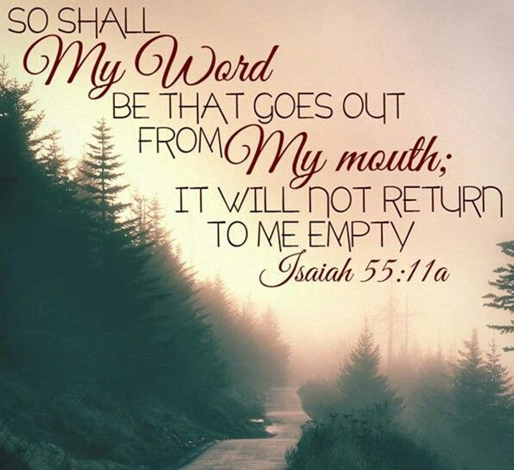

Coon Valley Lutheran Church

The Seventh Sunday in Pentecost

Thanksgiving at the Conclusion of a Call for
Pastor Julie Wollman and Coon Valley Lutheran Church

July 16, 2023

Head Usher: Jan Bender
Reader: Brian Rude

SCHEDULE
TODAY: Sign up for Vacation Bible School today!
THURSDAY: 10:00a/WELCA
SUNDAY: 10:00a/Worship with Pastor Meg Hoversten

*Jamie will be on vacation July 9-July 17th. Up through July 16th please contact Pastor Julie if you may need anything. If there is a need on July 17th, please contact Jamie. Thank you for this time away!

Coon Valley Lutheran Church
www.coonvalleylutheranchurch.org
Pastor: Rev. Julie Wollman, pastorjuliecvlc@gmail.com Home Phone 634-3797
Office Administrator: Jamie Thomas, jamiel@mwt.net
Office Hours: Tuesday 9:00a-11:30a; Wednesday & Thursday 9:00a-3:00p
Office 452-3772/Cell 317-0007
Treasurer: Becky Lusk, treasurer1005@mwt.net
Organist: Mary Schultz
Indoor Custodian: Tracy Stellner

FIRST READING: Isaiah 55:10-13
For as the rain and the snow come down from heaven, and do not return there until they have watered the earth, making it bring forth and sprout, giving seed to the sower and bread to the eater, so shall my word be that goes out from my mouth; it shall not return to me empty, but it shall accomplish that which I purpose, and succeed in the thing for which I sent it. For you shall go out in joy, and be let back in peace; the mountains and the hills before you shall burst into song, and all the trees of the field shall clap their hands. Instead of the thorn shall come up the cypress; instead of the brier shall come up the myrtle; and it shall be to the LORD for a memorial, for an everlasting sign that shall not be cut off.
The word of the LORD. Thanks be to God.

PSALM 65:1-13 (read responsively)
Praise is due to you, O God, in Zion; and to you shall vows be performed,
O you who answer prayer! To you all flesh shall come.
When deeds of iniquity overwhelm us, you forgive our transgressions.
Happy are those whom you choose and bring near to live in your courts. We shall be satisfied with the goodness of your house, your holy temple.
By awesome deeds you answer us with deliverance, O God of our salvation; you are the hope of all the ends of the earth and of the farthest seas.
By your strength you established the mountains; you are girded with might.
You silence the roaring of the seas, the roaring of their waves, the tumult of the peoples.
Those who live at earth’s farthest bounds are awed by your signs; you make the gateways of the morning and the evening shout for joy.
You visit the earth and water it, you greatly enrich it; the river of God is full of water; you provide the people with grain, for so you have prepared it.
You water its furrows abundantly, settling its ridges, softening it with showers, and blessing its growth.
You crown the year with your bounty; your wagon tracks overflow with richness.
The pastures of the wilderness overflow, the hills gird themselves with joy,
He meadows clothe themselves with flocks, the valleys deck themselves with grain, they shout and sing together for joy.

SECOND READING: Romans 8:1-11
There is therefore now no condemnation for those who are in Christ Jesus. For the law of the Spirit of life in Christ Jesus has set you free from the law of sin and of death. For God has done what the law, weakened by the flesh, could not do: by sending his own Son in the likeness of sinful flesh, and to deal with sin, he condemned sin in the flesh, so that the just requirement of the law might be fulfilled in us, who walk not according to the flesh but according to the Spirit. For those who live according to the flesh set their minds on the things of the flesh, but those who live according to the Spirit set their minds on the things of the Spirit. To set the mind on the flesh is death, but to set the mind on the Spirit is life and peace. For this reason the mind that is set on the flesh is hostile to God; it does not submit to God’s law—indeed it cannot, and those who are in the flesh cannot please God. But you are not in the flesh; you are in the Spirit, since the Spirit of God dwells in you. Anyone who does not have the Spirit of Christ does not belong to him. But if Christ is in you, though the body is dead because of sin, the Spirit is life because of righteousness. If the Spirit of him who raised Jesus from the dead dwells in you, he who raised Christ from the dead will give life to your mortal bodies also through his Spirit that dwells in you.
The word of the LORD. Thanks be to God.

GOSPEL READING: Matthew 13:1-9, 18-23
That same day Jesus went out of the house and sat beside the sea. Such great crowds gathered around him that he got into a boat and sat there, while the whole crowd stood on the beach. And he told them many things in parables, saying: “Listen! A sower went out to sow. And as he sowed, some seeds fell on the path, and the birds came and ate them up. Other seeds fell on rocky ground, where they did not have much soil, and they sprang up quickly, since they had not depth of soil. But when the sun rose, they were scorched; and since they had no root, they withered away. Other seeds fell among thorns, and the thorns grew up and choked them. Other seeds fell on good soil and brought forth grain, some a hundredfold, some sixty, some thirty. Let anyone with ears listen!” “Hear then the parable of the sower. When anyone hears the word of the kingdom and does not understand it, the evil one comes and snatches away what is sown in the heart; this is what was sown on the path. As for what was sown on rocky ground, this is the one who hears the word and immediately receives it with joy; yet such a person has no root, but endures only for a while, and when trouble or persecution arises on account of the word, that person immediately falls away. As for what was sown among thorns, this is the one who hears the word, but the cares of the world and the lure of wealth choke the word, and it yields nothing. But as for what was sown on good soil, this is the one who hears the word and understands it, who indeed bears fruit and yields, in one case a hundredfold, in another sixty, and in another thirty.”
The Gospel of the Lord. Praise to you, O Christ.

*We are always so happy to include you and our CVLC family in our prayers. If you feel your name, or the name of a family member can be removed from this list please contact Jamie. Thank you!

We remember in prayer:
† Those hospitalized this past week
† Our members whose names we lift up in prayer today: Corrine Appleman, Beverly Bagstad, Clifford Bakkum, Richard Brose, Jeanne Ebli, Kira Foster, Phyllis Galstad, Lucy Hardie, Bonnie Holey, Donna Ihle, Verlin Ihle, Alan Jacobson, Todd King, Mike Kellogg, Jim Knutson, Margaret Lee, Russell Lee, Aaron Leisso, Larry Lichtie, Cindy Manske, Aaron Marx, Frank Mathison, Bud Miyamoto, Marianne Myhre, LuEtta Nelson, Romaine Nelson, Sandy Nelson, Cathy Ofte, Lisa Olson, Sandra Onshus, Eunice Quast, Melanie Role, Jojo Satona, Mary Schultz, Billie Slater, LaVonne Stendahl, Suzanne Strangstalien, Patty Stuempges, Joyce Temp, Teri Tomten.
† Our members who are currently in health care facilities & Assisted Living: Tip Bagstad, Inez Beck, Rachel Berg, Evelyn Dahlen, Joanne Fletcher, Betty Gilbertson, Erma Graupe, Lenore Henley, Carl Holte, Sylvester King Jr., Bob Moilien, Irene Nestingen, Annie Olson, Beatrice Olson (Alden), Betty Sanders.
† Those who grieve: Family and friends of Bob Pederson & Sharon Stendahl; Becky Lusk and family in the death of her father Edwin Giese
† Our members who are currently home bound
† All those in need of God’s healing and help
† Family and friends of our members

