| The Carillon | |
| --- | --- |
| Page 1 | August, 2025 |



If I were asked to sum up the entirety of what we as Lutherans believe in one word, it would be easy…GRACE.  At the heart of the Bible is a story of God’s love for a broken world made manifest throughout all of history in an unending flow of grace towards the entire creation.

And as Lutherans we have a long insistence that the world should know this love story.   It is what motivated Martin Luther to translate the Bible into the language of the people. It inspired him to write hymns that the people could sing God’s great love song.  Countless others, led by the Spirit, have labored to proclaim this story to the world.  Luther, also insisted on the Priesthood of Believers, that each of us, through our baptism is called to proclaim the story through words and actions.   
  
Here in Coon Valley, this love of the story led new immigrants to build a gathering place where the story could be told. And so they erected a building whose steeple and bell would call the community to come hear it.  In time as Norwegian gave way to English, they took the courageous step to set aside their mother tongue so a new generation could hear the story in the language they knew best.  The story was told, through wars, a depression, and times of great upheaval.   
  
One of our most beloved hymns in our

hymnal, number 661, I Love to Tell the Story, says

I love to tell the story:  
how pleasant to repeat  
what seems, each time I tell it,  
more wonderfully sweet!  
I love to tell the story,  
for some have never heard

the message of salvation  
from God’s own holy word

And now we find ourselves in a moment like Luther’s asking the question “How do we tell the old old story to a new generation?”

This, really, is the challenge of the church in our time.  And we will need to be creative and faithful in how we answer it.   
  
I’d like to invite you to come to worship on **August 24th** and then stay for a community conversation where we will meet together, call on the Spirit to guide us, and talk about how can meet the challenges of being Church in 2025, both faithful to our history as Lutherans, and with a boldly envision of a future where we tell the story, of Jesus, and his Love.   
  
Peace and all good,

Pastor Ben

MCj03226430000[1]MAY CHURCH COUNCIL HIGHLIGHTS

**\*Treasurer’s Report:** The report was reviewed by Council. Report accepted.

**Finance Committee:** Bank statements approved. Requested Spring Stewardship Drive.

\***Ministry Minutes:** Pr. Ben will do the opening prayer for the Memorial Day Program. He will also serve as Camp Chaplin at Sugar Creek for 1 week. Pastor gave an update on the Viterbo training.

**\*Education:** Congrats to the Sunday School Staff and kids for a wonderful Spring Program. Planning for the new year will begin in Aug.

**\*Youth:** Planning for future youth trip

**\*Men’s Club:** June 22 is the cookout.

**\*Personnel Committee:** Job descriptions are ready for approval.

**\*Property & Grounds:** June 29th is the indoor clean-up day and lunch!

**\*Stewardship:** A fall campaign is planned.

**\*Worship:** Council to set-up for fellowship following Graduate service. Summer outdoor service dates were discussed.

**\*Membership, Life & Growth:** Amy Stakston & Jamie Thomas meeting to work on pictorial directory.

**Corn Roast:** Thank you to the Naomi Circle for volunteering to head the Corn Roast!

**Sugar Creek Explorer Day-June 18:** No one signed up to attend.

**Synod Assembly:** Pr. Ben, Laura Hofslien & Glen Hoff Will attend at Westby Coon Prairie.

*The meeting adjourned followed by the Lord’s Prayer.

Respectfully Submitted, Laura Hofslien

MCj03226430000[1]JUNE CHURCH COUNCIL HIGHLIGHTS

**\*Treasurer’s Report:** The report was reviewed by Council. Report accepted.

**Finance Committee:** Bank statements were approved. The Committee requests a stewardship drive before fall.

\***Ministry Minutes:**Baptism on June 15 and Betty Nelson funeral was June 19 and was well attended. Report on Synod Assembly. The resolution to become a Creation Care Synod was passed! Patty Nelson and Glen Hoff continue to attend the Servant Leadership Sessions at Viterbo.

**\*Education:** Amy reported that three Sunday School teachers from last year have agreed to teach again this next year.

**\*Men’s Club:** Outdoor worshipandCookout June 22.

**\*Personnel:** Job descriptions approval tabled until the next meeting due to changes that need to be made to all the descriptions.

**\*Property & Grounds:** Indoor clean-up day is Sunday June 29th.

**\*Stewardship:** Stewardship Campaign for fall of 2025 is being worked on.

**\*Worship:** Discussion on possibly adding an additional evening service and a new narrative lectionary.

**\*Membership, Life & Growth:** August deadline has been set to complete the Pictorial Directory.

**Discussion Items: Corn Roast:** Date needs to be changed depending on the maturity of the corn for the event.

**Funeral Policy:** Will be voted on at the July meeting.

**Coon Valley Heritage Day Parade:** On Aug. 23 the church will have an entry in the Parade! All are welcome to participate!

**Farmer’s Market:** Discussion on having freewill donation for produce. A sign up will be created for volunteers to work the market.

*The meeting adjourned followed by the Lord’s Prayer.

Respectfully Submitted, Laura Hofslien

COMMUNITY CORN ROAST!

Join us **on Tuesday, August 12th from 5:00-7:30pm.** Tables and chairs will be set up in the East lawn of our church. Feel free to bring your own chair if you wish. Stay and visit and enjoy some Traastad corn.

~Everyone in the community is invited.

~There is no charge for the meal!

**Menu:** Corn, hotdogs, sweets, lemonade & coffee

We are in need of several volunteers to roast corn, grill hotdogs, prepare sweet trays, set up, and clean up after the event. **Confirmation students and High School age youth we need your help!!** We need young strong legs to run food out to the lawn throughout the event. Please sign up on the sheets in the church located in the Narthex or outside the office. Or call the Church office 452-3772.

In the event of bad weather, the Corn Roast will be held in the Fellowship Hall.

We thank the Naomi Circle for spearheading this event!

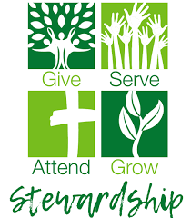

STEWARDSHIP CORNER

Precious treasure and oil are in the dwelling of a wise person, but a foolish man consumes them.

Proverbs 21:20

ONLINE GIVING

There are several ways you may get your offerings to the church. You may mail it to the church office, P.O. Box 280. Or use one of our eGiving options. 1) You may go to our website and click the Donate button at the top. 2) Give through the mobile app Vanco Mobile. Please let Jamie know if you need assistance in any way. Thank you for your support!

PARTICIPATE IN OUR WORSHIP SERVICES FROM HOME

**Facebook:** Services are live streamed, recorded and available Sunday mornings on the CVLC Facebook page.

**YouTube:** Subscribe to our page!

**Our Website:** [www.coonvalleylutheranchurch.org](http://www.coonvalleylutheranchurch.org)

BLOOD DRIVE

Our June 2 blood drive collected 42 units of blood! Thanks to all who donated and volunteered at this drive! Our next blood drive is scheduled for Monday, October 13th from 1-6pm. The current supply of blood is critically low! Visit [redcrossblood.org](https://d.docs.live.net/a077a1d88e72bfe6/Documents/Newsletter/redcrossblood.org) to schedule an appointment or call Mike Lusk to set up an appointment or to volunteer to help with the drive. After your donation, you will receive refreshments.

THANK YOU, CEMETERY COMMITTEE

Thanks to the members of the Cemetery Committee, Bruce Olson, Danny Thompson and Marc Moilien. For their continued efforts to keep our cemetery looking beautiful! They spend countless hours each week mowing and weeding the cemetery. Thank them next time you see them.

LWR SCHOOL KITS

Fall is fast approaching and school supplies are already on sale.  The following are the items to purchase for Lutheran World Relief - LWR - School Kits:

**FOUR**    70-sheet notebooks of wide- or college-ruled paper, approximately 8” x 10 ½”; no loose leaf paper  
**ONE**       30-centimeter ruler, or a ruler with centimeters on one side and inches on the other  
**ONE**         pencil sharpener  
**ONE**         pair of blunt scissors (safety scissors with embedded steel blades work well)  
**FIVE**          unsharpened #2 pencils with erasers; secure together with a rubber band  
**FIVE**          black or blue ballpoint pens (no gel ink); secure together with a rubber band  
**ONE**          box of 16 or 24 crayons  
**ONE**          2 ½” eraser

WELCA provides and assembles the bags.  We also accept monetary gifts for those unable to purchase items.

THIS IS A PROJECT FOR OUR ENTIRE CONGREGATION! We will need all donations at the church by Sunday, September 14.

Please contact Eunice Quast at 317-2547 if you have questions.

DO YOU HAVE A NEW ADDRESS OR PHONE NUMBER? PLEASE SHARE YOUR NEW CONTACT INFORMATION WITH THE CHURCH OFFICE! Sharing your cell phone number, email and address with us ensures that you receive important information about your church!

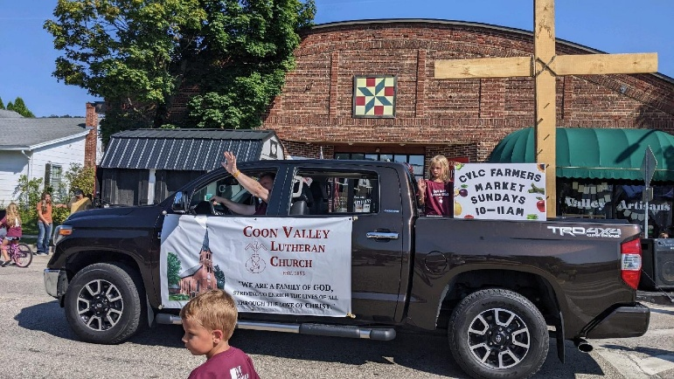COON VALLEY HERITAGE DAY PARADE

Our church will be walking in the Coon Valley Heritage Day Parade **at 10am on Sat. Aug. 23**. All are welcome to participate! This is a fun event for our church! Kids and families are welcome to walk. Kids may ride their bike or scooter. We are in search of a truck to use for the parade. Let Jamie know if you have one that we may use. We will hand out candy. If you are interested in walking in the parade sign up on the sign-up sheet in the narthex. If you would like to donate candy for us to hand out at the parade, please leave that donation in the church office. Stay tuned on Sundays for more announcements and updates about this fun event!

CVLC FARMER’S MARKET IS BACK!

Our Farmer’s Market is back! Beginning in August the Farmer’s Market table will be available after worship from 10-11am. Bring extra produce from your garden, canned goods, eggs, baked goods, flowers & plants and crafts to the table before worship. There will be a place available for freewill donations of all items on the table. We are looking for some volunteers to help set up the table each Sunday. Please sign-up on the sheet in the narthex. If you are interested in providing donations and need assistance please contact Jamie in the church office.

CHURCH CLEAN UP DAY

On Sunday June 29 over 20 members from our church showed up to clean our church and prepare and serve a lunch! Thank you to all for your work to keep our church beautiful and our bellies full!

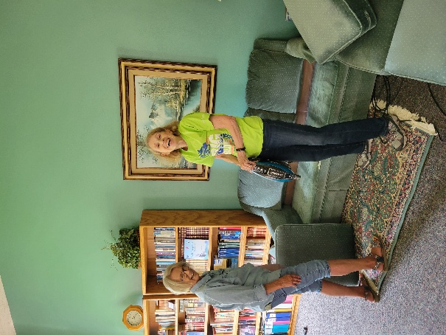

Jan Verse & Ainsley Lichtie cleaning furniture.

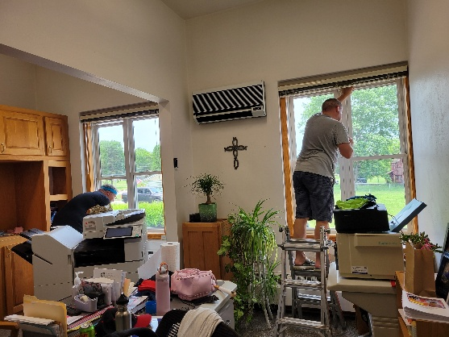

Glen Hoff & Jason Thomas cleaning windows.

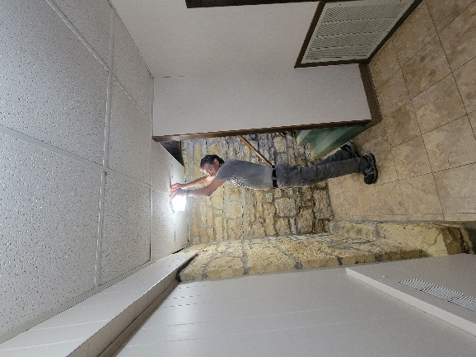

Steve Pauloski cleaning light fixtures.

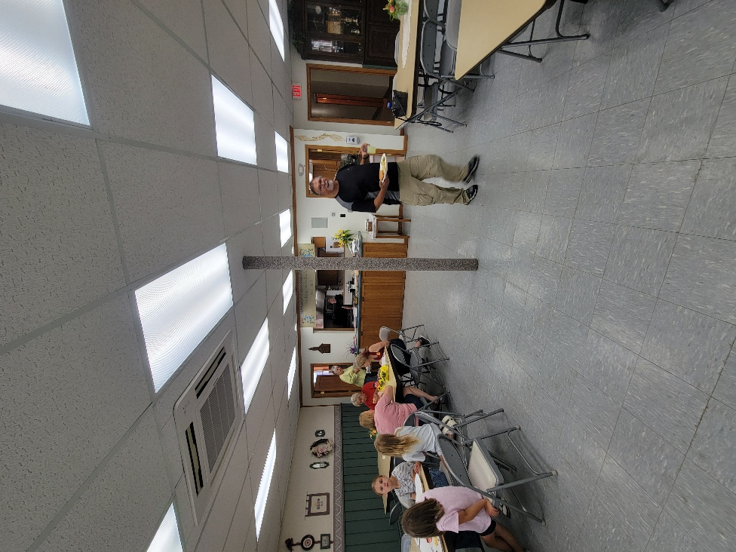

Lunchtime!

GIVING OPPORTUNITIES

Below is a list of the many funds you may wish to give to.

**GENERAL FUND**- Church operating expenses.

**BUILDING FUND** -Building and grounds projects, currently includes the Parking Lot Fund.

**MEMORIAL FUND**-Used for the life and ministry of the church as determined by Council.

**SHEPHERD FUND**-Funds for church & community members in need.

**CEMETERY**-Maintenance of the grounds.

**WELCA**-Woman of the ELCA includes Quilting and Kitchen funds.

**SUNDAY SCHOOL**-Teaching materials

**PRAYER SHAWL MINISTRY**-Supplies for the making of prayer shawls and prayer squares.

**YOUTH FUND**-Funds to pay for Mission Trips

**ENDOWMENT**-Only interest income may be used for community outreach, missions of ELCA, Capital Improvements.

**RUDIE BIBLE FUND**-Supply Bibles to youth.

**WELCA NEWS**

Our July meeting opened with the Table Prayer and coffee served by the Rebecca Circle. They also presented the program beginning with devotions by Kay Nelson. She brought several coffee cups comparing people to the cups that are all designed by God – some are fragile and beautiful, some are sturdy and dependable and all possess different talents. The speaker from APTIV (formerly Riverfront) was accompanied by two “Miss Remarkables.” This is a program that highlights the abilities and talents of their clients and make them feel very special. It is truly remarkable to see them preparing for the pageant – getting their hair and makeup done and wearing beautiful gowns. Shelby Reschke from our congregation is a former Miss Remarkable. Thank you, Rebecca Circle, for this enchanting program.

After our Purpose Statement, we began with Old Business thanking Deb Holen for adding colorful petunias to the Memorial Garden. Thanks also to Patty Nelson, Ainsley Lichtie and Cheryl Morey for helping Deb keep the church grounds looking beautiful.

New Business: There is a sign-up sheet in the back of the church for you to volunteer to bring bars, serve hot dogs, corn, etc.for the Community Corn Roast. This is a great opportunity to experience true fellowship. It’s happening soon – Tuesday, August 12.

The Spring WELCA Synod Convention will be hosted by the Southern District in 2026 and we have been asked to host. We voted to do this so on Saturday, April 18, 2026, we will welcome members from our Synod congregations. Our responsibilities will be to provide morning coffee and lunch and whatever else the Synod asks of us. As of now, the keynote speaker will be former Bishop April Larson. More information will be forthcoming.

Instead of each WELCA district having a summer outing, it has been decided that there should be one outing for everyone. This is going to be on Saturday, September 20 and will be a cruise on the Mississippi with a delicious meal included. Cost is $55 and pre-registration is required. If you are interested, please let Ellie know.

Our August program will be Thursday, August 21 and the General Board will present the program. Judy Koula will be the server. At our May and July meetings, we had 22 and 20 members attend. It was very heartwarming to have so many members join us and I hope we can keep the momentum going. See you in August!

**DATES TO REMEMBER**

Tues., Aug. 12, 5-7:30 pm – Community Corn Roast

Thurs., Aug. 21, 10 am, WELCA – General Board presents program. Server: Judy Koula

**LOOKING AHEAD**

Thurs., Sept. 18, 10 am, WELCA – General Board presents program honoring Quilters, Prayer Shawl Ministry, Prayer Chain. Server: Jean Gronvold

Wed., Sept 24, 4-7 pm – Chili/Chicken Soup Supper and Raffle.

**\* * * * \***

**\***Please note the article from Eunice Quast in this newsletter regarding school kits for Lutheran World Relief.

**\* * * * \***

God Bless, Ellie Brye, President

**ATTENDANCE & OFFERING**

|  |  |  |  |
| --- | --- | --- | --- |
| **2025** | **June** |  | **2025 YTD** |
| **Total Offerings** | $13,002.07 |  | $88,068.94 |
| **Expenses** | $15,661.74 |  | $109,754.58 |
| **Balance/Shortfall** | **-$2,659.67** |  | **-$21,685.64** |
| **Parsonage Int. Fund Transfer** | $0 |  | $0 |
| **Building Fund Transfer** | $0 |  | $8,372.00 |
| **Memorial Fund**  **Transfer** | $0 |  | $2,164.73 |

**5/25 – 9a:** 85; **Offering:** $2,305.50

**6/1 – 9a:** 70; **Offering:** $3,970.48

**6/8 – 9a:** 91; **Offering:** $2,700.61

**6/15 – 9a:** 88; **Offering:** $3,510.07

**6/22 – 9a:** 64; **Offering:** $2,397.43

**6/29 – 9a:**70; **Offering:** $2,464.73

**7/6 – 9a:** 91; **Offering:** $2,990.61

**7/13 – 9a:** 69; **Offering:** $3,058.27

**7/20 – 9a:** 79; **Offering:** $2,792.61

**\*\***Approximately **$4,365.00 a week** is needed to meet operating expenses.

**General Fund Balance:** 6/30/25: $28,054.27

**Memorial Fund Balance:**6/30/25: $61,084.53

**Building Fund Balance:** 6/30/25: $53,881.58

**CD Interest Balance:** 6/30/25: $23,829.84

**Shepherd Fund Balance:** 6/30/25: $2,274.65

BAPTISM

6/15 Aurora Lynn Buckmaster

FUNERALS/BURIALS

6/19 Betty Nelson

7/3 Jeff Nestingen

MEMORIALS

**Ingrid Schindler**

Memorial Fund: $50.00

**Jeff Nestingen**

Memorial Fund: $20.00

**Betty Nelson**

Memorial Fund: $650.00

Sunday School: $20.00

Quilting: $240.00

Prayer Shawl: $40.00

Youth Fund: $40.40

WELCA: $210.00

Parking Lot: $120.00

Endowment Fund: $80.00

**YEAR-TO-DATE BALANCE**

PRAYER GROUP

The Prayer Group continues to pray for the church, the congregation and our extended family and friends.

**† *Our church staff***

**† *Our members*:** Corrine Appleman, Beverly Bagstad, Clifford Bakkum, Herby Cornell, Kira Hoff, Becky Ihle, Donna Ihle, Todd King, Margaret Lee, Russell Lee, Aaron Leisso, Aaron Marx, LuEtta Nelson, Mike Nelson, Romaine Nelson, Cathy Ofte, Eunice Quast, Jojo Satona, Mary Schultz, Billie Slater, LaVonne Stendahl, Krin (Dreves) Stendalen, Joyce Temp, Teri Tomten, Renita Williamson.

**† *Our members who are currently in health care facilities & Assisted Living*:** Tip Bagstad, Rachel Berg, Carl Daffinrud, Evelyn Dahlen, Jeanne Ebli, Lenore Henley, Carl Holte, Bob Moilien, Pauline Moilien, Irene Nestingen, Geri Nestingen, Annie Olson, Beatrice Olson (Alden).

**† *Those who grieve:*** Family and friends of Betty Nelson, Jeff Nestingen & Verlin Ihle

**† *Family and friends of members***

**† *Local Military***

PLEASE NOTE OUR NEW EMAIL!

Pastor Benjamin: <pastor@coonvalleylutheranchurch.org>

Jamie Thomas, Office Administrator:

[office@coonvalleylutheranchurch.org](mailto:office@coonvalleylutheranchurch.org)

Becky Lusk, Treasurer:

[treasurer@coonvalleylutheranchurch.org](mailto:treasurer@coonvalleylutheranchurch.org)

**DAILY BIBLE READINGS**

**WEEK OF AUGUST 3**

**SUNDAY** Ecclesiastes 1:2, 12-14; 2:18-23

*Search out wisdom*

Psalm 49:1-12 *The folly of trust in riches*

*or Hosea 11:1-11 Like a mother, God loves Israel*

Psalm 107:1-9, 43 *Give thanks to the Most High*

Colossians 3:1-11 *Clothed in Christ*

Luke 12:13-21 *Be rich toward God, your treasure*

**MONDAY** Ecclesiastes 2:1-17 *The fool accumulates wealth*

**TUESDAY** Ecclesiastes 3:16—4:8 *Death comes to all*

**WEDNESDAY** Luke 12:22-31 *Trust in God*

**THURSDAY** Ecclesiastes 12:1-8, 13-14 *Remember God*

**FRIDAY** Colossians 3:18—4:5 *A household code*

**SATURDAY** Psalm 127 *The foolish life, the righteous life*

**WEEK OF AUGUST 10**

**SUNDAY** Genesis 15:1-6 *God’s promise of a child*

Psalm 33:12-22 Let your lovingkindness be upon us

*or* Isaiah 1:1, 10-20 *Learn to do good*

Psalm 50:1-8, 22-23 *The salvation of* *God*

Hebrews 11:1-3, 8-16 *Abraham’s faith in a home given by God*

Luke 12:32-40 *The treasure of the kingdom*

**MONDAY** 2 Chronicles 33:1-17 *Manasseh returns to God*

**TUESDAY** 2 Chronicles 34:22-33 *Huldah preaches the covenant*

**WEDNESDAY** Luke 12:41-48 *A parable of the slaves*

**THURSDAY** Jeremiah 33:14-26 God remembers the covenant with David

**FRIDAY** Hebrews 11:1-7, 17-28 *The ancestors’ faith*

**SATURDAY** Psalm 89:1-18 *God’s covenant with David*

**WEEK OF AUGUST 17**

**SUNDAY** Jeremiah 23:23-29 *God’s word is like fire*

Psalm 82 *O God, rule the earth*

*or* Isaiah 5:1-7 *The vineyard of the LORD is destroyed*

Psalm 80:1-2, 8-19 *O God, tend this vine*

Hebrews 11:29—12-2 *The faith of the Hebrew people*

Luke 12:49-56 *Jesus brings fire on earth*

**MONDAY** 1 Samuel 5:1-12 *The Philistines punished with plague*

**TUESDAY** 1 Samuel 6:1-16 *The Philistines atone for sacrilege*

**WEDNESDAY** Luke 19:45-48 *Jesus cleanses the temple*

**THURSDAY** Joshua 7;1, 10-26 *Achan punished for disobedience*

**FRIDAY** Hebrews 10:26-39 *God’s judgment*

**SATURDAY** Psalm 32 *Prayer for forgiveness*

**WEEK OF AUGUST 24**

**SUNDAY** Isaiah 58:9b-14 *Do not trample the sabbath*

Psalm 103:1-8 *Crowned with mercy and lovingkindness*

*or* Jeremiah 1:4-10 *Jeremiah called to be a prophet*

Psalm 71:1-6 *You have been my strength*

Hebrews 12:18-29 *Coming to the city of the living God*

Luke 13:10-17 *Jesus heals on the sabbath*

**MONDAY** Nehemiah 13:15-22 *Nehemiah enforces sabbath law*

**TUESDAY** Ezekiel 10:1-17 *The people profaned the sabbath*

**WEDNESDAY** Luke 6:1-11 *Jesus heals on the sabbath*

**THURSDAY** Acts 17:1-9 *Paul preaches Christ on the sabbath*

**FRIDAY** Hebrews 12:3-17 *Call for endurance*

**SATURDAY** Psalm 109:21-31 *Praise for healing*

**WEEK OF AUGUST 31**

**SUNDAY** Proverbs 25:6-7 *Do not put yourself forward*

*or* Sirach 10:12-18 *Judgment upon the proud*

Psalm 112 *The righteous are merciful*

*or* Jeremiah 2:4-13 *The people of Israel forsake the LORD*

Psalm 81:1, 10-16 *Honey from the rock*

Hebrews 13:1-8, 15-16 *God is with us*

Luke 14:1, 7-14 *Invite to poor to your banquet*

**MONDAY** Isaiah 2:5-17 *God condemns the proud*

**TUESDAY** Isaiah 57:14-21 *God blesses the humble*

**WEDNESDAY** Luke 14:15-24 *God’s hospitality to the humble*

**THURSDAY** 2 Chronicles 12:1-12 *King Rehoboam humbles himself*

**FRIDAY** Hebrews 13:7-21 *Call for faithfulness*

**SATURDAY** Psalm 119:65-72 *God blesses the humble*

**Moving? New contact information? Please update the church office.**

**Thank you!**

Please use our correct mailing address when sending us mail.

P.O. Box 280

Thank you!

Visit our website: coonvalleylutheranchurch.org to sign-up to receive our newsletter via email!

**THE CARILLON**

VOL. 54 August 2025 No.7

Coon Valley Lutheran Church, ELCA 1005 Central Avenue, P.O. Box 280

Coon Valley, WI 54623

Office Phone (608)452-3772

www.coonvalleylutheranchurch.org

Pastor: Rev. Ben Morris, 608-406-1556; [pastor@coonvalleylutheranchurch.org](mailto:pastor@coonvalleylutheranchurch.org)

Office Administrator: Jamie Thomas, [office@coonvalleylutheranchurch.org](mailto:office@coonvalleylutheranchurch.org),

Office: 608-452-3772; Cell Phone: 608-317-0007

Office Hours: Tuesday, Wednesday 9:00am-3:00pm

Treasurer: Becky Lusk, <treasurer@coonvalleylutheranchurch.org>

Organist: Mary Schultz

Indoor Custodian: Tracy Stellner

Church Council President: Steve Pauloski

Vice President: Ray Williamson; Secretary: Laura Hofslien

Paul Bahr, Kimberly Cade, Mark Hutson, Julie Nelson, Patricia Nelson,

Amy Stakston-Wiedemann

**Worship Schedule**

**Sunday Worship at 9:00**

**See calendar for change in worship times**

|  |  |  |  |  |  |  |
| --- | --- | --- | --- | --- | --- | --- |
| August 2025 | | | | | | |
| **Sunday** | **Monday** | **Tuesday** | **Wednesday** | **Thursday** | **Friday** | **Saturday** |
|  |  |  |  |  | **1**  Pr. Ben’s sabbath | **2** |
| **3**  **10:15a-**Worship with Holy Communion with Pr. Meg Hoversten  **5:15-7:30p-**VBS | **4**  **9:00a-**Naomi Circle  **5:15-7:30p-**VBS | **5**  **9:00a-**Pastor’s Text Study  **10:00a-**Ruth Circle  **5:15-7:30p-**VBS | **6**  **5:15-7:30p-**VBS @ Middle C.V.  **6:00p-**Rebecca Circle | **7**  **10:00a-**Bible Study | **8**  Pr. Ben’s sabbath | **9** |
| **10**  **9:00a-**Worship with Holy Communion | **11** | **12**  **9:00a-**Pastor’s Text Study | **13**  **9:00a-**Quilting | **14**  **10:00a-**Bible Study | **15**  **Carillon Deadline**  Pr. Ben’s sabbath | **16** |
| **17**  **9:00a-**Outdoor Worship | **18** | **19**  **9:00a-**Pastor’s Text Study | **20** | **21**  **10:00a-**WELCA  **6:00p-**Church Council | **22**  Pr. Ben’s sabbath | **23**  **Coon Valley Heritage Day**  **10:00a**-Parade |
| **24**  **9:00a**Worship  **10:00a**-Community Conversation | **25** | **26**  **9:00a-**Pastor’s Text Study | **27**  **9:00a-**Quilting | **28**  **10:00a-**Bible Study | **29**  Pr. Ben’s sabbath | **30** |
| **31**  **9:00a-**Worship |  |  | Related image |  | **Office Hours:**  **Tues 9a-3:00p**  **Wed 9a-3:00p** |  |